PRACTICAL-1
DEFINITION- This practical is based on analyzing a dataset of restaurent using microsoft Power Bi. The dataset file, restaurent csv,contains important details such as restaurant name, location and locality .
OUTCOMES/LEARNING- Gained experiences in using power bi to Import ,Transform ,and analyze a restaurant dataset by solving basic , intermediate ,,and advanced data-driven questions . developed competency in building visualization ,calculating key matrices ,and drawing business insights using Power Bi’s dashboard and report features.
REQUIRED TOOLS- Power Bi deskto(Report view , Power query editor).
WORKING- imported the restaurant dataset into Power i ,performed data cleaning and transformation ,and created visualizations to answer a variety of questions .utilized Power BI’S visuals tools(such as line charts , bar charts ,KPI) to explore data relationships and summarize findings.
Dataset Review
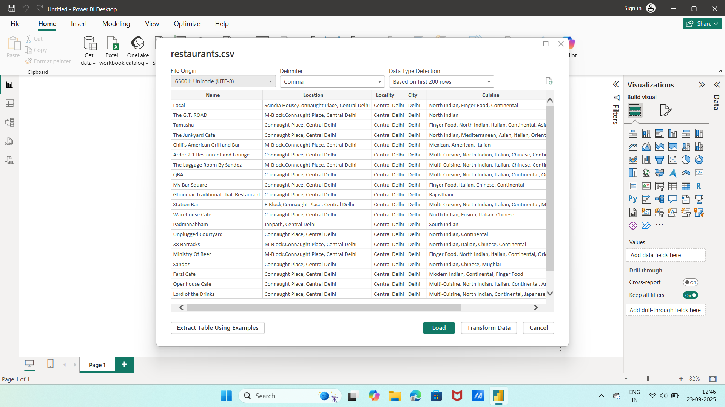
This datset contains information about various restaurants from different cities,including details such as restaurants name, location , city , rating,number of votes and cost etc.

STEP-1:Importing the restaurant data directly into Power Bi
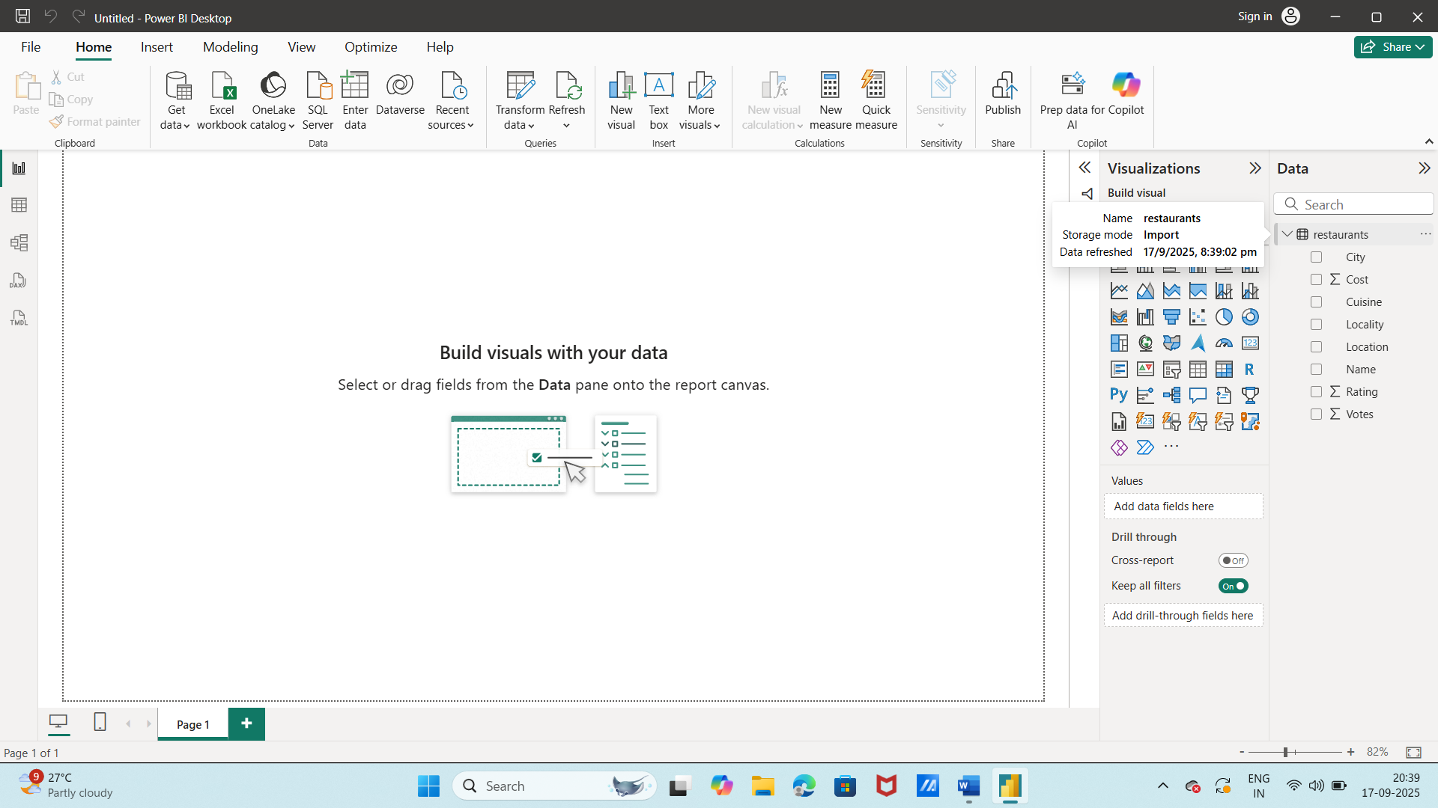
Imported restaurant data directly into Power Bi using the “Get Data” option.

STEP-2:Performing data transformation
Used power query editor to transform the data i.e. removed blank rows and duplicate rows.(we didn’t tranormed the data so much because we don’t need to. And also we are going according to questions).
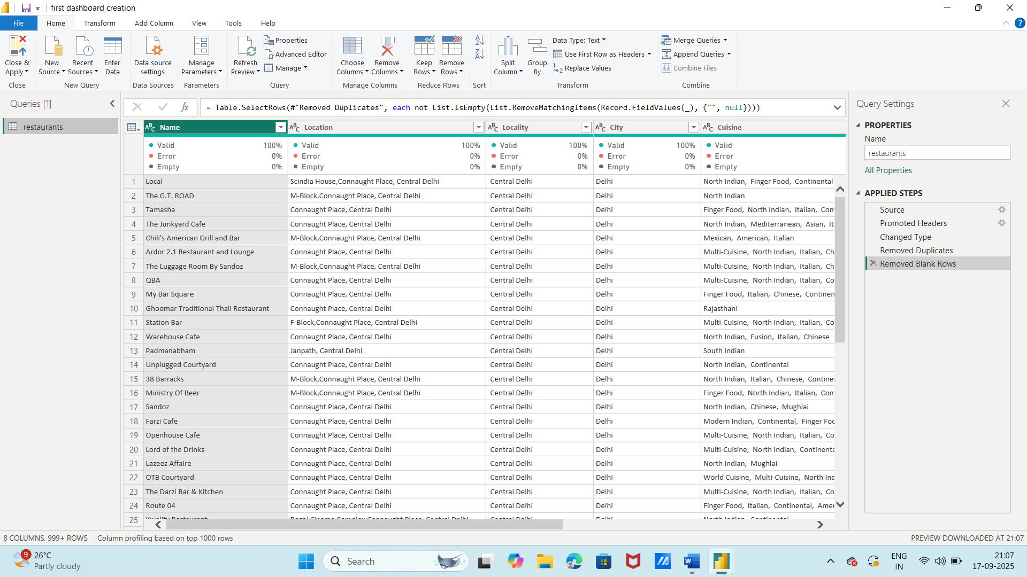
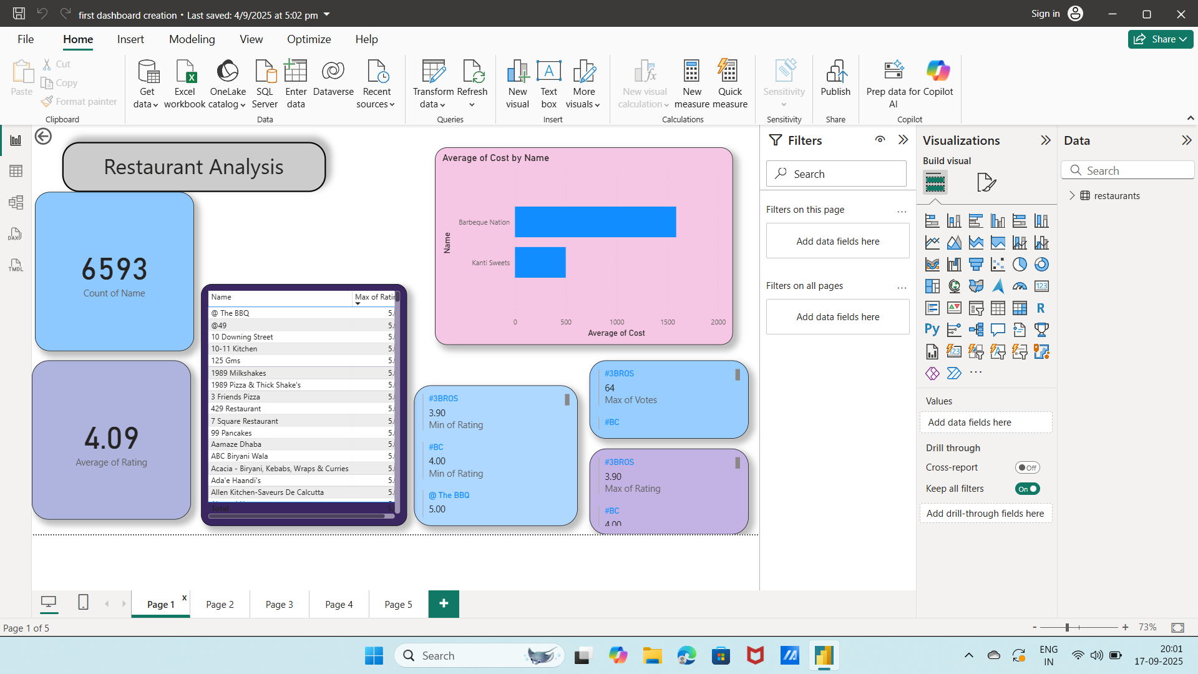
STEP-3:Performing Visualization in Report View(Basic Question)
Created a power bi report page titled “Restaurant Analysis” and added multiple visuals to summarize key matrices ,including
- total numbers of restaurants,
- average rating,
- list of restaurants with highest rating
- a bar chart comparing the average cost by restaurant name.

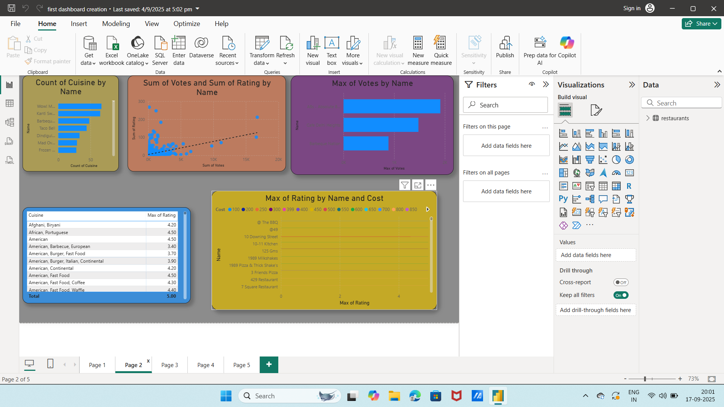
STEP-4;Another dashboard(Intermediate question)
Designed a detailed Power Bi dashboard with diverse visuals to display key insights such as
- count of cuisines by name
- sum of votes and sum of ratings by name
- maximum of votes by name ,
- maximum rating of cuisine and
5- maximum rating by name and cost.

STEP-5:Creating a comparative dashboard and another chart displaying the max cost
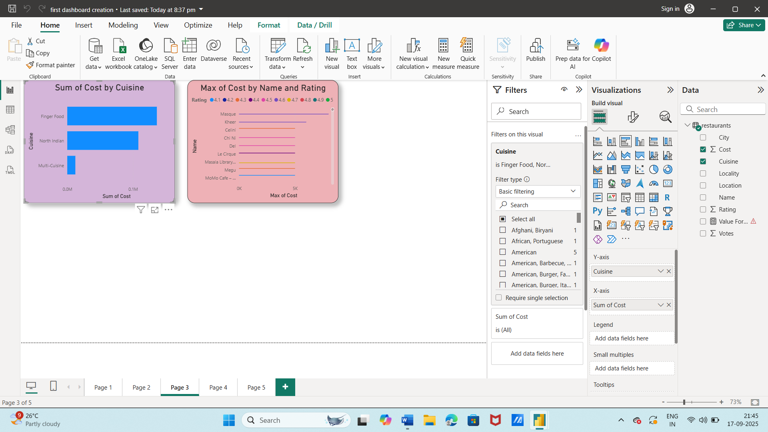
1-Created a comparative chart showing the total cost for three major cuisine types-finger food ,north Indian ,and multi cuisine-enabling visual comparison
.2- Included a second chart displaying the maximum cost for each restaurant along with it’s rating .
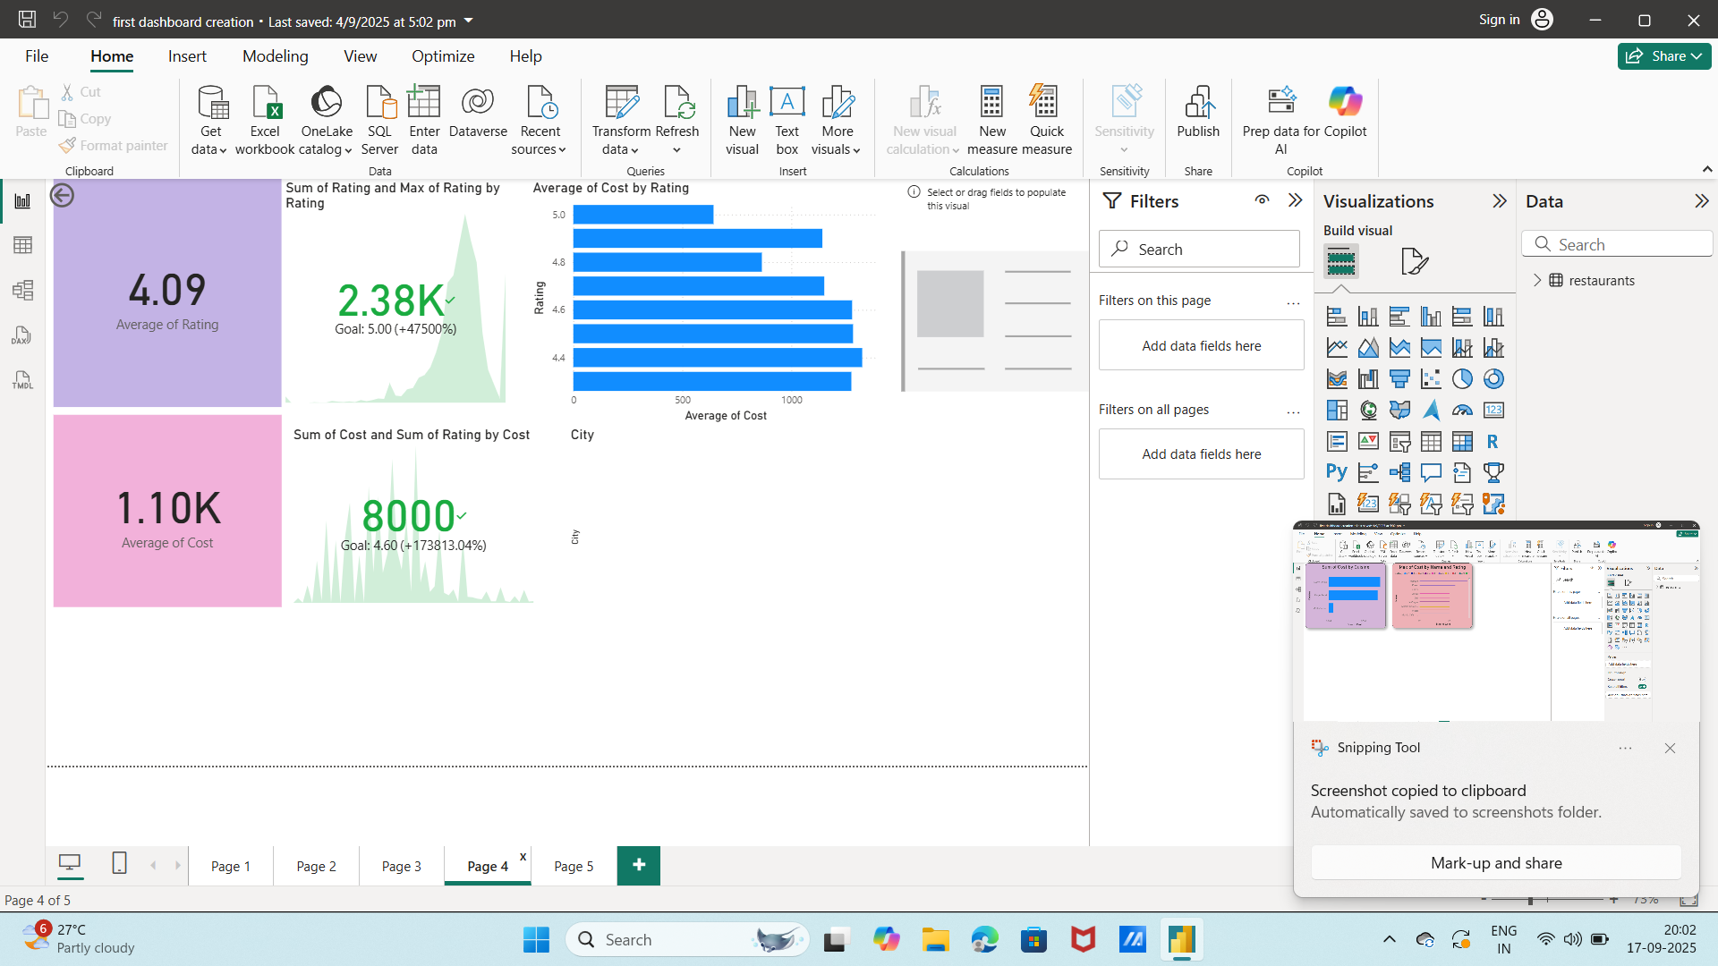
STEP-6:Another visualization(advanced)
Developed visualization to analyze restaurant data by presenting the sum of cost by cuisine and highlighting the restaurants with the highest cost along with their ratings. This dashboard provides a clear comparison of expenditure across different cuisines and pinpoints the most expensive restaurants .

