


Madhuben & Bhanubhai Patel Institute of Technology
(The Charutar Vidya Mandal (CVM) University) New V. V. Nagar

COMPUTER ENGINEERING
Case Study on
Risk Pooling Strategy in Inventory Management

Submitted By
DALWADI SHREY - (12302040701169)

Guided By Prof. H C Mevada

SUPPLY CHAIN & MANAGEMENT (202090622)
A.Y. 2025-26 EVEN TERM

Risk Pooling Strategy in Inventory Management
- Introduction to Inventory Management
Inventory management is a critical function in supply chain management that ensures the availability of products at the right time, place, and quantity. Organizations must balance between excess inventory and stockouts, both of which can lead to financial losses.
One of the biggest challenges in inventory management is demand uncertainty. Customer demand fluctuates due to seasonality, trends, and external factors. To manage this uncertainty effectively, companies adopt strategies like risk pooling.
Risk pooling is a powerful approach that reduces variability in demand by aggregating it across multiple locations, products, or time periods.

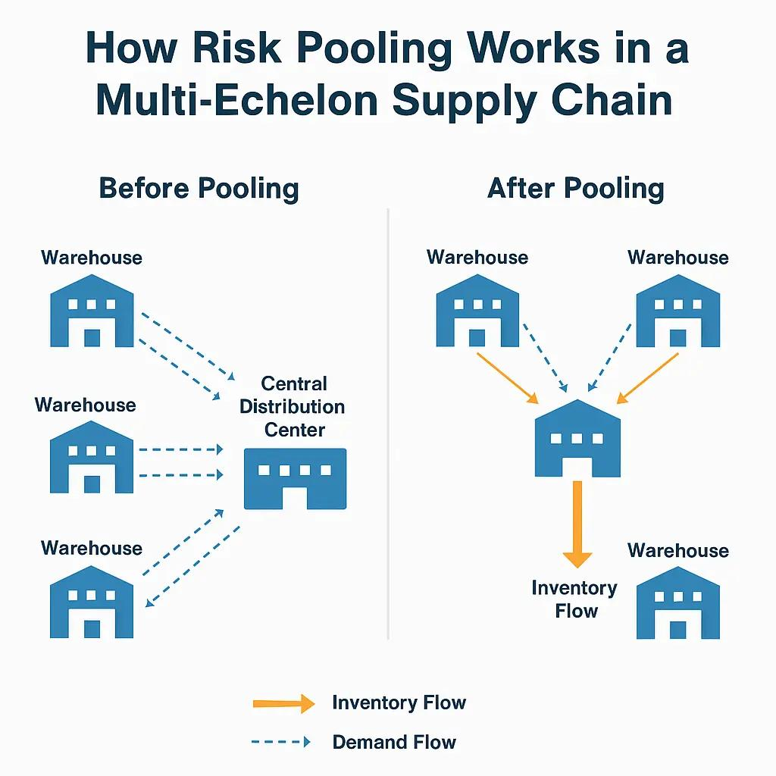

- Concept of Risk Pooling
Risk pooling is based on a simple statistical principle:
When demand from different sources is combined, the overall variability reduces.
Instead of managing inventory separately for each store or region, companies centralize or share inventory, which leads to better utilization.
Key Points:
- Reduces demand variability
- Decreases safety stock requirements
- Improves forecasting accuracy
- Enhances service levels
Example:
If 10 stores keep separate inventories, each must maintain safety stock. But if inventory is centralized, total safety stock required is significantly lower.

- Types of Risk Pooling
Risk pooling can be implemented in different ways depending on the supply chain design:
1. Inventory Pooling
- Centralizing inventory in one location
- Reduces duplication of stock
2. Virtual Pooling
- Sharing information across multiple locations
- Inventory remains decentralized but managed centrally
3. Lead Time Pooling
- Reducing variability in delivery times
- Faster and more reliable replenishment
4. Product Pooling
- Using standardized components for multiple products
- Reduces complexity and inventory levels

- Centralized vs Decentralized Inventory
Centralized Inventory (Risk Pooling)
- Lower safety stock
- Better demand visibility
- Cost-efficient
- Suitable for global operations
Decentralized Inventory
- Faster local response
- Higher inventory cost
- Increased risk of overstock/stockouts

- Benefits of Risk Pooling
Risk pooling provides several operational and financial benefits:
1. Reduced Inventory Costs
- Lower safety stock
- Reduced storage cost
2. Improved Demand Forecasting
- Aggregated data is more predictable
3. Better Customer Service
- Higher product availability
- Reduced stockouts
4. Efficient Resource Utilization
- Optimized warehouse and logistics operations
5. Reduced Bullwhip Effect
- Minimizes demand distortion across the supply chain

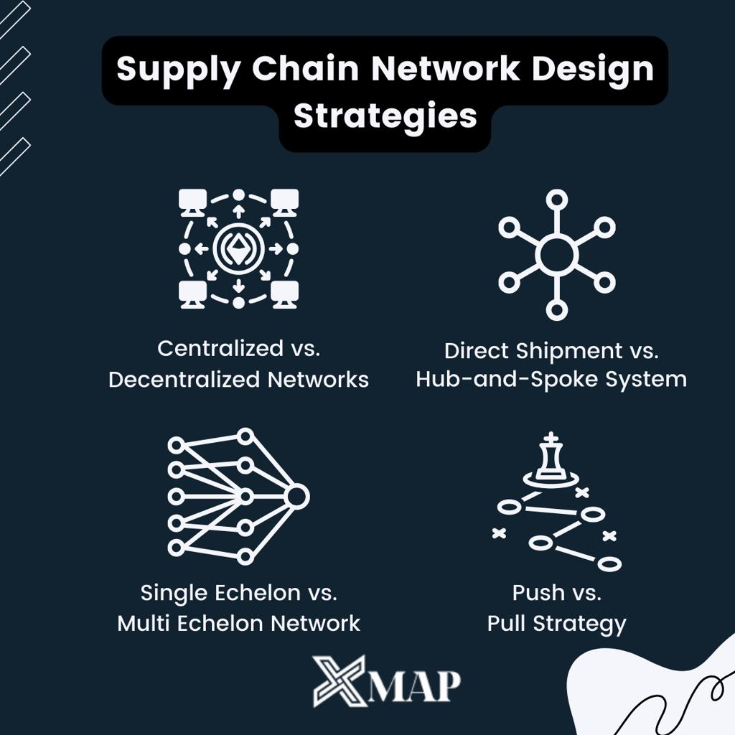

- Case Study – Zara’s Risk Pooling Strategy
Zara is a global leader in fast fashion and a benchmark for efficient supply chain management. Its success is largely driven by its ability to manage inventory effectively using risk pooling principles.
Zara follows a centralized distribution model, where most inventory is managed through its main distribution center in Arteixo, Spain.

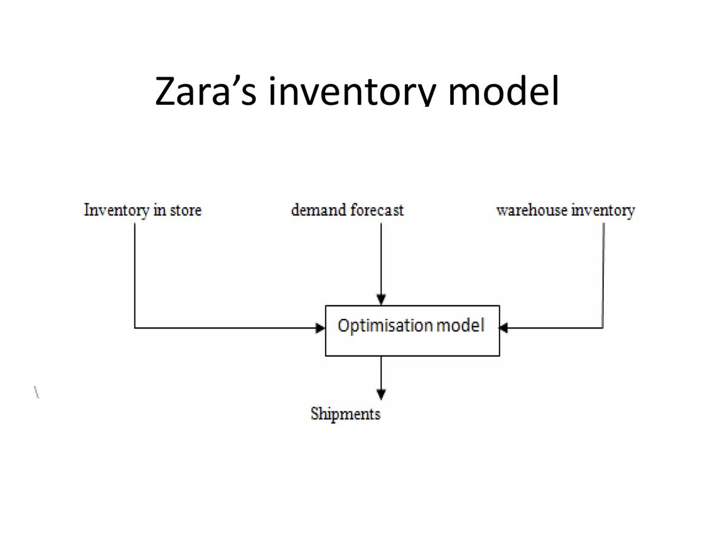

- Zara’s Supply Chain & Risk Pooling Approach
Centralized Distribution
- All products are sent to a central warehouse in Spain
- From there, items are distributed globally
Demand Aggregation
- Demand data from all stores is combined
- Reduces variability and improves forecasting
Frequent Replenishment
- Stores receive shipments twice a week
- Reduces need for high inventory at store level
Low Inventory Strategy
- Zara produces limited quantities
- Encourages quick turnover and reduces unsold stock

- Real-Time Example of Zara
- Zara collects real-time sales data from stores
- Store managers provide feedback on customer preferences
- Production decisions are adjusted quickly
Example:
During a fashion trend surge, Zara produces and distributes new designs within 2–3 weeks, based on aggregated demand data.
This approach minimizes risk and ensures high responsiveness.

9. Benefits of Risk Pooling in Zara
1. Lower Safety Stock
- Centralized inventory reduces overall stock requirements
2. Reduced Excess Inventory
- Limited production reduces unsold items
3. Faster Response to Trends
- Aggregated demand helps identify popular products quickly
4. High Inventory Turnover
- Average turnover is very high compared to competitors
5. Cost Efficiency
- Less wastage and markdowns

10. Challenges in Risk Pooling (Zara Case)
Despite its advantages, risk pooling has certain limitations:
1. Centralization Risk
- Heavy dependence on a single distribution center
2. Transportation Cost
- Frequent shipments increase logistics cost
3. Global Coordination Complexity
- Requires strong IT systems and communication
4. Expansion Challenges
- Scaling centralized systems globally can be difficult

11. Solutions & Improvements
To overcome these challenges, companies like Zara adopt:
- RFID Technology for real-time tracking
- AI-based forecasting systems
- Multiple distribution hubs (e.g., Netherlands expansion)
- Digital supply chain integration

12. Future Scope of Risk Pooling
The future of risk pooling is closely linked with technology:
- Integration with Artificial Intelligence
- Use of Big Data Analytics for demand prediction
- Automation in warehouses
- Real-time global inventory visibility
These advancements will make risk pooling even more efficient and scalable.

13. Conclusion
Risk pooling is a powerful strategy in inventory management that helps organizations reduce uncertainty, optimize inventory, and improve service levels.
The case of Zara demonstrates how centralized distribution, real-time data, and agile operations can successfully implement risk pooling in a global supply chain.
In today’s competitive market, companies that effectively use risk pooling can achieve cost efficiency, responsiveness, and sustainable growth.

