**Kubernetes Cluster Setup:**

1. Install docker in linux with the help of the scripts

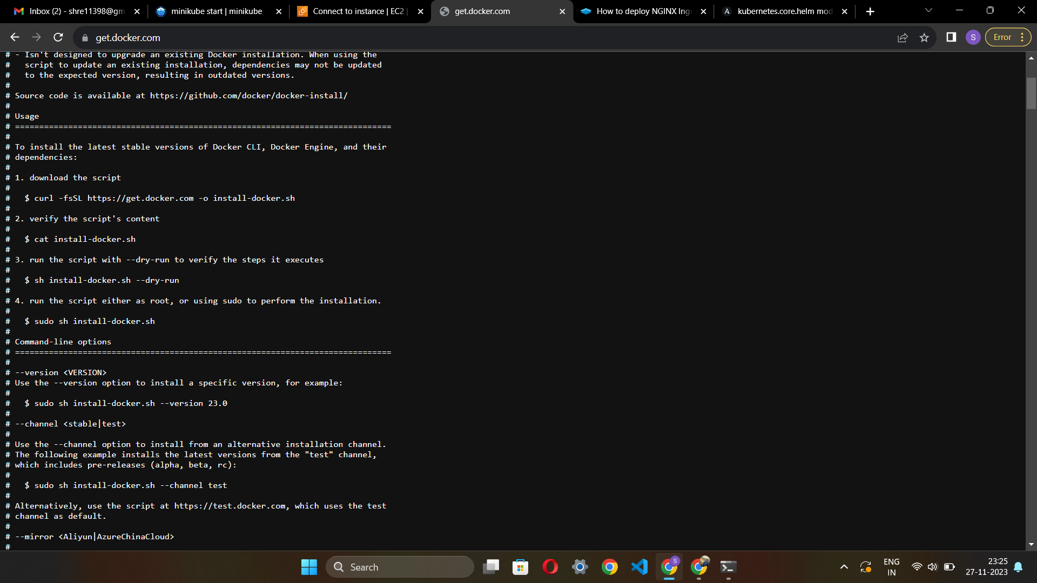

1. Check if its installing or showing some errors

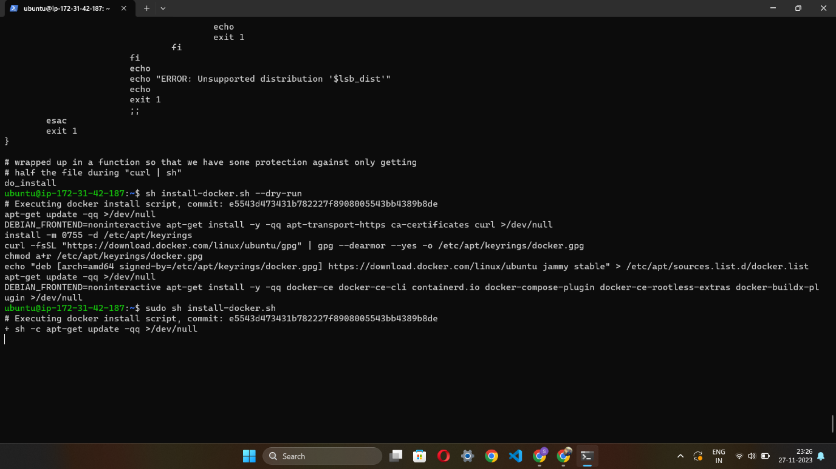

1. After installing check docker version you will get this error that user permission denied

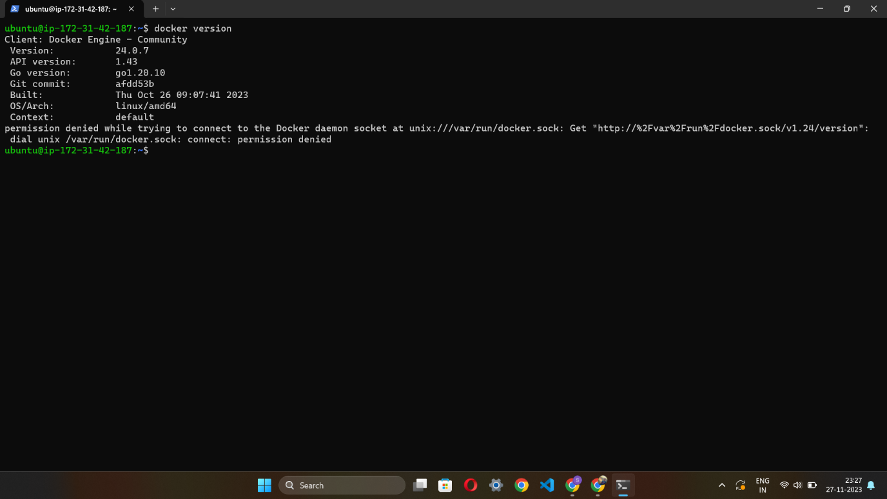

1. Give permission to the user with the command sudo usermod -aG docker (name of machine) in our case it is ubuntu

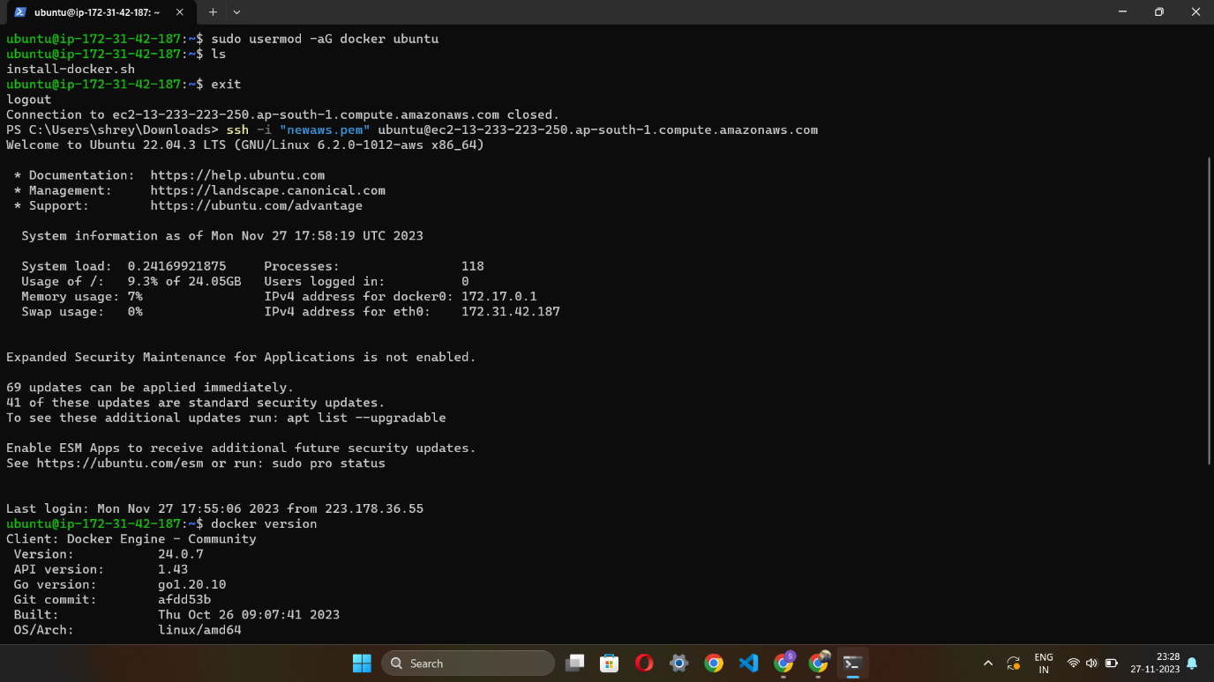

1. Then restart machine & check now with docker version & you will see that your docker his being successfully installed

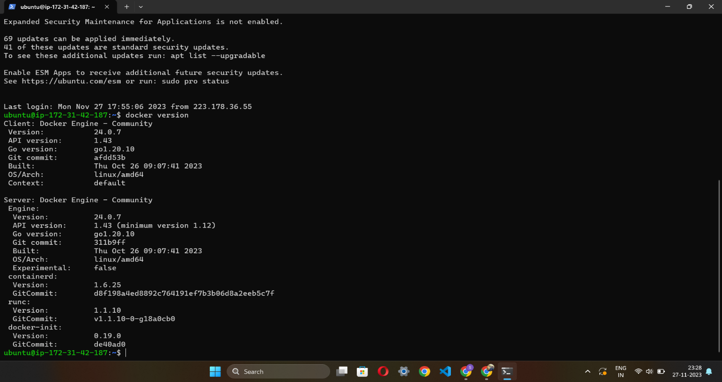

1. Now install kubectl

**sudo snap install kubectl –classic**

1. minikube with help of this command

**curl -LO https://storage.googleapis.com/minikube/releases/latest/minikube-linux-amd64**

**sudo install minikube-linux-amd64 /usr/local/bin/minikube**

**minikube start**

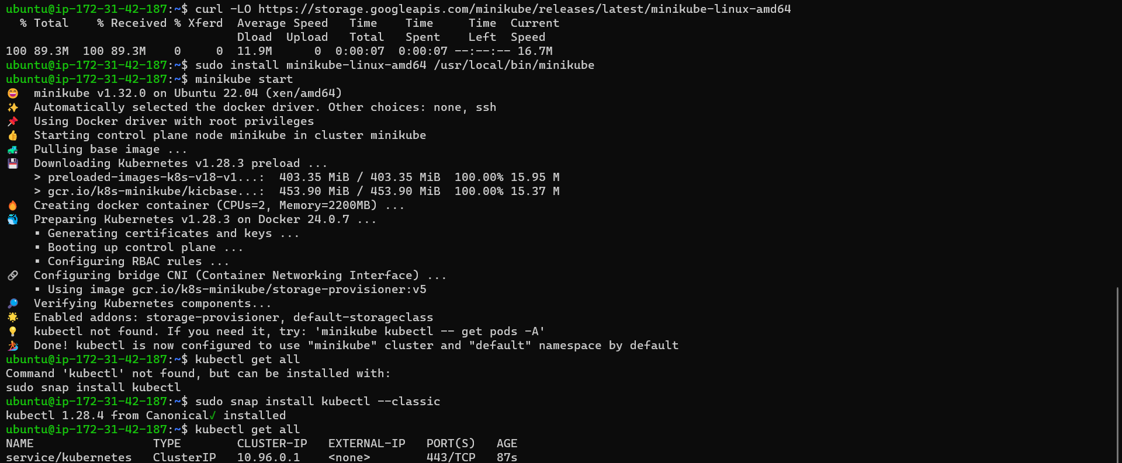

**Nginx Ingress Setup:**

1. Install helm on ubuntu with following commands

**curl -fsSL -o get_helm.sh https://raw.githubusercontent.com/helm/helm/main/scripts/get-helm-3**

**chmod 700 get_helm.sh**

**./get_helm.sh**

1. Install nginx ingress controller

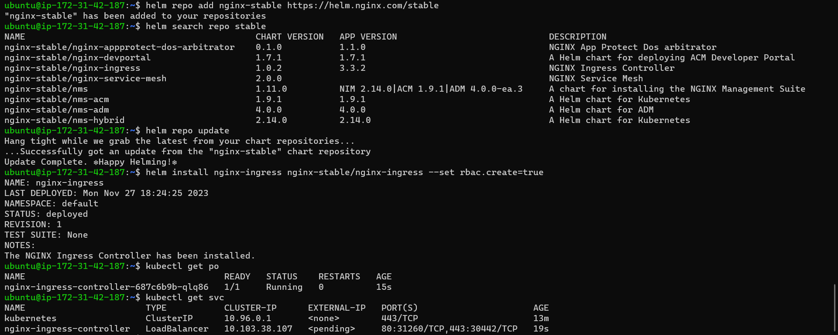

**Sample Application Deployment:**

1. Deploy “Hello-World” application using pre-built Docker image

