**Dual Access Control for Cloud-Based Data Storage and Sharing**

**OBJECTIVE:**

The main aim of this project is to provide privacy or security for uploaded data. Dual access for data owners by data owner permission.

**ABSTRACT:**

Cloud-based data storage service has drawn increasing interests from both academic and industry in the recent years due to its efﬁcient and low cost management. Since it provides services in an open network, it is urgent for service providers to make use of secure data storage and sharing mechanism to ensure data conﬁdentiality and service user privacy. To protect sensitive data from being compromised, the most widely used method is encryption. However, simply encrypting data (e.g., via AES) cannot fully address the practical need of data management. Besides, an effective access control over download request also needs to be considered so that Economic Denial of Sustainability (EDoS) attacks cannot be launched to hinder users from enjoying service. In this paper, we consider the dual access control, in the context of cloud-based storage, in the sense that we design a control mechanism over both data access and download request without loss of security and efﬁciency. Two dual access control systems are designed in this paper, where each of them is for a distinct designed setting. The security and experimental analysis for the systems are also presented.

Keywords: Cloud-based data sharing, access control, cloud storage service, Intel SGX, attribute-based encryption

**BLOCK DIAGRAM:**

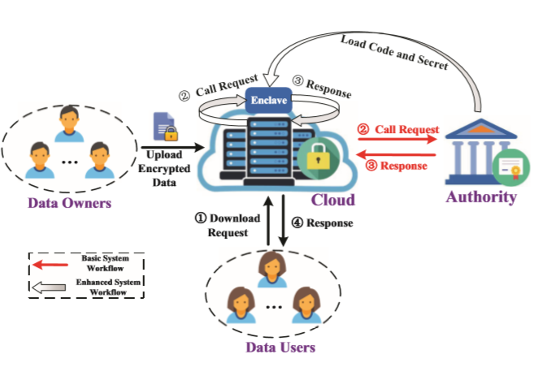

**EXISTING SYSTEM:**

The existing works, by using normal servers for storing and sharing data that causes un security lack of privacy. There is a chance of stole our data this is the main drawback of existing system to overcome this difficulty we can go for proposed system.

**DISADVANTAGES:**

* Searching the stored documents takes time linear in the size of the database
* It uses heavy arithmetic operations
* Less security.

**PROPOSED SYSTEM:**

In proposed system, we propose a new mechanism, dubbed dual access control, to tackle the above aforementioned two problems. To secure data in cloud-based storage service, attribute-based encryption is one of the promising candidates that enables the conﬁdentiality of out sourced data as well as ﬁne-grained control over the outsourced data

**ADVANTAGES:**

* Provides more security.
* It uses simple arithmetic operations.
* Storage capacity is high.

**SYSTEM SPECIFICATIONS:**

# H/W CONFIGURATION:

# Processor - I3/Intel Processor

* Hard Disk -160GB
* Key Board - Standard Windows Keyboard
* Mouse - Two or Three Button Mouse
* Monitor - SVGA

**S/W CONFIGURATION:**

* Operating System : Windows 7/8/10
* IDE : Pycharm
* Server side scripts : HTML, CSS, Js
* Libraries Used : Numpy, IO, OS,Sklearn, Flask
* Technology : Python 3.6+

**LEARNING OUTCOMES:**

* Scope of Real Time Application Scenarios.
* How Internet Works.
* What is a search engine and how browser can work?
* What type of technology versions is used?
* Use of HTML and CSS on UI Designs.
* Data Base Connections.
* About keyword guessing attacks model.
* About encryption, decryption and searchable encryption .
* Data Parsing Front-End to Back-End.
* Need of Pycharm-IDE to develop a web application.
* Working Procedure.
* Testing Techniques.
* Error Correction mechanisms.
* How to run and Deploy the applications.
* Introduction to basic technologies.
* How project works.
* Input and Output modules.
* How to test the project based on user inputs and observe the output.
* MySQL insertion and MySQL database creation.
* Practical exposure to software tools and solution providing for real time. problems working with team/ individual work on Creative ideas.
* How cloud computing works?
* Learn about types of algorithms and how to use?
* What is Cloud Storage?
* What is Public Auditing?
* How to Implement Secure Data Dynamics?
* Practical exposure on
  + Software tools.
  + Solution providing for real time problems.
  + Working with team/ individual.
  + Creative and Imagination Skills.
  + Work on Creative ideas.