**WORWI LINK**: https://wokwi.com/projects/435096560884796417

**WORKING CIRCUIT DIGRAMS**

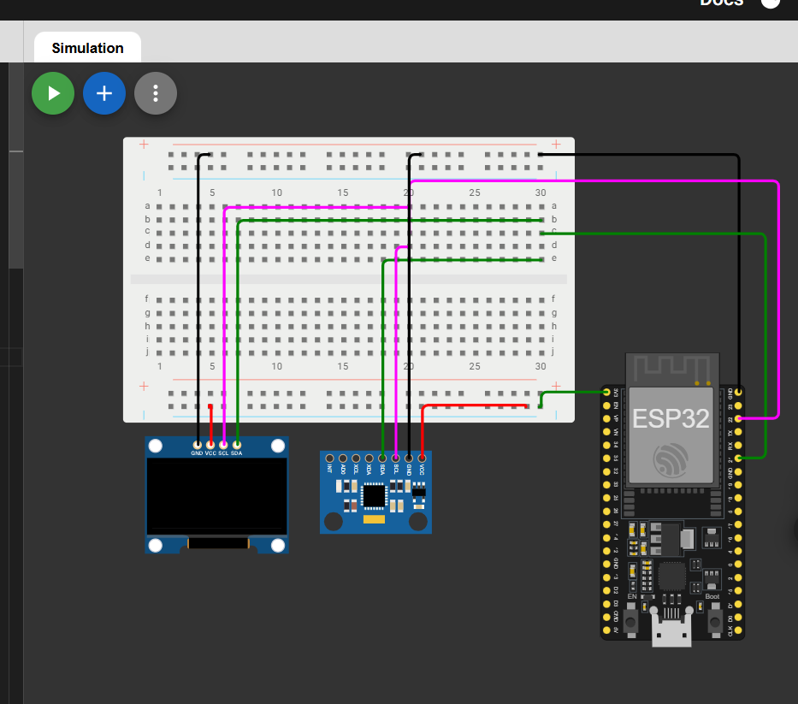

OLED

MPU6050

