**ITWS - 6600 Data Analytics**Assignment 1 – Review Existing Case Study

**Catapult: A brief case study detailing the use of big data as an innovation**

“Without big data, you are blind and deaf in the middle of a freeway.[2]”

* Geoffrey Moore

There are a plethora of things today, that once started with a possibility, which later turned out to be a reality. In this world of ever-growing disparity, where competition in each sector is growing rapidly, it is a must to evolve and grow continuously. One such potential lies in big data and its various innovative techniques. This is what a sports performance analytics company called Catapult did. Early in the 2000s when most of the major leagues were skeptical about data and its potential in sports, Catapult was already in its full gear of utilizing sports data for the benefit of athletes.

As mentioned by Adam Bornstein in his case study, all the top teams, leagues, and last season’s champions spread across various sports had a similarity: “They monitored their athletes’ health using Catapult.” (Catapult case study, 2015, Para1, italics added)[1]. This may have sounded odd, if not, insane back in the 90s, however, in today’s world, it is a norm. Catapult has its legs deeply rooted in the sports analytics business making more an array of devices that captures athletes’ physical body movements and turns them into useful analyzable data.

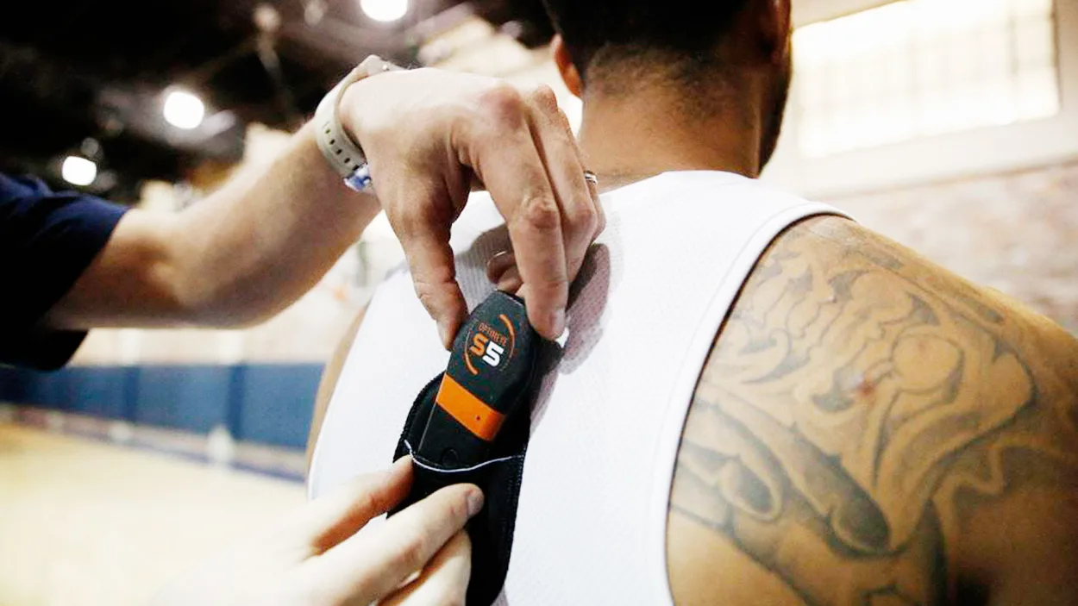

[Photo: courtesy of Catapult][1]

Adam Bornstein says that the devices Catapult creates have the potential to assess an athlete's strength and movement efficiency. He further adds that these devices may be used to determine crucial details such as if an injury is developing, or if a workout is too demanding. With so much potential in their devices and with major league champions using this platform, there is no doubt that the sales had to rise. It grew by about 65%, and they work with the majority of national football, and basketball teams as well as certain schools.

In conclusion, he says, with Catapult in its full gear, it has purposefully chosen not to collaborate, (and obviously, why would they?) with a tech-focused garment brand like Nike, allowing it to collaborate with every team, club, and institution directly (Catapult case study, 2015)[1].

*References:*

*[1] Adam Bornstein, “Catapult: For taking the guesswork out of injury prevention.”, Fast Company, 9th February 2015,* [*https://www.fastcompany.com/3039578/catapult*](https://www.fastcompany.com/3039578/catapult)

*[2] Geoffrey Moore,* [*https://twitter.com/geoffreyamoore/status/234839087566163968?lang=en*](https://twitter.com/geoffreyamoore/status/234839087566163968?lang=en)