🧪 1. Primary UX Audit Scope – Focus Areas
Use Microsoft Clarity to evaluate the following high-priority areas:

🔹 Product Detail Page (PDP)
- Is product information (title, benefits, ingredients, usage, reviews) easily accessible and scannable?
  - Hero image is extremely oversized
  - 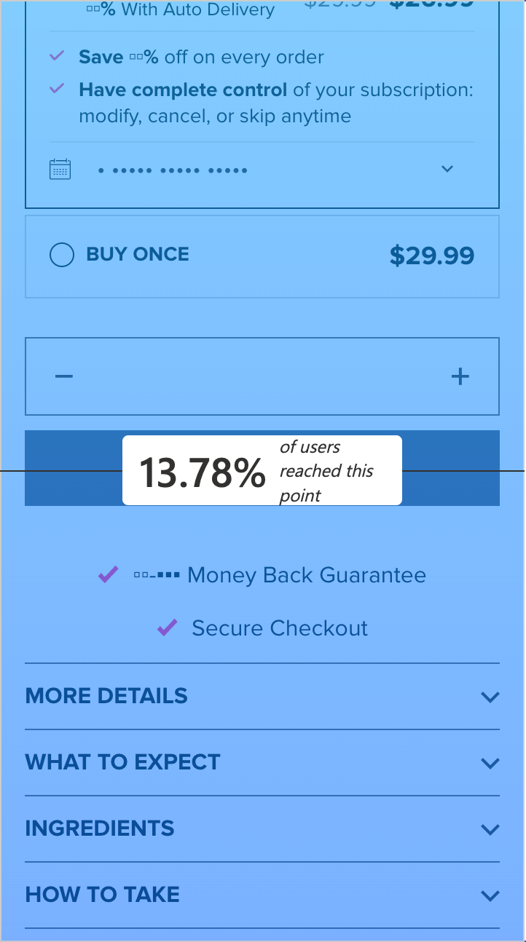CTA is at 13% level
  - Banner size can be reduced
  - NeoCell text redundant
  - If there’s only one size, consider removing for certain pages
- Are users clicking through tabs, expanding accordions, or ignoring key sections?
  - Auto-expand more details/ingredients
  - Consider using two column layout- move supplement facts/ accordion sections to the right
- Are “Add to Cart” buttons visible and clicked frequently?
  - Needs sticky CTA, Add to cart almost at 13% level
  - Reduce heading size
- Any signs of friction or confusion in product variant selection (flavors, sizes, bundles)?
  - For some pages, singular size may be confusing
  - No bundles on page- consider adding

🔹 Mini-Cart
- Do users interact with the mini-cart after adding items?
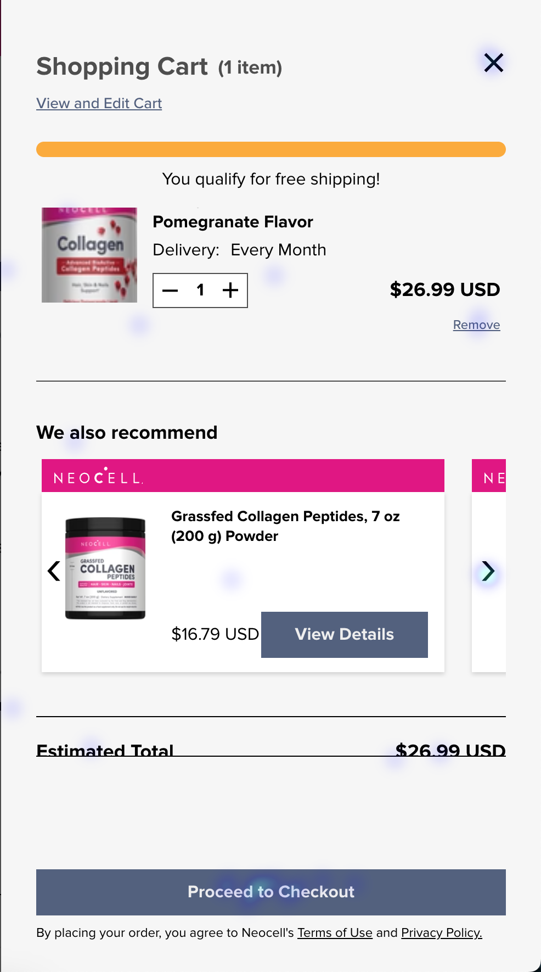
  - Some amount of interaction (2% swipe through we also recommend, some heat around “remove” from cart)
- Are they abandoning after opening it?
  - Proceed to checkout button seems to have very little interaction
  - Pink NeoCell bars unnecessary- format of card can be changed to include three before pressing arrow
  - Image quality super low, should be bigger
- Is key info (product, price, subtotal, CTA) clearly displayed?
  - Baymard Institute recommends naming all “In between” pages for PDP/checkout (e.g. mini-cart) something like “Item added to cart” to make messaging clear
  - Can be seen as inadequate cart otherwise
  - Option to change delivery in mini-cart also
- Is the transition from mini-cart to full cart or checkout smooth?
  - Smooth

🔹 Cart Page
- Are cart summaries informative and actionable?
  - 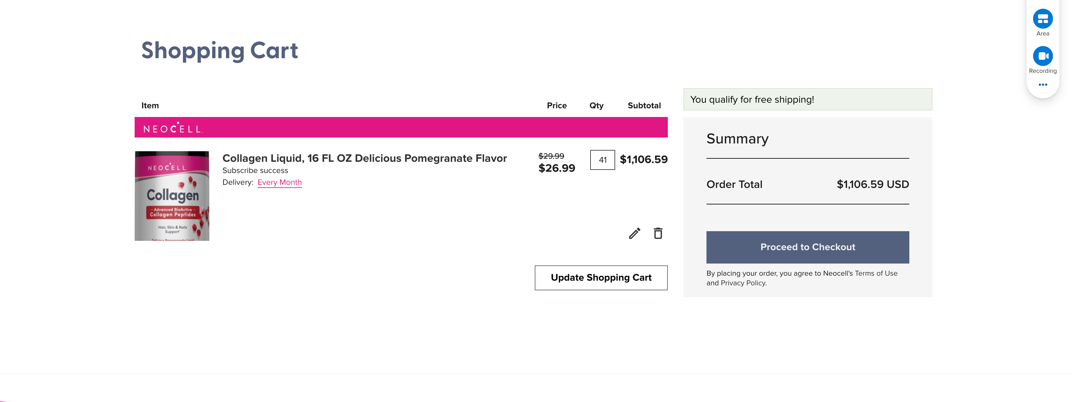
Still includes pink bars
Update button needs to be removed
You qualify for free shipping should be improved
- Are there distractions, missing information (e.g., shipping estimates, promo code field)?
  - 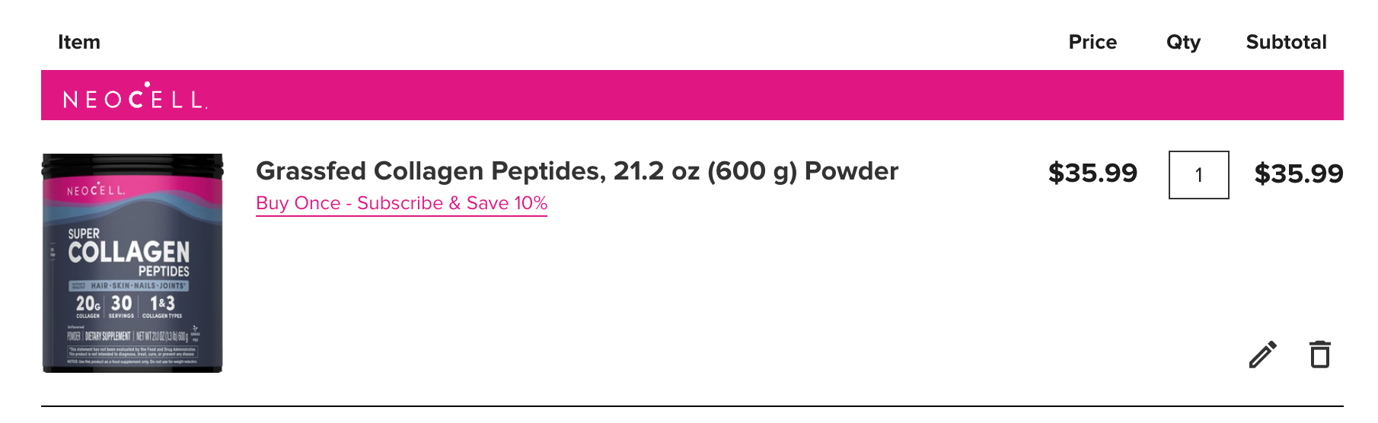
  - Could add slider to increase/decrease qty
  - Edit button goes back to PDP
  - Can add “are you sure” message when deleting items from cart to discourage
    - !! May cause friction in engagement
    - Alternatively have an [undo] button
- Look for rage clicks, back-and-forth behavior, or high exits here.
  - 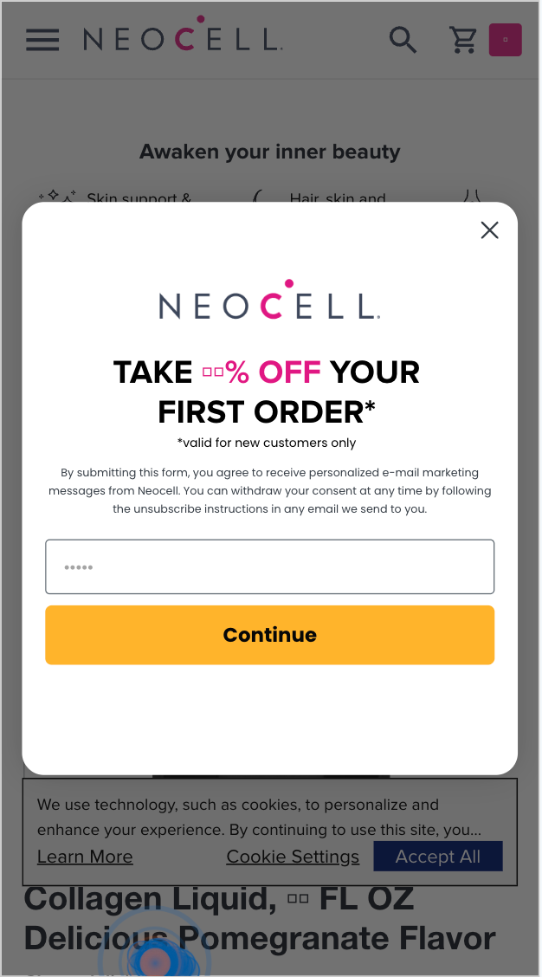
  - Popup confusion- consider making it so clicking outside of the popup will close it

🔍 2. Secondary UX Audit Scope – Brief Review
Quickly scan the following sections using Clarity data and site navigation to flag any significant issues:
- Homepage – Hero messaging, trust signals, feature banners, CTA clarity
  - Lacks trust marks
  - Why does mini-cart open when icon clicked on from homepage etc? Better to limit to PDP- only .68% clicks on proceed to checkout button, no other interactions
  - Spacing issues
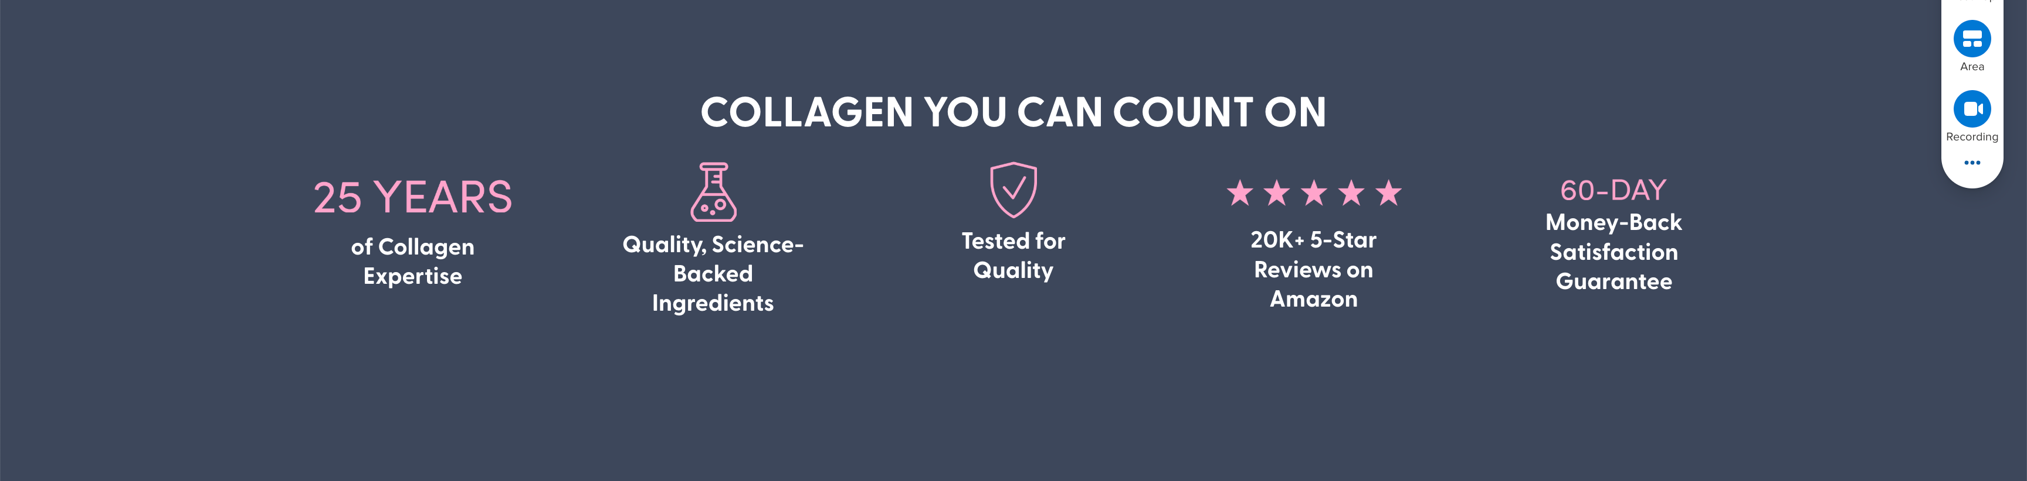

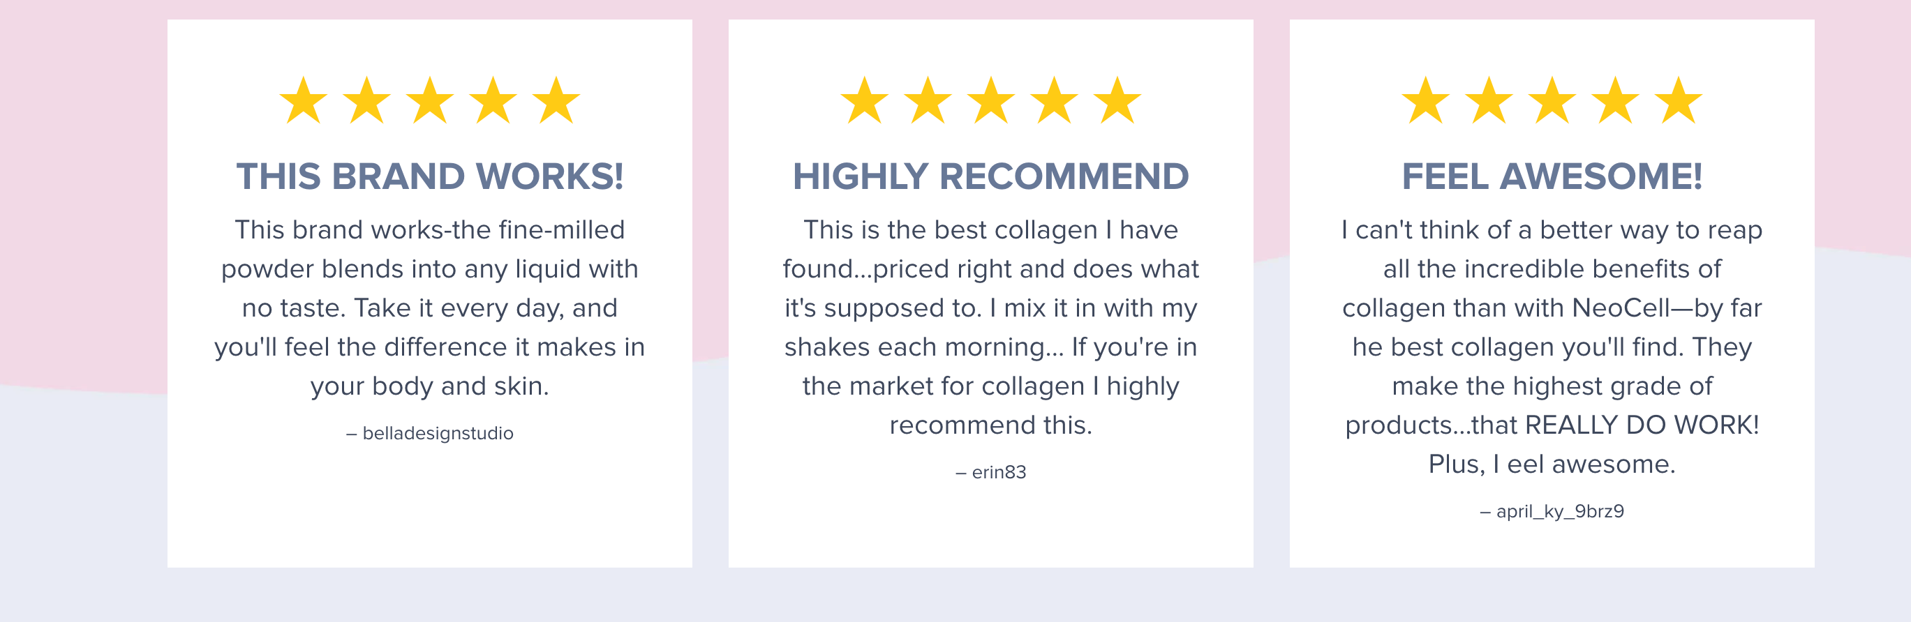
  - 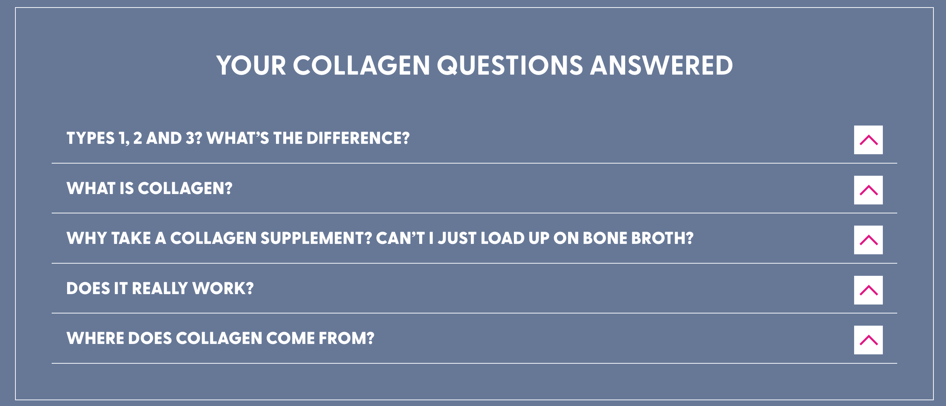
Button looks weird
  - 
button could be more interactive
- Collections Pages – Filter usability, category clarity, scroll behavior
  - Consider making filter sticky
  - Margins can be reduced, another product card added
  - Add to Cart button needs to be centered
  - Best seller tag blends in with site colors.. consider using alternative
- Search Experience – Speed, relevance, autocomplete, refinement options
  - Pretty fast, no major quirks/issues
- Account/Login – Ease of login/registration, visibility of account functions
  - My account button still opens in new tab
Summarize any major friction points, especially those impacting the path to purchase.

🧭 3. Competitor UX Benchmarking
Research 3–5 direct or aspirational competitor sites (e.g., Vital Proteins, Garden of Life, Nature’s Bounty) with a focus on:

Key Comparison Areas:
- Product Pages
  - Use of imagery, videos, reviews, sticky CTAs, comparison charts, or trust-building content
- Mini-Cart Functionality
  - Visibility, interactivity, upsell/cross-sell, checkout CTAs
- Cart Page Design
  - Layout, incentives (free shipping, promo fields), exit intent tactics

Optional Touchpoints to Note (only if something innovative stands out):
- Homepage hooks or loyalty program placement
- Category filtering or product quizzes
- Seamless login/account perks

1. 🛍 Product Pages

Vital Proteins
- Places “Subscribe & Save” towards the top above the fold, with dynamic pricing comparison between one-time and subscription options cssdesignawards.com+7appstle.com+7LinkedIn+7.
- Uses celebrity endorsements (e.g., Jennifer Aniston) and product rating visuals to build trust appstle.com+1xgentech.net+1.
- Strong visual hierarchy includes influencer quotes, social proof, and flexible delivery frequency selectors appstle.com+1xgentech.net+1.
- Offers contextual product recommendations and express checkout (ShopPay, Amazon Pay, etc.) under a distraction-free layout xgentech.net.

Garden of Life
- Emphasizes third-party certifications prominently (USDA Organic, Non-GMO, NSF, Vegan, etc.), with icons reinforcing trust/value GroceryNutrition.org+8gardenoflife.com+8Open Food Facts+8.
- Product pages combine ingredient transparency with clear subscription pricing and flexibility (skip/cancel any time) Baymard Institute.
- Displays trust badges and satisfaction guarantees visibly to reinforce quality perception gardenoflife.comgardenoflife.com.

NeoCell
- Product page currently includes high-resolution bottle imagery and basic details on features, pricing, and subscribe vs one-time options.
- It lacks prominent celebrity or influencer endorsements and visual badges for certifications that competitors use to reinforce credibility.
- Uses vertical collapsible sections (e.g., "Ingredients", "How to Take", etc.), but many users may overlook them if not auto-expanded; Baymard research suggests this format reduces missed content compared to horizontal tabs (only ~8% overlook vs ~27%) Baymard Institute+3Baymard Institute+3xgentech.net+3.

2. 🏷 Mini-Cart & Cart UX

Vital Proteins
- Mini-cart surfaces subscription upsells, recommended items, and encourages switching to subscription when adding a one-off item xgentech.net.
- Provides clear cart progress indicators in checkout, and offers express checkout options to reduce friction xgentech.net.

Garden of Life
- Mini-cart emphasizes free shipping thresholds, “60-day satisfaction guarantee” badges, and subscription upsell banners on product pages and in-cart gardenoflife.comgardenoflife.com.
- Clear messaging on delivery flexibility and expectations shown even before final checkout.

NeoCell
- May benefit from additional subscription upsell visibility in the mini-cart; current UX doesn’t push either subscription or complementary products as aggressively.
- Could increase reassurance by integrating recognizable trust badges (e.g. money-back, guarantee, shipping threshold messaging) within mini-cart visuals.

3. 🧺 Cart Page Design & Incentives

Vital Proteins
- Cart page often highlights value of switching to subscription: comparative pricing, free shipping thresholds, and attractive discounts at checkout xgentech.netappstle.com.
- Offers coupon code field in checkout — present but not distracting, preventing abandonment anxiety xgentech.net.

Garden of Life
- Cart reflects strong trusted-certification messaging, free shipping icons, and clear retry or cancel subscription language across flow gardenoflife.comgardenoflife.com.
- Visual layout balances incentive messages (promos, guarantees) with clean exit flow.

NeoCell
- Cart page currently offers subscription vs one-time, promo code field and guarantee note—but deeper hierarchy of shipping threshold, guarantee visuals, or subscription benefits could be strengthened.
- The design lacks comparison messaging (“subscribe saves X% vs one-time”) and could better align with best practices for reassurance and persuasion.

Area | Action Item | Priority
Product Page (PDP) | Reduce oversized hero image and redundant branding text | High
 | Move supplement facts/accordion content to a 2-column layout | High
 | Add sticky “Add to Cart” CTA to maintain visibility during scroll | High
 | Auto-expand “More Details” and “Ingredients” accordions | High
 | Add bundle options or value sets to encourage multi-buy | Medium
 | Add trust badges and certifications (e.g., Non-GMO, GMP) prominently | High
 | Integrate influencer or customer testimonials visually | Medium
 | Use icons to highlight key ingredients and benefits | Medium
 | Add side-by-side collagen format comparison chart | Medium
Mini-Cart | Improve image quality and increase size for product thumbnails | High
 | Add subscription upsell messaging and toggle switch | High
 | Include dynamic “$X away from free shipping” message | High
 | Remove pink bars; redesign layout to show up to 3 items without scrolling | Medium
 | Rename mini-cart header to “Item added to cart” for clarity | Medium
 | Add live product suggestions (e.g., “Customers also bought”) | Medium
 | Add undo option for item removal instead of friction-inducing modal | Medium
Cart Page | Improve “You qualify for free shipping” visual hierarchy | Medium
 | Add clear savings messaging (“Subscribe and save X%”) | High
 | Introduce quantity stepper (slider or +/– buttons) | Medium
 | Replace “Edit” with inline quantity editing instead of redirect to PDP | High
 | Remove unnecessary “Update” button | Low
 | Offer subtle popup confirmation or undo when deleting cart item | Medium

