Department of Electrical and Computer Engineering

ECE 358 – Computer Networks

Project 2: CSMA/CD Performance Evaluation

Group #45

Names: Shrey Kavi and Chris Huynh

User IDs: skavi (20613111) and cv2huynh (20616110)

Table of Contents

Question 1………………………………………………………………………………….Page 3 Question 2………………………………………………………………………………….Page 4 Source Code………………………………………………………………………………..Page 5

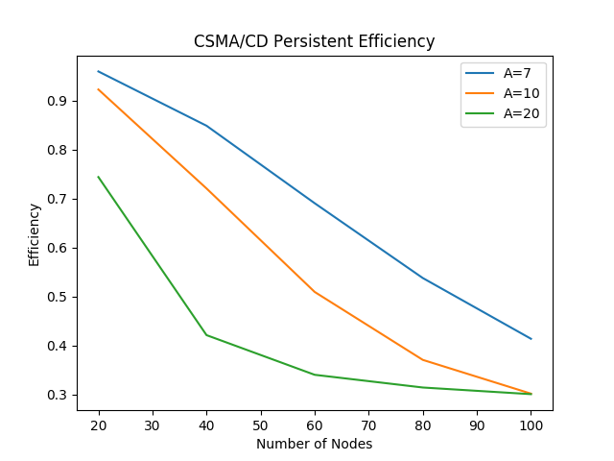

Figure 1: CSMA/CD Persistent Efficiency

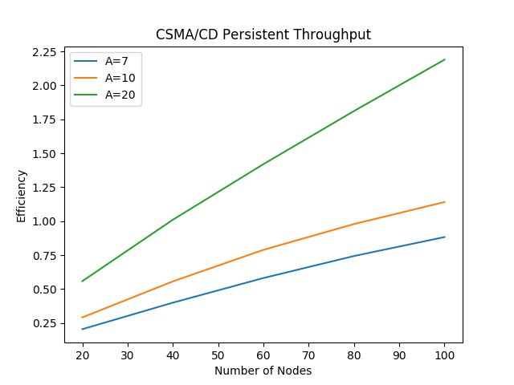

Throughput (Mbps)

Figure 2: CSMA/CD Persistent Throughput

It can be observed in Figure 1 that the efficiency decreases as more nodes are added, this is because more nodes cause more collisions to occur. The increase in arrival rate (A) causes a decrease in efficiency, because it also catalysts collisions; more packets at a time so more can potentially collide. It can also be observed from Figure 2 that the throughput increases as number of nodes increase, this is because the more nodes have more packets to transmit. The throughput increases for an increasing arrival rate, this is explained because more packets are transmitting at a time.



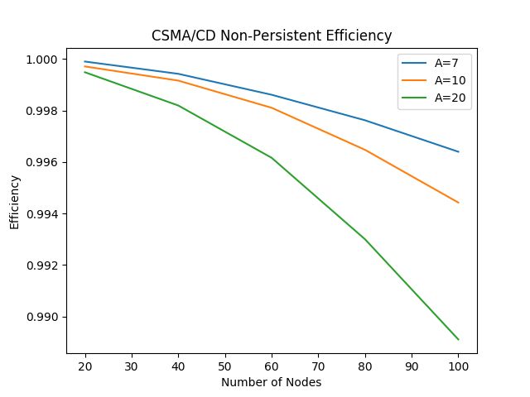

Figure 3: CSMA/CD Non-Persistent Efficiency

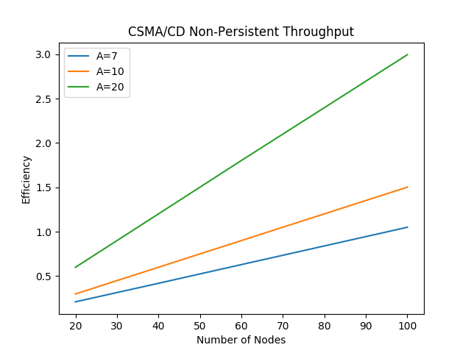

Throughput (Mbps)

Figure 4: CSMA/CD Non-Persistent Throughput

In the non-persistent case instead of packets just waiting for the transmission to finish (not be busy anymore), it goes through an exponential back-off. The efficiency and throughput are generally better than the persistent case which is as expected because the exponential back-off in a non-persistent process helps avoid collisions of nodes by giving them more randomized wait times.

Looking at Figure 3, the efficiency drops as number of nodes increases, and it drops when arrival rate increases as well. This is because both of these variables increasing cause a increase of collision potential.

Looking at Figure 4, the throughput trends the same way as persistent; increase in number of node increases throughput and the throughput increases for an increasing arrival.