Dynamic report

A plot of example3.csv random points.

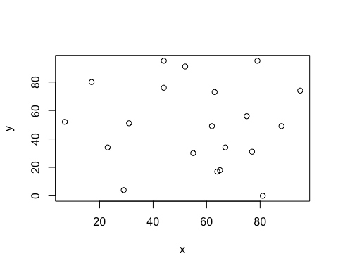

X and Y Values

|  |  |
| --- | --- |
| **x** | **y** |
| 62 | 49 |
| 44 | 95 |
| 23 | 34 |
| 67 | 34 |
| 31 | 51 |
| 55 | 30 |
| 64 | 17 |
| 75 | 56 |
| 29 | 4 |
| 63 | 73 |
| 44 | 76 |
| 95 | 74 |
| 79 | 95 |
| 88 | 49 |
| 77 | 31 |
| 81 | 0 |
| 17 | 80 |
| 52 | 91 |
| 65 | 18 |
| 7 | 52 |