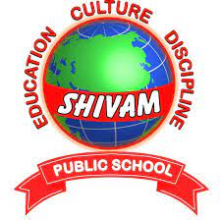

SHIVAM PUBLIC SCHOOL

Dhakar road, khurja

2021-22

Computer science(083)

Topic: Railway reservation

Submitted by: Submitted To:

Shreyansh kuntal Mr. Sushil sharma

XII - Science