CAPSTONE PROJECT REPORT
PhishGuard
Adversarially Robust Phishing Defense using
Email, URL and Behavioral Features
Project code: BAI-17
Submitted in partial fulfilment of the requirements for the degree of
Bachelor of Science in Artificial Intelligence
Submitted by
Shrey Mehta
Roll No. TDAI045A
[Team members, if any: Name - Roll No.]
Under the guidance of
[Guide's name, designation]
Department of Information Technology & Data Science
KES' Shroff College
T.Y. B.Sc. Artificial Intelligence - Semester V
Academic Year 2026-27

CERTIFICATE
This is to certify that the project entitled "PhishGuard: Adversarially Robust Phishing Defense using Email, URL and Behavioral Features" (BAI-17) is a bonafide work carried out by Shrey Mehta (Roll No. TDAI045A) in partial fulfilment of the requirements for the degree of Bachelor of Science in Artificial Intelligence, Semester V, during the academic year 2026-27, under my supervision in the Department of Information Technology & Data Science, KES' Shroff College.
To the best of my knowledge, the work presented in this report has not been submitted elsewhere for the award of any degree or diploma.
Project Guide Head of Department
[Name and signature] [Name and signature]
External Examiner Date and college seal
[Name and signature] [Date]

DECLARATION
I declare that this report, "PhishGuard: Adversarially Robust Phishing Defense using Email, URL and Behavioral Features", presents my own work, carried out as the capstone project BAI-17 of the T.Y. B.Sc. Artificial Intelligence programme. Wherever the work of others has been used, it has been acknowledged and cited. The software, the experiments and the results described here were produced for this project, and every reported number can be regenerated from the accompanying repository with the commands given in Appendix C.
I further declare that no personal data or confidential material has been included in the submitted repository, and that public datasets were used only under their published terms.
Shrey Mehta (Roll No. TDAI045A) Date: ____________
[Signature]

ACKNOWLEDGEMENT
I would like to thank my project guide, [Guide's name], for their guidance and for the discipline of asking, of every claim, how it was measured. I am grateful to the Head of the Department of Information Technology & Data Science and to the faculty of KES' Shroff College for the capstone framework, whose insistence on baselines, failure experiments and operational evidence shaped this project from its first week.
I also thank the maintainers of the open-source tools this work builds on - Python, scikit-learn, FastAPI, Prometheus and Grafana among them - and the maintainers of the public phishing and legitimate-mail corpora used for validation, who make research in this area possible.
Finally, I thank my family and friends for their patience and support throughout the semester.
Shrey Mehta

ABSTRACT
Phishing detectors perform well on a fixed dataset and fail when attackers change spelling, domains or message style. Phishing is the most frequently reported category of cybercrime, and the edits that defeat a detector cost an attacker almost nothing. This project builds and evaluates PhishGuard, a working phishing-defence system designed around that attacker rather than around a static test set.
PhishGuard extracts 265 features in three families - email (125), URL (107) and behavioural (33) - chosen by how much of each the attacker controls. Four members read different views of a message and are fused by a stacked, isotonically calibrated model into a three-way decision: ALLOW, REVIEW or BLOCK. Six named defensive controls are measured by ablation against a threat-informed suite of 35 semantic-preserving transformations in eight attack families, driven by budgeted and adaptive black-box attackers. The system is delivered as a service with role-based access, a content-free audit trail, a review queue with owners and service levels, an employee reporting page, W3C request tracing, Prometheus metrics, statistical drift detection, containers and CI/CD.
On a held-out, campaign-grouped test set of 1,938 messages PhishGuard reaches a macro F1 of 0.9880 with a false-positive rate of 0.10%, against 0.8954 for a 37-rule checklist and 0.9771 for a TF-IDF text model. Its advantage is robustness: on ordinary phishing under a 10-query attack, 0.0% of messages escaped auto-blocking against 29.3% for the text model, and on 48 hard phishing records attacked with up to 120 queries, 3 reached the inbox unwarned against 43 for the text model. On PG-HARD, a 192-record hard-case benchmark, 95.8% of outcomes were acceptable against 74.5% and 61.5% for the baselines, at the stated cost of sending 11.0% of ordinary mail to a person. All ten automated acceptance gates pass. The corpus is synthetic, so absolute accuracy is an upper bound; the comparative results, the limitations and a go/no-go recommendation are reported in full.
Keywords: phishing detection, adversarial machine learning, ensemble learning, calibration, explainability, MLOps, security engineering.

TABLE OF CONTENTS
1. Introduction 1
1.1 Background and motivation 1
1.2 Problem statement 1
1.3 Objectives 1
1.4 Scope and exclusions 2
1.5 Contributions 2
1.6 Organisation of the report 3
2. Literature Review 4
2.1 Feature-based phishing detection 4
2.2 Behavioural and relationship signals 4
2.3 Adversarial machine learning and realistic threat models 4
2.4 Obfuscation: homographs and Unicode 4
2.5 Calibration and decision thresholds 5
2.6 Dataset shift and monitoring 5
2.7 Leakage, reproducibility and documentation 5
2.8 Gap addressed by this project 5
3. Requirements Analysis 6
3.1 Stakeholders and personas 6
3.2 The current process and its baseline 7
3.3 User stories 8
3.4 Misuse and abuse cases 9
3.5 Success criteria: acceptance gates 9
3.6 Non-functional requirements 10
4. System Design 11
4.1 System context 11
4.2 Containers and components 11
4.3 Assessment data flow 12
4.4 Feature families 14
4.5 Model: members, fusion, calibration and the three-way decision 14
4.6 Threat model and attack taxonomy 14
4.7 Defensive controls 15
4.8 Workflow design: the review queue and user reports 16
4.9 Data design 19
4.10 Security and observability design 20
5. Implementation 22
5.1 Technology stack 22
5.2 Data 22
5.3 Service and interfaces 23
5.4 Engineering practice 26
6. Results and Evaluation 28
6.1 Experimental setup 28
6.2 Clean performance against the baselines 28
6.3 Calibration 29
6.4 The decision bands in operation 30
6.5 PG-HARD: the hard-case benchmark 31
6.6 Robustness under attack 32
6.7 Ablations 33
6.8 Seed sensitivity 35
6.9 Operating point and cost 35
6.10 Error analysis 35
6.11 Latency, load and scaling 36
6.12 Drift monitoring 37
6.13 Acceptance gates 37
7. Security, Privacy and Responsible AI 38
7.1 Security testing 38
7.2 Privacy by design 38
7.3 Responsible-AI review 38
7.4 Limitations and threats to validity 39
8. Deployment and Operations 40
8.1 Running the system 40
8.2 Configuration and scaling 40
8.3 Monitoring and alerting 40
8.4 Model lifecycle and release 40
9. Conclusion and Future Work 41
9.1 Outcomes against the objectives 41
9.2 Go / no-go recommendation 41
9.3 Future work 41
References 43
Appendix A. Requirements Traceability Summary 45
Appendix B. Repository Structure 46
Appendix C. Reproducing the Results 47

LIST OF FIGURES
Figure 1. Stakeholder influence and interest: who must be managed closely and who is served without being asked for effort. 7
Figure 2. The as-is process: three controls, each with a blind spot, and a reporting mailbox with no owner. 8
Figure 3. C4 level 1 - system context. The attacker reaches PhishGuard only through the mail they send. 11
Figure 4. C4 level 2 - containers. 12
Figure 5. C4 level 3 - components inside the API container. Decision logic (right) has no web-framework dependency. 12
Figure 6. Assessment data flow, with the defensive controls in green and the three bands in amber. 13
Figure 7. Review-queue state machine. Transitions are validated by a pure function and applied with compare-and-set. 17
Figure 8. Sequence: from an employee's report to an analyst's decision, including the escalation path for high-risk releases. 18
Figure 9. Sequence: inline assessment of one message, with the trace spans recorded at each stage. 18
Figure 10. Sequence: retraining, the acceptance gates, and promotion or rollback. 19
Figure 11. Audit database schema (entity-relationship diagram). 20
Figure 12. The analyst console assessing a cloned brand template, with the text-only comparison below the evidence. 24
Figure 13. The review queue with an employee's report open: evidence, timeline and the actions this analyst may take. 25
Figure 14. The report page used by employees: report a message, then follow its status under My reports. 26
Figure 15. ROC curves with a logarithmic false-positive axis: the region a mail filter actually operates in. 29
Figure 16. Reliability diagram of the calibrated score. 30
Figure 17. PG-HARD outcomes for the three systems at the same false-alarm budget. 32
Figure 18. Hard phishing delivered unwarned as the attacker's query budget grows. 33
Figure 19. Which ensemble members the strongest attack could move: the members' weaknesses matter only where they line up. 33
Figure 20. Modality ablation. 34
Figure 21. Operating point: expected cost of each policy, clean and under attack. 35
Figure 22. Drift monitoring: weekly worst-quantity PSI against calibrated alarm levels, before and after an injected shift. 37

LIST OF TABLES
Table 1. Stakeholders, their needs, and the cost of failure to each. 6
Table 2. Representative user stories with acceptance criteria and evidence. 8
Table 3. Misuse cases and the design response to each. 9
Table 4. The ten acceptance gates and the reason for each threshold. 9
Table 5. Non-functional requirements and how each is verified. 10
Table 6. The three feature families and why each is there. 14
Table 7. Attack taxonomy: what each family needs, what it costs, and what counters it. 15
Table 8. The six named defensive controls. Each can be switched off, and the defence ablation measures what each contributes. 15
Table 9. Technology stack and the role of each component. 22
Table 10. Main API endpoints and the role required. 23
Table 11. Experimental configuration. 28
Table 12. Clean performance on the held-out test set (0.5 cut-off). 28
Table 13. Outcome of the three-band policy on the test set. 31
Table 14. PG-HARD outcomes (192 records). 31
Table 15. Hard phishing records delivered unwarned (of 48) as the attacker's query budget grows. 32
Table 16. Modality ablation: every combination of the three feature families. 33
Table 17. Defence ablation (120 attacked messages per arm). 34
Table 18. The same configuration retrained with three seeds. 35
Table 19. The 23 test-set errors at a 0.5 cut-off, by category. 35
Table 20. Single-message latency through the full decision path (150 assessments). 36
Table 21. One server process under concurrent load (explanations on). 36
Table 22. Scaling with server processes, and the batch path. 36
Table 23. Acceptance gates: 10 of 10 passed. 37
Table 24. Security and privacy checks. 38
Table 25. Settings an operator is most likely to change. 40
Table 26. Objectives and what was delivered. 41
Table 27. Requirement status across the portfolio brief. 45
Table 28. Where each part of the system lives. 46

LIST OF ABBREVIATIONS
Abbreviation | Meaning
API | Application programming interface
ASR | Attack success rate: share of attacked phishing messages that escape automatic blocking
AUC | Area under the curve (ROC-AUC, PR-AUC)
BEC | Business email compromise
CI/CD | Continuous integration and continuous delivery
DKIM / DMARC / SPF | Email authentication standards
ECE | Expected calibration error
FPR / FNR | False-positive rate / false-negative rate
KS | Kolmogorov-Smirnov (two-sample test)
OWASP | Open Worldwide Application Security Project
PG-HARD | PhishGuard hard-case benchmark (192 records)
PSI | Population stability index
SLA | Service-level agreement (here: time allowed to decide a review case)
SOC | Security operations centre
SSRF | Server-side request forgery
STRIDE | Spoofing, Tampering, Repudiation, Information disclosure, Denial of service, Elevation of privilege
TF-IDF | Term frequency - inverse document frequency

1. Introduction

1.1 Background and motivation
Phishing remains the most common entry point for fraud against organisations and individuals. In 2025 the FBI's Internet Crime Complaint Center received 1,008,597 complaints with reported losses of $20.877 billion; phishing and spoofing was the most-reported category with 191,561 complaints, and business email compromise caused $3.05 billion in losses [1]. The 2026 Data Breach Investigations Report finds the human element in 62% of breaches and social engineering in 16% [2], and the Anti-Phishing Working Group observed 1,069,681 phishing attacks in the second quarter of 2026 alone, a 10.1% rise on the previous quarter [3]. In India, 22,68,346 cybercrime incidents were registered on the National Cyber Crime Reporting Portal in 2024 - 42% more than in 2023 - with reported losses to cyber fraud of Rs 22,845.73 crore [4]. MITRE ATT&CK catalogues phishing as initial-access technique T1566 [5].
Machine-learning phishing detectors routinely report accuracy above 98% on public corpora [6], [7], [8], yet phishing continues to reach inboxes. The two facts are compatible because a detector is evaluated on a fixed dataset but deployed against an adversary who adapts. A phishing kit is tested against filters before a campaign; if a message is caught, the operator edits it - a synonym, a Cyrillic look-alike character, a redirect, a new sending domain - and tries again. Each edit is cheap and none changes what the message does. A model that has learned the surface form of last quarter's phishing has learned exactly what the attacker is free to change.

1.2 Problem statement
Phishing detectors perform well on a fixed dataset and fail when attackers alter spelling, domains or message style. The problem addressed by this project is to build a phishing-defence system whose detection holds up against such an attacker, to measure that claim honestly against baselines under attack, and to deliver it as a system an organisation could operate: with explanations an analyst can act on, human review where the model is uncertain, an audit trail, and monitoring that detects when the world has moved.

1.3 Objectives
- Extract email, URL and behavioural features from a message without fetching any external content, and combine them in a calibrated, explainable model.
- Compare the model with two baselines - a rule checklist representing current practice and a conventional text classifier - on clean data, on a curated hard-case benchmark and under attack.
- Build a threat-informed adversarial suite with an explicit attack taxonomy, defensive controls that can each be switched off and measured, and a residual-risk register generated from the measurements.
- Deliver an end-to-end workflow - intake, decision, user action, audit trail and operational monitoring - with role-based access, a review queue and an employee reporting path.
- Apply production engineering controls: automated tests, input validation, secrets handling, dependency scanning, containers, CI/CD, and logs, metrics and traces.
- Evaluate against predefined acceptance thresholds, including stress, robustness, edge cases, load, security, privacy and a responsible-AI review, and state the limitations and a go/no-go recommendation.

1.4 Scope and exclusions
The system assesses inbound organisational email: headers, subject, plain-text and HTML body, attachment metadata and sender-relationship context supplied by the mail gateway. The following are excluded deliberately, each for a stated reason:
- Fetching URLs or opening attachments. Fetching attacker-controlled content from the gateway creates a server-side request forgery surface and tells the attacker the message arrived. Every URL signal is lexical.
- Mail genuinely sent from a compromised brand or partner domain. Such mail passes every authentication check by construction; it is an account-security problem.
- White-box gradient attacks. They assume leaked model weights; the response to that is key and model rotation, not a robustness claim.
- Other channels (SMS, voice), outbound data-loss prevention and automated remediation.

1.5 Contributions
- A tri-modal detector (265 features, four members, stacked calibrated fusion) with a three-way decision that turns uncertainty into human review instead of silent errors.
- A threat-informed adversarial evaluation: 35 transformations in eight families, budgeted and abstention-aware attackers, and ablations of every defensive control and every feature family.
- PG-HARD, a 192-record benchmark of hard cases, each designed to defeat a named detection cue.
- An operational service: review queue with object-level authorisation and service levels, employee reporting without a scoring oracle, content-free audit trail, W3C tracing, drift detection with calibrated alarm levels, and load-tested serving.
- A complete evidence pack: design documents, threat model, evaluation dossier with ten automated acceptance gates, 289 automated tests, CI/CD, and a requirements traceability matrix.

1.6 Organisation of the report
Chapter 2 reviews related work. Chapter 3 analyses the requirements: stakeholders, the current process, user stories, misuse cases and success criteria. Chapter 4 presents the design, Chapter 5 the implementation, and Chapter 6 the evaluation. Chapter 7 covers security, privacy, responsible AI and limitations; Chapter 8 deployment and operations; Chapter 9 concludes with a go/no-go recommendation and future work.

2. Literature Review

2.1 Feature-based phishing detection
Early learned detectors combined hand-crafted features of the message and its links. Fette et al. [6] showed that a small set of email features - IP-based URLs, link-text mismatches, HTML content, domain age - separates phishing from legitimate mail with high accuracy. Ma et al. [7] showed that lexical and host-based features of a URL alone can identify malicious sites without visiting them. Das et al. [8] surveyed the field and found that most published detectors are evaluated on static, often dated corpora, rarely against an adapting attacker, and seldom with the base rates of real traffic - the gap this project targets. PhishGuard keeps URL analysis strictly lexical, following [7], for a security reason as much as a practical one.

2.2 Behavioural and relationship signals
Content can be copied; relationships cannot. Ho et al. [9] detected lateral phishing from compromised internal accounts at scale using features of the sender-recipient relationship and the message's recipients, and Cidon et al. [10] built a high-precision detector for business email compromise from sender history and impersonation signals. Both motivate PhishGuard's behavioural family: first contact, prior correspondence, domain age, timing and campaign shape. An attacker controls the text fully and the infrastructure partly, but cannot fabricate years of correspondence with the recipient.

2.3 Adversarial machine learning and realistic threat models
Goodfellow et al. [11] showed that small, targeted perturbations can reverse a model's decision; Papernot et al. [12] showed that such attacks work in a black-box setting through queries alone; and Brendel et al. [13] showed that decision-based attacks, which observe only the final label, suffice. Apruzzese et al. [14] argue, from industry practice, that real attackers rarely compute gradients: they apply cheap, domain-specific edits and observe what gets through. NIST's taxonomy of adversarial machine learning [15] provides the vocabulary. PhishGuard's threat model follows [14]: a decision-based black-box attacker, a query budget, and semantic-preserving edits that keep the message a working phish.

2.4 Obfuscation: homographs and Unicode
Look-alike characters from other scripts make a domain or word read identically to a human while differing to a machine [16]. The Unicode security mechanisms standard [17] defines confusable characters and mixed-script detection. PhishGuard's canonicalisation control (D-NORM) folds confusables, strips zero-width and bidirectional control characters and removes diacritics before any text feature is computed - and keeps the amount of folding as evidence, so that obfuscation effort itself raises suspicion.

2.5 Calibration and decision thresholds
A threshold is a policy only if the score behind it is a probability. Guo et al. [18] showed that modern classifiers are often miscalibrated and popularised the expected calibration error (ECE). Isotonic regression [19] and Platt scaling are the standard post-hoc remedies, compared by Niculescu-Mizil and Caruana [20]. PhishGuard calibrates the fused score isotonically on a pool disjoint from both the members' and the fusion's training data, and chooses its thresholds against a false-positive budget and an expected-cost model. The fusion is a stacked generalisation [21] over members that include a gradient-boosted model [22], implemented with scikit-learn [23].

2.6 Dataset shift and monitoring
Deployed models degrade as the input distribution drifts [24]. Rabanser et al. [25] found two-sample tests on model outputs to be an effective and simple way to detect shift. PhishGuard monitors the member scores and message statistics recorded in its content-free audit trail with the population stability index and a two-sample Kolmogorov-Smirnov test, and - because mail arrives in campaigns rather than as independent samples - calibrates its alarm levels on stable windows instead of using textbook thresholds.

2.7 Leakage, reproducibility and documentation
Leakage between training and test data inflates results silently [26]; near-duplicate phishing campaigns make it especially likely in this domain, so PhishGuard splits by campaign and runs a leakage audit that fails the build. Model cards [27] and datasheets [28] document intended use, performance and limitations; PhishGuard generates its model card from the registry and the latest evaluation. The NIST AI Risk Management Framework [29] structures the responsible-AI review in Chapter 7.

2.8 Gap addressed by this project
Published detectors typically report clean accuracy on a static corpus. This project instead treats robustness as the primary requirement: it measures the system and its baselines at the deployed operating point, against attackers with a query budget and knowledge of the defences, on a benchmark of hard cases, and reports what gets through. It also treats the detector as part of an operational system, because a REVIEW decision is only a control if someone reviews it.

3. Requirements Analysis

3.1 Stakeholders and personas
Six stakeholder groups and one adversary shape the requirements. The adversary is listed deliberately: a system whose requirements do not contain the attacker's goals will only be tested against the cases its authors happened to imagine.
Table 1. Stakeholders, their needs, and the cost of failure to each.
Stakeholder | Needs | What failure costs them
Recipient (employee) | A clear signal when a message is dangerous; one-click reporting | Credential or financial loss
Security analyst (SOC) | A high-signal queue with evidence to act on | Alert fatigue; the queue stops being read
Mail administrator | No delay to mail; no false quarantines of business mail | One high-profile false positive gets the filter switched off
CISO / risk owner | Defensible, re-runnable assurance and a list of residual risks | Cannot answer an audit question
Finance / accounts payable | Protection against invoice fraud and payment diversion | Direct, often irrecoverable loss
Data protection officer | Detection without an archive of employees' mail | The monitoring tool becomes the privacy incident
Attacker (adversarial) | Cheap, repeatable evasion | Modelled explicitly in the threat model
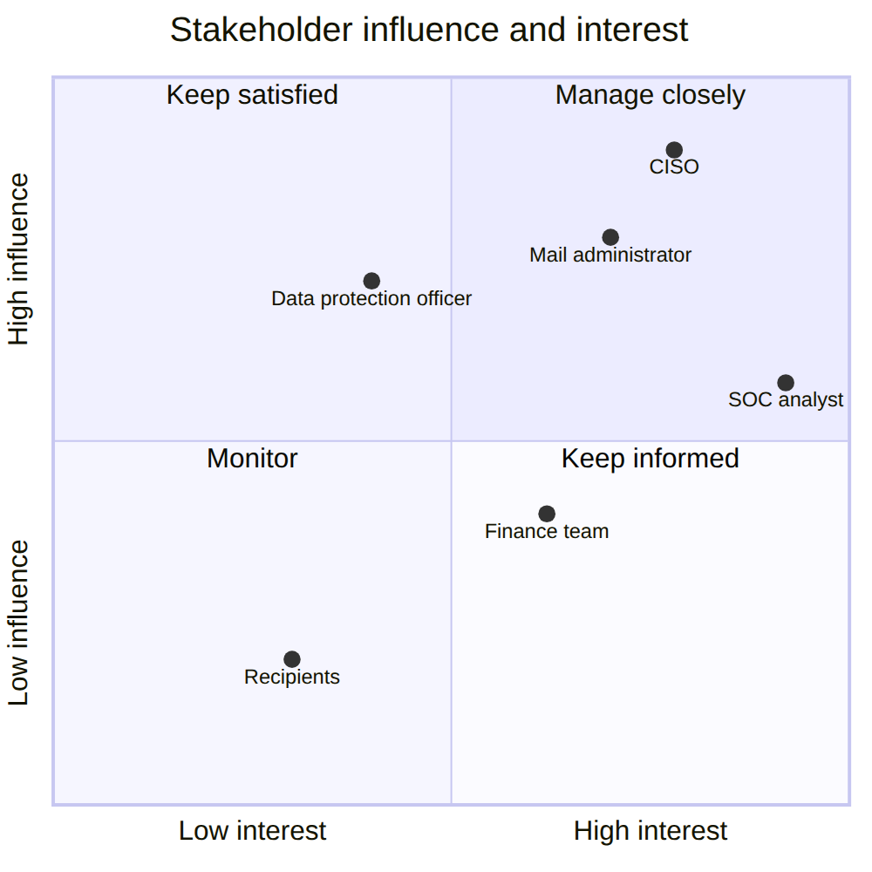
Figure 1. Stakeholder influence and interest: who must be managed closely and who is served without being asked for effort.
Four personas make the stakeholders concrete: Meera, an L1 SOC analyst with forty seconds per message; Arjun, a mail administrator whose last filter was switched off after quarantining payroll mail; Kavita, a CISO who needs every quoted number to be reproducible; and Rohan, an accounts-payable executive who pays two hundred invoices a week and is the organisation's most-targeted employee. A fifth, adversarial persona - the kit operator - seeks the cheapest edit that gets a message delivered.

3.2 The current process and its baseline
In a typical organisation, inbound mail passes three controls in sequence, each with a known blind spot (Figure 2): gateway authentication and reputation filtering, which a first-use domain with valid records passes; a keyword and rule checklist, which rewording and look-alike characters defeat; and user reporting to a shared mailbox, which has no owner, no service level and no answer back to the reporter.
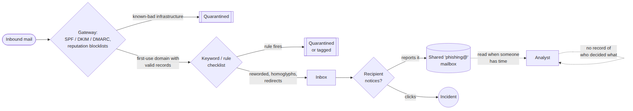
Figure 2. The as-is process: three controls, each with a blind spot, and a reporting mailbox with no owner.
The rule checklist was implemented as baseline B0 (37 named rules) so that the comparison is a measurement. On the held-out test set it reaches a macro F1 of 0.895 with a false-positive rate of 5.5% - 57 of 1,038 legitimate messages flagged - and misses 15.9% of phishing. That is the bar the learned system must clear, and the false-positive rate explains why such checklists usually run in tag-only mode.

3.3 User stories
Fourteen user stories, each with acceptance criteria and the automated test that proves it, are listed in the problem brief (docs/01). A representative selection:
Table 2. Representative user stories with acceptance criteria and evidence.
ID | Story | Acceptance criterion | Evidence
US-01 | As an employee, I want a dangerous message quarantined before I see it | A message at or above the block threshold is BLOCKed and audited | test_scan_records_a_decision_and_returns_a_band
US-03 | As an employee, I want to report a message in one step and learn what became of it | A report returns a case id and a plain status; never a score | test_a_user_report_is_queued_without_revealing_the_score
US-05 | As an analyst, I want to claim a case so no colleague works it at the same time | Another analyst cannot resolve a claimed case (403 / 409) | test_a_second_analyst_cannot_steal_a_claimed_case
US-07 | As an analyst, I want to record that the model was wrong without silently retraining it | Resolving records feedback; nothing retrains automatically | test_a_review_decision_opens_a_p2_case_and_resolution_records_feedback
US-10 | As a mail administrator, I want assessment inline within the gateway's budget | p95 latency at most 150 ms (gate G7) | Gate G7; load test
US-13 | As a CISO, I want the robustness claim to be a measurement I can re-run | phishguard evaluate reproduces the dossier and fails on a gate | CI acceptance job
US-14 | As a CISO, I want releasing a high-risk message to need a senior reviewer | Releasing a message scored at or above the block threshold needs an administrator | test_releasing_a_message_the_model_would_block_needs_an_administrator

3.4 Misuse and abuse cases
Table 3. Misuse cases and the design response to each.
# | Misuse case | Design response
M1 | Querying the API repeatedly to tune a message until it passes | Per-key rate limits; probes audited; the adversarial probe is admin-only
M2 | A crafted message designed to crash or hang the scanner | Bounded inputs, permissive parsers, no unbounded regex; security tests
M3 | Poisoning the model through analyst feedback | Feedback is recorded, never used to retrain automatically
M4 | An insider reading colleagues' mail through the audit trail | The audit trail stores no message content
M5 | Using the scanner for SSRF or to detect victim activity | No URL is ever resolved and no attachment opened
M9 | Using the reporting endpoint as a free scoring oracle | Reporters receive a case id and plain status, never a score
M10 | Talking an analyst into releasing a high-confidence phish | High-risk release needs an administrator and a written reason
M11 | Acting on a case another analyst owns (OWASP API1) | Object-level authorisation; compare-and-set state changes

3.5 Success criteria: acceptance gates
Success is defined as ten machine-checked gates. phishguard evaluate exits with a non-zero code if any gate fails, so a regression cannot be merged through CI.
Table 4. The ten acceptance gates and the reason for each threshold.
Gate | Criterion | Threshold | Why this number
G1 | Macro F1 | >= 0.90 | Weights both classes equally
G2 | PR-AUC | >= 0.93 | Threshold-free; honest when phishing is a minority
G3 | False-positive rate | <= 0.02 | The binding constraint: above it, the filter is switched off
G4 | Expected calibration error | <= 0.08 | Thresholds are policy; probabilities must mean what they say
G5 | Macro F1 drop under attack | <= 0.15 | The distinguishing requirement
G6 | Attack success (escapes auto-block) | <= 0.35 | Measured at the deployed operating point
G7 | p95 assessment latency | <= 150 ms | The gateway assesses inline
G8 | Macro F1 advantage over B0 | >= 0.01 | Must beat the checklist it replaces
G9 | Robustness advantage over B1 | >= 0 | The design is justified by robustness
G10 | Leakage audit | must pass | Leakage invalidates every other number

3.6 Non-functional requirements
Table 5. Non-functional requirements and how each is verified.
Requirement | Target | Verified by
Performance | p95 <= 150 ms single message; throughput reported under concurrency | Gate G7; load test
Availability | Liveness independent of the model; readiness reports why | Integration tests; container smoke test
Reproducibility | Seeds reproduce corpus, split and metrics; content-addressed data versions | Dataset fingerprints in manifest and report
Privacy | No message content in the database, logs or traces | Privacy tests
Security | Role-separated keys, object-level authorisation, rate limits, bounded inputs, scanning | Security tests; CI security job
Portability | Clean machine to running system in one command | python start.py; Docker Compose
Observability | Logs, metrics, traces, drift | Grafana dashboard and alert rules
Auditability | Every decision and review action recorded with actor and reason | Case-event tests

4. System Design
The design separates what decides from what transports. Everything that makes a decision - features, models, defences, evidence, the review-queue rules - lives in plain Python with no web framework, so it can be tested without a server; the HTTP layer is a thin adapter. The design is documented in C4 form (context, containers, components), with sequence diagrams for the three interactions that matter, and eight architecture decision records that state the alternatives rejected and why.

4.1 System context
PhishGuard sits beside the mail gateway (Figure 3). The gateway submits each message with its sender context and receives a score, a band and evidence. Analysts work the review queue, administrators tune thresholds and promote models, and employees report suspicious mail. The attacker is drawn on the diagram because every design decision is shaped by what they can do, even though they never call the system directly.
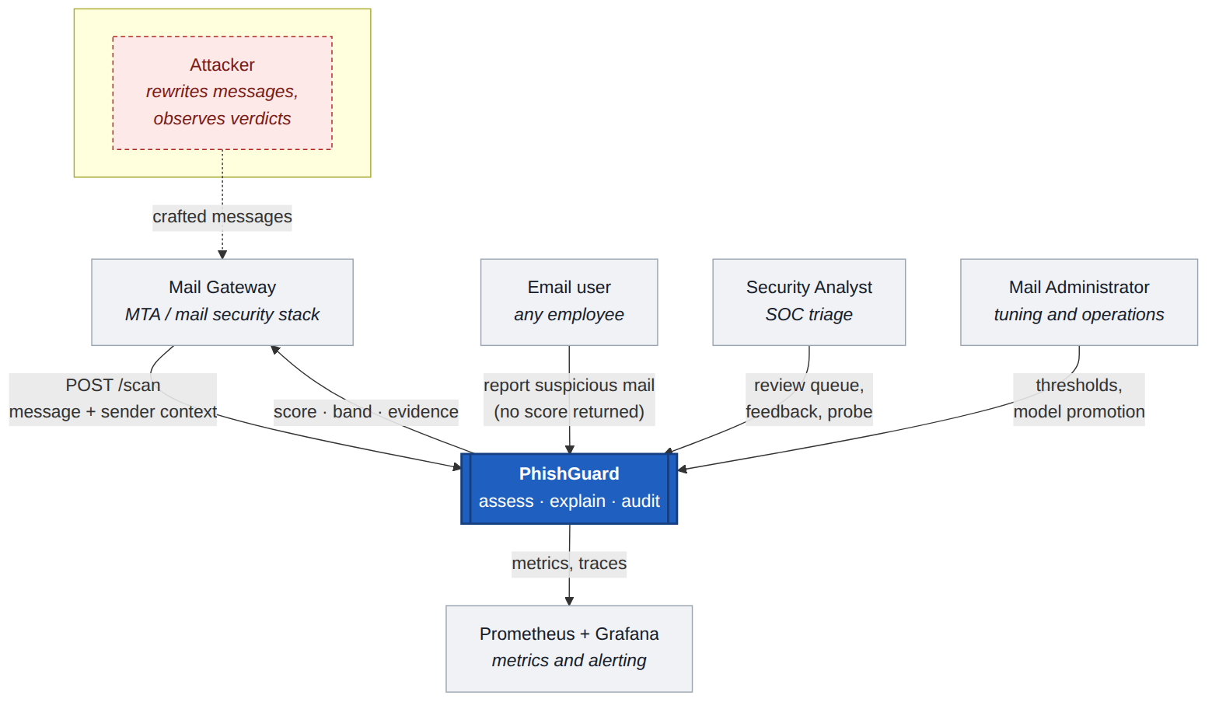
Figure 3. C4 level 1 - system context. The attacker reaches PhishGuard only through the mail they send.

4.2 Containers and components
A single application container serves the API, the analyst console and the report page, backed by a volume that holds the model registry and the audit database (SQLite in write-ahead-log mode). Prometheus scrapes metrics and Grafana presents a provisioned dashboard. One container rather than separate scoring and API services is deliberate: assessment is about 12 ms of CPU with no I/O, and splitting it would add a network hop and failure modes to the inline mail path without a scaling benefit.
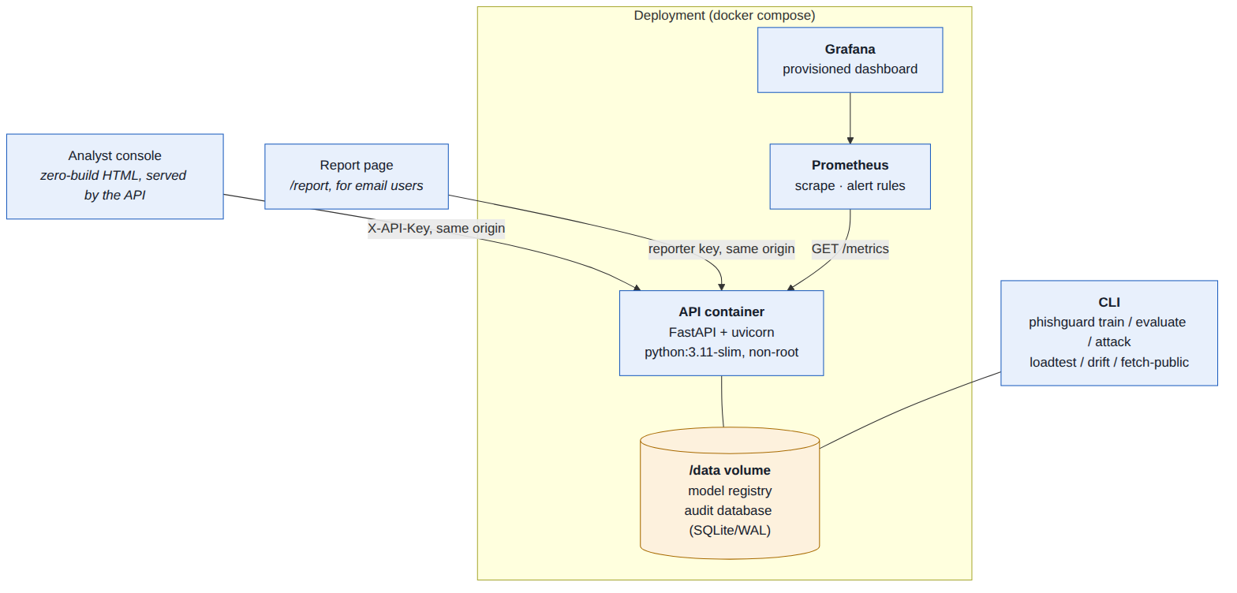
Figure 4. C4 level 2 - containers.
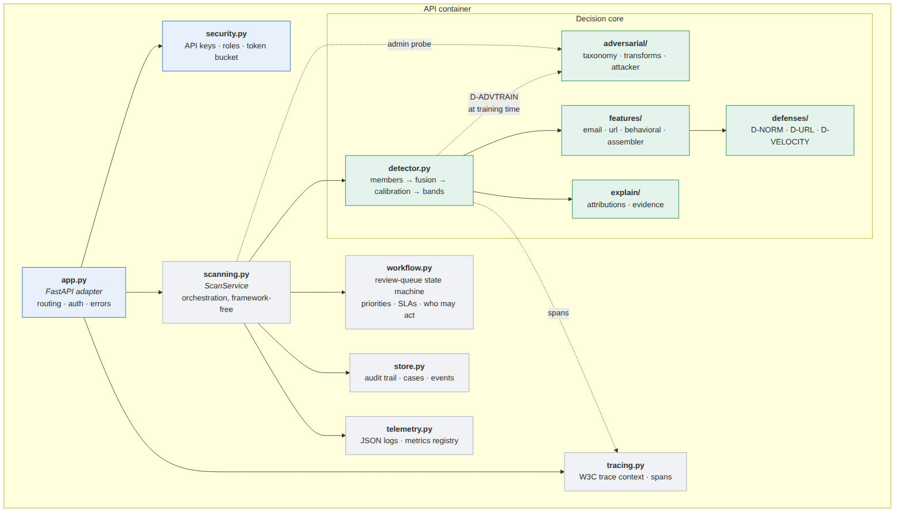
Figure 5. C4 level 3 - components inside the API container. Decision logic (right) has no web-framework dependency.

4.3 Assessment data flow
Figure 6 follows one message through the decision path. Input is validated against strict bounds; text is canonicalised (D-NORM) and links are canonicalised offline (D-URL). Three feature families are assembled into a fixed, ordered vector of 265 features whose layout is saved with the model and verified at load time. Four members score the message; a logistic stacker fuses their scores; isotonic calibration turns the result into a probability; the velocity guard (D-VELOCITY) raises it for burst campaigns from unknown senders; and banding with abstention (D-ABSTAIN) produces ALLOW, REVIEW or BLOCK. Evidence is assembled for the analyst, and a content-free audit record is written.
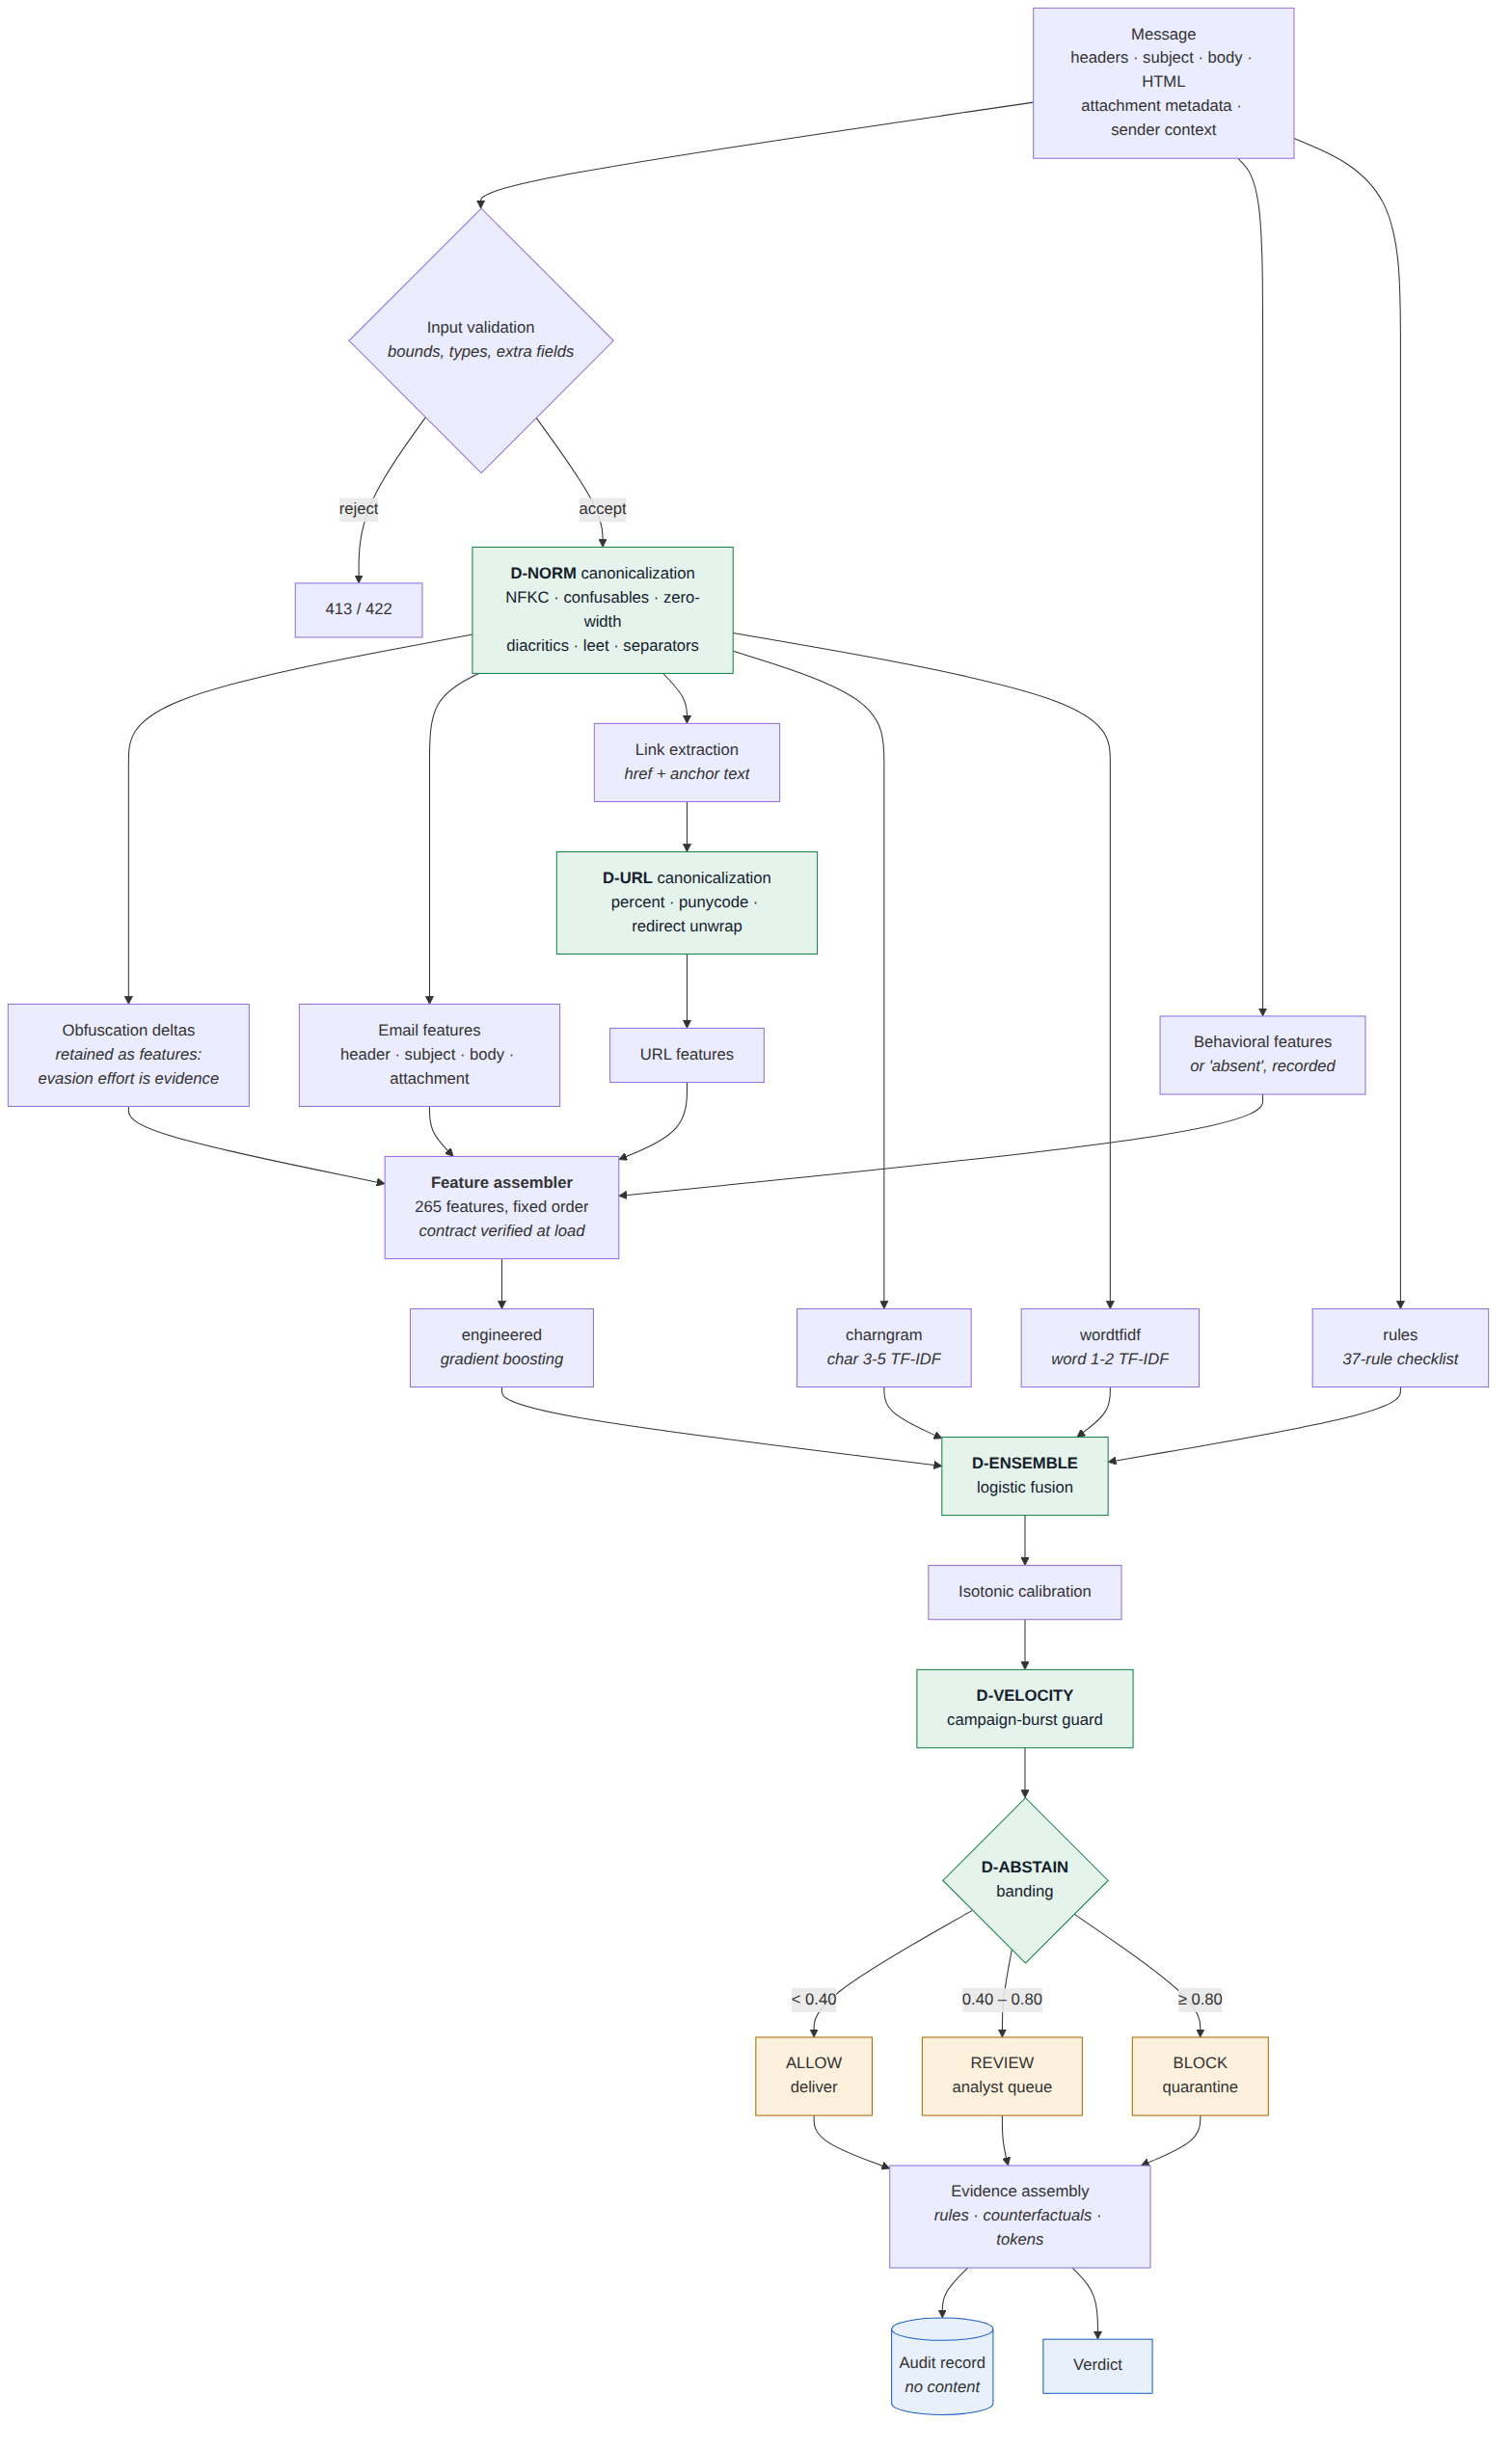
Figure 6. Assessment data flow, with the defensive controls in green and the three bands in amber.

4.4 Feature families
Table 6. The three feature families and why each is there.
Family | Features | Representative signals | Attacker control
Email | 125 | Display-name and brand mismatch, typosquat distance, Reply-To and Return-Path divergence, SPF/DKIM/DMARC, urgency and credential lexicons, hidden HTML, password inputs, attachment type, nine obfuscation-delta signals | Full - they author it
URL | 107 | Structure, brand squatting, punycode, mixed-script hosts, shorteners and open redirects (unwrapped offline), link-text versus destination mismatch; aggregated by worst link and by mean | High - they choose the infrastructure
Behavioural | 33 | First contact, prior messages and replies, domain age, send hour, recipients, burst size, display-name reuse, and a trust-deficit summary | Partial - they cannot fabricate the recipient's history
Two design choices matter here. Obfuscation effort is evidence: canonicalisation keeps measurements of how much it had to undo, so an attacker who obfuscates to defeat the text members pays for it in the engineered member. Absence is a feature: when the gateway supplies no sender history, the behavioural block records that it is absent rather than feeding the model misleading zeros, and the evidence tells the analyst the verdict rests on two families.

4.5 Model: members, fusion, calibration and the three-way decision
- Members. A 37-rule checklist (the B0 baseline, reused as a reader); a gradient-boosted model over the 265 engineered features; a character 3-5-gram TF-IDF logistic model; and a word 1-2-gram TF-IDF logistic model. The members read different views of the message, so an edit that lowers one often raises another.
- Three disjoint training pools, drawn by campaign. Members are fitted on one pool (60%), the stacker on a second using the members' out-of-sample scores (22%), and the calibrator on a third (18%). Pools are drawn by campaign so that no calibration message has a near-identical sibling in the fitting pool.
- Adversarial training (D-ADVTRAIN). Phishing training examples are augmented with attacked variants from the transform suite; legitimate examples are not, so the model does not learn that obfuscation is normal.
- Three-way decision. Below 0.40 the message is delivered; at or above 0.80 it is quarantined; in between - or when the members contradict each other (one reader clean while two are alarmed or one is certain) - it goes to a person. The thresholds are policy, published in the model card, and changeable without retraining.

4.6 Threat model and attack taxonomy
The adversary is a decision-based black-box attacker [13]: it can submit a message, observe the outcome and edit the message, within a query budget, while keeping it a working phish. Its capabilities are bounded by what an attacker actually controls. Eight families of semantic-preserving transformations implement it (Table 7), 35 transformations in all. Validity checks reject any "attack" that removes the payload or fabricates what the attacker cannot control, such as the recipient's correspondence history.
Table 7. Attack taxonomy: what each family needs, what it costs, and what counters it.
ID | Family | Capability required | Attacker cost | Countered by
A-LEX | Lexical and semantic perturbation | Free - the attacker authors the text | Low | D-NORM, D-ADVTRAIN, D-ENSEMBLE, D-ABSTAIN
A-UNI | Unicode and homoglyph obfuscation | Free - any mail client renders these identically | Low | D-NORM, D-ADVTRAIN
A-URL | URL obfuscation and redirection | Cheap - requires only a redirect host or a shortener account | Low to medium | D-URL, D-ADVTRAIN, D-ENSEMBLE
A-STRUCT | Structural and HTML manipulation | Free - the attacker authors the HTML part | Low | D-NORM, D-ENSEMBLE, D-ADVTRAIN
A-HDR | Header and identity shaping | Cheap for the attacker's own domain; impossible for the brand's real domain, which is domain compromise and out of scope | Medium | D-ENSEMBLE, D-ABSTAIN
A-BEH | Behavioral and timing mimicry | Attacker controls send time, pacing and framing; cannot fabricate the recipient's prior correspondence history or the age of their own domain | High - low-and-slow sending cuts campaign reach | D-VELOCITY, D-ENSEMBLE, D-ABSTAIN
A-TRUST | Payload relocation onto reputable infrastructure | Requires an account on the hosting platform and survives only until abuse takedown; the redirector must already exist on the trusted domain | Medium - accounts are cheap, takedowns are fast | D-URL, D-ENSEMBLE, D-ABSTAIN
A-CHANNEL | Out-of-band payload delivery | Requires a staffed phone line or an image pipeline, and converts far fewer victims per message because the victim must act manually | High - callback fraud needs live operators | D-ENSEMBLE, D-ABSTAIN, D-VELOCITY

4.7 Defensive controls
Table 8. The six named defensive controls. Each can be switched off, and the defence ablation measures what each contributes.
ID | Control | Counters | Cost
D-NORM | Text canonicalization | A-LEX, A-UNI, A-STRUCT | ~0.15 ms/message; no measurable clean-accuracy loss
D-URL | URL canonicalization | A-URL, A-TRUST | ~0.1 ms/URL; strictly offline, no DNS or HTTP lookups
D-ADVTRAIN | Adversarial training | A-LEX, A-UNI, A-URL, A-STRUCT | training set grows by the augmentation multiplier; inference unchanged
D-ENSEMBLE | Multi-view fusion | A-LEX, A-URL, A-STRUCT, A-HDR, A-BEH, A-TRUST, A-CHANNEL | ~4x single-model inference; still sub-10 ms/message on CPU
D-ABSTAIN | Confidence banding / abstention | A-LEX, A-HDR, A-BEH, A-TRUST, A-CHANNEL | analyst time proportional to the review-band width
D-VELOCITY | Campaign-burst guard | A-BEH, A-CHANNEL | one bounded arithmetic adjustment; no extra model call

4.8 Workflow design: the review queue and user reports
A REVIEW band is a promise that a person will look at the message. Every held message and every employee report therefore becomes a case with a state, an owner, a priority and a service level (Figure 7). Only the analyst who claimed a case, or an administrator, may decide it (object-level authorisation [30]); releasing a message the model scored at or above the block threshold needs an administrator and a written reason; and every transition is recorded with actor, role, both states and the note. Priorities encode urgency: P1 (1 hour) for a report on mail the model delivered, P2 (4 hours) for a held message, P3 (24 hours) for a report on mail already blocked.
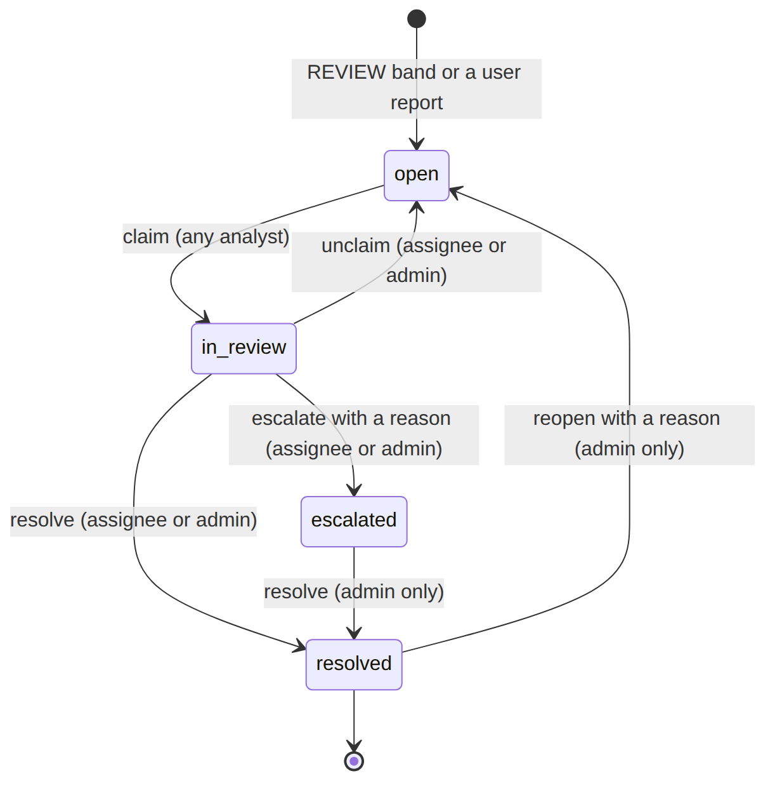
Figure 7. Review-queue state machine. Transitions are validated by a pure function and applied with compare-and-set.
Figure 8 shows the full journey of an employee report. The reporter receives a case number and a plain-language status, never a score, so the report page cannot be used as a scoring oracle.
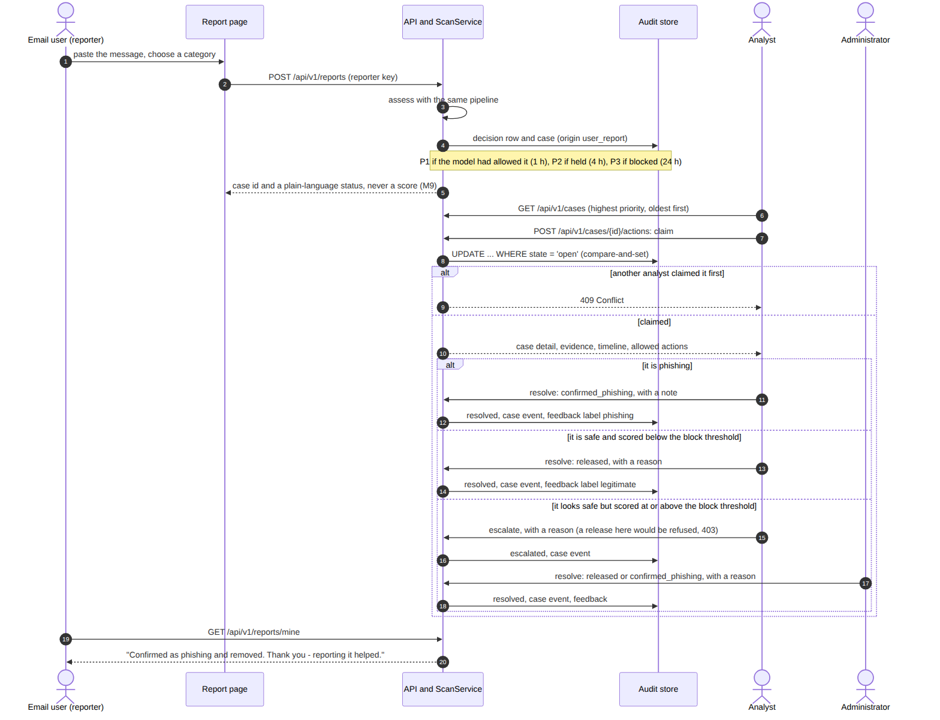
Figure 8. Sequence: from an employee's report to an analyst's decision, including the escalation path for high-risk releases.
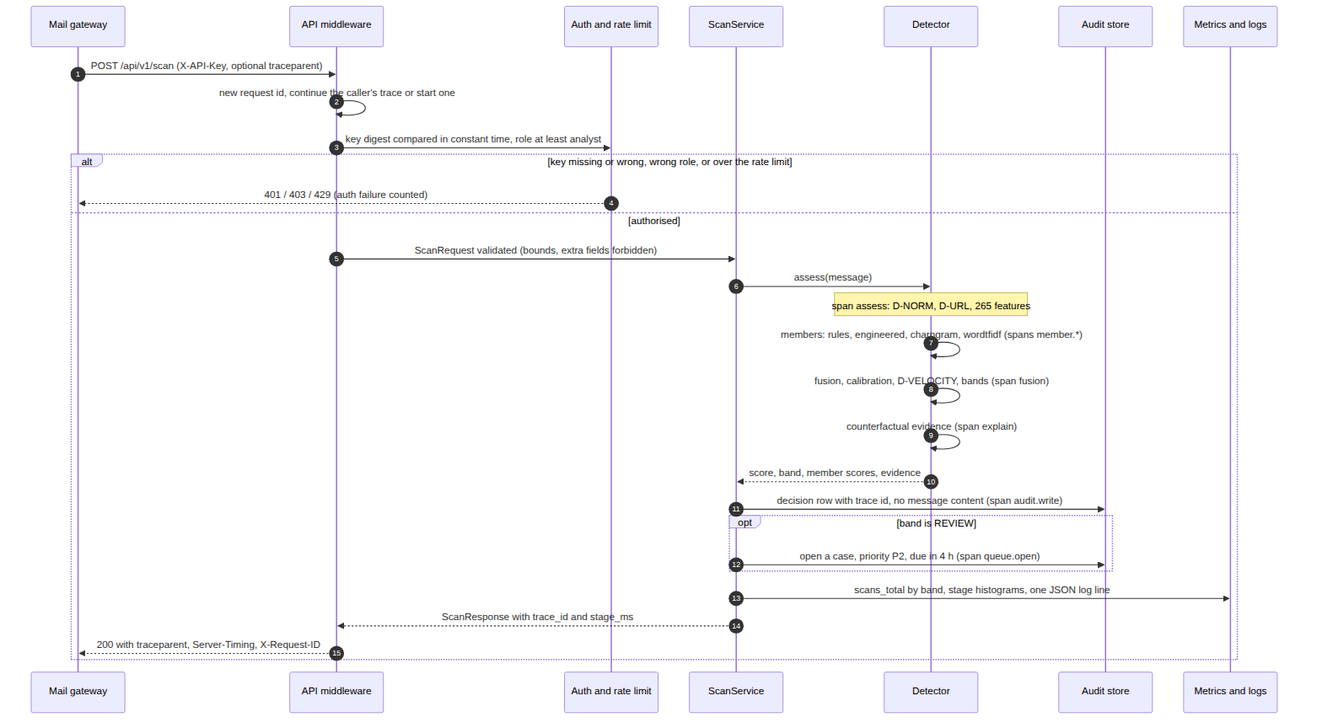
Figure 9. Sequence: inline assessment of one message, with the trace spans recorded at each stage.
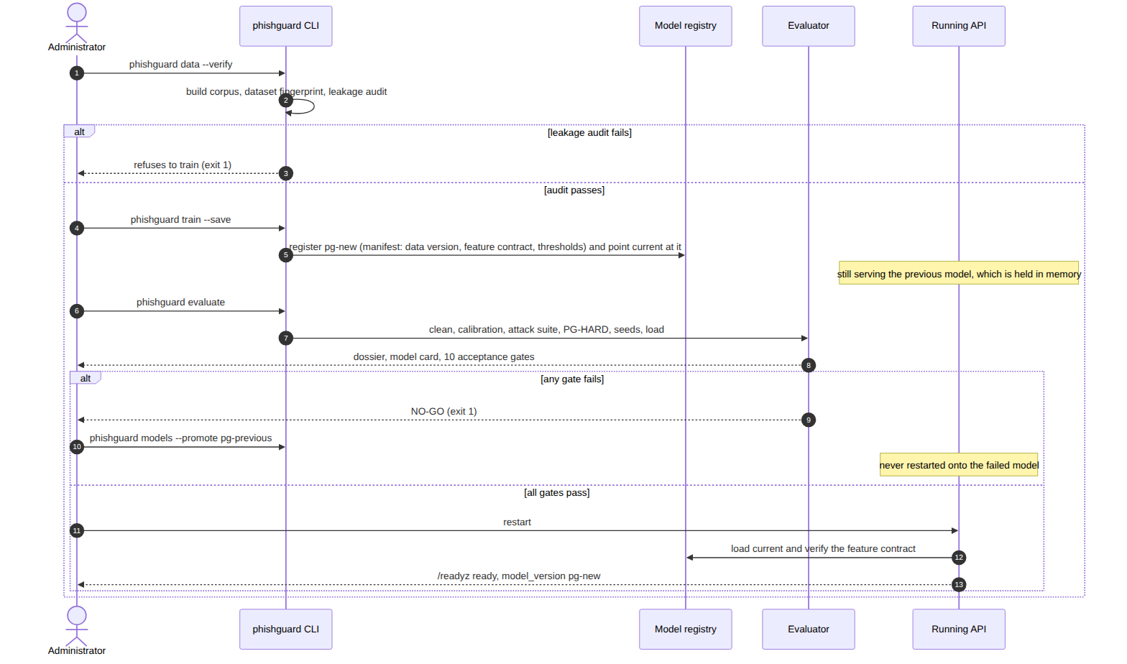
Figure 10. Sequence: retraining, the acceptance gates, and promotion or rollback.

4.9 Data design
The audit database holds decisions, analyst feedback, review cases, case events and adversarial probes (Figure 11). No table holds message content: subjects are salted digests, senders are pseudonyms, and evidence is stored as titles only. Retention is bounded and swept at start-up, except for decisions attached to an active case.
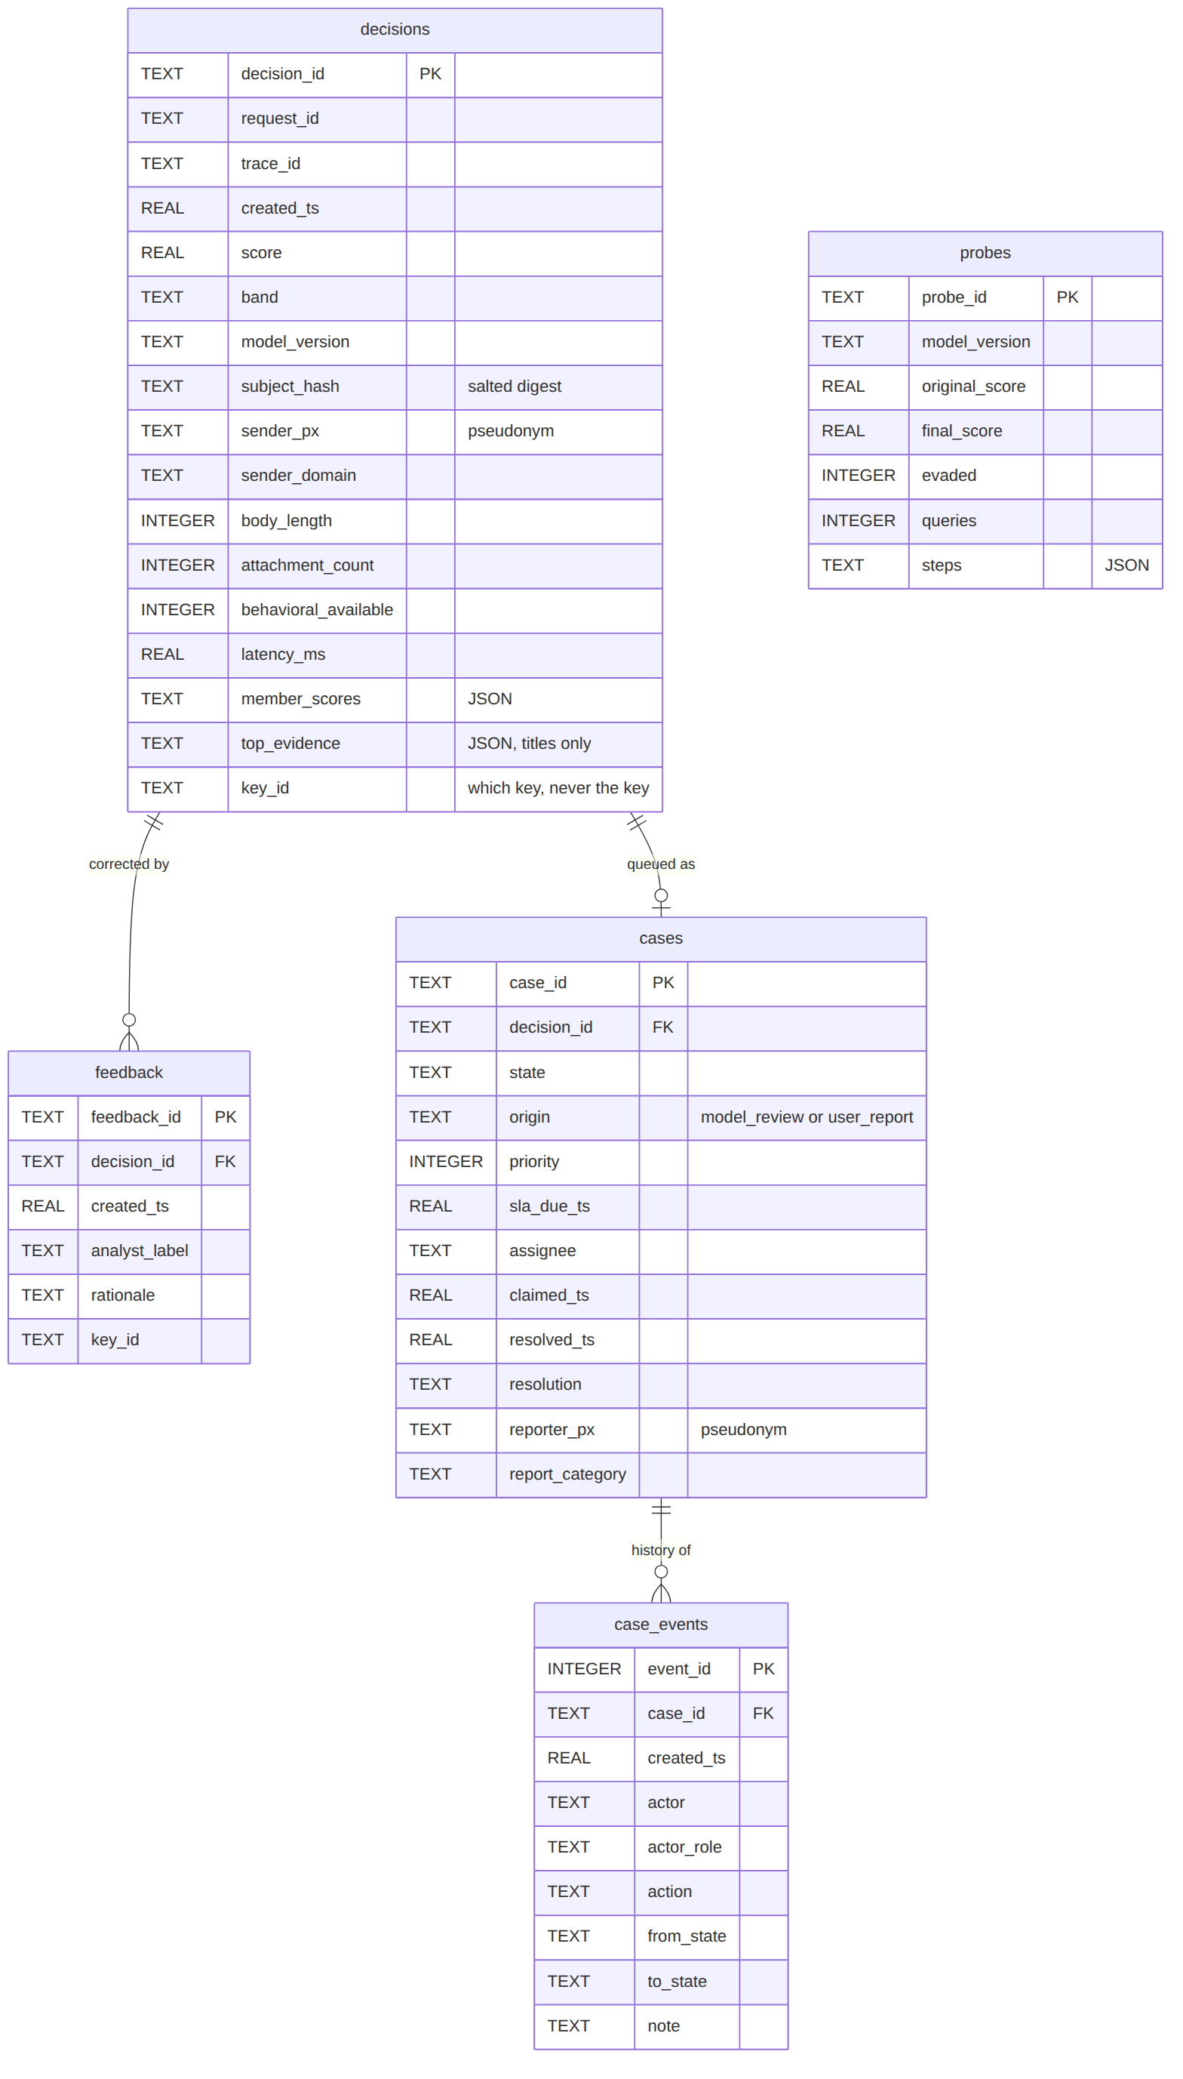
Figure 11. Audit database schema (entity-relationship diagram).

4.10 Security and observability design
Three roles - reporter, analyst and administrator - are enforced on every endpoint, with API keys stored as SHA-256 digests and compared in constant time. The service refuses to start in production without configured keys. A STRIDE analysis of the service and a residual-risk register for the model are maintained in the threat model. For operations, every request carries a request id and a W3C Trace Context [31]; per-stage timings are returned in a Server-Timing header, exported as a Prometheus histogram and recorded on the audit row, so one identifier connects a decision, its log line and its trace.

5. Implementation

5.1 Technology stack
Table 9. Technology stack and the role of each component.
Layer | Technology | Role
Language | Python 3.10-3.12 | Everything; tested on three versions in CI
Machine learning | scikit-learn, NumPy, SciPy | Members, stacking, isotonic calibration, baselines, statistics
Optional deep member | PyTorch + Hugging Face transformers (DistilBERT) | Off by default; needs a GPU to be practical
Service | FastAPI, Uvicorn, Pydantic | REST API, OpenAPI document, strict request and response contracts
Storage | SQLite (WAL mode) | Audit trail, review cases and events; behind a repository interface
Interfaces | Zero-build HTML and JavaScript | Analyst console and employee report page, shipped inside the package
Observability | Prometheus, Grafana, W3C Trace Context | Metrics, dashboards, alert rules, request traces
Experiment tracking | MLflow (optional) | Runs with parameters, metrics and artefacts
Delivery | Docker, Docker Compose, GitHub Actions | Container image, local stack, CI/CD, CodeQL, releases
Quality | pytest, ruff (with security rules), pip-audit | Tests, lint, formatting, dependency audit

5.2 Data
The primary corpus is synthetic and campaign-structured: messages are generated in campaigns that share templates, senders and infrastructure, with difficulty built in - cloned brand templates, business email compromise without links, thread hijacking, and legitimate mail with a phishing-shaped surface. This was chosen because public corpora contain real people's mail (and so cannot be committed), carry no behavioural context, and are dated. The trade-off is stated plainly: a model can learn a generator, so absolute accuracy is an upper bound. Loaders, a corpus audit and a fetcher for the Nazario phishing corpus [32] and the SpamAssassin public corpus [33] allow the email and URL families to be evaluated on real mail; the fetcher records the terms, source and SHA-256 of every download, and nothing is downloaded until the terms are acknowledged.
The 9,000-message corpus is split by campaign into 6,750 training and 1,938 test messages (1256 campaigns, 284 in test), near-duplicates are scrubbed from the test set, and a leakage audit - exact duplicates, near duplicates, campaign overlap and suspiciously predictive single features - must pass before training runs. In this run it found 0 exact and 0 near-duplicate pairs and 0 overlapping campaigns. Each dataset is versioned by a content fingerprint: the training set of this run is a1c09c445b31 and the test set f67d182863fb.

5.3 Service and interfaces
Table 10. Main API endpoints and the role required.
Endpoint | Role | Purpose
POST /api/v1/scan | analyst | Assess one message: score, band, evidence, trace id, stage timings
POST /api/v1/scan/batch | analyst | Assess up to 100 messages in one vectorised pass
POST /api/v1/ingest | analyst | Import a saved .eml or a whole .mbox; every message is audited and queued
POST /api/v1/reports | reporter | Report a suspicious message; returns a case id and plain status
GET /api/v1/reports/mine | reporter | The caller's own reports and their outcomes
GET /api/v1/cases, /cases/{id} | analyst | The review queue and one case with its history and allowed actions
POST /api/v1/cases/{id}/actions | analyst | Claim, release, escalate, resolve, reopen or comment
POST /api/v1/feedback | analyst | Record an analyst correction
GET /api/v1/drift | analyst | Drift of recent traffic against the training reference
GET /api/v1/decisions | admin | The audit trail
POST /api/v1/adversarial/probe | admin | Attack one message to test whether its verdict holds
GET /api/v1/traces/recent | admin | Recent request traces (timings only)
GET /healthz, /readyz, /metrics | none | Liveness, readiness with reason, Prometheus metrics
The analyst console (Figure 12) shows the verdict, the member scores and the evidence as sentences - never feature names - with mitigating evidence beside incriminating evidence, and a side-by-side comparison with the text-only filter. The review queue (Figure 13) shows cases by priority and age, with only the actions the caller's key may take. The report page (Figure 14) is deliberately simple and contains no number anywhere.
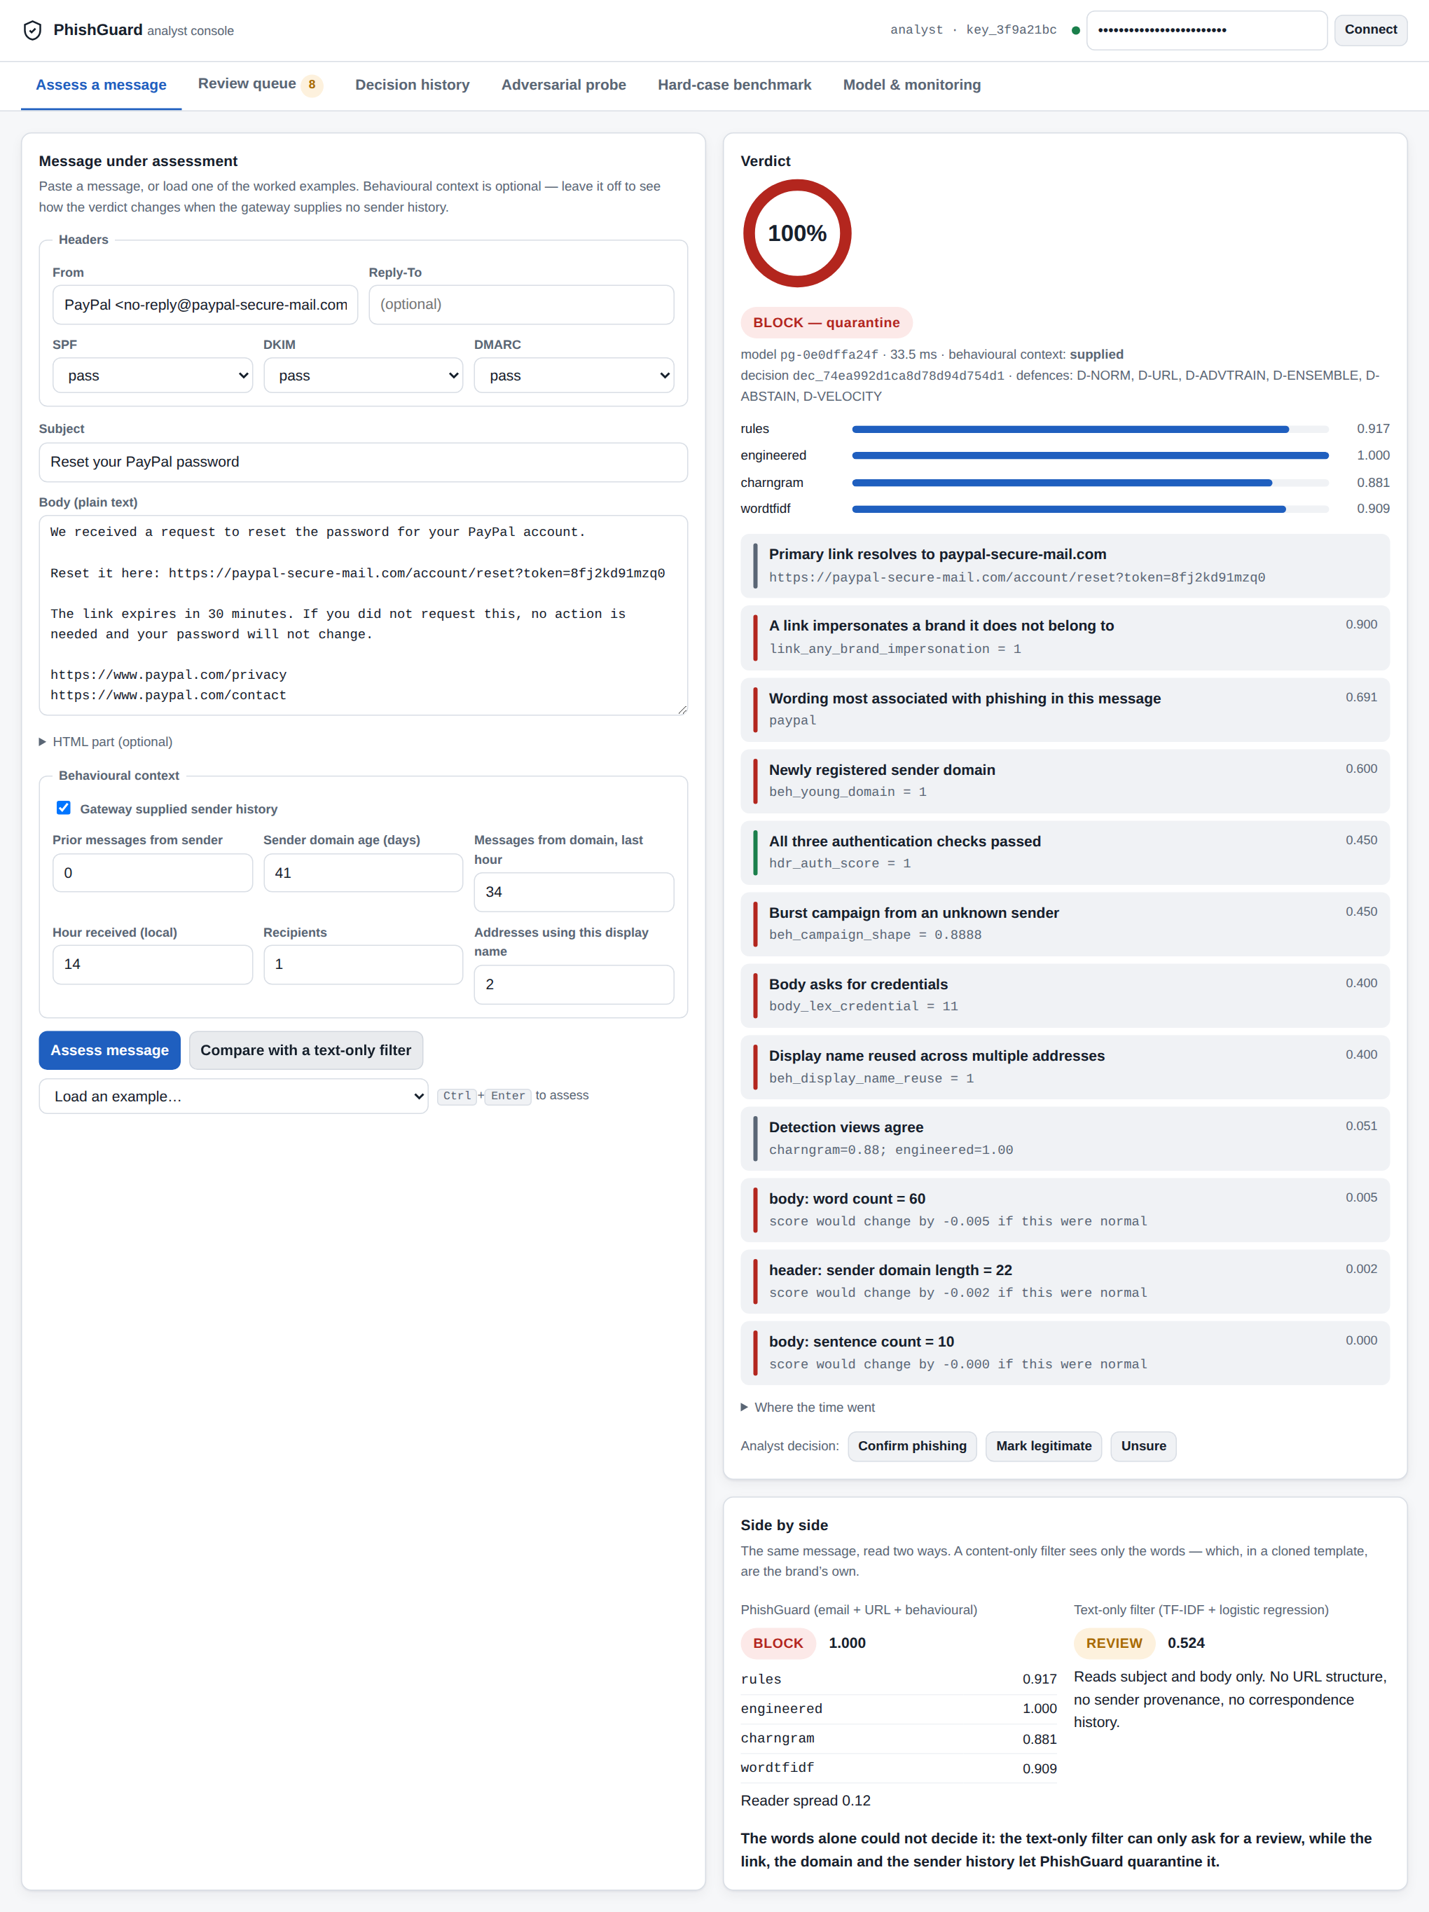
Figure 12. The analyst console assessing a cloned brand template, with the text-only comparison below the evidence.
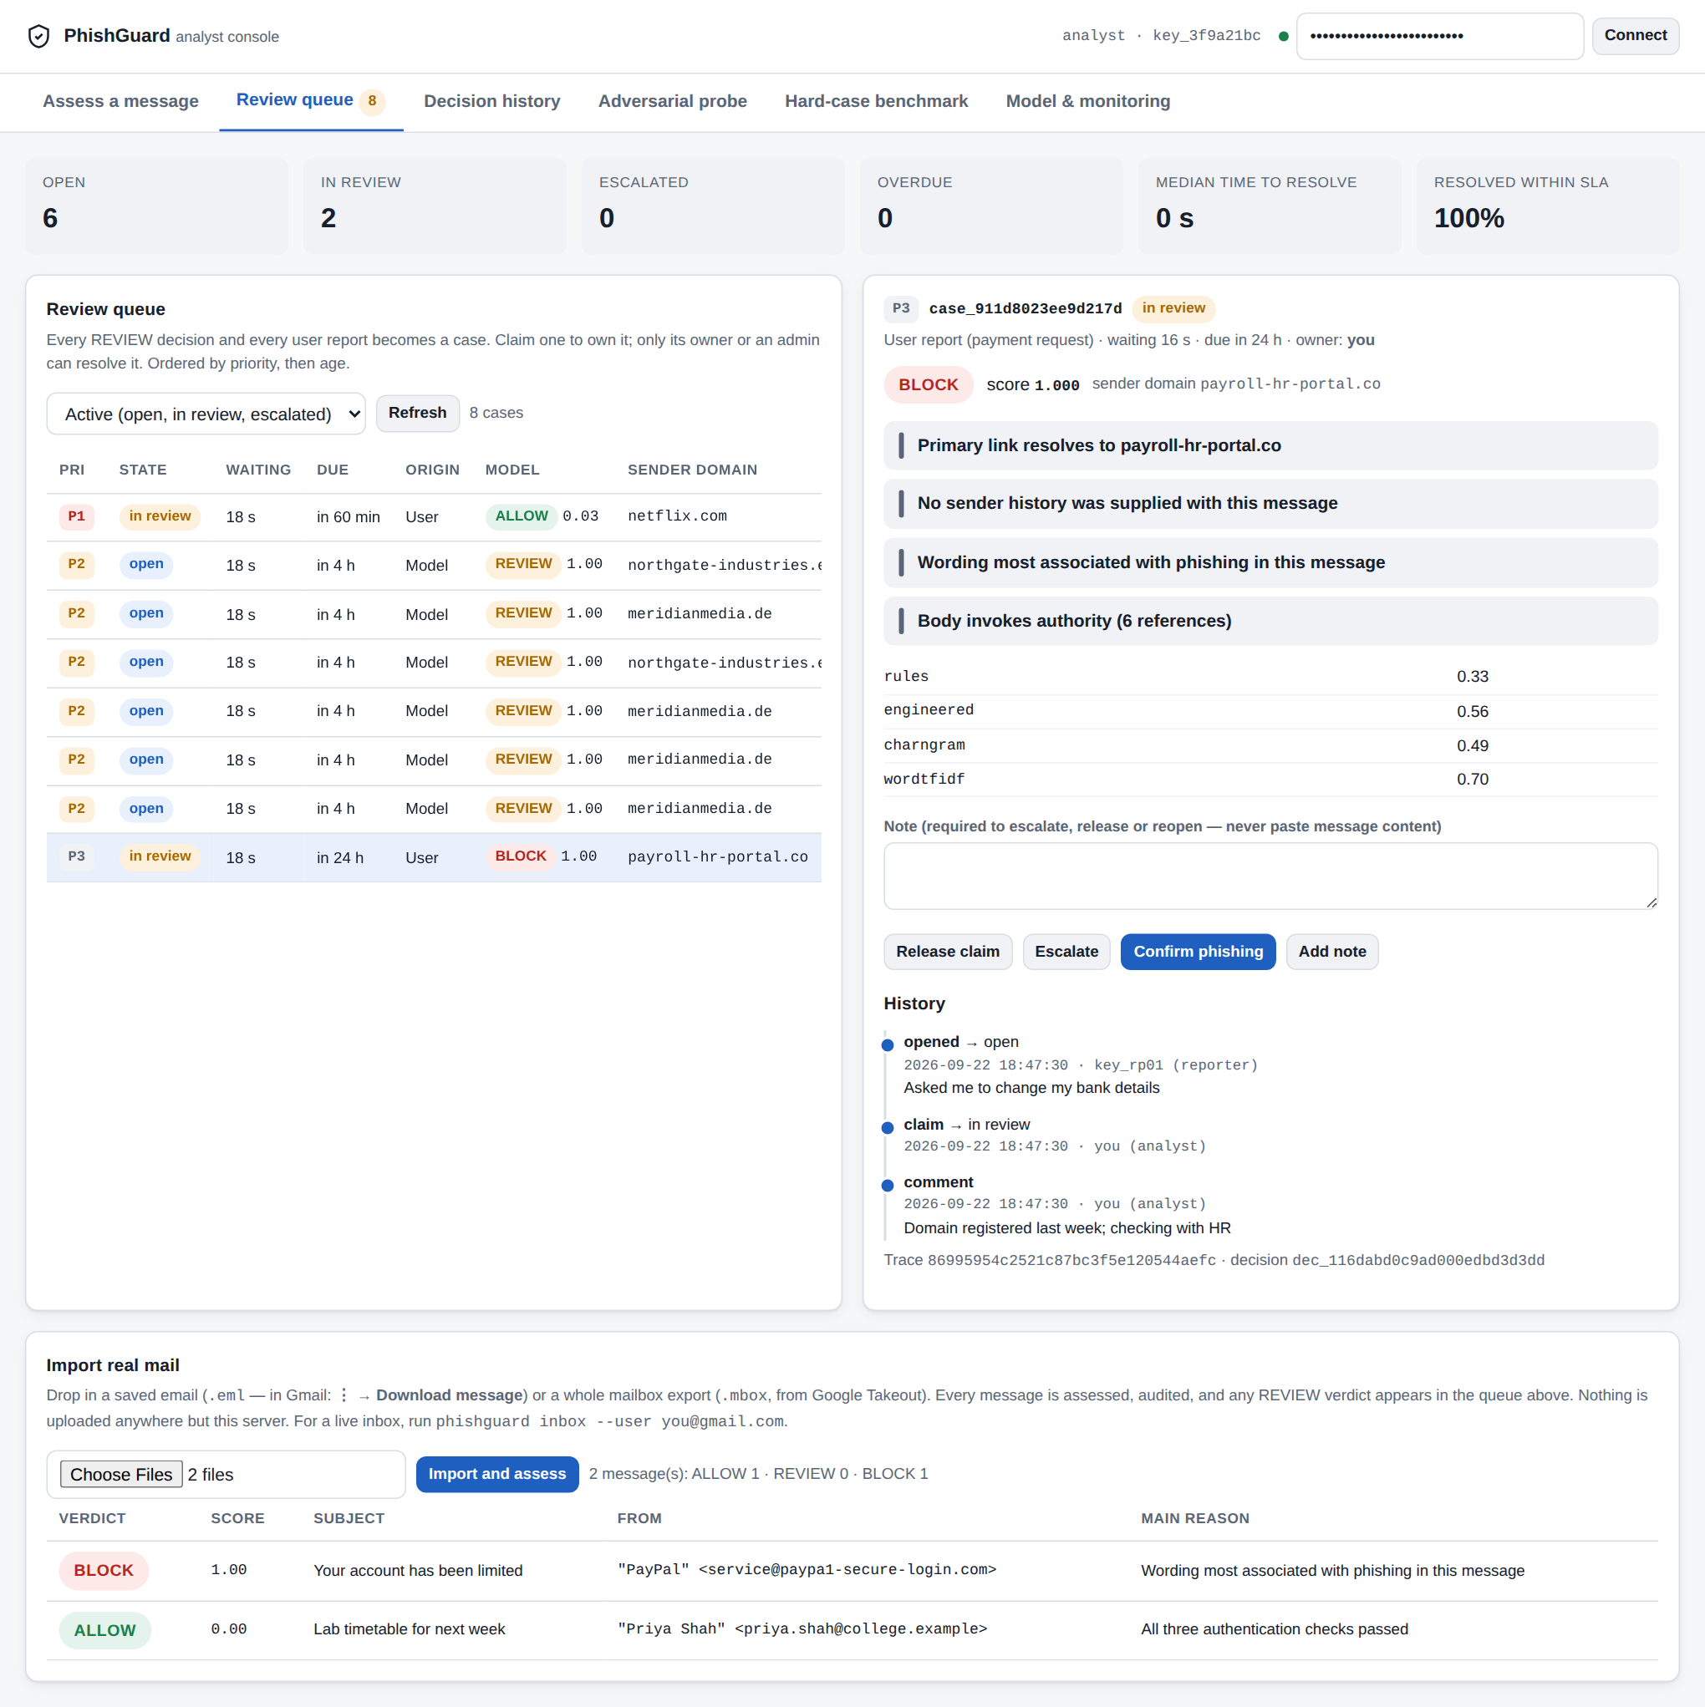
Figure 13. The review queue with an employee's report open: evidence, timeline and the actions this analyst may take.
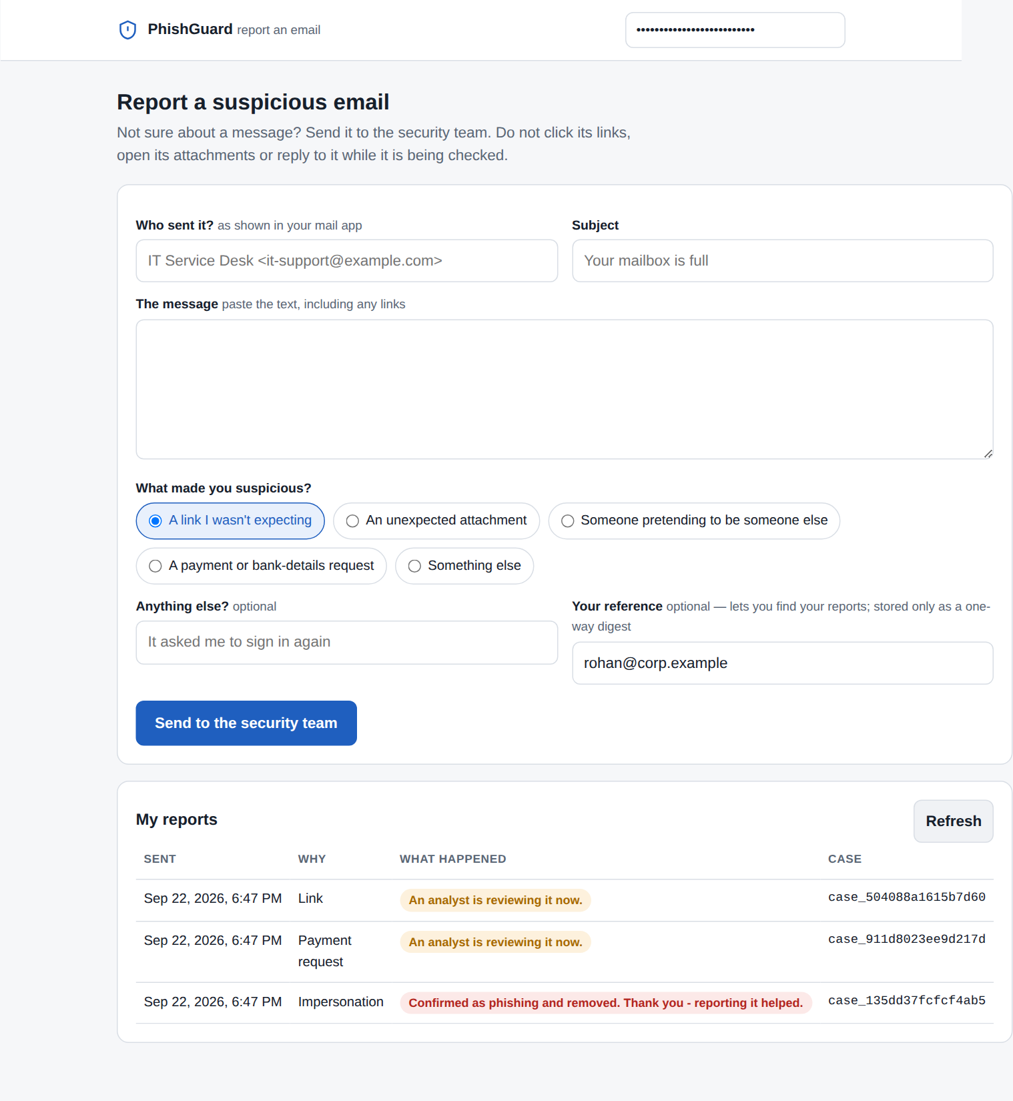
Figure 14. The report page used by employees: report a message, then follow its status under My reports.

5.4 Engineering practice
- Tests. 289 automated tests across unit, integration and security layers run in about a minute with no network and no running server. They assert properties rather than outputs: that a split cannot leak, that an attack transform cannot cheat, that the audit trail holds no content, that a model cannot load against the wrong feature layout.
- Static analysis found a real defect. A second function named t_open_redirect silently replaced the first, so the open-redirect chaining transform (A-URL-02) ran another transform's code and one attack was never tested or trained against. The linter's redefinition check caught it; the fix and a regression test shipped in version 1.3.0, and all results in this report use the corrected suite.
- Contract testing found another. Rendering the console against the real service exposed that the model-information endpoint failed its own response contract after thresholds gained a text explanation. It is fixed, with a regression test that validates the service output against the declared response model.
- Review found a third. The defence catalogue and the attack taxonomy each kept a list of which control counters which attack family, and for five of the six controls they disagreed; the catalogue predated the two newest families. The mapping is now written once, in the taxonomy, the catalogue is derived from it, and a test holds the two together.
- CI/CD. Every push runs lint (including security rules), the tests on Python 3.10, 3.11 and 3.12, a dependency audit and secret scan, the full training and evaluation with the ten gates, and a container build with a smoke test covering authentication, authorisation, reporting and tracing. CodeQL runs weekly; a release workflow builds, smoke-tests and publishes the image when a version tag is pushed.
- Load testing. The load test found that concurrent requests in one process competed for the interpreter lock and lost about 40% of throughput; requests are now served one at a time per process in arrival order, and throughput scales with processes (Chapter 6).

6. Results and Evaluation
All results in this chapter come from one evaluation run of model pg-0e0dffa24f (generated 2026-09-22 18:18:47 UTC), recorded in evaluation.json and reproducible with the commands in Appendix C. Every figure is drawn from the same file.

6.1 Experimental setup
Table 11. Experimental configuration.
Setting | Value
Corpus | synthetic(n=9000, seed=20260907), campaign-structured
Split | Grouped by campaign: 6,750 train / 1,938 test messages, 284 of 1256 campaigns held out; 46.4% phishing in test
Dataset versions | train a1c09c445b31, test f67d182863fb
Decision thresholds | REVIEW at 0.40, BLOCK at 0.80, abstention on a contradiction between members
Attack on ordinary phishing | 150 messages, query budget 10, all eight families composed
Defence ablation | Each control removed in turn and the model retrained; 120 attacked messages per arm
PG-HARD | 192 records: 24 hand-designed cases x 8 variants
Adaptive attack | 48 hard phishing records, budgets 0, 10, 40, 120 queries
Seed sensitivity | Two further retrainings with seeds 101 and 202
Hardware | 2 CPU cores, 8 GB RAM, no GPU

6.2 Clean performance against the baselines
On the held-out test set PhishGuard reaches a macro F1 of 0.9880 and a PR-AUC of 0.9983, with 1 false positive among 1,038 legitimate messages (FPR 0.10%) and 22 missed of 900 phishing messages at a 0.5 cut-off (Table 12). It beats the rule checklist by 0.093 macro F1 and the text model by 0.011. The clean difference from the text model is small and is not the argument for the design; Sections 6.5 and 6.6 are.
Table 12. Clean performance on the held-out test set (0.5 cut-off).
System | Macro F1 | PR-AUC | FPR | Phishing recall
PhishGuard (fusion) | 0.9880 | 0.9983 | 0.10% | 97.6%
B0 - rule checklist | 0.8954 | 0.9559 | 5.49% | 84.1%
B1 - TF-IDF + logistic regression | 0.9771 | 0.9985 | 0.00% | 95.1%
Member: engineered features (gradient boosting) | 0.9762 | 0.9980 | 3.37% | 98.8%
Member: character n-grams | 0.9756 | 0.9986 | 0.77% | 95.7%
Member: word n-grams | 0.9682 | 0.9958 | 0.58% | 93.9%
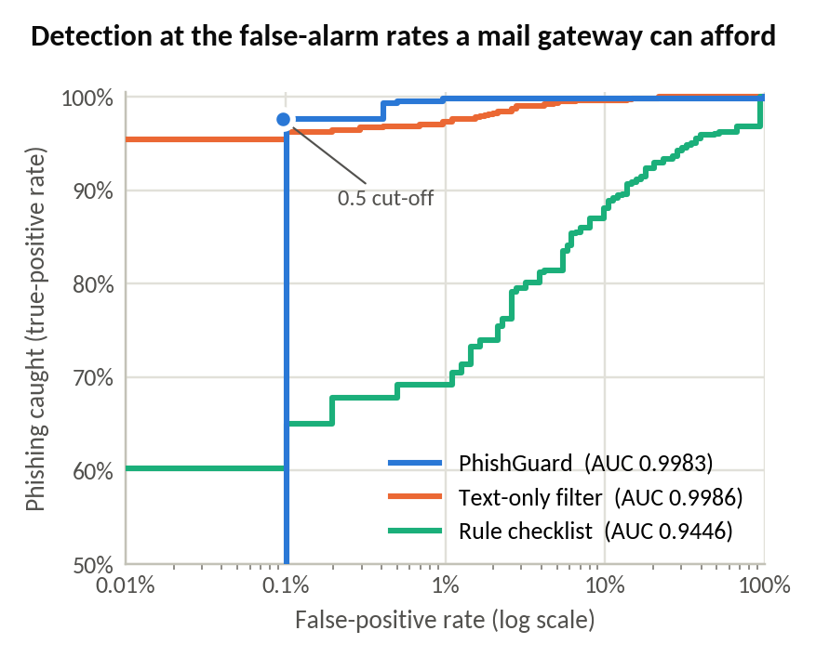
Figure 15. ROC curves with a logarithmic false-positive axis: the region a mail filter actually operates in.

6.3 Calibration
The expected calibration error is 0.0077 against a gate of 0.08 (before calibration: 0.0093). This should be read with care: isotonic calibration on a well-separated pool approaches a step function, so a near-zero ECE mostly reflects strong separation on this corpus. Calibration under distribution shift is untested and is listed as a limitation.
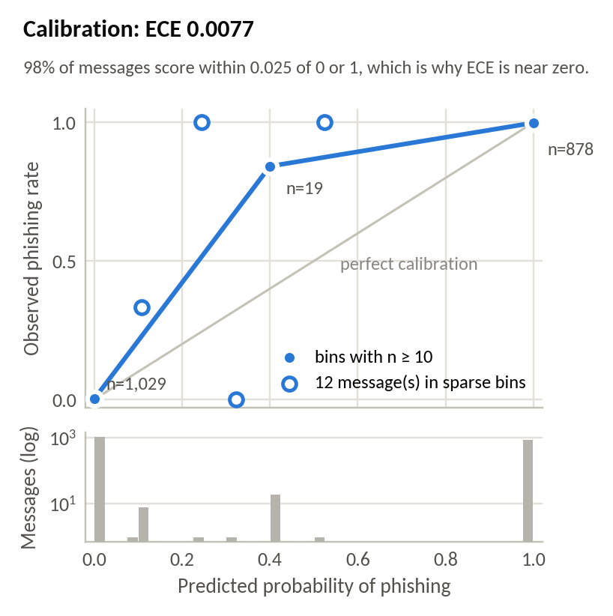
Figure 16. Reliability diagram of the calibrated score.

6.4 The decision bands in operation
Under the deployed three-band policy, 2 of 900 test phishing messages were delivered with no warning and 0 legitimate message was blocked; 11.0% of all test mail (213 messages: 154 phishing, 59 legitimate) was sent to a person. On the messages the system decided automatically, macro F1 is 0.9988. Most REVIEW decisions come from abstention on a contradiction between members rather than from mid-range scores: the band trades analyst time for fewer silent errors, and that cost is reported, priced (Section 6.9) and monitored in production.
Without sender history. Mail imported from a mailbox or an IMAP inbox carries none of the gateway's behavioural context. Scored that way, the same test set gives 12.1% to a person, 5 phishing messages delivered unwarned and 0 legitimate messages blocked - the honest figures for real mail scored outside a gateway. Release 1.4.0 changed the abstention rule for exactly this condition: a single lukewarm text reader no longer escalates on its own, which cut the review load on ordinary mail from 16.1% to 11.0% and on PG-HARD from 70.8% to 57.8% with silent delivery and false blocks unchanged.
Table 13. Outcome of the three-band policy on the test set.
Band | Messages | Share | Meaning
ALLOW | 981 | 50.6% | Delivered; includes 2 missed phishing
REVIEW | 213 | 11.0% | Held for an analyst
BLOCK | 744 | 38.4% | Quarantined; 0 legitimate

6.5 PG-HARD: the hard-case benchmark
The ordinary test set is mostly easy mail. PG-HARD contains 24 cases - half legitimate, half phishing - each designed to defeat a named detection cue (URL reputation, domain age, SMTP authentication, sender history, text content), with 8 variants each. All three systems are first tuned to the same false-alarm budget on ordinary mail, so their columns are comparable. A silent delivery is a hard phish the user receives with no warning; a false block is legitimate mail the user never sees; routing a hard case to a person counts as acceptable for both labels.
Table 14. PG-HARD outcomes (192 records).
System | Silent delivery | False block | Acceptable outcome | Sent to a person
PhishGuard | 0.0% (0) | 8.3% (8) | 95.8% | 57.8%
B1 - text-only filter | 0.0% (0) | 51.0% (49) | 74.5% | 4.2%
B0 - rule checklist | 77.1% (74) | 0.0% (0) | 61.5% | 4.2%
The checklist lets most hard phishing through; the text-only filter blocks half of the hard legitimate mail; PhishGuard does neither, at the cost of sending 57.8% of these deliberately ambiguous records to a person. Its 8 false blocks are all one case, HN-REBRAND - a genuine supplier writing from a three-week-old domain about a billing change, which is textually identical to invoice fraud. Across three training seeds PhishGuard delivered 0-1 hard phishing records unwarned and blocked 7-8 hard legitimate ones, so the result is quoted as a range.
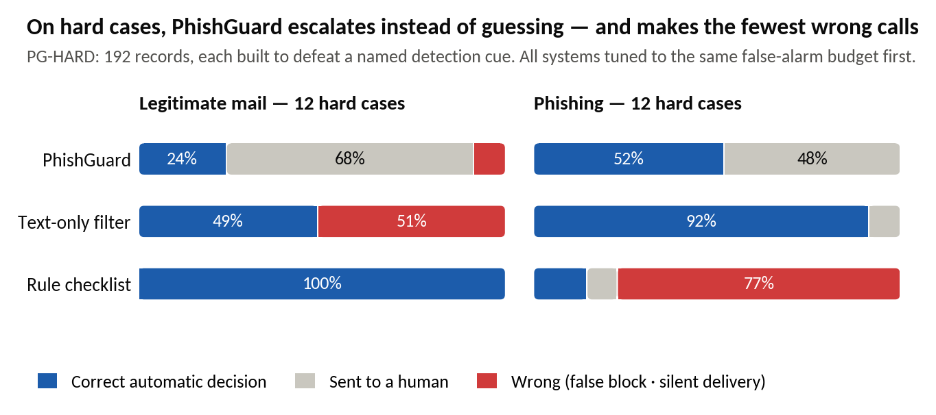
Figure 17. PG-HARD outcomes for the three systems at the same false-alarm budget.

6.6 Robustness under attack
Ordinary phishing. With a 10-query budget and all eight attack families composed, 0.0% of 150 attacked messages escaped PhishGuard's automatic blocking, against 29.3% for the text-only filter; the macro F1 drop was 0.0000 and 0.0005 respectively. At this budget the ordinary set is too easy to separate the individual defences (Section 6.7); the adaptive attack on hard records is the more discriminating test.
Hard phishing, adaptive attacker. The attacker was given up to 120 queries per message and, in the adaptive variant, knowledge of the abstention control, so that it targets disagreement between members as well as the score. Table 15 counts how many of the 48 hard phishing records each defender delivered with no warning.
Table 15. Hard phishing records delivered unwarned (of 48) as the attacker's query budget grows.
Query budget | 0 | 10 | 40 | 120
PhishGuard vs score-minimising attacker | 0 | 0 | 0 | 0
PhishGuard vs abstention-aware attacker | 0 | 0 | 3 | 3
Text-only filter vs the same attacker | 0 | 3 | 29 | 43
PhishGuard: share still auto-blocked | 52.1% | 43.8% | 12.5% | 6.3%
At 120 queries the text-only filter delivered 43 of 48 hard phishing records (89.6%) with no warning; PhishGuard delivered 3 (6.3%). The attack is not free for PhishGuard either: the share it still blocks automatically falls from 52.1% to 6.3%, with the rest escalated to a person rather than delivered. That is the design working as intended - uncertainty is converted into review - and also its cost.
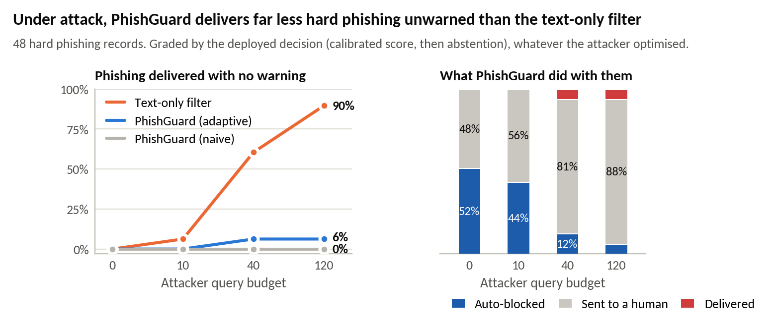
Figure 18. Hard phishing delivered unwarned as the attacker's query budget grows.
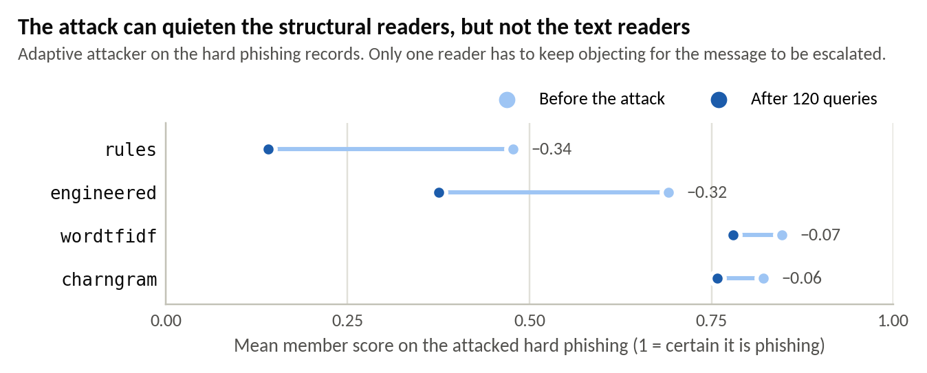
Figure 19. Which ensemble members the strongest attack could move: the members' weaknesses matter only where they line up.

6.7 Ablations
Modality ablation. Each combination of feature families was trained and evaluated on the same split (Table 16). The email family carries most of the clean accuracy on its own (macro F1 0.9845) but with a false-positive rate of 2.12%; the URL and behavioural families are weaker alone (0.9408 and 0.9343), and all three together reach 0.9865 with a false-positive rate of 0.96%. The ablation measures clean data only; the case for the behavioural family is its behaviour under attack and on PG-HARD, where the attacker cannot rewrite it.
Table 16. Modality ablation: every combination of the three feature families.
Families | Features | Macro F1 | PR-AUC | FPR | Recall
email | 125 | 0.9845 | 0.9995 | 2.12% | 99.1%
url | 107 | 0.9408 | 0.9890 | 4.72% | 92.8%
behavioral | 33 | 0.9343 | 0.9872 | 3.47% | 90.0%
email + url | 232 | 0.9845 | 0.9996 | 2.22% | 99.2%
email + behavioral | 158 | 0.9839 | 0.9993 | 1.16% | 97.9%
url + behavioral | 140 | 0.9860 | 0.9993 | 0.48% | 97.6%
email + url + behavioral | 265 | 0.9865 | 0.9996 | 0.96% | 98.2%
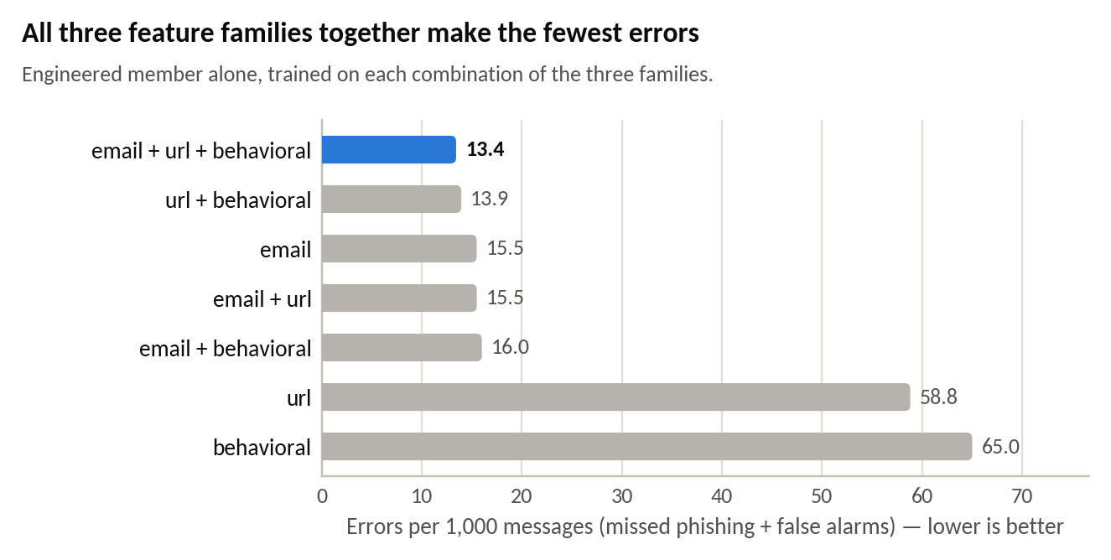
Figure 20. Modality ablation.
Defence ablation. Each control was removed in turn, the model retrained and the attack repeated on 120 messages (Table 17). At this budget, removing the multi-view ensemble (D-ENSEMBLE) - or all defences - is what lets attacks through; removing any other single control does not register on the ordinary set. That is an honest limit of the measurement rather than evidence that those controls are useless: PG-HARD and the adaptive attack are where abstention and the behavioural signals show their value.
Table 17. Defence ablation (120 attacked messages per arm).
Arm | Clean macro F1 | Clean FPR | Attack success | Silent delivery
all defences | 0.9880 | 0.10% | 0.0% | 0.0%
without D-NORM | 0.9886 | 0.10% | 0.0% | 0.0%
without D-URL | 0.9912 | 0.29% | 0.0% | 0.0%
without D-ADVTRAIN | 0.9943 | 0.39% | 0.0% | 0.0%
without D-ENSEMBLE | 0.9783 | 3.37% | 10.0% | 10.0%
without D-ABSTAIN | 0.9880 | 0.10% | 0.0% | 0.0%
without D-VELOCITY | 0.9880 | 0.10% | 0.0% | 0.0%
no defences | 0.9736 | 3.37% | 9.2% | 6.7%

6.8 Seed sensitivity
Table 18. The same configuration retrained with three seeds.
Run | Model | PG-HARD silent delivery | PG-HARD false block | Ordinary: phishing unwarned | Ordinary: review share
evaluated model | pg-0e0dffa24f | 0 of 96 | 8 of 96 | 0.22% | 11.0%
retrained, seed 101 | pg-28d6cfc41d | 1 of 96 | 8 of 96 | 0.78% | 9.1%
retrained, seed 202 | pg-41e78f6d93 | 0 of 96 | 7 of 96 | 0.44% | 10.9%
The seed decides which campaigns fall in each training pool and which messages are augmented. On PG-HARD a single borderline case tips with the seed (HP-HIJACK for silent delivery, HN-REBRAND for false blocks), which is why results are quoted as ranges. The corpus and split seeds remain fixed; varying them is future work.

6.9 Operating point and cost
The thresholds were checked against an expected-cost model with illustrative assumptions (a missed phish costs 200 analyst-reviews, a false block 10, a review 1; 2% phishing prevalence; a tenth of traffic hard). At those assumptions the deployed policy costs 262.2 review-equivalents per 1,000 messages and the cheapest policy on the grid 191.4. The cheaper policy was not adopted: under the adaptive attack it delivered 12.5% of hard phishing unwarned against 6.3% for the deployed policy, and candidates chosen on the evaluation data cannot be adopted on the strength of the same data.
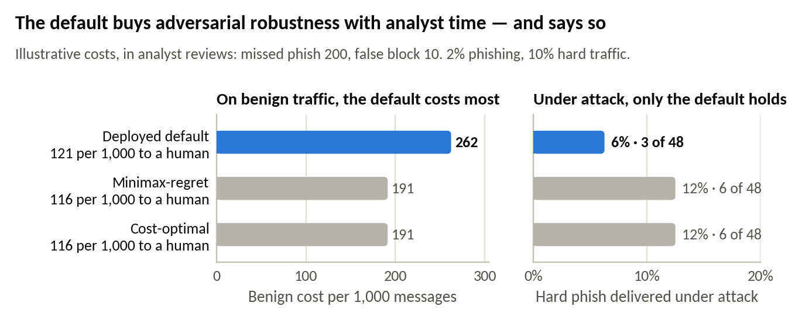
Figure 21. Operating point: expected cost of each policy, clean and under attack.

6.10 Error analysis
Table 19. The 23 test-set errors at a 0.5 cut-off, by category.
Category | Count
missed: cloned legitimate template, signal is header/URL only | 19
missed: thread hijack inside an existing conversation | 2
missed: business email compromise, no link and no lexical tells | 1
false alarm: unknown but legitimate sender | 1
Most misses are cloned legitimate templates whose only signal is the header and the link - exactly the case the URL and behavioural families exist for, and the reason the REVIEW band exists. On the hard subset of the test set (cloned templates, business email compromise, thread hijacking and phishing-shaped legitimate mail; 489 messages) macro F1 is 0.9547 with phishing recall 90.7% and no false positives.

6.11 Latency, load and scaling
Table 20. Single-message latency through the full decision path (150 assessments).
Statistic | With evidence | Without evidence
p50 | 21.2 ms | 11.8 ms
p95 | 30.5 ms | 16.9 ms
p99 | 62.3 ms | 29.2 ms
Throughput | 43.9 msg/s | 70.8 msg/s
Gate G7 requires a p95 under 150 ms; observed 30.5 ms. Under concurrent load (Table 21) one process serves requests in arrival order, so throughput stays close to the single-request rate and latency grows with the queue; p95 stays within the budget up to eight requests in flight. This behaviour is the result of a fix found by the load test: before it, concurrent threads competed for the interpreter lock and throughput fell by about 40%.
Table 21. One server process under concurrent load (explanations on).
Requests in flight | Messages/s | p50 | p95 | p99 | Errors
1 | 44.4 | 21.5 ms | 32.7 ms | 39.6 ms | 0
2 | 44.1 | 44.5 ms | 57.6 ms | 70.4 ms | 0
4 | 41.0 | 93.6 ms | 120.8 ms | 150.6 ms | 0
8 | 40.8 | 191.9 ms | 234.4 ms | 251.9 ms | 0
Table 22. Scaling with server processes, and the batch path.
Configuration | Messages/s | Note
1 server process | 49.0 | 1.00x; p95 28.0 ms
2 server processes | 96.5 | 1.97x; p95 29.4 ms
Batch path, no evidence | 337.3 | 2.3x one call per message (147.0); identical results on 600 messages
Batch path, evidence only for review | 182.0 | What phishguard triage uses
One process handles about 44 messages a second on one core of this host - roughly 160,000 an hour - so an organisation of 1,200 people needs one or two processes; throughput scales almost linearly with processes (1.97x with two). Peak memory was 214 MB per process. These timings are from a shared two-core container and are slower than the previous run's on faster hardware; the model is identical.

6.12 Drift monitoring
In a ten-week simulation of 400 messages a week at 2% phishing, from week 6 a quarter of traffic was replaced by hard-case mail the model had not seen. The monitor flagged 0 of 5 stable weeks and 5 of 5 shifted weeks, using alarm levels calibrated on stable campaign-structured windows rather than the textbook population-stability thresholds, which on campaign-structured mail fire on most normal weeks.
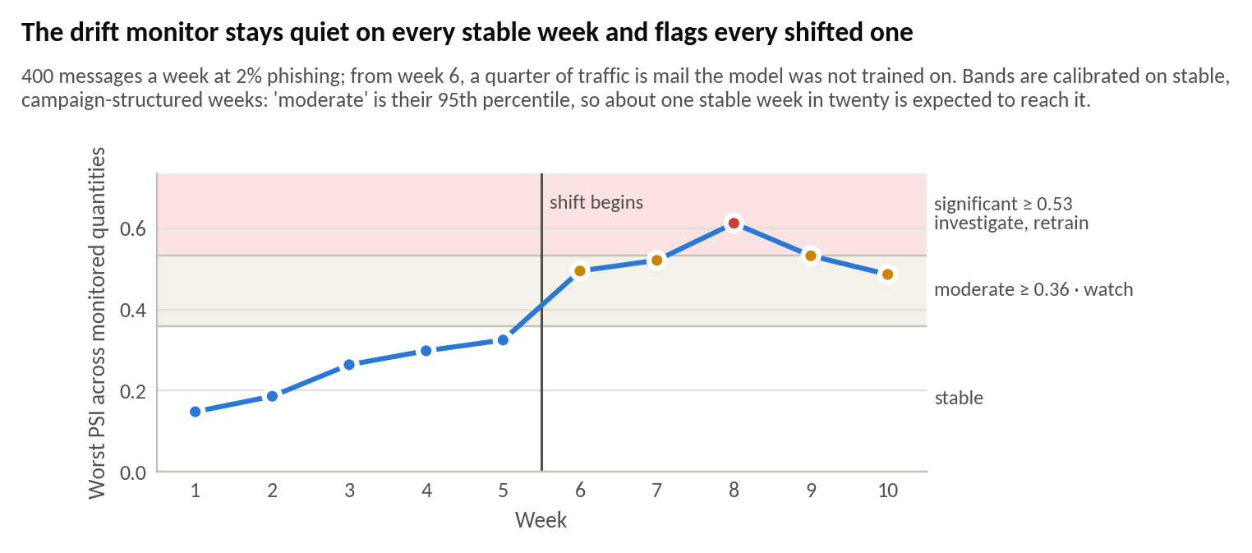
Figure 22. Drift monitoring: weekly worst-quantity PSI against calibrated alarm levels, before and after an injected shift.

6.13 Acceptance gates
Table 23. Acceptance gates: 10 of 10 passed.
Gate | Criterion | Observed | Threshold | Result
G1 | Detection quality | 0.9880 | >= 0.9 | PASS
G2 | Ranking quality | 0.9983 | >= 0.93 | PASS
G3 | False positives | 0.0010 | <= 0.02 | PASS
G4 | Calibration | 0.0077 | <= 0.08 | PASS
G5 | Adversarial robustness | 0.0000 | <= 0.15 | PASS
G6 | Attack success (escapes auto-block) | 0.0000 | <= 0.35 | PASS
G7 | Inference latency | 30.4730 | <= 150 | PASS
G8 | Beats the manual baseline | 0.0926 | >= 0.01 | PASS
G9 | Robustness advantage over the text-only baseline | 0.2933 | >= 0 | PASS
G10 | No data leakage | 1.0000 | >= 1 | PASS

7. Security, Privacy and Responsible AI

7.1 Security testing
Security requirements are enforced by automated tests that run on every change. Table 24 summarises the checks; the full list, with the test that proves each, is in the evaluation dossier (docs/07, section 7.15).
Table 24. Security and privacy checks.
Area | What is checked | Result
Authentication | Missing or wrong key rejected; constant-time comparison against stored digests; key id reveals nothing | Pass
Authorisation | Role separation (reporter, analyst, admin); object-level checks on review cases; high-risk release needs an admin | Pass
Scoring oracle | Reporter responses never contain a score or band | Pass
Input validation | Oversized fields and batches rejected; unknown fields rejected | Pass
Hostile input | Injection strings, path traversal, null bytes, right-to-left overrides, XML entities and a 100,000-character body neither crash nor hang the scanner | Pass
Injection | SQL metacharacters in filters do not affect the store; all SQL parameterised | Pass
Abuse | Per-key token-bucket rate limiting | Pass
SSRF / egress | The model never opens a network connection while scoring | Pass
Secrets | Production refuses to start without keys; development keys flagged; CI secret scan | Pass
Privacy | No message content in the database, logs or traces; pseudonyms stable and non-reversible | Pass
Static analysis | Ruff including flake8-bandit security rules: zero findings; CodeQL in CI | Pass
Dependencies | pip-audit and Dependabot in CI | Runs in CI

7.2 Privacy by design
PhishGuard processes message content in memory for one assessment and stores none of it. The audit trail keeps a salted digest of the subject, a pseudonym for the sender, the sender's domain, sizes, the verdict, the member scores and the titles of the evidence items. Reporter identities are stored as salted digests. Retention is bounded and swept at start-up. Public corpora, which contain real people's mail, are never committed to the repository and are downloaded only after their terms are acknowledged.

7.3 Responsible-AI review
The review follows the trustworthiness characteristics of the NIST AI Risk Management Framework [29]. Its findings, each with the mitigation in place and the action recommended before production, are:
- RAI-1 - New and rebranded small businesses are the group most likely to be blocked in error. Every legitimate PG-HARD message the deployed model blocked came from HN-REBRAND, a genuine supplier on a 22-day-old domain; across three seeds, 7-8 of its 8 variants were blocked. Mitigation: the case is in the benchmark, blocked mail can be reported and released, and the evidence names domain age. Recommended: use the organisation's supplier register as behavioural context.
- RAI-2 - Writing style is a feature, and so is not writing like a native English speaker. Unusual phrasing is a phishing signal, and also a property of mail from people writing in a second language. The synthetic corpus is English-only and cannot measure this; false-positive rates by sender language are the first measurement recommended for a pilot.
- RAI-3 - Human oversight must be staffed to be real. The REVIEW band sent 11.0% of ordinary test mail to a person. Queue depth and overdue cases are metrics with alert rules, and the cost model prices review time.
- RAI-4 - Dual use. The adversarial probe and the attack suite show which edits lower a score. The probe is admin-only, audited and alerted on; nothing in the project sends mail, registers a domain or resolves a URL.
- RAI-5 - Reporters are people, not labels. Employees who report a message are told the outcome in plain words and never shown a score, so the channel cannot become a scoring oracle and nobody is made to feel foolish for a false alarm.

7.4 Limitations and threats to validity
- The corpus is synthetic. It is campaign-structured, difficulty-balanced and leakage-audited, but a 265-feature model can learn a generator. Absolute accuracy is an upper bound; the comparative results - fusion against baselines, under attack and on PG-HARD - are the claims that transfer.
- The attacks were written by the defenders. A genuinely novel attack family is untested by construction, and adversarial training uses the same transform library it is evaluated against. An independent red-team exercise is the strongest available check.
- Behavioural context is simulated. Public corpora carry no correspondence history, so the behavioural family is evaluated only on synthetic data.
- The ordinary attack set is not discriminating at budget 10. Only removing the ensemble registers in the defence ablation; the hard-case adaptive attack is the more informative measurement.
- Calibration is measured in distribution. Behaviour of the probabilities under shift is monitored in production but not measured here.
- Load was measured in-process on two cores. It shows the model is not the bottleneck and how the service scales; the deployment host should be measured with the HTTP load test.

8. Deployment and Operations

8.1 Running the system
On a clean machine, one documented command, python start.py, checks the interpreter, creates an isolated environment, installs dependencies, trains a model if none exists and opens the console. Docker Compose (docker compose up --build) starts the API with Prometheus and Grafana, and the container trains a model on first start if the registry is empty. A preflight command, phishguard doctor --self-test, checks the machine and runs a small end-to-end pipeline; every failure message names the command that fixes it.

8.2 Configuration and scaling
Table 25. Settings an operator is most likely to change.
Variable | Default | Purpose
PG_ENVIRONMENT | dev | prod refuses to start without configured keys
PG_API_KEYS | development keys | role:key pairs for reporter, analyst and admin
PG_REVIEW_THRESHOLD / PG_BLOCK_THRESHOLD | 0.40 / 0.80 | The decision policy; changeable without retraining
PG_API_WORKERS | 1 | Server processes, up to one per core; throughput scales almost linearly
PG_SCORING_CONCURRENCY | 1 | Messages scored at once per process
PG_RATE_LIMIT_PER_MINUTE | 120 | Per key
PG_AUDIT_RETENTION_DAYS | 90 | Audit retention, swept at start-up

8.3 Monitoring and alerting
Prometheus scrapes request counts and latency, decisions by band, per-stage latency from traces, the score distribution, behavioural-context availability, analyst feedback, authentication failures, adversarial probes and the review queue. A provisioned Grafana dashboard shows them, and ten alert rules cover an outage, a missing model, latency over budget, collapsed blocking, excess review traffic, lost behavioural context, overdue cases, a review backlog, authentication-failure spikes and probe evasions. Drift against the training reference is checked from the console, the API or the command line.

8.4 Model lifecycle and release
Every model is versioned with its manifest, feature contract, metrics and the fingerprint of its training data. Promotion is gated on the ten acceptance gates, rollback is one command, and a tagged release builds, smoke-tests and publishes the container image with its changelog section as the release notes.

9. Conclusion and Future Work

9.1 Outcomes against the objectives
Table 26. Objectives and what was delivered.
Objective | Outcome
Calibrated, explainable tri-modal detector | 265 features, four members, stacked isotonic fusion, three-way decision; macro F1 0.9880, FPR 0.10%, ECE 0.0077; evidence in sentences
Comparison with baselines | Beats the checklist by 0.093 macro F1 and the text model by 0.011; 95.8% acceptable on PG-HARD against 74.5% and 61.5%
Threat-informed adversarial suite | 35 transforms in eight families; 3 of 48 hard phishing delivered unwarned at 120 queries against 43 for the text model; residual-risk register
End-to-end operational workflow | Scanning, review queue with owners and SLAs, employee reporting, audit trail, monitoring, drift detection
Production controls | 289 tests, input validation, secrets handling, dependency and code scanning, containers, CI/CD, logs, metrics and traces
Evaluation against thresholds | 10 of 10 acceptance gates pass; load, security, privacy and responsible-AI reviews; limitations stated

9.2 Go / no-go recommendation
- Release as a demonstrable prototype: GO. All gates pass; tests, security checks and the load test pass; the documentation runs on a clean machine.
- Supervised pilot on a real mailbox, in tag-only mode: GO, with conditions. Evaluate the email and URL families on the organisation's own labelled mail, measure false positives by sender language and for new domains, staff the review queue, keep the default thresholds.
- Autonomous quarantine in production: NO-GO for now. It requires evaluation on the organisation's own mail within the false-positive budget, an independent red-team exercise, supplier-register integration, and a signed acceptance of the residual risks.
The evidence supports the design - that fusing three families with abstention is much harder to evade than a text model, and that the operational controls do what they claim - far better than it supports any absolute accuracy figure on real traffic. A tag-only pilot is how that second kind of evidence is gathered without putting business mail at risk.

9.3 Future work
- Evaluate on real, labelled organisational mail, now that a mailbox can be imported and an inbox watched; measure false-positive rates by sender language and for new domains.
- Report the DistilBERT reader's effect under attack once it has been trained on a GPU with the transformer extra.
- An independent red-team exercise against the deployed API, with its findings added to the transform suite.
- Supplier-register and directory integration as behavioural context, to reduce false blocks of new legitimate senders.
- Vary corpus and split seeds as well as training seeds, and report confidence intervals for every headline figure.
- Decode QR codes in image attachments in a separate sandbox and feed the decoded URLs to the URL family.
- Single sign-on for the console, an OpenTelemetry exporter for traces, and a PostgreSQL audit store for multi-node deployments.

References
- Federal Bureau of Investigation, Internet Crime Complaint Center, "2025 IC3 annual report," 2026. [Online]. Available: https://www.ic3.gov/AnnualReport/Reports/2025_IC3Report.pdf
- Verizon Business, "2026 Data Breach Investigations Report," May 2026. [Online]. Available: https://www.verizon.com/business/resources/reports/dbir/
- Anti-Phishing Working Group, "Phishing activity trends report, 2nd quarter 2026," Aug. 2026. [Online]. Available: https://docs.apwg.org/reports/apwg_trends_report_q2_2026.pdf
- Ministry of Home Affairs, Government of India, "Cases of cybercrime," Lok Sabha Unstarred Question No. 432, answered 2 Dec. 2025. [Online]. Available: https://www.mha.gov.in/MHA1/Par2017/pdfs/par2025-pdfs/LS02122025/432.pdf
- The MITRE Corporation, "Phishing, Technique T1566 - Enterprise," MITRE ATT&CK. Accessed: Sep. 22, 2026. [Online]. Available: https://attack.mitre.org/techniques/T1566/
- I. Fette, N. Sadeh, and A. Tomasic, "Learning to detect phishing emails," in Proc. 16th Int. Conf. World Wide Web (WWW), 2007, pp. 649-656, doi: 10.1145/1242572.1242660.
- J. Ma, L. K. Saul, S. Savage, and G. M. Voelker, "Beyond blacklists: Learning to detect malicious web sites from suspicious URLs," in Proc. 15th ACM SIGKDD Int. Conf. Knowledge Discovery and Data Mining, 2009, pp. 1245-1254, doi: 10.1145/1557019.1557153.
- A. Das, S. Baki, A. El Aassal, R. Verma, and A. Dunbar, "SoK: A comprehensive reexamination of phishing research from the security perspective," IEEE Commun. Surveys Tuts., vol. 22, no. 1, pp. 671-708, 2020, doi: 10.1109/COMST.2019.2957750.
- G. Ho, A. Cidon, L. Gavish, M. Schweighauser, V. Paxson, S. Savage, G. M. Voelker, and D. Wagner, "Detecting and characterizing lateral phishing at scale," in Proc. 28th USENIX Security Symp., 2019, pp. 1273-1290.
- A. Cidon, L. Gavish, I. Bleier, N. Korshun, M. Schweighauser, and A. Tsitkin, "High precision detection of business email compromise," in Proc. 28th USENIX Security Symp., 2019, pp. 1291-1307.
- I. J. Goodfellow, J. Shlens, and C. Szegedy, "Explaining and harnessing adversarial examples," in Proc. Int. Conf. Learning Representations (ICLR), 2015, arXiv:1412.6572.
- N. Papernot, P. McDaniel, I. Goodfellow, S. Jha, Z. B. Celik, and A. Swami, "Practical black-box attacks against machine learning," in Proc. ACM Asia Conf. Computer and Communications Security (ASIA CCS), 2017, pp. 506-519, doi: 10.1145/3052973.3053009.
- W. Brendel, J. Rauber, and M. Bethge, "Decision-based adversarial attacks: Reliable attacks against black-box machine learning models," in Proc. 6th Int. Conf. Learning Representations (ICLR), 2018.
- G. Apruzzese, H. S. Anderson, S. Dambra, D. Freeman, F. Pierazzi, and K. Roundy, "‘Real attackers don’t compute gradients’: Bridging the gap between adversarial ML research and practice," in Proc. IEEE Conf. Secure and Trustworthy Machine Learning (SaTML), 2023, pp. 339-364, doi: 10.1109/SaTML54575.2023.00031.
- A. Vassilev, A. Oprea, A. Fordyce, H. Anderson, X. Davies, and M. Hamin, "Adversarial machine learning: A taxonomy and terminology of attacks and mitigations," National Institute of Standards and Technology, NIST AI 100-2 E2025, Mar. 2025, doi: 10.6028/NIST.AI.100-2e2025.
- E. Gabrilovich and A. Gontmakher, "The homograph attack," Commun. ACM, vol. 45, no. 2, p. 128, Feb. 2002, doi: 10.1145/503124.503156.
- Unicode Consortium, "Unicode security mechanisms," Unicode Technical Standard #39. [Online]. Available: https://www.unicode.org/reports/tr39/
- C. Guo, G. Pleiss, Y. Sun, and K. Q. Weinberger, "On calibration of modern neural networks," in Proc. 34th Int. Conf. Machine Learning (ICML), PMLR vol. 70, 2017, pp. 1321-1330.
- B. Zadrozny and C. Elkan, "Transforming classifier scores into accurate multiclass probability estimates," in Proc. 8th ACM SIGKDD Int. Conf. Knowledge Discovery and Data Mining, 2002, pp. 694-699, doi: 10.1145/775047.775151.
- A. Niculescu-Mizil and R. Caruana, "Predicting good probabilities with supervised learning," in Proc. 22nd Int. Conf. Machine Learning (ICML), 2005, pp. 625-632, doi: 10.1145/1102351.1102430.
- D. H. Wolpert, "Stacked generalization," Neural Netw., vol. 5, no. 2, pp. 241-259, 1992, doi: 10.1016/S0893-6080(05)80023-1.
- J. H. Friedman, "Greedy function approximation: A gradient boosting machine," Ann. Statist., vol. 29, no. 5, pp. 1189-1232, 2001, doi: 10.1214/aos/1013203451.
- F. Pedregosa et al., "Scikit-learn: Machine learning in Python," J. Mach. Learn. Res., vol. 12, pp. 2825-2830, 2011.
- J. Gama, I. Žliobaitė, A. Bifet, M. Pechenizkiy, and A. Bouchachia, "A survey on concept drift adaptation," ACM Comput. Surv., vol. 46, no. 4, Art. no. 44, 2014, doi: 10.1145/2523813.
- S. Rabanser, S. Günnemann, and Z. C. Lipton, "Failing loudly: An empirical study of methods for detecting dataset shift," in Advances in Neural Information Processing Systems 32 (NeurIPS), 2019, pp. 1394-1406.
- S. Kaufman, S. Rosset, C. Perlich, and O. Stitelman, "Leakage in data mining: Formulation, detection, and avoidance," ACM Trans. Knowl. Discov. Data, vol. 6, no. 4, Art. no. 15, 2012, doi: 10.1145/2382577.2382579.
- M. Mitchell, S. Wu, A. Zaldivar, P. Barnes, L. Vasserman, B. Hutchinson, E. Spitzer, I. D. Raji, and T. Gebru, "Model cards for model reporting," in Proc. Conf. Fairness, Accountability, and Transparency (FAT*), 2019, pp. 220-229, doi: 10.1145/3287560.3287596.
- T. Gebru, J. Morgenstern, B. Vecchione, J. W. Vaughan, H. Wallach, H. Daumé III, and K. Crawford, "Datasheets for datasets," Commun. ACM, vol. 64, no. 12, pp. 86-92, 2021, doi: 10.1145/3458723.
- National Institute of Standards and Technology, "Artificial intelligence risk management framework (AI RMF 1.0)," NIST AI 100-1, Jan. 2023, doi: 10.6028/NIST.AI.100-1.
- OWASP Foundation, "API1:2023 Broken object level authorization," OWASP API Security Top 10 - 2023. [Online]. Available: https://owasp.org/API-Security/editions/2023/en/0xa1-broken-object-level-authorization/
- S. Kanzhelev, M. McLean, A. Reitbauer, B. Drutu, N. Molnar, and Y. Shkuro, Eds., "Trace Context," W3C Recommendation, 23 Nov. 2021. [Online]. Available: https://www.w3.org/TR/trace-context-1/
- J. Nazario, "Phishing corpus." [Online]. Available: https://monkey.org/~jose/phishing/
- The Apache SpamAssassin Project, "SpamAssassin public mail corpus." [Online]. Available: https://spamassassin.apache.org/old/publiccorpus/

Appendix A. Requirements Traceability Summary
Every requirement in the BAI-17 portfolio brief is mapped to its evidence in the repository's requirements traceability matrix (docs/12-requirements-traceability.md). Summary:
Table 27. Requirement status across the portfolio brief.
Status | Meaning | Count
Met | Implemented and evidenced in the repository | 109
Met, with a stated limitation | Implemented; the limitation is documented with the evidence | 4
Needs the student | Cannot be produced honestly by software: commit and review history, recorded hours, the demo video | 5
Not used, by decision | TensorFlow (PyTorch covers the optional deep member); OpenCV (no image input in scope) | 2

Appendix B. Repository Structure
Table 28. Where each part of the system lives.
Path | Contents
src/phishguard/features/ | Email, URL and behavioural feature extraction; the feature contract
src/phishguard/data/ | Synthetic generator, public-corpus loaders and fetcher, splits, PG-HARD, dataset fingerprints
src/phishguard/models/ | Baselines, members, fusion, calibration, model registry
src/phishguard/adversarial/ | Attack taxonomy, 35 transforms, budgeted and adaptive attackers
src/phishguard/defenses/ | Canonicalisation, URL unwrapping, velocity guard, control registry
src/phishguard/explain/ | Counterfactual attributions and analyst evidence
src/phishguard/eval/ | Metrics, acceptance gates, PG-HARD evaluation, cost model, seeds, load test
src/phishguard/monitoring/ | Drift detection with calibrated alarm levels
src/phishguard/service/ | API, contracts, security, audit store, review workflow, tracing, telemetry
src/phishguard/static/ | Analyst console and report page
tests/ | 289 unit, integration and security tests
docs/ | Problem brief, design pack, API contract, threat model, test strategy, data package, evaluation dossier, guides, work log, traceability, ADRs
docker/, .github/ | Container, compose, Prometheus rules, Grafana dashboard; CI, CodeQL and release workflows

Appendix C. Reproducing the Results
From a clean checkout with Python 3.10 or later:
python start.py # set up, train if needed, open the console
phishguard data --n 9000 # build the corpus and audit it for leakage
phishguard train --n 9000 --save # train and register a model
phishguard evaluate --n 9000 --budget 10 --max-attacked 150 --defense-ablation
phishguard hard # PG-HARD
phishguard cost --attack # the cost model
phishguard figures # the report figures
phishguard loadtest --concurrency 1,2,4,8 ; phishguard loadtest --processes 1,2
phishguard drift --simulate # the drift demonstration
phishguard import saved-mail/ # score real .eml/.mbox files into the queue
phishguard inbox --user you@example.com # watch a real inbox, read-only
pytest # 289 tests
Numbers reproduce exactly with the same seeds (corpus 20260907, split 11, attack 7); results are written to artifacts/reports/, and every report records its model version and dataset fingerprints.

