FENESTRATION DESIGN & PRICING TOOL
Complete System Design & Product Blueprint

Production-Ready Architecture • Rule Engine Design • Competitive Strategy • Development Roadmap

Version 1.0 — April 2025

This document is the complete product blueprint for a fenestration design and pricing system that competes directly with EVA WinOptimize, LogiKal, and ReynaPro. It covers architecture, rule engine design, BOM generation, pricing strategy, competitive positioning, and a phased development plan — all oriented toward real fabrication workflows in the Indian market.

Table of Contents
Table of Contents 2
1. System Understanding 4
1.1 What This System Does 4
1.2 Three Core Engines 4
1.3 End-to-End Data Flow 4
2. Competitive Gap Analysis — vs EVA WinOptimize 6
2.1 Competitive Positioning Overview 6
2.2 Where This System Can Outperform EVA WinOptimize 6
2.3 Where This System Will Struggle vs EVA 6
3. Missing Components — Critical Gaps 8
3.1 Constraint Validation Engine 8
3.2 Parametric Deductions — The Most Critical Missing Element 8
3.3 Assembly Hierarchy — Multi-Level Structure 8
3.4 Cutting Optimisation — Stick Allocation 9
3.5 Multi-Design Project Handling 9
4. Architecture Design 10
4.1 Architecture Layers Overview 10
4.2 API Layer Design 10
4.3 Service Layer Breakdown 10
4.4 Technology Stack 11
5. Advanced Rule Engine Design 12
5.1 Rule Engine Execution Flow 12
5.2 Rule Schema — Database Design 12
5.3 Formula Variable Namespace 13
5.4 Types of Rules 13
5.5 Security — Why eval() Is Never Used 13
6. Profile Intelligence System 14
6.1 Purpose of Profile Intelligence 14
6.2 Recommendation Scoring Model 14
6.3 Data Requirements for Profile Intelligence 14
7. Pricing Engine — Advanced Design 15
7.1 Core Pricing Formula 15
7.2 Multi-Mode Pricing 15
7.3 Margin Simulation Dashboard 15
7.4 Cost Optimisation Suggestions 15
8. MVP vs Scale Plan 16
8.1 Development Roadmap Overview 16
8.2 Phase 1 — MVP (Weeks 1–4): Build This First 16
8.3 Phase 2 — Expand (Weeks 5–8) 16
8.4 Phase 3 — Intelligence (Weeks 9–12) 17
8.5 Phase 4 — Scale (Weeks 13–16+) 17
9. Real-World Practical Improvements & Risk Mitigation 18
9.1 Fabrication Workflow Improvements 18
9.2 Risk: Incorrect Deduction Values 18
9.3 Risk: Aluminum Price Volatility 18
9.4 Risk: Formula Errors by Admin Users 18
9.5 Common Mistakes to Avoid 18
10. How to Design This Software — Complete Implementation Plan 20
10.1 Pre-Development (Week 0) — Foundation Work 20
10.2 Database First — Then Logic 20
10.3 Rule Engine — Test Driven 20
10.4 Admin Panel — Before Client UI 20
10.5 Client UI — Guided Wizard Flow 20
10.6 Testing Strategy 21
10.7 Go-to-Market — Onboarding a Fabricator 21
11. Summary & Key Principles 22

1. System Understanding

1.1 What This System Does
The Fenestration Design & Pricing Tool is a rule-driven, parametric configurator built for aluminum window and door fabricators. A fabricator enters the product type (Sliding Window, Casement Window, Sliding Door), the overall dimensions (width and height in millimetres), and the configuration (number of panels, track type). The system then automatically computes every profile length needed, generates a complete bill of materials with hardware, calculates glass sizes with proper deductions, and produces a fully costed quotation — all in under 30 seconds.
Unlike general-purpose CAD tools, this system is not a drawing tool. It is a knowledge-encoded configurator: the fabrication knowledge that experienced estimators carry in their heads is stored in a database as formulas and rules. This makes the system teachable, updatable, and scalable across multiple fabricators and profile brands without rewriting code.
Core insight: The competitive advantage is not the UI — it is the rule engine. A fabricator who takes 45 minutes to manually calculate a BOM should be able to get the same result in under 60 seconds, with zero math errors.

1.2 Three Core Engines
The system is built around three tightly coupled engines, each with a single responsibility:
- Design Engine — Takes raw user input (type, dimensions, config) and applies parametric formulas to compute every profile length in the assembly. This includes frame members, sash/shutter members, mullions, glazing beads, and tracks. It must enforce constraint validation to reject physically impossible configurations before computation begins.
- BOM Engine — Takes the Design Engine output (a map of component roles to computed lengths) and resolves each role to a specific profile code, stick count, and wastage allowance. It also resolves the glass schedule (size and area per pane) and maps the hardware kit for the product type and panel count.
- Pricing Engine — Takes the BOM and costs every line using the formula: profile cost = (length in metres) × (weight per metre in kg) × (cost per kg). Glass is costed by square footage. Hardware is costed per unit. Fabrication charge, margin percentage, and GST are applied on top to produce a final line-itemised quotation.

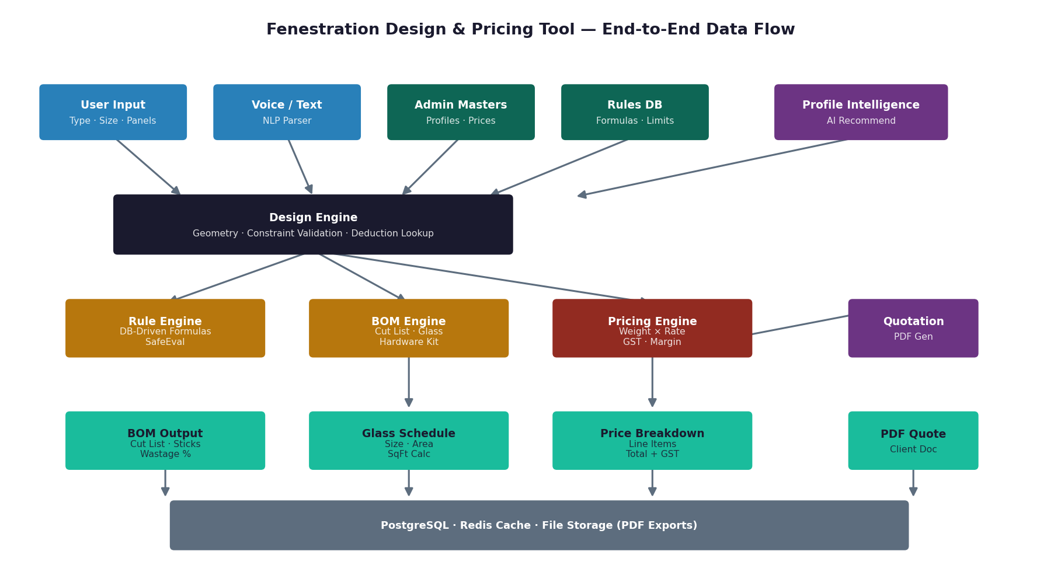
1.3 End-to-End Data Flow
The diagram below shows how data moves from the user's input through each processing layer to the final output:
Important: The flow is unidirectional during computation. User input flows into the Design Engine, which feeds the BOM Engine, which feeds the Pricing Engine. There is no feedback loop during a single design run — recalculation is triggered only when the user changes an input.
2. Competitive Gap Analysis — vs EVA WinOptimize

2.1 Competitive Positioning Overview
EVA WinOptimize is a mature German-engineered fenestration software used by large fabricators globally. It has deep CAD integration, extensive profile libraries, and decades of refinement. However, it is expensive, complex to onboard, and not optimised for the Indian fabrication market. The chart below shows how our system can outperform EVA on the dimensions that matter most to Indian fabricators:
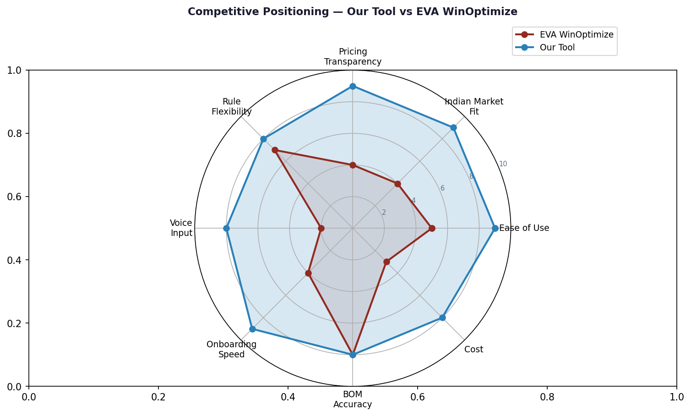

2.2 Where This System Can Outperform EVA WinOptimize
Dimension | EVA WinOptimize | Our System | Advantage
Onboarding Speed | 2–4 weeks training | Under 1 day — guided UI | Critical for SME market
Indian Market Fit | Generic, no Indian pricing | INR-native, GST-ready, Indian series | First-mover advantage
Pricing Transparency | Black-box cost output | Line-itemised weight × rate breakdown | Builds fabricator trust
Rule Flexibility | CAD-embedded, hard to change | DB-driven formulas editable by admin | No developer needed
Voice Input | Not available | Whisper + GPT voice-to-design pipeline | Unique differentiator
Cost (Licence) | ₹2–5 lakh/yr per seat | SaaS model ₹3,000–8,000/month | 80%+ cost saving
Mobile Access | Windows desktop only | Progressive Web App (PWA) | Field estimators

2.3 Where This System Will Struggle vs EVA
- CAD Accuracy: EVA generates fabrication drawings and DXF files. This system will not do this in Phase 1 or 2. For fabricators who need shop-floor drawings, this is a gap.
- Profile Library Depth: EVA has thousands of pre-loaded profiles from global brands. This system starts with a manually maintained admin database and will require data entry effort to match EVA's breadth.
- Thermal & Structural Simulation: EVA can compute U-values and structural load compliance. This system does not perform engineering simulation — it is a configurator, not a compliance tool.
- Multi-storey & Curtain Wall: EVA handles complex facade systems. This system targets standard residential and light commercial windows and doors — curtain wall is a Phase 4+ feature at earliest.
Strategic recommendation: Do not try to beat EVA at what it does best (CAD, simulation). Beat it at what it does worst — speed, simplicity, Indian market fit, and price. Own the SME and mid-market segment first.

3. Missing Components — Critical Gaps

3.1 Constraint Validation Engine
The most dangerous gap in any early build is the absence of input constraint validation. Without it, the system will accept and process physically impossible configurations, producing BOMs that fabricators will cut and only discover are wrong on the shop floor. Every product type must have a constraint table with minimum and maximum values for every dimension.
Constraint | Sliding Window | Casement Window | Sliding Door
Minimum Width (mm) | 600 | 400 | 1200
Maximum Width (mm) | 4500 | 2400 | 4000
Minimum Height (mm) | 450 | 400 | 1800
Maximum Height (mm) | 2400 | 2100 | 3000
Min Panel Width (mm) | 300 per panel | 350 | 500
Max single span (no mullion) | 1800 | 1200 | 2000
Min sash weight (kg) | — | — | < 80 kg for standard rollers
Constraint rules must be checked before any formula is evaluated. If a constraint fails, the API must return a structured error with the specific limit that was violated — not a generic failure.

3.2 Parametric Deductions — The Most Critical Missing Element
Every aluminum profile series has specific dimensional deductions that determine the actual cut length of each component. These deductions are not generic — they are specific to the profile series, the component role, and the product type. Without correct deductions, every cut size will be wrong by a fixed amount, and no fabricator will trust the system after the first job.
For example, in a Domal 25-series sliding window, the top and bottom frame members are cut to the full outer width of the window. But the left and right frame members are cut to the height minus twice the frame depth (typically 40 mm each side). The shutter stiles are not simply height divided by two — they are cut to the frame inner height minus a sash clearance (typically 4 mm) minus the track height. None of this is captured in the simple formula 2W + 2H.
This data — the deduction table per profile series — is the core intellectual property of the system. It must be populated by sitting with a fabricator for two hours per profile series and recording every deduction value. This is not engineering guesswork; it is measurement.

3.3 Assembly Hierarchy — Multi-Level Structure
A window is not a flat list of profiles. The hierarchy matters for both quantity calculation and BOM clarity:
- Frame Assembly: top rail, bottom rail, left jamb, right jamb (with series-specific deductions)
- Sash / Shutter Assembly (per panel): top sash rail, bottom sash rail, left stile, right stile
- Glazing Bead Assembly (per glass pane): top bead, bottom bead, left bead, right bead
- Mullion Assembly (if multi-span): vertical mullion members, horizontal meeting rails
- Hardware Kit (resolved by product type + panel count): rollers, locks, handles, weatherstripping
For a 3-panel sliding window with one fixed panel, the quantities are: 1 frame set + 2 sash sets (sliding) + 1 fixed glazing bead set + 1 central mullion. If the system only counts profiles without understanding hierarchy, it will produce wrong quantities for anything beyond a basic 2-panel window.

3.4 Cutting Optimisation — Stick Allocation
Aluminum profiles are purchased in standard 6-metre sticks. The system must not only compute total length per profile code but also calculate how many sticks are needed and what the cutting waste percentage is. A simple ceiling division (total length divided by 6000 mm, rounded up) is a start, but a proper cutting optimisation engine considers nested cuts — fitting multiple pieces from one stick to minimise waste.
Minimum viable approach: For Phase 1, total length + 8% wastage overhead, then ceiling divide by stick length.
Phase 2 approach: Bin-packing algorithm that fits cut pieces into sticks optimally, reporting exact off-cut lengths per stick.

3.5 Multi-Design Project Handling
Real projects have multiple windows and doors. A fabricator quoting a house will have 8 windows, 2 sliding doors, and 1 casement window — all potentially different sizes. The system must support a project model where multiple designs are grouped, and the final quotation rolls up all designs with a single project total, material summary by profile code (so the fabricator orders efficiently), and a combined hardware list.

4. Architecture Design

4.1 Architecture Layers Overview
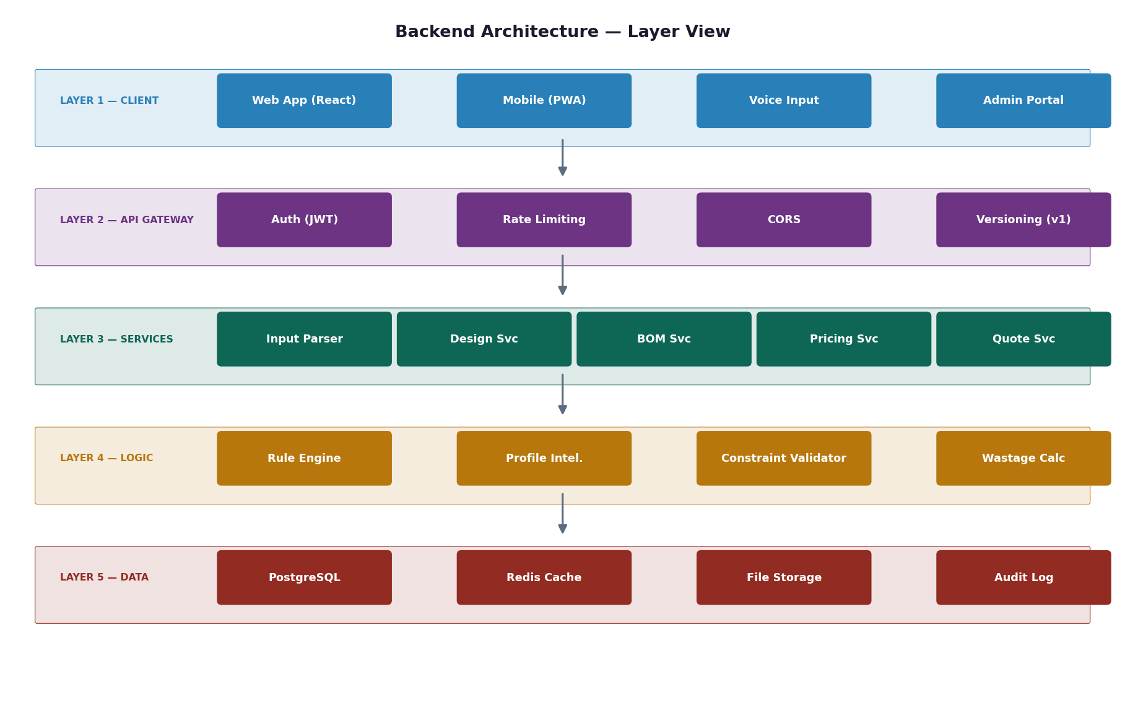

4.2 API Layer Design
The API is RESTful, versioned at /api/v1/, and secured with JWT authentication. All endpoints are documented via auto-generated OpenAPI (Swagger) docs. The key endpoint groups:
Endpoint Group | Endpoints | Purpose
Design | /api/v1/designs (POST, GET, PATCH, DELETE) | Create, retrieve, update designs
BOM | /api/v1/designs/{id}/bom | Get full bill of materials for a design
Pricing | /api/v1/designs/{id}/pricing | Get cost breakdown for a design
Quotation | /api/v1/designs/{id}/pdf | Generate PDF quotation
Projects | /api/v1/projects (CRUD) | Manage multi-design projects
Rules | /api/v1/admin/rules (CRUD) | Admin: manage formula rules
Profiles | /api/v1/admin/profiles (CRUD) | Admin: manage profile master data
Voice | /api/v1/voice/parse | Convert speech to structured design intent

4.3 Service Layer Breakdown
Each service has a single responsibility and communicates through well-defined interfaces:
DesignService: Orchestrates the full pipeline. Validates input, loads constraint rules, calls RuleEngineService, calls BOMService and PricingService, persists everything to the DB. This is the only service that writes to the designs table.
RuleEngineService: Pure computation, zero database access. Takes a sorted rule set and a context object, evaluates each formula using SafeEval, and returns a named result map. Fully unit-testable with no mocking.
BOMService: Resolves rule engine output to concrete profile codes, quantities, and stick requirements. Resolves the hardware kit from the hardware_kits table.
PricingService: Fetches current cost data from the DB and computes profile cost (weight-based), glass cost, hardware cost, and applies margin and GST.
ParserService: Handles text and voice input. Uses GPT as the primary parser with a regex fallback. Returns a normalised DesignIntent object.
QuotationService: Renders the final quotation, manages PDF generation, and handles revision tracking.

4.4 Technology Stack
Layer | Recommended Technology
Backend API | Python (FastAPI) — best AI/NLP ecosystem, auto-generates OpenAPI docs
Rule Engine | Python with simpleeval library — safe formula evaluation, no code injection risk
Database | PostgreSQL — relational data, JSON fields for flexible rule conditions
Cache | Redis — cache compiled rule sets (1 hr TTL) and recent calculation results
Job Queue | BullMQ (Redis-backed) — async PDF generation, cutting optimisation
Frontend | React.js with TypeScript — component-based, fast to build guided UI
Voice Pipeline | OpenAI Whisper (STT) + GPT-4o (intent parsing) + Amazon Polly (TTS)
PDF Generation | WeasyPrint (Python) or Puppeteer (Node) — HTML-to-PDF quotation
File Storage | AWS S3 or Cloudflare R2 — PDF exports, backup
Authentication | JWT + refresh tokens, bcrypt password hashing
Deployment | Docker + docker-compose for dev; AWS ECS or Railway for production

5. Advanced Rule Engine Design

5.1 Rule Engine Execution Flow
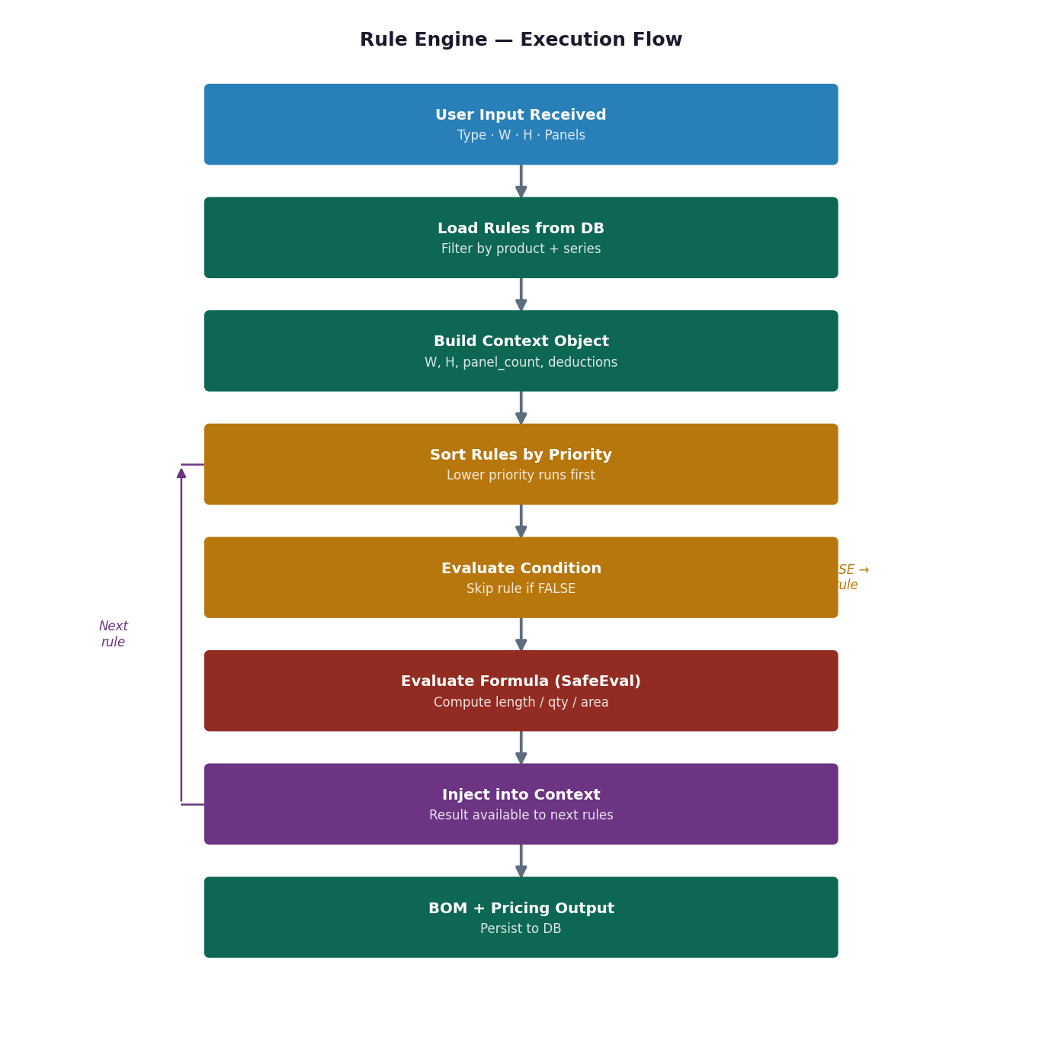

5.2 Rule Schema — Database Design
Every formula is stored as a structured record in the design_rules table. This is what makes the system configurable without code changes:
Column | Type | Purpose
id | Integer (PK) | Unique identifier
product_type_id | Integer (FK) | Which product this rule applies to
profile_series_id | Integer (FK, nullable) | Specific series override; NULL = all series
component_role | Text | Name of output: frame_top, sash_stile, glass_width, etc.
output_type | Text | length_mm, area_mm2, quantity, boolean
formula | Text | Safe math expression: 2*W + 2*H - (2*frame_deduction)
condition_expr | Text (nullable) | Evaluated first; skip rule if FALSE or NULL
priority | Integer | Lower = runs first; higher rules can reference lower results
is_active | Boolean | Enable/disable without deleting
notes | Text | Documents what this rule computes and why

5.3 Formula Variable Namespace
Formulas reference a controlled set of variable names. No raw database column names or code are ever allowed in formulas. The context object is built by the system before evaluation:
- W — outer width in mm (from user input)
- H — outer height in mm (from user input)
- panel_count — number of panels (from user input)
- track_count — track type count (2 or 3)
- frame_deduction — loaded from series_deductions table (per series)
- sash_overlap — shutter overlap amount (per series)
- bead_deduction — glazing bead inner deduction (per series)
- track_height — track component height (per product type + series)
- [Any previously computed result] — rules with higher priority can reference outputs of lower-priority rules by their component_role name

5.4 Types of Rules
Formula Rules: The most common type. A straightforward mathematical expression that computes a length, area, or quantity. Example: glass_width = sash_width - (2 * bead_deduction)
Conditional Rules: Rules with a condition_expr field. They only execute if the condition evaluates to true. Example: a mullion rule that only runs when panel_count is greater than 2.
Constraint Rules: Stored in a separate constraint_rules table. These validate that inputs are within acceptable ranges. They run before any formula rules and return structured error messages if violated.
Override Rules: Rules with a non-null profile_series_id override the general rule for a specific series. This allows Alumil-specific deductions to differ from Domal deductions without duplicating all rules.

5.5 Security — Why eval() Is Never Used
A critical implementation requirement: formula evaluation must never use the programming language's native eval() function or equivalent (Function() in JavaScript, exec() in Python). These execute arbitrary code. If an attacker or malicious admin stores os.system('rm -rf /') as a formula, eval() will execute it with server privileges.
The simpleeval library in Python restricts evaluation to pure math expressions and named variables. It raises an error on any import, function call, or assignment. This is the only safe approach for user-configurable formulas in a production system.

6. Profile Intelligence System

6.1 Purpose of Profile Intelligence
The Profile Intelligence System is a recommendation layer that sits between the user's product selection and the rule engine. Instead of requiring the fabricator to know which profile series to use for a given window size and requirement, the system recommends the best profile based on a scoring model that considers span, load, cost, and client requirement.
This is a significant differentiator over EVA WinOptimize, which requires the user to already know which profile they want. Our system can serve as a consultant, guiding less experienced estimators toward the right choice.

6.2 Recommendation Scoring Model
Each profile series is scored across four dimensions, with weights that can be adjusted per project context:
Scoring Dimension | Weight | How Computed
Span Suitability (Structural) | 35% | Is the window width within the series' safe span? Score drops steeply near limit.
Cost Efficiency | 30% | Profile cost per square foot of window area vs. alternatives.
Hardware Compatibility | 20% | Does this series have compatible hardware for the requested panel count and type?
Client Preference / Brand | 15% | Has the fabricator or client specified a brand preference? Boost that series.
The system returns the top 3 recommended series with a score, a brief explanation of the recommendation, and a cost comparison. The fabricator can accept the recommendation or override it.

6.3 Data Requirements for Profile Intelligence
- Each profile series must have a max_span_mm field defining the maximum safe single panel width
- Each series must have a structural_class field (light, medium, heavy) for span-based filtering
- Series must be linked to hardware compatibility records (which roller, lock, handle kits work with this series)
- Cost data must be current — the recommendation engine uses live cost_per_kg data, not cached values
In Phase 1, profile intelligence can be a simple rule-based filter and ranking — no machine learning required. ML-based personalisation (learning a fabricator's preferred series over time) is a Phase 3 feature.

7. Pricing Engine — Advanced Design

7.1 Core Pricing Formula
The correct formula for aluminum profile cost is based on weight, not length. This is how every supplier invoices and how every fabricator actually calculates:
Profile Cost = (Total Length in mm ÷ 1000) × Weight per Metre (kg/m) × Cost per kg (INR/kg) Glass Cost = Glass Area (sq ft) × Price per sq ft (INR/sqft) Hardware Cost = Sum of (Unit price × Quantity) for each hardware item Fabrication Charge = Fixed amount per unit, or per sq ft of window area Subtotal = Profile Cost + Glass Cost + Hardware Cost + Fabrication Charge Margin = Subtotal × Margin percentage GST = (Subtotal + Margin) × 18% Total = Subtotal + Margin + GST

7.2 Multi-Mode Pricing
The pricing engine supports multiple pricing modes that can be selected per quotation:
Pricing Mode | Description
Dealer Cost | Raw material cost only, no margin. Used internally to know the fabricator's floor cost.
Retail / Client Price | Dealer cost + fabrication + margin + GST. The price shown on a client quotation.
Project Price | Bulk discount applied for large projects (typically 5–12% below retail). Triggered by project area threshold.
Competitor Comparison | System computes approximate competitor price using market benchmarks, so the fabricator knows their price position.
Target Margin Mode | Fabricator enters their target selling price; system back-computes the implied margin percentage.

7.3 Margin Simulation Dashboard
The margin simulation feature allows a fabricator or sales person to adjust the margin slider and see in real time how the total price and per-square-foot rate change. This is critical for on-site price negotiation — the fabricator can immediately see what discount they can offer while staying above their minimum margin threshold.
- Minimum margin alert: when the margin slider drops below a configured threshold (e.g. 12%), the system shows a red warning
- Price per sq ft display: always shown alongside total price, as many clients compare on this metric
- Material cost lock: shows the material cost as a fixed floor, making it clear to the fabricator that the margin is the only adjustable component

7.4 Cost Optimisation Suggestions
After pricing is computed, the system analyses the BOM and suggests cost optimisation opportunities:
- Glass substitution: if the glass cost is more than 35% of total, suggest a cost-equivalent alternative glass type
- Profile series downgrade: if structural requirements are well within the current series' capacity, suggest a lighter (cheaper) series
- Cutting wastage alert: if wastage exceeds 15%, flag that the cutting plan could be optimised
- Hardware kit alternative: if a premium hardware kit is mapped but a standard kit is structurally adequate, suggest the alternative with the cost saving

8. MVP vs Scale Plan

8.1 Development Roadmap Overview
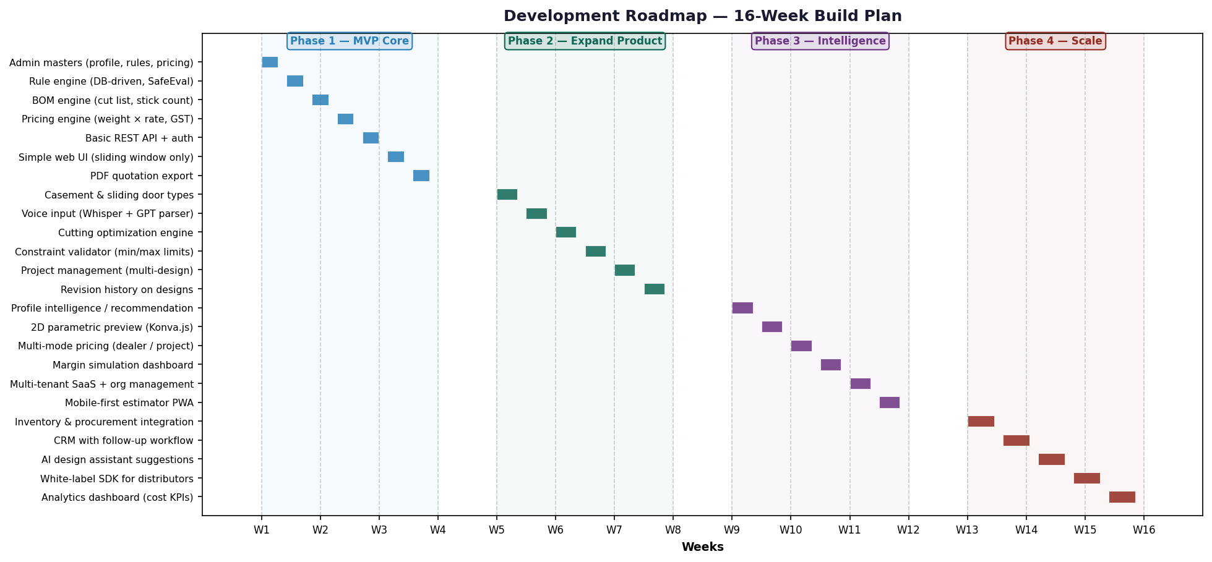

8.2 Phase 1 — MVP (Weeks 1–4): Build This First
The MVP is intentionally narrow. It does exactly one thing well: take a 2-panel sliding window with basic dimensions and produce a correct BOM and priced quotation. Everything else is deferred.
MVP Component | What to Build | What to Skip
Product Types | Sliding window only | Casement, door — Phase 2
Profile Series | 1 series (most used locally) | Multiple brands — Phase 2
Input | Text input only | Voice — Phase 2
Rule Engine | DB-driven, SafeEval, priority ordering | Conditional overrides — Phase 2
BOM | Cut list, stick count, 8% wastage | Cutting optimisation — Phase 2
Pricing | Weight × rate formula, margin, GST | Multi-mode pricing — Phase 2
Output | Line-itemised PDF quotation | 2D preview — Phase 3
Users | Single-user per account | Multi-user orgs — Phase 2
Admin | Profile master, rules, pricing | Advanced rule UI — Phase 2
Do not skip the Admin Panel in Phase 1. You cannot test the rule engine without correct master data, and you need a UI to manage profiles, formulas, and pricing. Build the Admin Panel before the client-facing UI.

8.3 Phase 2 — Expand (Weeks 5–8)
- Add casement window and sliding door product types with their own rule sets
- Add voice input pipeline (Whisper STT + GPT parsing)
- Add constraint validation with structured error messages
- Add cutting optimisation (bin-packing algorithm for stick allocation)
- Add multi-design project management with rolled-up quotation
- Add user authentication with role-based access (admin, estimator, viewer)
- Add design revision history (track changes to dimensions over time)

8.4 Phase 3 — Intelligence (Weeks 9–12)
- Profile intelligence recommendation system (span-based scoring model)
- 2D parametric visual preview using Konva.js (labelled diagram, not CAD)
- Multi-mode pricing engine (dealer, retail, project, target-margin modes)
- Margin simulation dashboard with real-time total price update
- Multi-tenant SaaS with organisation management, user invites, billing
- Mobile-first Progressive Web App (PWA) for field estimators

8.5 Phase 4 — Scale (Weeks 13–16+)
- Inventory integration — alert when profile stock is below order threshold
- CRM module — client follow-ups, quotation status tracking, order conversion
- AI design assistant — suggests adding a mullion for oversized spans, recommends glazing options based on thermal requirements
- Analytics dashboard — average margin by product type, most quoted profiles, cost trend charts
- White-label SDK — allow profile brand distributors to deploy a branded version

9. Real-World Practical Improvements & Risk Mitigation

9.1 Fabrication Workflow Improvements
Site Measurement Mode: Add a simplified input mode where the estimator enters the rough opening size and the system automatically deducts sub-frame clearance to compute the window size. Many Indian fabricators measure the rough opening, not the window.
Batch Design Entry: Allow a fabricator to enter dimensions for 10 windows in a table view (like a spreadsheet) and generate all BOMs and pricing in a single operation. This mirrors how they currently work on paper.
Quick Re-Quote: Allow an existing design to be re-quoted at updated material prices without re-entering dimensions. When aluminum prices change monthly, this saves enormous time.
Fabrication Notes: Allow per-design notes that print on the PDF — special instructions like 'use rubber seal instead of brush for this unit' that do not affect the BOM calculation.

9.2 Risk: Incorrect Deduction Values
The single biggest risk to the system's credibility is publishing incorrect cut lengths. If the deduction values for a profile series are wrong by even 2mm, every profile cut using that series will be wrong. Fabricators will discover this on the first job and lose confidence immediately. This risk must be managed with extreme care.
Mitigation strategy: Before loading deduction values into the database, verify them by running the system against 3–5 historical jobs for which the fabricator already knows the correct cut list. Compare the system output to the actual cut list that was used. Fix all discrepancies before the system goes live with any fabricator.

9.3 Risk: Aluminum Price Volatility
Aluminum prices in India follow LME (London Metal Exchange) prices and fluctuate monthly. A quotation generated at one price may become unprofitable within weeks if the fabricator has not ordered material yet.
- Display the price date prominently on every quotation — fabricators must know when the prices were captured
- Add a price validity period (typically 7–15 days) that appears on the PDF quotation
- Send an alert to admin users when a quotation that has not been approved is older than the validity period
- Provide a one-click re-price function that recalculates at current prices without changing the design

9.4 Risk: Formula Errors by Admin Users
The rule engine allows admin users to write formulas directly in the database via the Admin Panel. An admin who makes a formula error (wrong variable name, incorrect deduction reference) will produce wrong BOMs for every design of that product type until the error is caught.
- Build a formula test harness in the Admin Panel: enter test dimensions and immediately see the formula output before saving
- Add formula syntax validation — catch undefined variable references before saving, not at runtime
- Add a formula change log with author and timestamp — show which formula was active when a design was computed
- Test suites: maintain a library of known-correct test cases (10–20 per product type) that run automatically when any rule is changed

9.5 Common Mistakes to Avoid
Mistake | Why It Fails / Correct Approach
Building the UI before the Rule Engine | The UI has no data to show. Build Admin Panel + Rule Engine first, validate outputs, then build client UI.
Using eval() for formula evaluation | Critical security vulnerability. Use simpleeval (Python) or mathjs (Node) with locked namespace.
Mixing units internally | Store everything in mm. Convert to metres only for weight calculation, to sq ft only for glass pricing.
Hardcoding deductions in the code | Deductions change per series. Store in series_deductions table. Code that hardcodes them becomes unmaintainable.
Skipping constraint validation | System will produce BOMs for physically impossible windows. Fabricators will lose trust after one failed job.
One database per fabricator | Monolithic schema with org_id multi-tenancy scales better and reduces operational overhead.
Adding CAD features in Phase 1 | Enormous scope increase, zero fabrication value. A 2D preview in Phase 3 is sufficient for years.
Not versioning designs | Fabricators revise dimensions. Without revision history, there is no audit trail for disputes.

10. How to Design This Software — Complete Implementation Plan

10.1 Pre-Development (Week 0) — Foundation Work
Before writing a single line of code, complete these steps. They are the most important part of the entire project:
- Fabricator visits: Spend 2 full days with 2–3 fabricators observing their current workflow. Document every step from receiving an order to handing a cut list to the shop floor. Identify where they spend the most time and where errors occur most often.
- Deduction data collection: For your target profile series (start with the brand your fabricator uses most), measure or extract the frame deduction, sash overlap, bead deduction, and track height values. Verify them against 5 historical jobs.
- Rule writing: Write the complete formula set for a 2-panel sliding window in the target series on paper (or a spreadsheet). Verify the output against a real job before writing any code.
- Competitive analysis: Create a free trial account with EVA WinOptimize or a competitor tool. Use it for one real design. Document every step that is unnecessarily complex or slow — these are your UI improvements.

10.2 Database First — Then Logic
The database schema is the foundation of everything. Get it right before writing service code:
- Create the full schema as described in this document (organisations, users, projects, designs, profiles, series_deductions, design_rules, hardware_kits, bom_items, design_pricing)
- Write seed data scripts that populate the database with the profile series, deduction values, and formula rules for the first product type
- Write database migration scripts from the start — never modify the schema directly in production
- Add database-level constraints (NOT NULL, CHECK constraints for positive dimensions) as a safety net below the application layer

10.3 Rule Engine — Test Driven
Build the rule engine as a pure computational module with no web framework dependencies. This makes it independently testable:
- Write 20 test cases against known correct outputs before writing any UI
- Each test case: a set of inputs (product type, series, dimensions, panel count) and an expected BOM output
- All 20 tests must pass before moving to the API layer
- Add the constraint validator as the first step in the pipeline — no formula runs if a constraint is violated

10.4 Admin Panel — Before Client UI
Build a functional Admin Panel first. It is the tool you use to configure and validate the system before exposing it to end users:
- Profile Series Master: create, edit, deactivate profile series with all deduction values
- Profile Code Master: map component roles to manufacturer codes with weight and cost per kg
- Formula Rule Editor: create, edit, and test formula rules with a live preview against test dimensions
- Hardware Kit Manager: define hardware kits per product type and panel count
- Pricing Master: update cost_per_kg for profiles and price_per_sqft for glass types

10.5 Client UI — Guided Wizard Flow
The client-facing UI should be a guided wizard, not an open form. Each step confirms before proceeding to the next:
Step | What Happens
Step 1 — Product Type | Dropdown with icons for each product type. Profile Intelligence suggests a series or user selects manually.
Step 2 — Dimensions | Width and Height inputs with live constraint feedback (red warning if out of range). Panel count and track type selectors.
Step 3 — Generate | Single button. System runs the full pipeline and shows the results in under 2 seconds.
Step 4 — Review BOM | Tabbed output: BOM cut list, Glass schedule, Hardware list. Each tab shows component-level detail.
Step 5 — Price & Quote | Pricing breakdown with margin slider. Client details entry. Generate PDF button.

10.6 Testing Strategy
- Unit tests: test every formula rule against known outputs (at least 20 cases per product type)
- Integration tests: test the full API pipeline from input to BOM to pricing for each product type
- Fabricator validation: before going live, run the system against 10 real historical jobs and compare output to actual cut lists used — target < 2mm variance on all cut lengths
- Load testing: simulate 50 simultaneous design calculations to ensure the rule engine handles concurrent requests without performance degradation
- Security testing: test the formula evaluator with malicious inputs (code injection attempts) to verify SafeEval blocks them correctly

10.7 Go-to-Market — Onboarding a Fabricator
The onboarding process for a new fabricator should take less than 1 working day:
- Hour 1–2: Admin setup — create organisation, load their profile series and current prices (from their supplier invoice)
- Hour 2–3: Rule validation — run 3 historical jobs through the system and compare outputs
- Hour 3–4: Training — walk the fabricator through the client UI flow for each product type they use
- Day 2: First live job — fabricator uses the system for a real quotation with support available
- Week 1: Collect feedback — record every case where the fabricator corrects or overrides the system output, and update rules accordingly

11. Summary & Key Principles
This document defines a complete, production-ready system design for a fenestration design and pricing tool. The system is built on a small number of core principles that must be maintained throughout development:
- The rule engine is the product. The UI is packaging. If the formulas are wrong, the product fails regardless of how good the interface looks.
- Never evaluate formulas with eval(). Use a sandboxed expression evaluator (simpleeval) with a controlled variable namespace.
- Store everything in millimetres internally. Convert to other units only at the boundary (weight calculation, glass pricing, display).
- Validate fabricator knowledge before releasing to market. Run the system against real historical jobs and achieve less than 2mm variance on all cut lengths before any fabricator depends on it.
- Build in phases, validate at each phase. Do not build Phase 2 features until Phase 1 has been used in production by at least 3 fabricators.
- The competitive advantage vs EVA WinOptimize is speed, simplicity, and Indian market fit — not feature depth. Resist scope expansion in the early phases.

Fenestration Design & Pricing Tool — System Blueprint v1.0
This document covers architecture, rule engine, competitive strategy, and 16-week development plan.

