Micro Service in a nutshell

**Micro-Service basics- AT&T recordings**

<https://wiki.web.att.com/pages/viewpage.action?pageId=555251459>

CSI service POC for AJSC 6 & related- 

**CICD (Continuous Integration Continuous Delivery) principles and basics**

Content coming soon….

**Docker Basics-**

[**https://www.docker.com/what-docker**](https://www.docker.com/what-docker)

[**https://docs.docker.com/get-started/**](https://docs.docker.com/get-started/)

Presentation by Mrunal Rege- 

Docker is a platform to containeralise your application and avoid “works only on my machine” problems.

Docker can host multiple containers (each as one process) where each container is nothing but a light weight image running in memory. Image consists of software and all the libraries, environment variables, configurations required to run the software.

Docker run on Linux machine so for windows we need a virtual machine to host a docker and containers.

**Docker Installation-**

<https://docs.docker.com/toolbox/toolbox_install_windows/>

Docker Toolbox for windows is a suite of tools/software needed to install and manage a docker.

1. Download Docker Toolbox for windows installable and run the .exe to install docker

It will install Docker machine, Docker engine, Oracle VM, Git for windows and Docker UI.

Note:-

1. Please choose to install Virtual machine driver during the installation
2. You may need to enable the virtualization (VTx) through BIOS otherwise the oracle virtual machine may not work.
3. To test the installation, open the “docker quickstart terminal “ (Short cut on desktop). It should start VM and configure docker on your local machine.

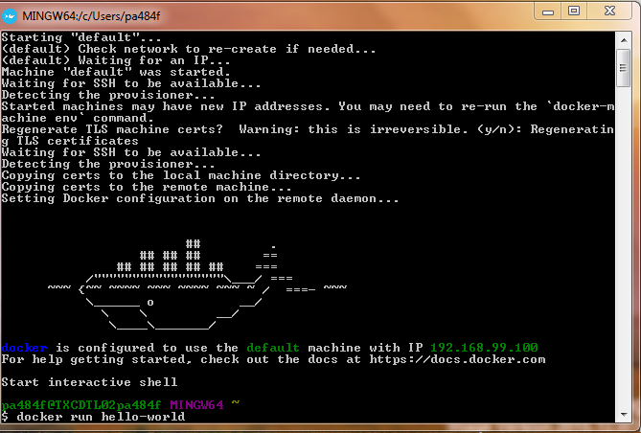

1. To test the installation, run docker command in docker interactive shell

$ docker run hello-world

Other handy docker interactive shell commands

1. Docker –version 🡪 to know the installed docker version
2. Docker search <image name> -- > to search the image in docker hub (host for private/public docker repositores)
3. Docker pull <image name> 🡪 to pull the Image from docker hub to local
4. Docker ps 🡪 to check running containers ( Images)
5. Docker push 🡪 to push an image to docker hub ( Private/public repository)

**Kubernetes Basics**

Content coming soon…

**Eco**

<https://wiki.web.att.com/display/SDT/AS-ECO>

<https://tspace.web.att.com/communities/service/html/communitystart?communityUuid=3554733d-7fab-4a9f-a990-27d1231e94e9>