Digital Literacy Project Report

Name: Shreyoshree Ghosh
Registration Number: 25BOE10078
Course: CSE0001 – Digital Literacy
University: VIT Bhopal University
Instructor: KANNAN
Date: 31/03/2026

INTRODUCTION
Digital literacy is the ability to use digital tools, technologies, and the internet effectively, safely, and responsibly. In today’s digital age, it is an essential skill for students as most academic work, communication, and professional activities are conducted online. This project focuses on building a strong foundation in digital literacy by exploring various platforms and tools. Through this project, I learned how to create a professional online presence using GitHub, LinkedIn, and Kaggle. I also gained knowledge about coding platforms, email etiquette, and cybercrime awareness. The tasks in this project helped me improve my technical and communication skills, making me more confident in using digital technologies for both academic and future professional purposes.

Task 1 – Infographic on Digital Literacy

In Task 1, I created an infographic on the topic “Digital Literacy for Students”. The infographic included information about online safety, digital communication, cyber security, and digital tools used by students. I used an online tool to design the infographic and included icons and short points to make it easy to understand. This task helped me learn how to present information visually and creatively.

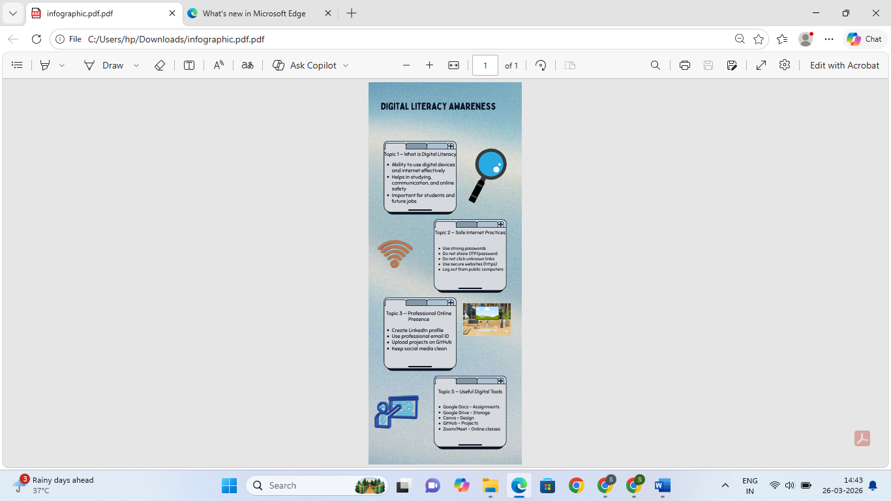

Task 2 – Digital Portfolio
In Task 2, I created my digital portfolio using platforms like GitHub, LinkedIn, and Kaggle. I created a GitHub repository to upload and organize all my project files and folders. I created a LinkedIn profile to build my professional profile where I added my education, skills, and profile photo. I also created a Kaggle account to explore data science and programming activities. This task helped me understand the importance of maintaining a professional online presence. I learned how these platforms are useful for showcasing skills, projects, and achievements. This task also helped me improve my digital skills and understand how to use online platforms for learning and career development.
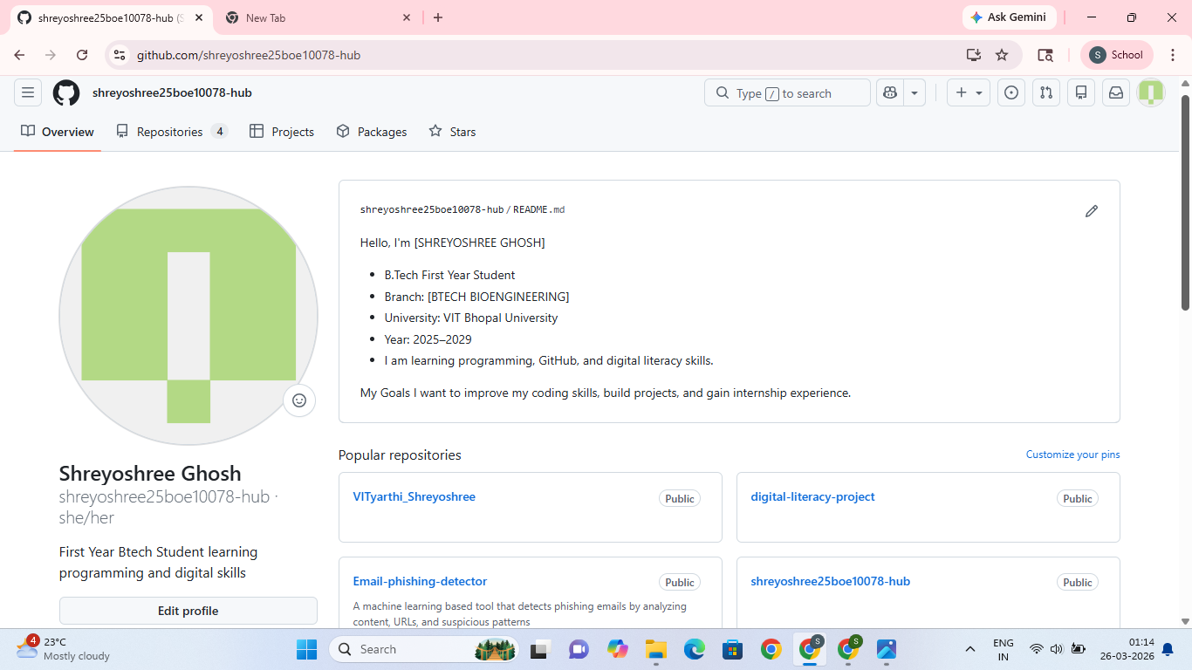
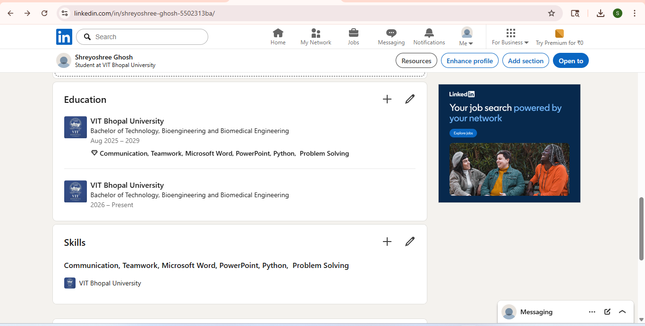
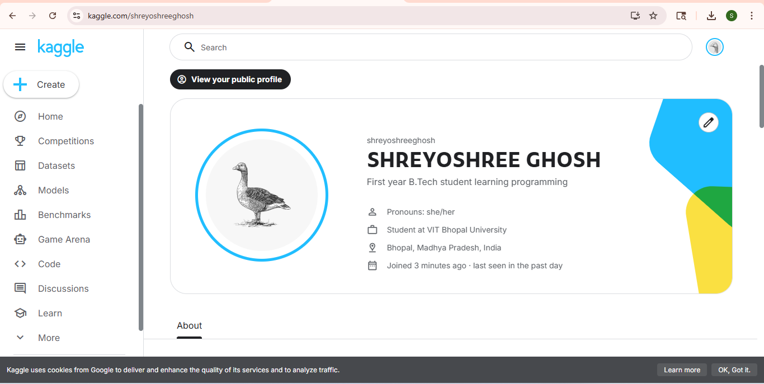

Task 3 – Online Platforms (HackerRank and Google Forms)
In Task 3, I worked on online platforms like HackerRank and Google Forms. I created a HackerRank account and solved a basic programming problem to improve my coding skills. This helped me understand how coding platforms work and how problems are tested using test cases. I also created a Google Form on the topic “Digital Literacy Awareness” and added multiple-choice questions. I linked the form responses to Google Sheets to automatically collect and organize the responses. This task helped me learn how to conduct online quizzes and collect data. It also improved my technical skills and understanding of online tools used for education, surveys, and assessments.

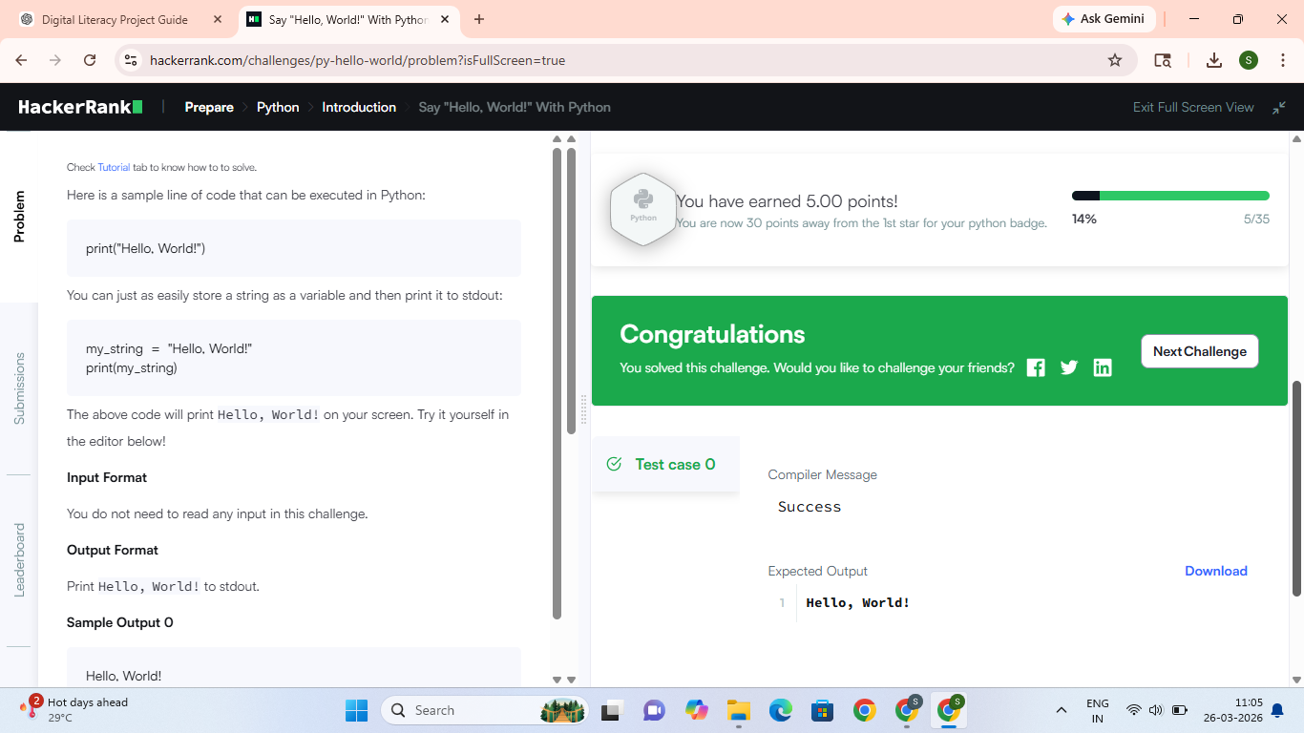
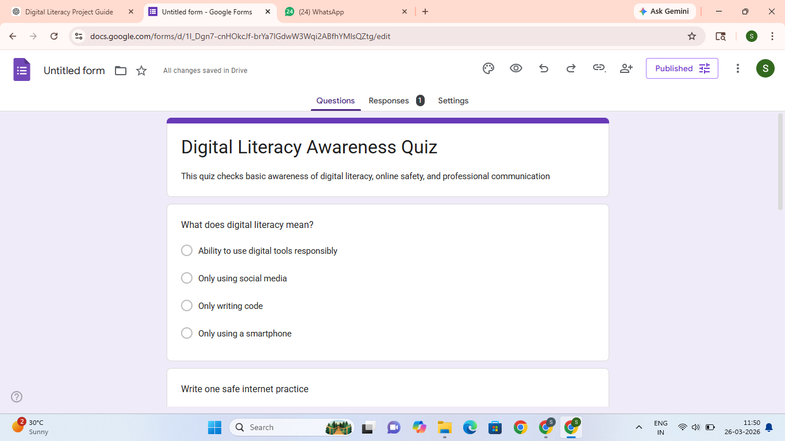
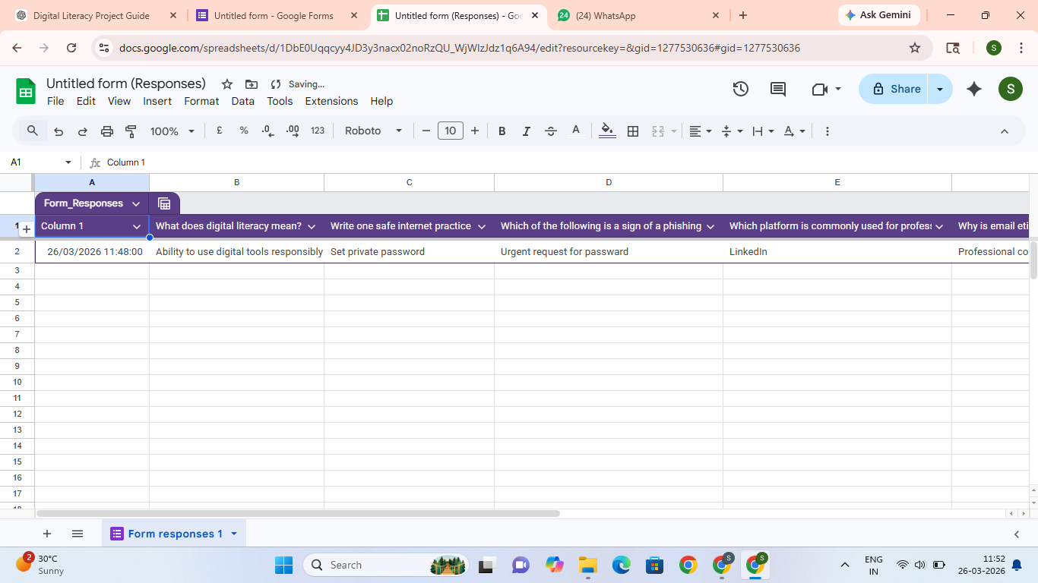

Task 4 – Email and Social Media Etiquette
In Task 4, I learned about professional email writing and social media etiquette. I wrote two professional emails, one for requesting an assignment extension and another for inquiring about an internship opportunity. This task helped me understand the correct format of a professional email, including subject line, greeting, body, and signature. I also created a social media do’s and don’ts checklist to understand how students should behave responsibly online. I learned that we should use polite language, avoid sharing personal information, and think before posting anything on social media. This task helped me improve my communication skills and understand the importance of maintaining a positive and professional digital image online.

Task 5 – Cybercrime Awareness
In Task 5, I learned about cybercrime and how to stay safe online. I studied a case study about phishing, which is a common cybercrime where attackers trick people into sharing personal information such as passwords, bank details, or OTPs. I also created a prevention checklist to spread awareness about online safety. Through this task, I learned that cybercrime is increasing and students must be very careful while using the internet. We should not click on unknown links, share personal information, or trust unknown emails and messages. This task helped me understand the importance of cyber security and how small precautions can help us stay safe from online fraud and cyber attacks.

Conclusion

This digital literacy project helped me learn many important digital skills. I learned how to create a GitHub repository, build a LinkedIn profile, solve problems on HackerRank, create Google Forms, write professional emails, and understand cybercrime prevention. These skills are very useful for my academic and professional career. This project improved my confidence in using digital tools and platforms.

References

1. www.github.com
2. www.linkedin.com
3. www.kaggle.com
4. www.hackerrank.com
5. forms.google.com
6. www.cybercrime.gov.in

