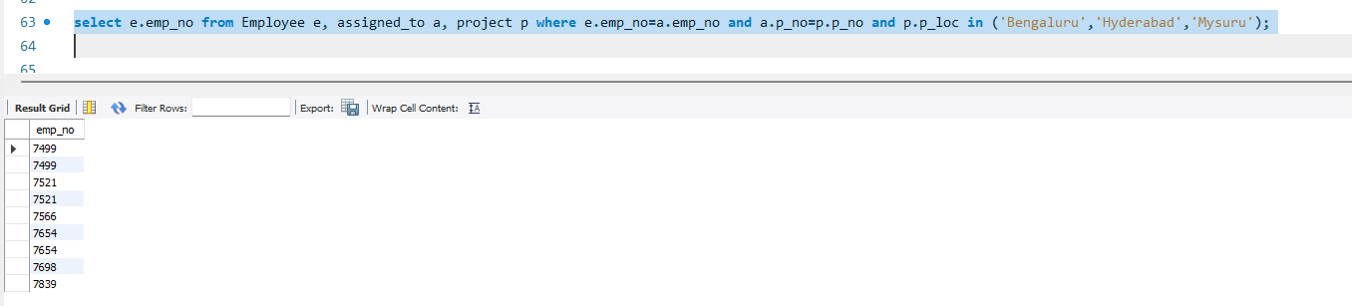

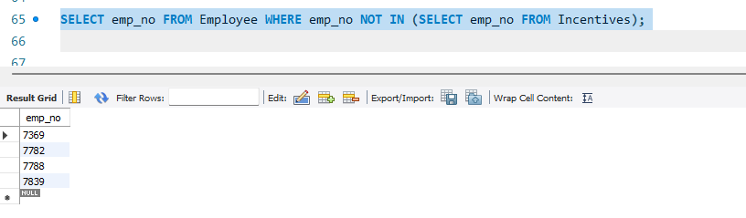

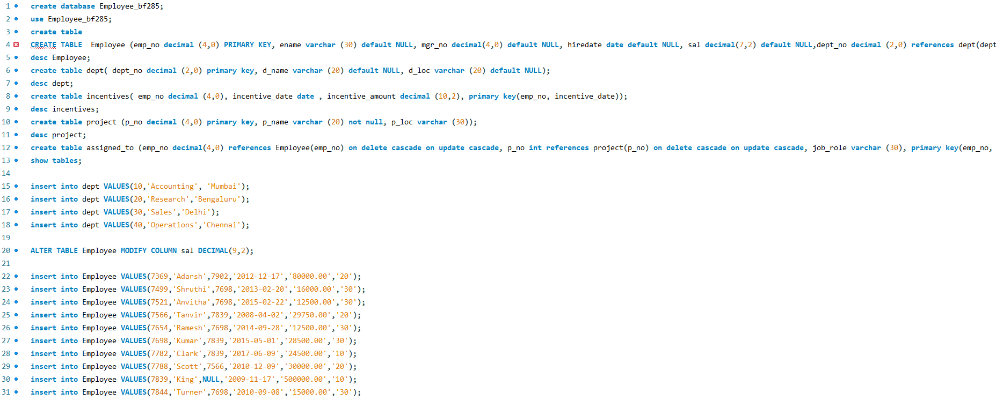
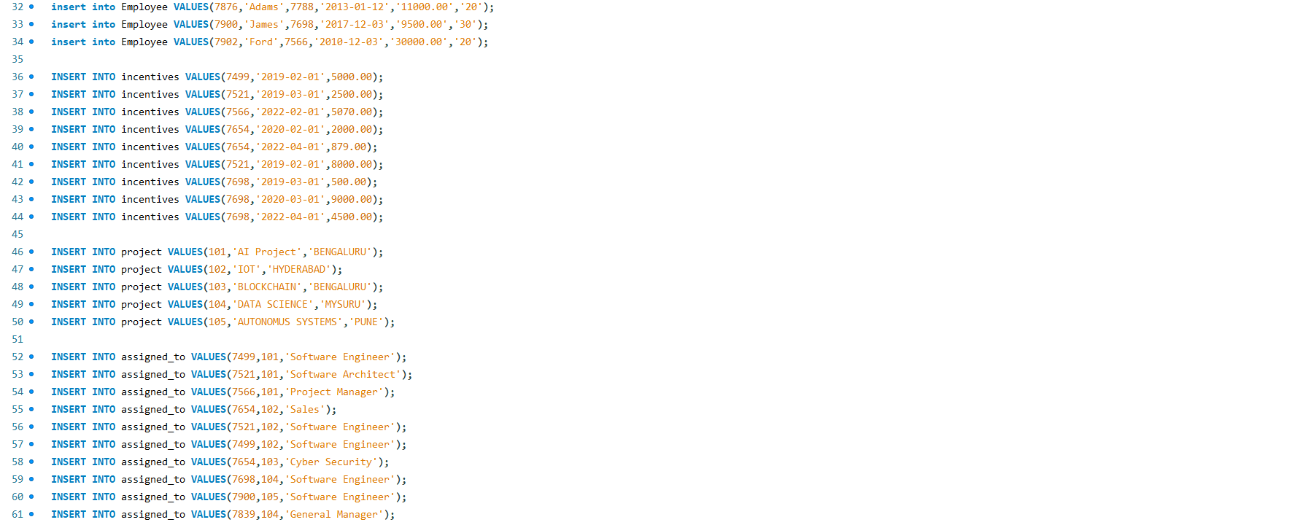

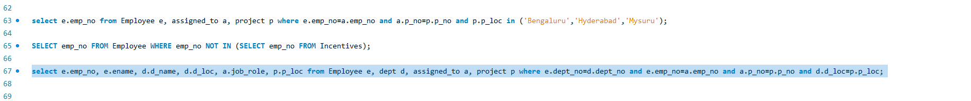
WEEK - 6

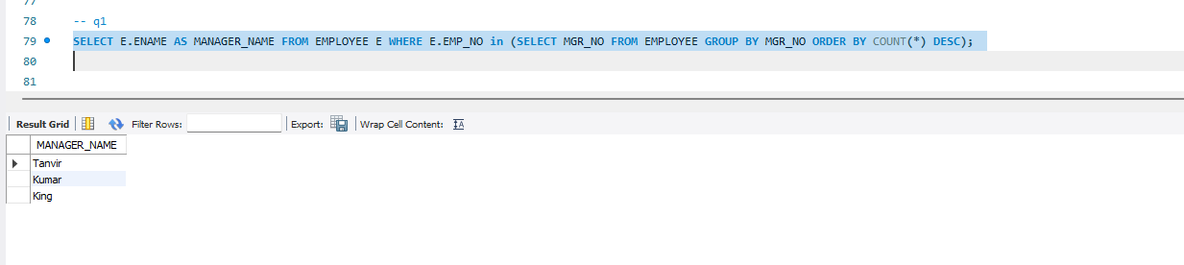

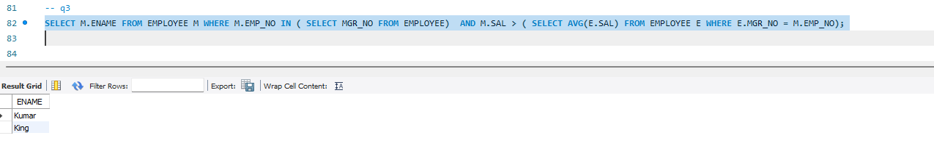

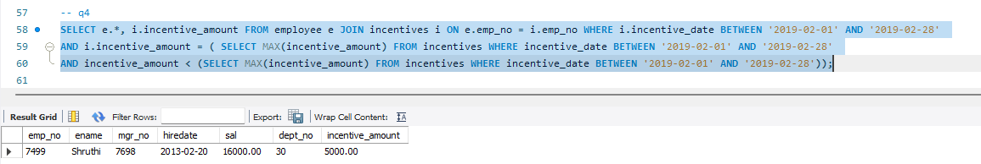

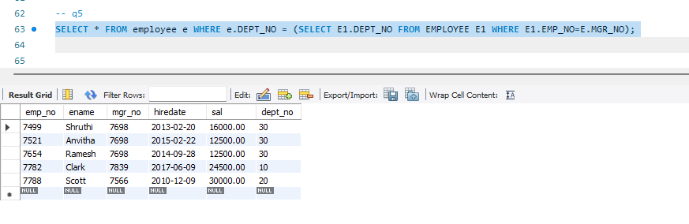

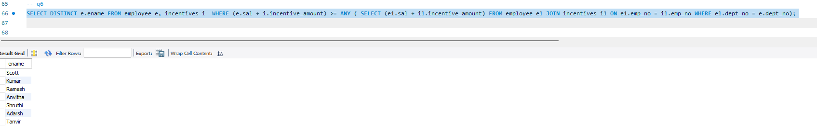

SELECT E.ENAME AS MANAGER_NAME
FROM EMPLOYEE E
WHERE E.EMPNO = (
SELECT MGR_NO
FROM EMPLOYEE
GROUP BY MGR_NO
ORDER BY COUNT(*) DESC
FETCH FIRST 1 ROW ONLY
);

SELECT M.ENAME
FROM EMPLOYEE M
WHERE M.EMPNO IN (
SELECT MGR_NO FROM EMPLOYEE
)
AND M.SAL > (
SELECT AVG(E.SAL)
FROM EMPLOYEE E
WHERE E.MGR_NO = M.EMPNO);

SELECT D.DNAME, E.ENAME AS TOP_MANAGER
FROM DEPT D, EMPLOYEE E
WHERE D.DEPTNO = E.DEPTNO
AND E.MGR_NO IS NULL;

SELECT E.*
FROM EMPLOYEE E
WHERE E.EMPNO = (
SELECT EMPNO
FROM INCENTIVES
WHERE EXTRACT(MONTH FROM INCENTIVE_DATE) = 2
AND EXTRACT(YEAR FROM INCENTIVE_DATE) = 2019
ORDER BY INCENTIVE_AMOUNT DESC
OFFSET 1 ROW FETCH NEXT 1 ROW ONLY
);

SELECT E.ENAME
FROM EMPLOYEE E, EMPLOYEE M
WHERE E.MGR_NO = M.EMPNO
AND E.DEPTNO = M.DEPTNO;

SELECT E.*
FROM EMPLOYEE E
WHERE (
E.SAL +
NVL((SELECT SUM(I.INCENTIVE_AMOUNT)
FROM INCENTIVES I
WHERE I.EMPNO = E.EMPNO), 0)
) >= ANY (
SELECT SAL FROM EMPLOYEE
);

