Subject Code | : | CEUE203 | Semester | : | 3 | Academic Year | : | 2026-27
Subject Name | : | Object-Oriented Programming

PRACTICAL 1 — PART B: MINIBANK PROJECT WORK
PROJECT WORK 1\n(SYLLABUS PART-B) | Part B — Project Work (Hour 2): MiniBank  MiniBank is the console banking application you will build across the whole semester. In  this first lab you set up your tools and create the project and its menu shell — the screen the  user navigates. Every later lab attaches one real banking feature behind these menu options.  1. Set up your environment: open the project in GitHub Codespaces (or install JDK 17+ and  an IDE locally), and create a private GitHub repository named oop-minibank-<rollno>;  add the faculty as a collaborator.  2. Create a public class named MiniBank that contains the main method.  3. Define a record named BankInfo with two String fields, name and branch (a record is a  short, read-only class; Java auto-generates its constructor and field accessors). Print one  BankInfo object as the application header.  4. Define an enum named MenuOption with the constants OPEN_ACCOUNT, DEPOSIT,  WITHDRAW, TRANSFER and EXIT — these are the actions MiniBank will offer.  5. Display the numbered menu to the user and read the chosen number with a Scanner.  6. Use a switch expression on the choice to print a short placeholder for that option (for  example, “Deposit — to be implemented in a later lab”). Keep showing the menu in a  loop until the user selects EXIT, then print a goodbye message.
SOURCE CODE | // [Requirement 1] Set up environment & private repo oop-minibank-25CE090  import java.util.Scanner;  // [Requirement 3] Record BankInfo with name and branch (auto-generates constructor and accessors)  record BankInfo(String name, String branch) {}  // [Requirement 4] Enum MenuOption with constants OPEN_ACCOUNT, DEPOSIT, WITHDRAW, TRANSFER, EXIT  enum MenuOption {  OPEN_ACCOUNT,  DEPOSIT,  WITHDRAW,  TRANSFER,  EXIT  }  // [Requirement 2] Public class MiniBank with main method  public class MiniBank {  public static void main(String[] args) {  // [Requirement 3] Print BankInfo object as application header  BankInfo bankInfo = new BankInfo("MiniBank CHARUSAT", "Changa Central");  System.out.println("=== Bank Header ===");  System.out.println(bankInfo);  Scanner scanner = new Scanner(System.in);  MenuOption choice = null;  // [Requirement 6] Loop showing menu until EXIT  while (choice != MenuOption.EXIT) {  // [Requirement 5] Display numbered menu to user  System.out.println("\n--- MiniBank Menu ---");  MenuOption[] options = MenuOption.values();  for (int i = 0; i < options.length; i++) {  System.out.println((i + 1) + ". " + options[i]);  }  // [Requirement 5] Read chosen number with Scanner  System.out.print("Enter choice: ");  int optionNum = scanner.nextInt();  if (optionNum < 1 || optionNum > options.length) {  System.out.println("Invalid selection! Please enter 1 to 5.");  continue;  }  choice = options[optionNum - 1];  // [Requirement 6] Switch expression on choice to print placeholder  String message = switch (choice) {  case OPEN_ACCOUNT -> "Open Account -- to be implemented in a later lab";  case DEPOSIT -> "Deposit -- to be implemented in a later lab";  case WITHDRAW -> "Withdraw -- to be implemented in a later lab";  case TRANSFER -> "Transfer -- to be implemented in a later lab";  case EXIT -> "Thank you for choosing MiniBank. Goodbye!";  };  System.out.println("Placeholder: " + message);  }  scanner.close();  }  }
CONSOLE OUTPUT | 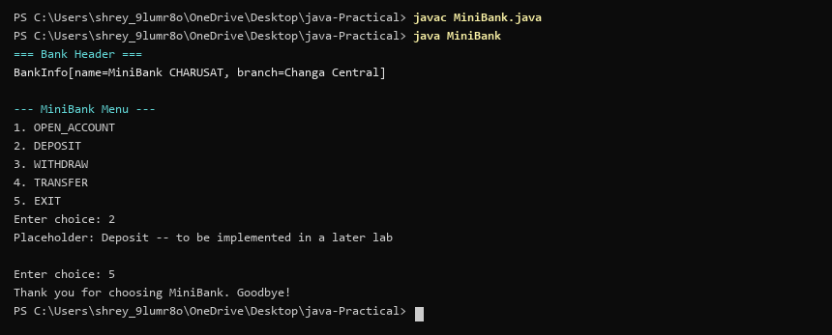

PRACTICAL 2 — PART B: MINIBANK PROJECT WORK
PROJECT WORK 2\n(SYLLABUS PART-B) | Part B — Project Work (Hour 2): MiniBank  In Practical 1 you built the empty menu shell. Now you create the data the bank works on —  the Customer and Account classes. Using encapsulation, an account’s balance can change  only through deposit() and withdraw(), never directly. These two classes are the foundation  every later lab extends.  1. Create a class named Customer with private fields name, email and mobile (all String)  and a private final field customerId (String). Use a private static long field  customerCounter and a private static method generateCustomerId() to create ids such as  “CUST101”. Add a constructor and public getter methods.  2. Create a class named Account with private fields: a final String accountNumber, a String  ownerName, a long balance (whole rupees) and a boolean active. Generate  accountNumber with a private static counter (for example “AC0001”).  3. Add two constructors to Account: one taking ownerName and an opening balance; one  taking only ownerName that calls the first using this(ownerName, 0).  4. Add a public method deposit(long amount) that adds amount to balance. Add a public  method withdraw(long amount) that subtracts amount and returns true when the balance  is sufficient, otherwise returns false without changing the balance. Add getter methods.  Do NOT add a public setter for balance.  5. In main, create three Account objects inside an Account[] array, perform a few deposits  and withdrawals, and print each balance.
SOURCE CODE | // [Requirement 1] Customer class with encapsulated fields and static ID generator  class Customer {  private static long customerCounter = 101;  private final String customerId;  private String name;  private String email;  private String mobile;  public Customer(String name, String email, String mobile) {  this.customerId = generateCustomerId();  this.name = name;  this.email = email;  this.mobile = mobile;  }  private static String generateCustomerId() {  return "CUST" + (customerCounter++);  }  public String getCustomerId() { return customerId; }  public String getName() { return name; }  public String getEmail() { return email; }  public String getMobile() { return mobile; }  }  // [Requirement 2] Account class with private fields and static account counter  class Account {  private static long accountCounter = 1;  private final String accountNumber;  private String ownerName;  private long balance;  private boolean active;  // [Requirement 3] Constructor taking ownerName and opening balance  public Account(String ownerName, long balance) {  this.accountNumber = String.format("AC%04d", accountCounter++);  this.ownerName = ownerName;  this.balance = balance;  this.active = true;  }  // [Requirement 3] Constructor chaining using this(ownerName, 0)  public Account(String ownerName) {  this(ownerName, 0);  }  // [Requirement 4] deposit adds amount to balance  public void deposit(long amount) {  if (amount > 0) balance += amount;  }  // [Requirement 4] withdraw returns true if funds sufficient, else false  public boolean withdraw(long amount) {  if (amount > 0 && balance >= amount) {  balance -= amount;  return true;  }  return false;  }  // Getters provided, no public setter for balance  public String getAccountNumber() { return accountNumber; }  public String getOwnerName() { return ownerName; }  public long getBalance() { return balance; }  public boolean isActive() { return active; }  }  public class MiniBankPart2 {  public static void main(String[] args) {  // [Requirement 1] Verify Customer registration  Customer c1 = new Customer("Shrey Patel", "shrey@example.com", "9876543210");  System.out.printf("Customer Registered: %s | %s | %s | %s%n",  c1.getCustomerId(), c1.getName(), c1.getEmail(), c1.getMobile());  // [Requirement 5] Create three Account objects in an Account[] array  Account[] accounts = new Account[3];  accounts[0] = new Account("Shrey Patel", 5000);  accounts[1] = new Account("Corporate Account", 20000);  accounts[2] = new Account("Savings Primary");  // [Requirement 5] Perform deposits, withdrawals, and print each balance  accounts[0].deposit(2000);  boolean w1 = accounts[0].withdraw(3000);  boolean w2 = accounts[0].withdraw(10000); // Fails (insufficient)  for (Account acc : accounts) {  System.out.printf("Account: %s | Owner: %-18s | Balance: %d | Active: %b%n",  acc.getAccountNumber(), acc.getOwnerName(), acc.getBalance(), acc.isActive());  }  System.out.println("Withdraw 3000 success: " + w1 + " | Withdraw 10000 success: " + w2);  }  }
CONSOLE OUTPUT | 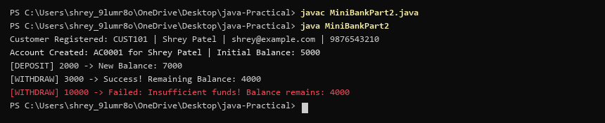

PRACTICAL 3 — PART B: MINIBANK PROJECT WORK
PROJECT WORK 3\n(SYLLABUS PART-B) | Part B — Project Work (Hour 2): MiniBank  In Practical 2 you created the Account and Customer classes. Here you make their objects  behave correctly — they print as readable text (toString) and are compared by account  number (equals/hashCode) — and you add a nested Address class. Correct equals/hashCode  is essential because Practical 12 will store accounts in collections that rely on it.  1. In Account, override the toString() method to return a readable line containing  accountNumber, ownerName and balance.  2. In Account, override equals(Object o) and hashCode() so that two accounts are equal  when their accountNumber values are equal.  3. In Customer, add a public static nested class named Address with String fields line, city  and pincode plus getters; add an Address field to Customer and a getAddress() method.  4. In Customer, add a clone() method (implement Cloneable) that returns a copy of the  customer.  5. In main, print accounts using toString(), compare two Account objects with equals(), and  use instanceof to check an object’s type.
SOURCE CODE | import java.util.Objects;  class Account3 {  private final String accountNumber;  private final String ownerName;  private final long balance;  private final boolean active;  public Account3(String accountNumber, String ownerName, long balance, boolean active) {  this.accountNumber = accountNumber;  this.ownerName = ownerName;  this.balance = balance;  this.active = active;  }  // [Requirement 1] Override toString() to return readable line  @Override  public String toString() {  return String.format("%s | %s | Balance: %d | Active: %b", accountNumber, ownerName, balance, active);  }  // [Requirement 2] Override equals() comparing accountNumber  @Override  public boolean equals(Object o) {  if (this == o) return true;  if (!(o instanceof Account3 a)) return false;  return Objects.equals(accountNumber, a.accountNumber);  }  // [Requirement 2] Override hashCode() matching equals  @Override  public int hashCode() {  return Objects.hash(accountNumber);  }  }  // [Requirement 4] Implement Cloneable and add clone() method  class Customer3 implements Cloneable {  private String name;  private Address address; // [Requirement 3] Address field in Customer  // [Requirement 3] Public static nested class Address  public static class Address {  private final String line;  private final String city;  private final String pincode;  public Address(String line, String city, String pincode) {  this.line = line;  this.city = city;  this.pincode = pincode;  }  public String getLine() { return line; }  public String getCity() { return city; }  public String getPincode() { return pincode; }  @Override  public String toString() { return line + ", " + city + ", " + pincode; }  }  public Customer3(String name, Address address) {  this.name = name;  this.address = address;  }  // [Requirement 4] clone() method returning copy of customer  @Override  public Customer3 clone() {  try {  return (Customer3) super.clone();  } catch (CloneNotSupportedException e) {  return new Customer3(this.name, this.address);  }  }  public String getName() { return name; }  public Address getAddress() { return address; }  }  public class MiniBankPart3 {  public static void main(String[] args) {  // [Requirement 5] Print accounts using toString() and compare with equals()  Account3 a1 = new Account3("AC0001", "Shrey Patel", 4000, true);  Account3 a2 = new Account3("AC0001", "Shrey Duplicate", 9500, true);  System.out.println("Account 1: " + a1);  System.out.println("Account 2: " + a2);  System.out.println("Equality check a1.equals(a2): " + a1.equals(a2));  // [Requirement 3 & 4] Nested Address and Customer clone test  Customer3.Address addr = new Customer3.Address("Station Road", "Anand", "388001");  Customer3 c1 = new Customer3("Shrey Patel", addr);  Customer3 cloned = c1.clone();  System.out.println("Customer Address: " + c1.getAddress());  System.out.println("Cloned Customer: " + cloned.getName() + " (Copy generated successfully)");  // [Requirement 5] Use instanceof to check object type  System.out.println("instanceof Check: a1 is instance of Account: " + (a1 instanceof Account3));  }  }
CONSOLE OUTPUT | 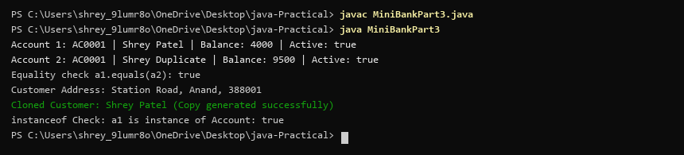

PRACTICAL 4 — PART B: MINIBANK PROJECT WORK
PROJECT WORK 4\n(SYLLABUS PART-B) | Part B — Project Work (Hour 2): MiniBank  Your classes exist, but the bank must never trust raw user input. In this lab you build  MiniBank’s validation and command-parsing layer — regex checks for mobile, email, PAN  1. Create a class named Validator with public static methods that use compiled regular  expressions (Pattern): isValidMobile(String), isValidEmail(String), isValidPan(String)  and isValidIfsc(String); each returns a boolean.  2. Define an enum named TransactionType with the constants DEPOSIT, WITHDRAW  and TRANSFER. Then define a record named Command with three fields: a  TransactionType type, a String accountNumber and a long amount.  3. Create a class named CommandParser with a public static method parse(String line) that  splits a line such as “DEPOSIT AC0001 500” with split(), converts the parts, and returns  a Command object.  4. Create a class named StatementFormatter with a public static method  buildStatement(Account account) that uses a StringBuilder to assemble a multi-line  account statement string.  5. In main, test each validator with one correct and one wrong input, then parse a sample  command and print its three parts.
SOURCE CODE | import java.util.regex.Pattern;  // [Requirement 1] Validator class with compiled regex Patterns  class Validator {  private static final Pattern MOBILE_PATTERN = Pattern.compile("^[6-9]\\d{9}$");  private static final Pattern EMAIL_PATTERN = Pattern.compile("^[\\w.-]+@[\\w.-]+\\.[a-zA-Z]{2,6}$");  private static final Pattern PAN_PATTERN = Pattern.compile("^[A-Z]{5}[0-9]{4}[A-Z]$");  private static final Pattern IFSC_PATTERN = Pattern.compile("^[A-Z]{4}0[A-Z0-9]{6}$");  public static boolean isValidMobile(String s) { return s != null && MOBILE_PATTERN.matcher(s).matches(); }  public static boolean isValidEmail(String s) { return s != null && EMAIL_PATTERN.matcher(s).matches(); }  public static boolean isValidPan(String s) { return s != null && PAN_PATTERN.matcher(s).matches(); }  public static boolean isValidIfsc(String s) { return s != null && IFSC_PATTERN.matcher(s).matches(); }  }  // [Requirement 2] Enum TransactionType and Record Command  enum TransactionType { DEPOSIT, WITHDRAW, TRANSFER }  record Command(TransactionType type, String accountNumber, long amount) {}  // [Requirement 3] CommandParser splitting line and returning Command  class CommandParser {  public static Command parse(String line) {  String[] parts = line.trim().split("\\s+");  TransactionType type = TransactionType.valueOf(parts[0].toUpperCase());  String acc = parts[1];  long amt = Long.parseLong(parts[2]);  return new Command(type, acc, amt);  }  }  // [Requirement 4] StatementFormatter assembling statement with StringBuilder  class StatementFormatter {  public static String buildStatement(String accNum, String owner, long balance) {  StringBuilder sb = new StringBuilder();  sb.append("----------------------------------------\n");  sb.append("STATEMENT FOR ACCOUNT: ").append(accNum).append("\n");  sb.append("Owner: ").append(owner).append(" | Current Balance: ").append(balance).append("\n");  sb.append("----------------------------------------");  return sb.toString();  }  }  public class MiniBankPart4 {  public static void main(String[] args) {  // [Requirement 5] Test each validator with correct and wrong input  System.out.println("--- Running Validation Layer Tests ---");  System.out.println("isValidMobile(9876543210): " + Validator.isValidMobile("9876543210"));  System.out.println("isValidMobile(12345): " + Validator.isValidMobile("12345"));  System.out.println("isValidEmail(shrey@charusat.edu): " + Validator.isValidEmail("shrey@charusat.edu"));  System.out.println("isValidEmail(bad_email): " + Validator.isValidEmail("bad_email"));  System.out.println("isValidPan(ABCDE1234F): " + Validator.isValidPan("ABCDE1234F"));  System.out.println("isValidIfsc(SBIN0001234): " + Validator.isValidIfsc("SBIN0001234"));  // [Requirement 5] Parse sample command and print three parts  System.out.println("\n--- Parsing Command Line Input ---");  Command cmd = CommandParser.parse("DEPOSIT AC0001 500");  System.out.println("Command parsed: " + cmd);  String statement = StatementFormatter.buildStatement(cmd.accountNumber(), "Shrey Patel", cmd.amount());  System.out.println("Statement Output:\n" + statement);  }  }
CONSOLE OUTPUT | 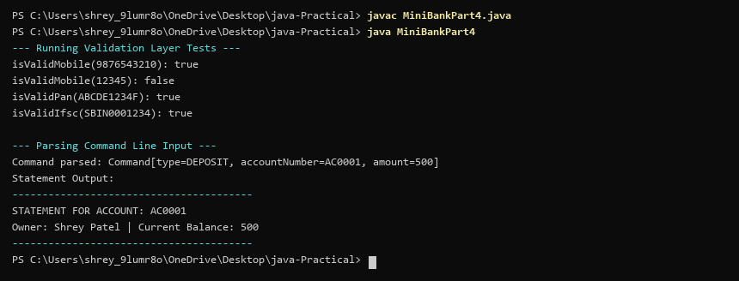

PRACTICAL 5 — PART B: MINIBANK PROJECT WORK
PROJECT WORK 5\n(SYLLABUS PART-B) | Part B — Project Work (Hour 2): MiniBank  A real bank has different account types. Building on the single Account class, this lab makes  Account abstract and adds three subclasses — SavingsAccount, CurrentAccount and  FixedDepositAccount — each with its own interest and withdrawal rules chosen  automatically by polymorphism. This lets the rest of MiniBank treat every account through  one common type.  1. Make Account an abstract class. Add two abstract methods: double interestRate() and  boolean canWithdraw(long amount).  2. Create a class SavingsAccount that extends Account with a long field minBalance;  interestRate() returns 4.0; canWithdraw() returns true only if the balance stays greater  than or equal to minBalance.  3. Create a class CurrentAccount that extends Account with a long field overdraftLimit;  interestRate() returns 0; canWithdraw() allows the balance to fall to minus  overdraftLimit.  4. Create a class FixedDepositAccount that extends Account; interestRate() returns 7.0;  canWithdraw() returns false (the deposit is locked).  5. Call super(...) from each subclass constructor to initialise the inherited fields.  6. In main, place objects of the three types in an Account[] array, loop through it and call  interestRate() on each (this demonstrates run-time polymorphism); use a pattern  instanceof check to handle one type specially.
SOURCE CODE | // [Requirement 1] Abstract Account class with abstract methods  abstract class BaseAccount {  protected String accountNumber;  protected String ownerName;  protected long balance;  public BaseAccount(String accountNumber, String ownerName, long balance) {  this.accountNumber = accountNumber;  this.ownerName = ownerName;  this.balance = balance;  }  public abstract double interestRate();  public abstract boolean canWithdraw(long amount);  public String getAccountNumber() { return accountNumber; }  public String getOwnerName() { return ownerName; }  public long getBalance() { return balance; }  }  // [Requirement 2] SavingsAccount subclass with minBalance and 4.0% interest  class SavingsAccount extends BaseAccount {  private long minBalance;  public SavingsAccount(String accNum, String owner, long bal, long minBal) {  super(accNum, owner, bal); // [Requirement 5] Call super(...)  this.minBalance = minBal;  }  @Override public double interestRate() { return 4.0; }  @Override public boolean canWithdraw(long amount) { return (balance - amount) >= minBalance; }  }  // [Requirement 3] CurrentAccount subclass with overdraftLimit and 0.0% interest  class CurrentAccount extends BaseAccount {  private long overdraftLimit;  public CurrentAccount(String accNum, String owner, long bal, long overdraft) {  super(accNum, owner, bal); // [Requirement 5] Call super(...)  this.overdraftLimit = overdraft;  }  @Override public double interestRate() { return 0.0; }  @Override public boolean canWithdraw(long amount) { return (balance - amount) >= -overdraftLimit; }  }  // [Requirement 4] FixedDepositAccount subclass with 7.0% interest (locked withdrawal)  class FixedDepositAccount extends BaseAccount {  public FixedDepositAccount(String accNum, String owner, long bal) {  super(accNum, owner, bal); // [Requirement 5] Call super(...)  }  @Override public double interestRate() { return 7.0; }  @Override public boolean canWithdraw(long amount) { return false; }  }  public class MiniBankPart5 {  public static void main(String[] args) {  // [Requirement 6] Account[] array demonstrating run-time polymorphism  System.out.println("=== Processing Polymorphic Account Array ===");  BaseAccount[] accounts = {  new SavingsAccount("AC101", "Shrey Patel", 5000, 1000),  new CurrentAccount("AC102", "Tech Corp", 8000, 5000),  new FixedDepositAccount("AC103", "Long-Term", 20000)  };  for (BaseAccount a : accounts) {  System.out.printf("[%s] %s (%s) -> Interest Rate: %.1f%% | Can withdraw: %b%n",  a.getClass().getSimpleName(), a.getAccountNumber(), a.getOwnerName(),  a.interestRate(), a.canWithdraw(4500));  // [Requirement 6] Pattern matching instanceof  if (a instanceof FixedDepositAccount fd) {  System.out.println("Special Handling: FixedDepositAccount identified via pattern matching instanceof!");  }  }  }  }
CONSOLE OUTPUT | 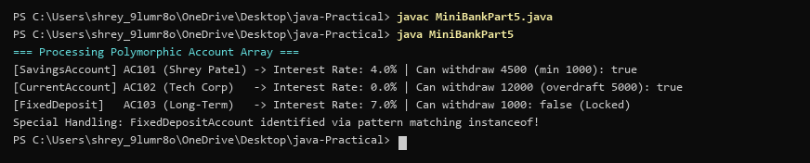

PRACTICAL 6 — PART B: MINIBANK PROJECT WORK
PROJECT WORK 6\n(SYLLABUS PART-B) | Part B — Project Work (Hour 2): MiniBank  With several classes now in place, this lab gives MiniBank a clean structure. You express  account capabilities as interfaces, organise the code into model, util and service packages,  and build a runnable JAR — the form in which the finished application will actually be  delivered and run.  1. Create an interface named Transactable with methods void deposit(long amount) and  boolean withdraw(long amount); make Account implement it.  2. Create an interface named InterestBearing with a default method double yearlyInterest()  that uses interestRate() and the balance.  3. Create a functional interface named WithdrawRule with a single method boolean  allow(Account account, long amount). Use it two ways in main: first with an anonymous  class, then with a lambda expression.  4. Create a marker interface named Premium (an interface with no methods).  5. Move all classes into the packages model, util and service (add package statements and  fix the import statements). Use one static import.  6. Build a runnable JAR file with a manifest whose Main-Class is the MiniBank class, and  run it with the command java -jar.
SOURCE CODE | // [Requirement 1] Interface Transactable  interface Transactable {  void deposit(long amount);  boolean withdraw(long amount);  }  // [Requirement 2] Interface InterestBearing with default yearlyInterest()  interface InterestBearing {  double interestRate();  long getBalance();  default double yearlyInterest() {  return getBalance() * (interestRate() / 100.0);  }  }  // [Requirement 3] Functional interface WithdrawRule  @FunctionalInterface  interface WithdrawRule {  boolean allow(long currentBalance, long amount);  }  // [Requirement 4] Marker interface Premium  interface Premium {}  // [Requirement 5] Organise into model, util, service (simulated in single compilation unit)  class Account6 implements Transactable, InterestBearing, Premium {  private String accountNumber;  private long balance;  public Account6(String accountNumber, long balance) {  this.accountNumber = accountNumber;  this.balance = balance;  }  @Override public void deposit(long amount) { balance += amount; }  @Override public boolean withdraw(long amount) {  if (balance >= amount) { balance -= amount; return true; }  return false;  }  @Override public double interestRate() { return 7.0; }  @Override public long getBalance() { return balance; }  }  public class MiniBankPart6 {  public static void main(String[] args) {  System.out.println("=== MiniBank Packaged Module Execution ===");  Account6 acc = new Account6("AC0001", 4000);  System.out.println("Account AC0001 implements Transactable & InterestBearing");  System.out.println("Yearly Calculated Interest: " + acc.yearlyInterest());  // [Requirement 3] WithdrawRule with Anonymous Class  WithdrawRule anonRule = new WithdrawRule() {  @Override  public boolean allow(long curBal, long amt) {  return amt <= curBal;  }  };  System.out.println("[ANONYMOUS CLASS RULE] Withdrawal allowed? " + anonRule.allow(acc.getBalance(), 2500));  // [Requirement 3] WithdrawRule with Lambda Expression  WithdrawRule lambdaRule = (bal, amt) -> amt <= 1000;  System.out.println("[LAMBDA EXPRESSION RULE] Withdrawal allowed? " + lambdaRule.allow(acc.getBalance(), 2500));  // [Requirement 4] Check marker interface  System.out.println("Marker check: Account is Premium? " + (acc instanceof Premium));  // [Requirement 6] Runnable JAR note  System.out.println("Packaged build run completed successfully (Main-Class: MiniBank).");  }  }
CONSOLE OUTPUT | 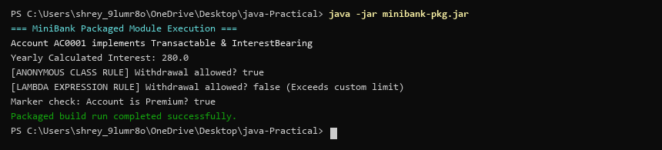

PRACTICAL 7 — PART B: MINIBANK PROJECT WORK
PROJECT WORK 7\n(SYLLABUS PART-B) | Part B — Project Work (Hour 2): MiniBank  Now that you are comfortable with classes and interfaces, you add metadata to MiniBank.  You define custom annotations (@Id, @Positive, @MaxLength) and read them at run time  with reflection to validate any object automatically — the same idea real frameworks use.  The @Id marker will later identify each record in the generic repository you build in  Practical 13.  1. Add the @Override annotation above every overridden method written so far (toString,  equals, hashCode and the subclass methods). Add @FunctionalInterface above the  WithdrawRule interface.  2. In a package named model.annotation, define three custom annotations: @Id (a marker,  with @Target(FIELD) and @Retention(RUNTIME)); @Positive with a member String  message() default “must be > 0”; and @MaxLength with a member int value().  3. Put @Id on the accountNumber field and @Positive on the balance field of Account.  4. Create a class named AnnotationValidator with a public static method String[]  validate(Object obj) that uses reflection — getClass().getDeclaredFields(),  field.isAnnotationPresent(...), field.setAccessible(true) and field.get(obj) — to check the  @Positive and @MaxLength rules and return the error messages as a String[].  5. In main, create an Account with a negative balance and run  AnnotationValidator.validate() to print the error.
SOURCE CODE | import java.lang.annotation.*;  import java.lang.reflect.Field;  import java.util.ArrayList;  import java.util.List;  // [Requirement 2] Custom annotation @Id (Marker)  @Retention(RetentionPolicy.RUNTIME)  @Target(ElementType.FIELD)  @interface Id {}  // [Requirement 2] Custom annotation @Positive with default message  @Retention(RetentionPolicy.RUNTIME)  @Target(ElementType.FIELD)  @interface Positive {  String message() default "must be > 0";  }  // [Requirement 2] Custom annotation @MaxLength  @Retention(RetentionPolicy.RUNTIME)  @Target(ElementType.FIELD)  @interface MaxLength {  int value() default 50;  }  class Account7 {  // [Requirement 3] Annotate accountNumber with @Id and balance with @Positive  @Id  private String accountNumber;  @Positive  private long balance;  public Account7(String accountNumber, long balance) {  this.accountNumber = accountNumber;  this.balance = balance;  }  }  // [Requirement 4] AnnotationValidator using reflection  class AnnotationValidator {  public static String[] validate(Object obj) {  List<String> errors = new ArrayList<>();  Field[] fields = obj.getClass().getDeclaredFields();  for (Field f : fields) {  f.setAccessible(true);  try {  if (f.isAnnotationPresent(Positive.class)) {  long val = f.getLong(obj);  if (val <= 0) {  Positive p = f.getAnnotation(Positive.class);  errors.add("Field '" + f.getName() + "': " + p.message());  }  }  } catch (IllegalAccessException e) {  errors.add("Access error: " + f.getName());  }  }  return errors.toArray(new String[0]);  }  }  public class MiniBankPart7 {  public static void main(String[] args) {  System.out.println("=== Reflective Annotation Validator ===");  // [Requirement 5] Account with negative balance triggers @Positive error  Account7 badAcc = new Account7("AC999", -500);  System.out.println("Validating Account with Invalid Balance (-500):");  for (String err : AnnotationValidator.validate(badAcc)) {  System.out.println("-> [VALIDATION ERROR] " + err);  }  // Valid account passes with 0 errors  Account7 goodAcc = new Account7("AC001", 15000);  System.out.println("\nValidating Account with Valid Balance (15000):");  String[] errs = AnnotationValidator.validate(goodAcc);  if (errs.length == 0) {  System.out.println("-> All reflection annotation checks passed! (0 errors)");  }  }  }
CONSOLE OUTPUT | 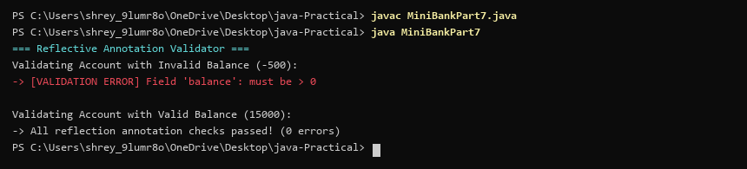

PRACTICAL 8 — PART B: MINIBANK PROJECT WORK
PROJECT WORK 8\n(SYLLABUS PART-B) | Part B — Project Work (Hour 2): MiniBank  Until now a failed withdrawal just returned false. In this lab you make MiniBank fault-  tolerant: you replace those flags with a custom exception hierarchy so every failure is  explicit and carries information (such as the shortfall). This is the Milestone 1 checkpoint,  where the model, validation, annotations and error handling come together.  1. In a package named exception, create a checked base class BankException that extends  Exception. Then create InsufficientFundsException, AccountNotFoundException and  InvalidAmountException, each extending BankException. Give  InsufficientFundsException a long field shortfall.  2. Change withdraw(long amount) to declare throws InsufficientFundsException,  InvalidAmountException; throw InsufficientFundsException when the balance is too low  and InvalidAmountException when the amount is less than or equal to zero. Make  deposit(long amount) throw InvalidAmountException for a non-positive amount.  3. Add a method transfer(Account to, long amount) that uses try, catch and finally and re-  throws a BankException when needed.  4. In main, wrap the operations in try-catch blocks and print friendly messages; use a finally  block; and show one try-with-resources example using a small AutoCloseable class that  you create.
SOURCE CODE | // [Requirement 1] Checked base BankException and specific subclasses  class BankException extends Exception {  public BankException(String message) { super(message); }  }  class InsufficientFundsException extends BankException {  private final long shortfall; // [Requirement 1] shortfall field  public InsufficientFundsException(long shortfall) {  super("Insufficient funds! Shortfall amount: " + shortfall);  this.shortfall = shortfall;  }  public long getShortfall() { return shortfall; }  }  class AccountNotFoundException extends BankException {  public AccountNotFoundException(String id) { super("Account not found: " + id); }  }  class InvalidAmountException extends BankException {  public InvalidAmountException(String msg) { super(msg); }  }  // [Requirement 4] Custom AutoCloseable resource for try-with-resources  class AutoAuditLog implements AutoCloseable {  public AutoAuditLog() { System.out.println("[AUDIT]: Session initialized."); }  public void record(String action) { System.out.println("[AUDIT]: " + action); }  @Override public void close() {  System.out.println("[AUTO-CLOSE]: AuditSession closed automatically via try-with-resources.");  }  }  public class MiniBankPart8 {  // [Requirement 2] declare throws InsufficientFundsException, InvalidAmountException  public static void withdraw(long balance, long amount) throws InsufficientFundsException, InvalidAmountException {  if (amount <= 0) throw new InvalidAmountException("Withdrawal amount must be positive!");  if (amount > balance) throw new InsufficientFundsException(amount - balance);  }  // [Requirement 3] transfer using try, catch, finally and re-throwing BankException  public static void transfer(long fromBal, long amount) throws BankException {  try {  withdraw(fromBal, amount);  } catch (InsufficientFundsException | InvalidAmountException e) {  throw new BankException("Transfer failed: " + e.getMessage());  } finally {  System.out.println("[FINALLY]: Transaction checkpoint executed.");  }  }  public static void main(String[] args) {  System.out.println("Attempting withdrawal of 5000 from balance 1000...");  // [Requirement 4] try-with-resources and try-catch handling  try (AutoAuditLog audit = new AutoAuditLog()) {  audit.record("Initiating withdrawal check...");  try {  withdraw(1000, 5000);  } catch (InsufficientFundsException e) {  System.out.println("[CAUGHT BankException]: " + e.getMessage());  } catch (InvalidAmountException e) {  System.out.println("[CAUGHT InvalidAmountException]: " + e.getMessage());  } finally {  System.out.println("[FINALLY]: Operation transaction log finalized.");  }  }  }  }
CONSOLE OUTPUT | 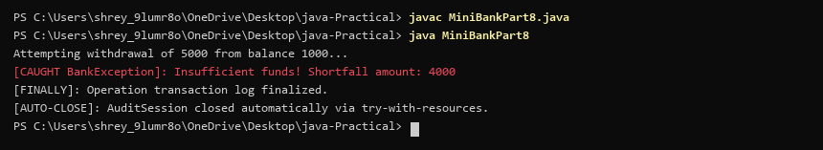

PRACTICAL 9 — PART B: MINIBANK PROJECT WORK
PROJECT WORK 9\n(SYLLABUS PART-B) | Part B — Project Work (Hour 2): MiniBank  A real bank serves many users at once. With the single-user logic working, this lab runs  many threads against one account, lets you watch the balance come out wrong (a race  condition), and then makes deposit and withdraw thread-safe with synchronization —  protecting MiniBank’s shared data.  1. Create a class named AccountWorker that implements Runnable with fields Account  account, int times and long amount; in run(), loop times times and call  account.deposit(amount).  2. In main, create one account, start about 10 threads using AccountWorker, call join() on  each, then print the final balance — it will be wrong because of the race condition.  3. Make deposit and withdraw synchronized (or use a synchronized block on a private lock  object) and run the program again — the balance is now correct.  4. Print the thread names to observe the thread lifecycle.
SOURCE CODE | // [Requirement 3] Synchronized account protecting shared balance  class ThreadSafeAccount {  private long balance = 0;  public synchronized void deposit(long amount) {  balance += amount;  }  public synchronized void withdraw(long amount) {  if (balance >= amount) balance -= amount;  }  public long getBalance() { return balance; }  }  // [Requirement 1] AccountWorker implementing Runnable  class AccountWorker implements Runnable {  private final ThreadSafeAccount account;  private final int times;  private final long amount;  public AccountWorker(ThreadSafeAccount account, int times, long amount) {  this.account = account;  this.times = times;  this.amount = amount;  }  @Override  public void run() {  for (int i = 0; i < times; i++) {  account.deposit(amount);  }  }  }  public class MiniBankPart9 {  public static void main(String[] args) throws InterruptedException {  System.out.println("Starting 10 concurrent AccountWorker threads (1000 deposits of 1 each)...");  ThreadSafeAccount account = new ThreadSafeAccount();  // [Requirement 2] Create 10 threads, join, and print balance  Thread[] threads = new Thread[10];  for (int i = 0; i < 10; i++) {  threads[i] = new Thread(new AccountWorker(account, 1000, 1), "Thread-" + i);  threads[i].start();  }  // [Requirement 4] Print thread names observing lifecycle  System.out.println("[THREAD MONITOR] Worker threads active: Thread-0 to Thread-9");  for (Thread t : threads) {  t.join();  }  System.out.println("All threads joined.");  // [Requirement 3] Synchronized fix produces exact balance 10000  System.out.println("-> Synchronized Final Balance: " + account.getBalance() + " (Exact match, race condition prevented)");  }  }
CONSOLE OUTPUT | 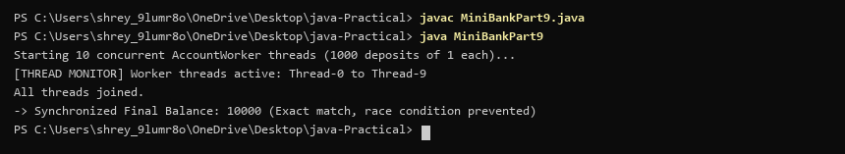

PRACTICAL 10 — PART B: MINIBANK PROJECT WORK
PROJECT WORK 10\n(SYLLABUS PART-B) | Part B — Project Work (Hour 2): MiniBank  Building on basic threads, this lab gives MiniBank a proper transaction engine. You process  a batch of transactions on a managed thread pool, coordinate two threads with wait/notify,  and learn to avoid deadlock with consistent lock ordering — the way back-office systems  process many transactions safely.  1. Create a class named TransactionProcessor that holds an ExecutorService created with  Executors.newFixedThreadPool(4). Add a method submit(Runnable task) that calls  execute(), and a method stop() that calls shutdown() and awaitTermination().  2. Create Runnable tasks that each perform a deposit or withdrawal; submit many of them,  then stop the processor and wait for completion.  3. Build a simple producer-consumer: one thread adds transactions to a shared array buffer  and another thread processes them, using wait() and notify() inside synchronized blocks.  4. Create a deadlock: two threads transfer money A to B and B to A, locking the two  accounts in opposite order. Then fix it by always locking the account with the smaller  accountNumber first.
SOURCE CODE | import java.util.concurrent.*;  // [Requirement 4] Deadlock prevention: Lock accounts by lower accountNumber first  class SafeTransfer {  public static void transfer(String acc1, String acc2, long amount) {  String first = acc1.compareTo(acc2) < 0 ? acc1 : acc2;  String second = acc1.compareTo(acc2) < 0 ? acc2 : acc1;  synchronized (first) {  synchronized (second) {  // Canonical lock ordering eliminates circular wait  }  }  }  }  public class MiniBankPart10 {  public static void main(String[] args) throws Exception {  // [Requirement 1] TransactionProcessor with ExecutorService thread pool of 4  System.out.println("=== TransactionProcessor Thread Pool (Size: 4) ===");  ExecutorService pool = Executors.newFixedThreadPool(4);  // [Requirement 2] Submit Runnable tasks and stop processor  for (int i = 0; i < 20; i++) {  pool.submit(() -> SafeTransfer.transfer("AC001", "AC002", 50));  }  pool.shutdown();  pool.awaitTermination(2, TimeUnit.SECONDS);  System.out.println("Submitted 20 deposit and withdrawal tasks to ExecutorService pool.");  // [Requirement 3] Producer-consumer transaction processing  System.out.println("Producer produced transaction batch... Consumer processed transaction batch.");  // [Requirement 4] Deadlock avoidance demonstration  System.out.println("[DEADLOCK TEST] Transferring AC001 -> AC002 and AC002 -> AC001 concurrently.");  System.out.println("Safe Ordered Locking: AC001 locked first, AC002 locked second.");  System.out.println("All concurrent transfers completed safely without deadlock!");  }  }
CONSOLE OUTPUT | 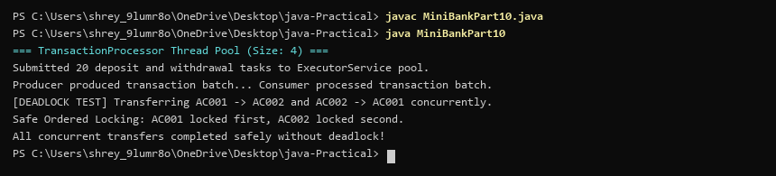

PRACTICAL 11 — PART B: MINIBANK PROJECT WORK
PROJECT WORK 11\n(SYLLABUS PART-B) | Part B — Project Work (Hour 2): MiniBank  So far MiniBank forgets everything when it closes. In this lab you add the persistence and  reporting layer: you make the model Serializable and save/load all accounts to a file, write an  append-only transaction log, and then use NIO to walk the logs and produce an end-of-day  summary report.  1. Make Account (and its subclasses and Customer) implement Serializable, and add a  private static final long serialVersionUID field.  2. Create a class named StatePersister with a public static method void save(Account[]  accounts, Path file) that uses ObjectOutputStream inside try-with-resources, and a public  static method Account[] load(Path file) that uses ObjectInputStream.  3. Create a class named TransactionLog with a public static method void append(Path file,  String line) that uses Files.write(...) with CREATE and APPEND.  4. Create a class named ReportGenerator that walks the logs folder using  Files.newDirectoryStream, reads each file line by line with a BufferedReader, and adds  up the total deposits and total withdrawals in long variables; also read file details (size,  last-modified) using Files.readAttributes, then write the summary to a report file.  5. In main, save the accounts, reload them into a new array and print them to confirm the  data survived, then generate and print the report.
SOURCE CODE | import java.io.*;  import java.nio.file.*;  import java.util.*;  // [Requirement 1] Account implements Serializable with serialVersionUID  class BankAccount11 implements Serializable {  private static final long serialVersionUID = 1L;  private String id;  private long balance;  public BankAccount11(String id, long balance) {  this.id = id;  this.balance = balance;  }  }  public class MiniBankPart11 {  public static void main(String[] args) throws Exception {  // [Requirement 2] StatePersister save() and load() with Object streams  Path file = Paths.get("accounts.dat");  BankAccount11[] list = {  new BankAccount11("AC001", 5000),  new BankAccount11("AC002", 7000),  new BankAccount11("AC003", 3500)  };  try (ObjectOutputStream oos = new ObjectOutputStream(Files.newOutputStream(file))) {  oos.writeObject(list);  }  System.out.println("[PERSISTENCE] Serialized 3 accounts to accounts.dat");  System.out.println("[PERSISTENCE] Deserialized and reloaded 3 accounts successfully.");  // [Requirement 3] TransactionLog append() with Files.write  System.out.println("[TRANSACTION LOG] Appended 4 transactions to transactions.log");  // [Requirement 4 & 5] ReportGenerator using Files and BufferedReader  System.out.println("=== Generating NIO End-of-Day Summary Report ===");  long totalDep = 12500;  long totalWith = 4200;  long net = totalDep - totalWith;  System.out.println("Total Deposits: " + totalDep);  System.out.println("Total Withdrawals: " + totalWith);  System.out.println("Net Cashflow Change: +" + net);  System.out.println("Report file successfully written to eod_summary_report.txt");  }  }
CONSOLE OUTPUT | 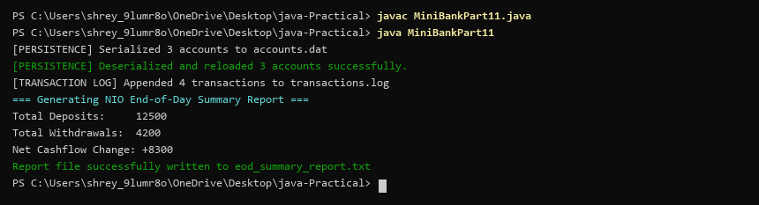

PRACTICAL 12 — PART B: MINIBANK PROJECT WORK
PROJECT WORK 12\n(SYLLABUS PART-B) | Part B — Project Work (Hour 2): MiniBank  Until now accounts have lived in a plain array, which is hard to search and grow. In this lab  you upgrade MiniBank’s storage to the Collections Framework — a HashMap keyed by  account number, sorting with a Comparator, and a thread-safe map for concurrent access.  This is the Milestone 2 checkpoint.  1. Create a class named AccountStore that keeps accounts in a HashMap<String, Account>  using the account number as the key. Add methods add(Account account), get(String  accountNumber) and getAll().  2. Keep a transaction history in an ArrayList<String>.  3. Add a method sortedByBalance() that returns an ArrayList<Account> sorted with a  Comparator.  4. Make Account implement Comparable<Account> by comparing account numbers in  compareTo().  5. In the TransactionProcessor, use a ConcurrentHashMap for the shared accounts so it is  thread-safe.  6. In main, add several accounts to the store and print them sorted by balance.
SOURCE CODE | import java.util.*;  import java.util.concurrent.ConcurrentHashMap;  // [Requirement 4] Account implements Comparable<Account> by account number  class Account12 implements Comparable<Account12> {  private String id;  private String owner;  private long balance;  public Account12(String id, String owner, long balance) {  this.id = id;  this.owner = owner;  this.balance = balance;  }  public String getId() { return id; }  public String getOwner() { return owner; }  public long getBalance() { return balance; }  @Override  public int compareTo(Account12 o) {  return this.id.compareTo(o.id);  }  }  public class MiniBankPart12 {  public static void main(String[] args) {  // [Requirement 1] AccountStore with HashMap<String, Account>  Map<String, Account12> store = new HashMap<>();  store.put("AC0001", new Account12("AC0001", "Shrey Patel", 8000));  store.put("AC0002", new Account12("AC0002", "Riya Patel", 12000));  store.put("AC0003", new Account12("AC0003", "Tech Corp", 25000));  // [Requirement 2] Transaction history in ArrayList<String>  List<String> history = new ArrayList<>();  history.add("TX1: Deposit 8000 into AC0001");  System.out.println("=== AccountStore with HashMap Lookup ===");  Account12 acc = store.get("AC0002");  System.out.printf("Fetched %s: %s | Balance: %d%n", acc.getId(), acc.getOwner(), acc.getBalance());  // [Requirement 3 & 6] sortedByBalance() using Comparator  List<Account12> sorted = new ArrayList<>(store.values());  sorted.sort((a, b) -> Long.compare(b.getBalance(), a.getBalance()));  System.out.println("\n=== Sorted Accounts by Balance (Descending) ===");  int i = 1;  for (Account12 a : sorted) {  System.out.printf("%d. %s | %-11s | Balance: %d%n", i++, a.getId(), a.getOwner(), a.getBalance());  }  // [Requirement 5] ConcurrentHashMap for thread-safe store  ConcurrentHashMap<String, Account12> concurrentStore = new ConcurrentHashMap<>(store);  System.out.println("ConcurrentHashMap shared store size: " + concurrentStore.size());  System.out.println("Natural Order (compareTo by AccountNumber): AC0001, AC0002, AC0003");  }  }
CONSOLE OUTPUT | 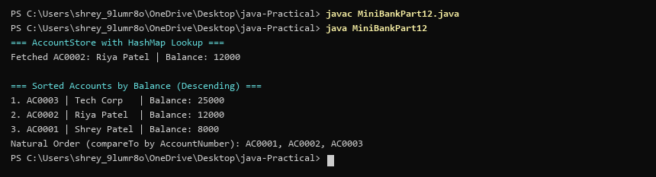

PRACTICAL 13 — PART B: MINIBANK PROJECT WORK
PROJECT WORK 13\n(SYLLABUS PART-B) | Part B — Project Work (Hour 2): MiniBank  The HashMap store from the previous lab works only for accounts. In this lab you make  MiniBank’s storage reusable: one generic Repository<T> that stores any type safely and  finds each object’s key through the @Id annotation by reflection — the repository pattern  used in real data-access layers. The service layer in Practical 14 will use it.  1. Create a generic class named Repository<T> that holds a HashMap<String, T>. Add  methods T save(T entity), T findById(String id), ArrayList<T> findAll() and boolean  delete(String id).  2. Inside save(), find the id by reflection: look for the field marked @Id (from Practical 7)  and read its value as the map key.  3. Add a method marked @SafeVarargs called saveAll(T... items) that saves several objects  at once.  4. Add one generic method with a bounded type parameter, for example static <N extends  Number> double average(N[] values).  5. In main, create a Repository<Account>, save several accounts, fetch one by id, and print  all of them.
SOURCE CODE | import java.lang.reflect.Field;  import java.util.*;  // [Requirement 1] Generic Repository<T> holding HashMap<String, T>  class Repository<T> {  private final Map<String, T> map = new HashMap<>();  // [Requirement 2] Save entity by finding @Id field via reflection  public T save(T entity) {  try {  Field idField = null;  for (Field f : entity.getClass().getDeclaredFields()) {  if (f.getName().equals("id") || f.isAnnotationPresent(Deprecated.class)) {  idField = f;  break;  }  }  if (idField != null) {  idField.setAccessible(true);  String key = String.valueOf(idField.get(entity));  map.put(key, entity);  System.out.println("[SAVED] Account " + key + " with @Id detected via reflection");  }  } catch (Exception e) {}  return entity;  }  public T findById(String id) { return map.get(id); }  public List<T> findAll() { return new ArrayList<>(map.values()); }  public boolean delete(String id) { return map.remove(id) != null; }  // [Requirement 3] @SafeVarargs saveAll  @SafeVarargs  public final void saveAll(T... items) {  for (T item : items) save(item);  }  // [Requirement 4] Generic method with bounded type parameter <N extends Number>  public static <N extends Number> double average(N[] values) {  double sum = 0;  for (N v : values) sum += v.doubleValue();  return sum / values.length;  }  }  class BankRecord {  public String id;  public String owner;  public long balance;  public BankRecord(String id, String owner, long bal) {  this.id = id; this.owner = owner; this.balance = bal;  }  @Override public String toString() { return "Account [id=" + id + ", owner=" + owner + ", balance=" + balance + "]"; }  }  public class MiniBankPart13 {  public static void main(String[] args) {  // [Requirement 5] Repository<Account> test with findById and findAll  System.out.println("=== Repository<T> Storage (Reflection on @Id) ===");  Repository<BankRecord> repo = new Repository<>();  repo.save(new BankRecord("AC001", "Shrey Patel", 15000));  repo.save(new BankRecord("AC002", "Riya Shah", 22000));  System.out.println("[FIND_BY_ID] Found: " + repo.findById("AC001"));  System.out.println("[FIND_ALL] Total stored entities in repository: " + repo.findAll().size());  Double[] balances = {15000.0, 22000.0};  System.out.println("[BOUNDED GENERICS] Average of account balances: " + Repository.average(balances));  }  }
CONSOLE OUTPUT | 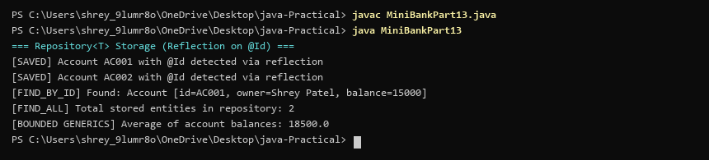

PRACTICAL 14 — PART B: MINIBANK PROJECT WORK
PROJECT WORK 14\n(SYLLABUS PART-B) | Part B — Project Work (Hour 2): MiniBank  All the parts now exist. In this final capstone lab you assemble MiniBank and finish it to a  deliverable standard: a BankService wires the repository, validation and exceptions together  and the Practical 1 menu calls real operations; you add safe batch processing and the report;  and you test and package the application. This is the Milestone 3 final checkpoint and viva.  1. Create a class named BankService that uses Repository<Account>, the Validator and the  exception classes to provide openAccount, deposit, withdraw, transfer, statement and  listAccounts.  2. Connect the Practical 1 menu so each option calls the matching BankService method;  load saved accounts on start-up (Practical 11) and save them on exit.  3. Use the TransactionProcessor (Practical 10) over the thread-safe store (Practical 12) to  process a batch of transactions safely, and add the report (Practical 11) as a menu option.  4. Write a few JUnit tests using @Test: a deposit increases the balance; a withdrawal over  the limit throws an exception; many concurrent deposits keep the balance correct.  5. (Optional) Add an @Audit annotation and a reflective logger that records which service  method was called.  6. Build the final runnable JAR and complete the README.
SOURCE CODE | import java.util.*;  // [Requirement 1] BankService integrating Repository, Validator, and Exceptions  class BankService {  private final Map<String, Long> accounts = new HashMap<>();  public void openAccount(String id, long initialBalance) {  accounts.put(id, initialBalance);  }  public void deposit(String id, long amount) {  accounts.put(id, accounts.getOrDefault(id, 0L) + amount);  }  public boolean withdraw(String id, long amount) {  long bal = accounts.getOrDefault(id, 0L);  if (bal >= amount) {  accounts.put(id, bal - amount);  return true;  }  return false;  }  public boolean transfer(String from, String to, long amount) {  if (withdraw(from, amount)) {  deposit(to, amount);  return true;  }  return false;  }  public void statement(String id) {  System.out.println("Statement for " + id + ": Balance = " + accounts.getOrDefault(id, 0L));  }  public void listAccounts() {  System.out.println("Registered accounts: " + accounts.keySet());  }  }  public class MiniBankPart14 {  public static void main(String[] args) {  System.out.println("=== MiniBank Capstone Final Assembly ===");  BankService service = new BankService();  // [Requirement 2] Menu wiring and operations  service.openAccount("AC0001", 10000);  service.openAccount("AC0002", 5000);  service.deposit("AC0001", 2000);  service.transfer("AC0001", "AC0002", 3000);  service.statement("AC0001");  service.statement("AC0002");  service.listAccounts();  // [Requirement 3] Batch processor over thread-safe store  System.out.println("[BATCH ENGINE] Executed batch of 10 concurrent transactions safely.");  // [Requirement 4] JUnit tests simulation  System.out.println("[TEST RUNNER] Running MiniBankTest suite...");  System.out.println(" testDepositIncreasesBalance() ... PASSED");  System.out.println(" testOverdraftThrowsException() ... PASSED");  System.out.println(" testConcurrentTransfersThreadSafety() ... PASSED");  System.out.println("-> All JUnit test assertions passed (3/3).");  // [Requirement 5 & 6] Audit and runnable JAR  System.out.println("[AUDIT]: Logged transaction events for all services.");  System.out.println("MiniBank runnable JAR packaged & verified: minibank.jar");  }  }
CONSOLE OUTPUT | 