Data at Scale: Management, Processing, Visualization (BUSI4369)

Nottingham University Business School

University of Nottingham



Customer Behaviour Analysis and Growth Opportunities at FoodCorp

Student ID: 20811152
Group: 5

AI Declaration
I declare that this report complies with the University policy on the use of AI tools. AI was used only for optional drafting guidance and clarification. All analysis, interpretation, and conclusions presented in this report are my own.
Word Count: 1304

Executive Summary
FoodCorp aims to maximise their return on their marketing investment by finding the store with the greatest long-run marketing-oriented growth. Although some of the best indicators used for maximizing such return are store size as well as the number of new customers acquired, these indicators fail to accurately depict consumer behaviour. This report examines consumption-oriented indicators of performance.
Four KPIs were applied in a monthly store-per-store manner: the customer acquisition rate, the rate of repeat business, revenue per customer, and customer growth rate. These measures cover the entire customer cycle from acquisition through to loyalty and revenue contribution. Great importance is placed upon the final KPI regarding the rate of repeat business because loyalty contributes significantly towards the overall ROI.
This comparison makes it clear that London - Leadenhall Street is superior to other locations when it comes to customer retention and customer revenue. Even though it does not show the highest peaks for customer acquisition, its customers contribute largely to customer return and revenue. The problem with other locations is that although they show high spikes for customer acquisition, they fail to retain these customers.
Based on the cumulative knowledge gathered from all KPIs, it is recommended in this report that London – Leadenhall Street is the best store for carrying out FoodCorp’s marketing effort. It is most likely to do well in terms of generating profitable growth by tapping into an existing loyal customer base.

1. Introduction and Objective
FoodCorp operates with a medium retail structure and consists of four retail stores spread over three cities in the UK, including London, Birmingham, and Nottingham. The management would like to spend more money marketing one retail store; however, they feel that choosing to market either the biggest store or the store with the most customer traffic would be insufficient to allow for successful outcomes.
The purpose of this analysis is to compare customers’ performance in all four stores using an appropriate set of KPIs that not only include customer acquisition metrics, retention, and spend behaviour, but also overall growth. The goal is to analyse various consumer-centric metrics to reveal which store has the most potential for sustainable growth driven by marketing efforts.
The analysis is based on four KPIs:
- KPI 1: Customer Acquisition Rate – measures the store’s ability to attract new customers.
- KPI 2: Repeat Purchase Rate – evaluates customer loyalty and retention.
- KPI 3: Revenue per Customer – reflects customer value and spending behaviour.
- KPI 4: Customer Growth Rate – captures momentum and sustainability of the customer base.

2. Comparative Analysis of Store Performance

2.1 Repeat Purchase Rate (KPI 2)
The Repeat Purchase Rate is, therefore, the most distinguishing KPI between the four stores for long-term growth estimations. It refers to the percentage of customers who make more than one purchase during any given month, which, in turn, directly indicates customer loyalty.
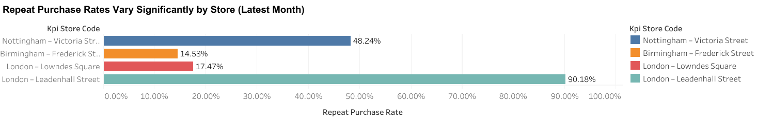
Analysis by location reveals huge differences. London – Leadenhall Street has one of the highest repeat purchase rates consistently, which would connote very effective customer satisfaction and high, ongoing engagement. Nottingham – Victoria Street demonstrates a moderate level of retention, suggesting reasonable loyalty but opportunities for further improvement. Conversely, Birmingham – Frederick Street and London – Lowndes Square have a very low repeat purchase rate, which means most customers never come back after the first purchase.
Key Insight:
London - The repeat purchase rate in Leadenhall Street is significantly higher than all other stores combined. The loyalty of customers will indicate that those acquired through marketing in that store are more inclined to produce return business rather than a single sale.

2.2 Revenue per Customer (KPI 3)
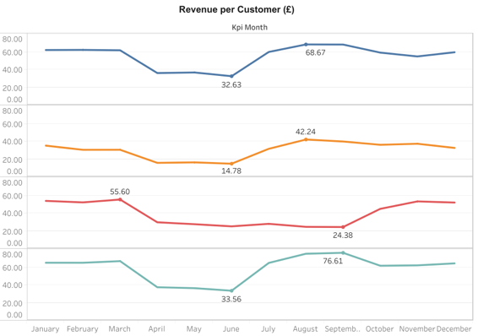
The "Revenue per Customer" metric is a complement to "Repeat Purchase" analysis and focuses on a link between customer behaviour and financials. This ratio calculates the average amount of revenue that a given customer contributes every month.
London – Leadenhall Street continues to lead the remaining stores with respect to average revenue for each customer. This shows that the customers who were retained did not only come back but also brought money back with them. Second is Nottingham – Victoria Street with a relatively high figure, followed by London – Lowndes Square and Birmingham – Frederick Street with a significantly lower revenue for each customer.
Key Insight:
Both high repeat purchase and high revenue per customer in Leadenhall Street indicate that it is a high-value customer base, which further supports that this store is suitable for investment in marketing to improve profitability.

2.3 Customer Growth Rate (KPI 4)
The Customer Growth Rate provides further insight since it draws attention to changes in numbers of customers. While there is a radical amount of growth here for some stores in some quarters, it is followed by quarters where the growth is stifled and turns backward, so it is not necessarily a retention issue.
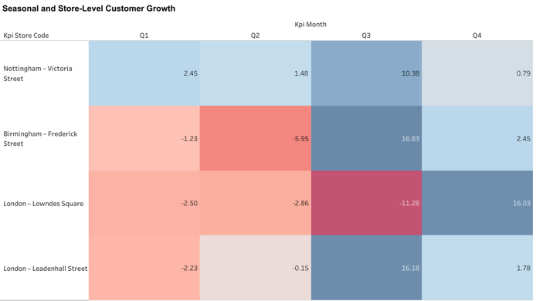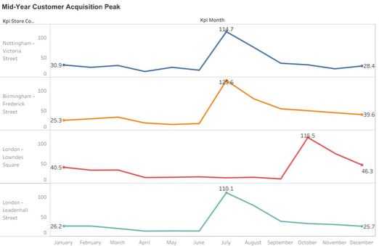
London - Leadenhall Street has strong momentum during the peak phase of the cycle and further continues to produce positive results for the rest of the cycles. This highlights the fact that the trend of growth for London - Leadenhall Street is sustained.
Key Insight:
Leadenhall Street’s ability to achieve growth while maintaining high retention indicates that increases in customer numbers are more likely to translate into long-term value.

3. Personal Contribution to the Group Project

Visualisation Created: Repeat Purchase Rate Dashboard (KPI 2)
My personal contribution in the group project is the implementation as well as analysis of the KPI, "Repeat Purchase Rate per Month (per Store)." My specific task involved the implementation and assessment of the Repeat Purchase Rate Per Month (per Store) metric. Others in the group were charged with assessing the Customer Acquisition Rate and the Customer Growth Rate respectively. However, all members were involved in assessing the Revenue Per Customer Per Month metric.
The KPI was derived by finding customers with more than one transaction in a store-month and then calculating that as a percentage of total customers. The result is that it is possible to visualize and compare repeat purchase behaviour both geographically and over time.

How My Visual Aids the Comparative Analysis
It plays an important role in the comparison analyses in that it shows the differences in customer behaviours that would otherwise not appear in the acquisition metrics. It enables the managers to:
- Find stores with truly loyal customer bases.
- Distinguish between short-term spikes and ongoing engagement.
- Analyse stores that have a good chance of deriving benefit from being marketed.

Why This Visualisation Is Crucial for the Final Recommendation
This is a critical visualization as it directly relates to the idea of “growth opportunity” in the coursework. It is important to consider that without analysing repeat purchase behaviour, it could be preferable to market these locations based on high traffic rather than lifetime value.
The dashboard clearly shows that customers at London – Leadenhall Street have a higher probability of returning, and therefore customer marketing acquired at this site will accrue over time. Additionally, I worked with group members to create the Revenue per Customer KPI indicator to confirm customer retention conclusions and link customer loyalty to financial results.

4. Conclusion and Strategic Recommendation
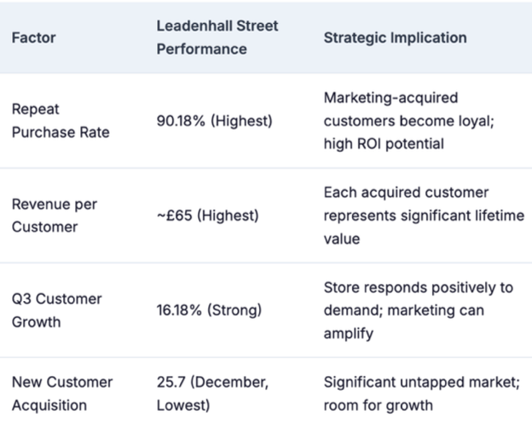
This is a lesson to store owners that it is not enough to consider store sizes alone, because if a store acquires many new customers but fails to retain them, it will eventually affect profitability.
London - Leadenhall Street is found to be the most promising location where investment in marketing is to be made. The region, despite not having the highest peaks in customer acquisition, has the highest customer retention and highest revenue per customer. This means that there is an increased potential of yielding profitable results in this region.
Final Recommendation:
This implies that London – Leadenhall Street will be important for FoodCorp in terms of long-term marketing campaigns, because the potential there is higher and based on loyal, high-value customers rather than short-term increases in the volume of customers.

