**DevOps (handwritten)**

**Practical 1A : installation of github**

**Practical 1B : perform Gitbash with VCS**

**STEP 1:--** **Create a repository by specifying a name to it.**

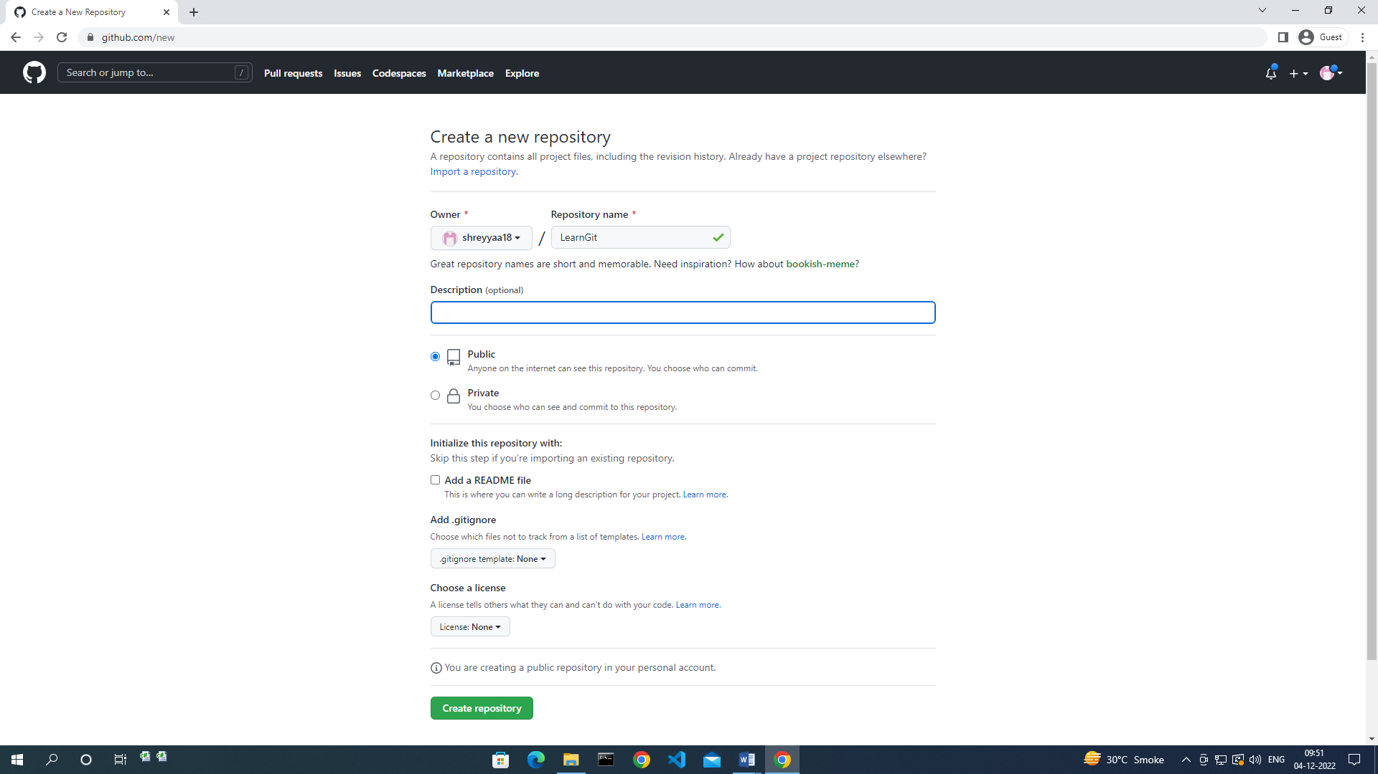

Repo - <https://github.com/shreyyaa18/LearnGit.git>

Username – shreyyaa18

Email – [jaiswalshreya595@gmail.com](mailto:jaiswalshreya595@gmail.com)

**Commands :**

1. git config

Des-

Syntax –

Command –

ss

$ git config --global user.email jaiswalshreya595@gmail.com

$ git config --global user.name shreyyaa18

$ git config --global –list

git init

$ mkdir shreya067

C:\Users\COL-BSCIT-PC41\shreya067 --- create one txt file inside ths folder

Cd shreya067

$ ls

$ git status

1. git init

git init

1. git clone

git clone https://github.com/shreyyaa18/LearnGit.git

1. Git add

$ git add shreya.txt

$ git add.

1. Git commit

$ git commit -m "this is my first commit"

1. Git status

$ git status

1. Git log

$ git log

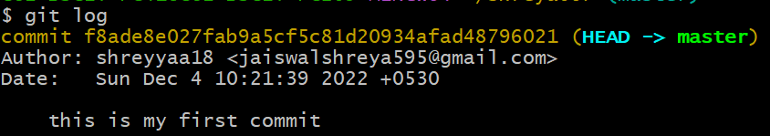

1. Git remote
2. git push