**STEP 1:--**

Create a repository by specifying a name to it.

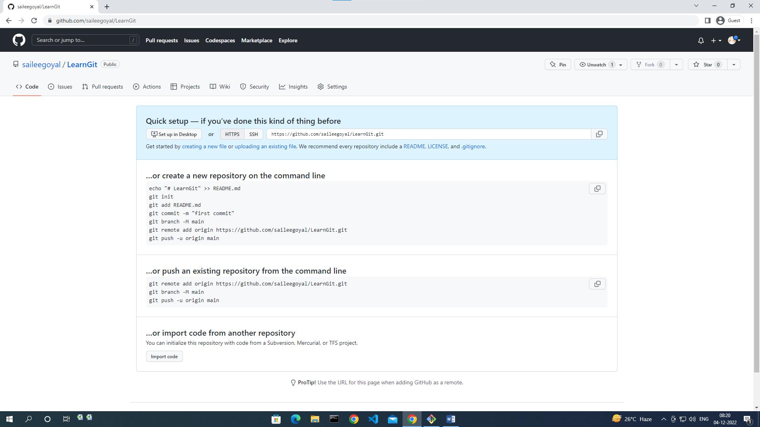

<https://github.com/saileegoyal/LearnGit.git>

Username: saileegoyal

Email: [saileaykgoel@gmail.com](mailto:saileaykgoel@gmail.com)

1. Config:

Syntax:

Command: (username) git config —global user.name saileegoyal

git config—global user.email [saileaykgoel@gmail.com](mailto:saileaykgoel@gmail.com)

git config—global – list

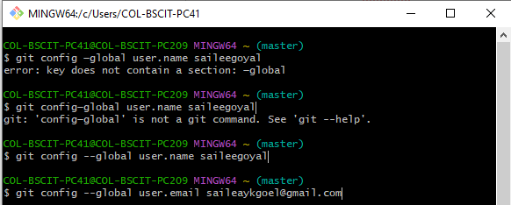

1. Git init:

Syntax:

Command: git init

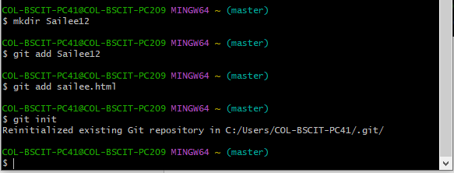

1. Git clone:

Syntax: git clone url <https://github.com/saileegoyal/LearnGit.git>

Command: git

1. Git add:

Git add *.htmlfile

Git add*.javafile

Git commit-m firstcommit

Git log

1. Push command

Syntax: git remote add origin url

git remote show orign