Regex Matching Engine V2
A From-Scratch Guide to How the Project Works
A beginner-first technical report: no previous knowledge of compiler design, regular expressions, finite automata, Python, APIs, or web dashboards is assumed.
Team member | Registration number
Aprark | 24BCI0052
Aayushi | 24BCE0481
Shrey | 24BCE2454

What this report does
It starts with the meaning of a character and a string, builds the necessary compiler-design ideas one at a time, follows a pattern through every project stage, explains the actual source modules and dashboard, and ends with exact run commands, measured behavior, safety limits, testing, glossary, and limitations.

Contents
Part | What the reader will learn
1. Foundations | Characters, strings, languages, regex, compilers, and why this is a compiler-design project
2. The complete pipeline | What enters the system, every transformation, and what comes out
3. Parsing | Grammar, precedence, cursor-based reading, AST nodes, and diagnostics
4. NFA construction | States, transitions, epsilon, fragments, and Thompson’s rules
5. DFA matching | Epsilon closure, move, subset states, laziness, caching, and full-string semantics
6. V2 features | Character classes, numeric repetition, symbolic input classes, and minimization
7. Project surfaces | Simulation, analysis, API, dashboard, and test suite
8. Evidence and operation | Measured comparison, safety budgets, files, commands, glossary, and limitations

How to read the notation
Notation | Plain-language meaning
'a' | One character: the lowercase letter a
abc | A string containing a, then b, then c
ε | The empty string: zero characters
∅ | No possible state or result
q0, q1 | Names used for automaton states
{q0, q2} | A set containing two states
→ | The next transformation or transition

Important scope
This engine performs full-string matching. The complete input must fit the complete pattern. It is not a substring search tool and it does not use Python’s built-in regular-expression engine to decide matches.

1 Foundations: the ideas needed before the code

1.1 Characters, strings, alphabets, and languages
A character is one unit of text, such as a, 7, ?, or a Unicode symbol. A string is an ordered sequence of characters. The empty string contains no characters and is written ε. The length of ε is zero. An alphabet is the set of characters allowed in a discussion. A language is a set of strings. In compiler design, a language does not mean English or Hindi; it means precisely which strings are considered valid.
Term | Example | Meaning
Character | a | One text symbol
String | abba | Four characters in order
Empty string | ε | A valid string of length zero
Alphabet | {a,b} | Only a and b are being considered
Language | {a, ab, abb, ...} | A selected set of strings

1.2 What is a regular expression?
A regular expression, shortened to regex, is a compact description of a language. The pattern a*b describes every string containing zero or more a characters followed by exactly one b. Therefore b, ab, aaab, and aaaaab belong to this language, while a, ba, and aaba do not.
Pattern part | Name | Plain meaning | Example accepted text
a | literal | Match exactly a | a
. | wildcard | Match any one character | x
ab | concatenation | Match a and then b | ab
a|b | alternation | Match a or b | b
a* | Kleene star | Zero or more a characters | aaa
a+ | plus | One or more a characters | a
a? | optional | Zero or one a | ε or a
(ab) | group | Treat ab as one unit | ab
[a-z] | class range | One lowercase a through z | m
[^0-9] | negated class | One character that is not a digit | Q
a{2,4} | numeric repeat | Two, three, or four a characters | aaa

1.3 What is a compiler?
A compiler translates one representation into another while preserving meaning. A programming-language compiler may translate source code into machine code. This project translates a regex from human-readable syntax into machine-executable automata. The destination is not CPU instructions; it is a network of states and transitions that can consume input characters and decide MATCH or NO MATCH.
Regex text | → | Syntax tree | → | NFA | → | Lazy DFA | → | Decision

Why this counts as compiler design
It has a source language, grammar, parser, intermediate representation, code-like lowering stages, execution model, diagnostics, resource limits, and correctness tests—the same categories found in larger compilers, on a deliberately smaller language.

2 The complete system from input to result

2.1 Inputs and outputs
The main match operation receives two strings: a pattern and an input. For example, pattern (a|b)*abb and input aabb. The output contains a Boolean decision, structured error data if compilation failed, the number of lazy-DFA states explored, and a bounded transition trace for the interface.
Stage | Receives | Produces | Actual module
Parse | Pattern text | Abstract syntax tree | regex_engine/parser.py
Construct | Syntax tree | Thompson NFA | regex_engine/nfa.py
Prepare | NFA | Lazy DFA start state | regex_engine/dfa.py
Execute | DFA + input | MATCH or NO MATCH | regex_engine/matcher.py
Explain | Pattern + input | NFA/DFA step table | regex_engine/simulation.py
Analyze | Workload | Timing and size metadata | regex_engine/analysis.py
Serve | JSON requests | JSON responses + dashboard | server/main.py and web/

2.2 A running example
We will repeatedly use (a|b)*abb. Read it left to right as: choose a or b, repeat that choice zero or more times, and finally require a, then b, then b. It describes all a/b strings ending in abb. The input aabb matches because it ends in abb. The input abab does not.
Layer | Representation of the same meaning
Source pattern | (a|b)*abb
Informal meaning | Any a/b prefix, followed by abb
AST shape | Concat(Star(Union(a,b)), a, b, b)
NFA meaning | Several possible active states connected by symbol and ε transitions
DFA meaning | One current subset of NFA states after each input character
Result for aabb | MATCH, because the final subset contains the NFA accept state

2.3 Compile once, match repeatedly
compile_pattern is cached for up to 256 distinct pattern strings. The first use parses and constructs the automata. Reusing the same pattern can reuse that compiled object. A re-entrant lock protects the shared lazy-DFA cache so concurrent requests do not mutate it unsafely. This cache is an optimization; it does not change the language accepted by the pattern.
Two uses of the word state
A parser state means where the parser cursor is. An automaton state means a node in an NFA or DFA. They are related only by the general idea of remembering the current situation.

3 Parsing: turning symbols into structure

3.1 Why parsing is necessary
The text a|bc is ambiguous unless precedence rules are defined. This project gives repetition the highest precedence, concatenation the next precedence, and alternation the lowest. Therefore a|bc means a or (b followed by c), not (a or b) followed by c. Parentheses override the normal grouping.
Priority | Operation | Example | Interpretation
Highest | Postfix repeat | ab* | a followed by zero or more b
Middle | Concatenation | abc | a, then b, then c
Lowest | Alternation | a|bc | a, or the complete string bc
Explicit | Parentheses | (a|b)c | a or b first, then c

3.2 The grammar in plain language
union := concat ('|' concat)*
concat := repeat*
repeat := atom postfix?
atom := literal | '.' | class | '(' union ')' | escaped-character
postfix:= '*' | '+' | '?' | numeric-repeat

The := symbol means ‘is formed from’. The final * in the grammar is descriptive notation meaning repeat the grammar piece, not the star token being parsed. union first asks for a concatenation and then absorbs additional | branches. concat collects adjacent repeated atoms. repeat attaches at most one postfix operator to one atom. atom recognizes the smallest units.

3.3 Cursor-based reading
The Parser object stores the complete pattern and a cursor position. peek observes the current character without consuming it. advance returns the current character and moves the cursor one place. Each grammar function consumes exactly the characters belonging to its construct. At the end, parse verifies that no unexpected character remains.
• Loops parse long flat concatenations and alternations without growing Python’s call stack.
• Recursion is used only when parentheses create real nesting.
• Group nesting is counted and rejected above 200 levels.
• The top-level empty pattern is legal and becomes an Empty AST node; an empty group or alternation branch is an error.

3.4 Abstract syntax tree (AST)
An AST keeps meaning and removes punctuation that is no longer needed. Each node is a data object. Literal stores one character. AnyChar represents the dot wildcard. CharClass stores explicit characters plus a negated flag. Concat and Union store ordered child lists. Star, Plus, Optional, and Repeat wrap one inner node.
AST node | Children/data | Meaning
Empty | none | Accept only ε
Literal | character | Accept exactly that character
AnyChar | none | Accept any one character
CharClass | characters + negated | Accept membership or non-membership
Concat | parts | Accept parts in sequence
Union | branches | Accept any one branch
Star / Plus / Optional | inner | Apply repetition rule
Repeat | inner, minimum, maximum | Apply numeric repetition

3.5 Parsing the running example step by step
Cursor sees | Parser action | AST result so far
( | Start a group and recursively parse its contents | pending group
a | Create Literal('a') | a
| | Finish first concat and start another union branch | Union(a, ...)
b | Create Literal('b') | Union(a,b)
) | Close the group | Union(a,b)
* | Wrap the group in Star | Star(Union(a,b))
a | Append another literal to concatenation | ..., a
b | Append b | ..., a, b
b | Append final b | ..., a, b, b
end | Return the complete root | Concat(Star(Union(a,b)),a,b,b)

3.6 Character classes
Inside brackets, ordinary characters are collected into a set. A hyphen between two valid endpoints expands an inclusive range, so [a-c] becomes {a,b,c}. A leading ^ after [ negates membership. Escapes allow a class metacharacter to be literal. A descending range such as [z-a], an unclosed class, or an empty class is rejected with a typed diagnostic.

3.7 Numeric quantifiers
Form | Minimum | Maximum | Meaning
{m} | m | m | Exactly m copies
{m,n} | m | n | Between m and n inclusive
{m,} | m | unbounded | At least m copies

The parser checks for missing numbers, missing closing braces, a maximum smaller than the minimum, and counts above 1,000. Only one postfix quantifier is allowed, so a** or a+? is rejected rather than assigned an accidental meaning.

3.8 Structured errors instead of crashes
RegexSyntaxError carries a stable code, human message, start and end positions, and an optional hint. diagnostic extracts a short context window and creates a caret pointer. RegexLimitError represents a safe refusal when an input or automaton would exceed a budget. The public match function catches both and returns a MatchResult; malformed user input does not leak a Python traceback.
Pattern: a{4,2}
Code: reversed_repeat_bounds
Context: a{4,2}
^^^^^
Meaning: the upper bound cannot be smaller than the lower bound

4 Finite automata: machines made of states

4.1 The four ingredients
A finite automaton is a small abstract machine. It has a finite set of states, one start state, some accepting states, and labeled transitions. It reads the input from left to right. A transition answers: if the machine is here and sees this character, where may it go next?
Ingredient | Question it answers
State | What situation is the machine currently remembering?
Start state | Where is the machine before reading any character?
Transition | Where can it move after consuming a character?
Accept state | Is the complete consumed input valid?

4.2 NFA versus DFA
Property | NFA | DFA
Full name | Nondeterministic finite automaton | Deterministic finite automaton
Next choices | May have zero, one, or many | At most one for a character
ε transitions | Allowed | Not used during matching
Runtime representation | Set of active states | One DFA state
Ease of construction | Very convenient from regex syntax | Convenient and fast to execute

Nondeterministic does not mean random. It means the mathematical machine may follow all valid choices at once. Software represents those simultaneous possibilities as a set. A DFA state can therefore be understood as one frozen set of NFA states.

4.3 Epsilon transitions
An ε transition moves without consuming an input character. It is wiring used to combine fragments. If q0 has an ε transition to q1, the NFA may be in q1 immediately while the input cursor stays in the same place. Epsilon closure repeatedly follows ε transitions until no new state can be reached.
Common misconception
ε is not a visible letter in the input. It represents consuming nothing. An ε transition can change the machine state but cannot advance the input position.

4.4 Thompson construction and fragments
The project uses Thompson construction. Every AST node is compiled into a fragment containing a start state and an accept state. Larger fragments are built by connecting smaller fragments with ε transitions. This gives a simple, systematic rule for every supported regex operator.

4.5 Thompson rules, one operator at a time
AST form | Construction rule | Why it works
Literal a | Two states; a transition from start to accept | Exactly one a must be consumed
Wildcard/class | Two states; symbolic transition | Exactly one matching character is consumed
Concat XY | Connect X accept to Y start with ε | Y begins only after X finishes
Union X|Y | New start fans out to X/Y; accepts join | Either branch may succeed
Star X* | May skip X; after X may loop or exit | Allows zero or more copies
Plus X+ | Must enter X; then may loop or exit | Allows one or more copies
Optional X? | May enter X or skip directly | Allows zero or one copy
Repeat | Build required copies, optional copies, and possibly a trailing star | Reduces numeric syntax to the primitive rules

4.6 Internal NFA representation
NFAState stores a mapping from a transition symbol to target state IDs plus a separate epsilon target set. A literal symbol is a character. The wildcard uses an ANY sentinel. A character class uses an immutable CharSet object. symbol_matches centralizes the question ‘does this symbolic edge accept this input character?’ State IDs are allocated by the builder and are stable within that constructed NFA.

4.7 Why the NFA grows linearly
Each primitive and operator adds a bounded number of states around its children. A flat pattern therefore produces an NFA whose size grows roughly in proportion to the pattern representation. Numeric repeats deliberately copy the inner fragment, which is why repeat counts are capped at 1,000 and total NFA states are capped at 50,000.

4.8 Worked miniature: a|b
new start --ε--> a-start --a--> a-accept --ε--> new accept
\--ε--> b-start --b--> b-accept --ε--/

Before reading input, epsilon closure activates the new start and both branch starts. Reading a reaches the a-accept, then closure reaches the final accept. Reading b follows the other branch. Reading c reaches no symbol transition and therefore cannot match.

5 From NFA choices to deterministic matching

5.1 The move operation
move receives a set of active NFA states and one input character. It inspects outgoing symbol transitions from every active state, tests each symbol with symbol_matches, and unions all matching targets. It does not follow epsilon transitions; that is handled by epsilon_closure immediately afterward.

5.2 One character-processing cycle
Current subset | → | move(char) | → | ε closure | → | Next subset | → | accept?

1. Start with epsilon_closure({NFA start}).
2. For the next input character, compute all symbol-transition targets.
3. Expand those targets through every reachable ε transition.
4. Treat the resulting frozen set as the next DFA state.
5. After the entire input, accept only if that set contains the NFA accept state.

5.3 Subset construction
Classic subset construction can build every reachable NFA-state subset in advance. The theoretical maximum for an N-state NFA is 2^N subsets. Many of those subsets are never needed for a real input. This project therefore performs subset construction lazily: it creates a DFA state only when matching or graph exploration asks for a transition that reaches it.

5.4 LazyDFA internals
Each DFAState has an integer ID, a frozenset of NFA state IDs, and an is_accept flag. LazyDFA keeps a dictionary from frozenset to the canonical DFAState object and a transition cache. The start DFA state is the epsilon closure of the NFA start. A missing move returns None, which acts as immediate rejection rather than storing a permanent dead state in normal matching.

5.5 Character signatures and cache reuse
A transition cannot be cached only by the literal input character when wildcard and character classes exist. Instead, character_signature describes how a character behaves against the NFA’s symbolic transitions. Characters with the same signature share one cached transition. For example, many characters not explicitly mentioned by a pattern can share the same ‘other’ behavior.

5.6 Full-string matching
The engine begins before the first character, consumes characters in order, and checks acceptance only after all characters are consumed. If a transition becomes impossible, it rejects early. This is equivalent to asking whether the input belongs to the complete language of the pattern, not whether any substring happens to fit.

5.7 The public match algorithm in exact order
Step | Operation | Possible result
1 | Look up or compile the pattern | CompiledPattern or structured syntax/limit error
2 | Reject input above 2,000,000 characters | Limit result
3 | Lock the shared compiled object | Safe access to lazy cache
4 | Set current state to DFA start | Initial trace row
5 | For each character, call dfa.step | Next state, None, or state-limit error
6 | Record at most 500 trace rows | Bounded UI data
7 | Test final state’s is_accept flag | MATCH or NO MATCH
8 | Return counts and diagnostics | MatchResult data object

5.8 A trace of (a|b)*abb against aabb
The exact numeric state IDs depend on the constructed NFA, but the semantic progression is stable. The subset after each character remembers every suffix-progress possibility that remains alive.
Input position | Character | Conceptual situation | Accept?
0 | — | At start; star may repeat or finish; final abb may begin | No
1 | a | Prefix loop remains possible; suffix has matched a | No
2 | a | Prefix loop remains possible; newest suffix candidate has matched a | No
3 | b | A candidate suffix has matched ab | No
4 | b | A candidate suffix has matched abb | Yes

Why multiple possibilities matter
After reading an a, the engine cannot know whether that a belongs to the arbitrary prefix or is the first character of the final abb. The NFA keeps both possibilities. The corresponding DFA subset packages them into one deterministic runtime state.

5.9 Thread safety and the compilation cache
lru_cache(maxsize=256) avoids rebuilding frequently used patterns. Since the LazyDFA inside a compiled pattern learns new states and transitions, CompiledPattern owns an RLock. Matching the same compiled object is serialized around that mutation. Simulations create a fresh LazyDFA when they need deterministic isolated state numbering.

6 V2 language and automata features

6.1 Character classes are symbolic edges
A class such as [A-Za-z] does not create one NFA branch for every letter. It becomes one CharSet transition holding the accepted set. A negated class reverses membership: [^0-9] accepts a character if it is not in the stored digit set. This compact representation is important for graph size and Unicode behavior.

6.2 Numeric repetition is compiled, not interpreted at runtime
Repeat nodes are lowered during NFA construction. For {m}, the builder concatenates m copies. For {m,n}, it adds m required copies and n−m optional copies. For {m,}, it adds m required copies followed by a star copy. The matcher therefore needs no special counter; it executes the resulting ordinary automaton.

6.3 Symbolic input equivalence classes
For complete-DFA graphing and minimization, the engine groups characters that cause identical NFA transition behavior. Each group has a representative character and a readable label. The dashboard draws compact edge labels C0, C1, and so on, then shows the full meaning in a legend. One extra representative covers characters not explicitly mentioned by the pattern.
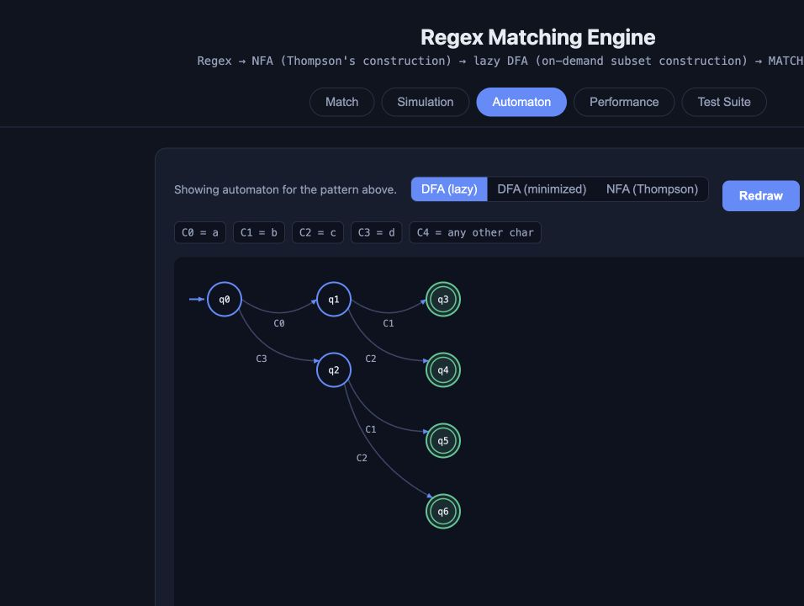
Lazy DFA graph: compact C-labels keep class-heavy transitions readable; the legend expands their meanings.

7 DFA minimization from first principles

7.1 What minimization means
Two DFA states are equivalent if no possible future input can make one accept and the other reject. Equivalent states remember different histories but have identical future behavior. Minimization merges them, producing a smaller DFA that recognizes exactly the same language.

7.2 Why a complete DFA is required
The minimizer needs a defined destination for every state and every symbolic input class. It therefore constructs a complete reachable DFA and includes the empty subset as a dead state. The dead state represents ‘the match has already become impossible’; every later character remains dead. Normal lazy matching does not need to store this state, but formal minimization does.

7.3 Partition refinement
1. Build every reachable complete-DFA state over the symbolic input classes.
2. Split states into two initial groups: accepting and non-accepting.
3. For each state, record which current group each input class leads to.
4. If two states in one group have different destination-group signatures, split the group.
5. Repeat until no group changes. Each remaining group becomes one minimized state.

7.4 Demonstration workload
The project’s live demonstration uses (ab|ac|db|dc). Before minimization, the complete reachable DFA has 8 states. Partition refinement merges equivalent suffix situations, leaving 4 states. The reduction is 4 states, or 50%. The language remains exactly the four strings ab, ac, db, and dc.
Input | Expected | Reason
ab | MATCH | Listed branch
ac | MATCH | Listed branch
db | MATCH | Listed branch
dc | MATCH | Listed branch
aa | NO MATCH | Second character is invalid
abc | NO MATCH | Full-string match rejects the extra c
 | NO MATCH | Two characters are required

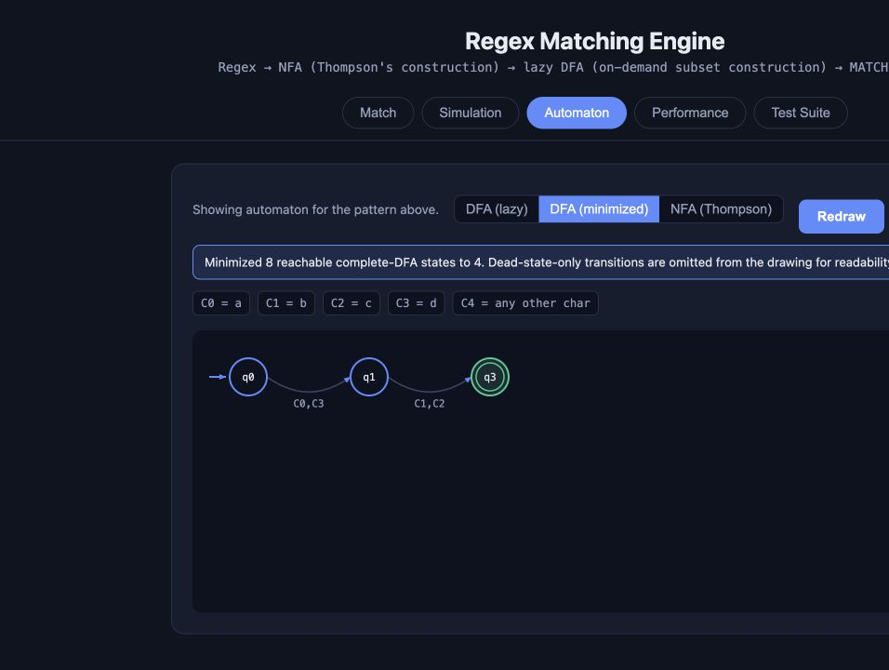
Minimized DFA view. Dead-state-only edges are omitted from the drawing for readability, while the minimization calculation still includes the dead state.

8 Simulation: making invisible execution visible

8.1 NFA simulation
NFA simulation begins with an epsilon closure. For each input character it reports the previous active states, symbol transitions actually taken, direct move targets, the next epsilon-closed active set, and whether the accept state is active. States and transitions are sorted so repeated runs are deterministic and easy to compare.

8.2 DFA simulation
DFA simulation starts from a fresh LazyDFA, records the current DFA ID and its underlying NFA subset, then records one row per consumed character. A missing transition is shown as a dead step. The result is MATCH only if all input was consumed and the final state is accepting.
NFA column | Meaning
before_states | Epsilon-closed set before consuming the character
transitions | Matching labeled NFA edges taken
move_states | Direct symbol-edge targets
active_states | Move targets after epsilon closure
accept | Whether the NFA accept is active

DFA column | Meaning
from_state | DFA ID before the character
dfa_state | DFA ID after the character, or null
nfa_states | The subset represented by the new DFA state
dead | True when no transition exists
accept | Whether the represented subset contains NFA accept

8.3 Simulation budgets
The engine returns at most 500 displayed steps and at most 200 transition records per NFA step. Matching may continue after the display limit; only explanatory output is truncated. This prevents a huge input from generating a huge browser table or response object.

8.4 Match trace versus simulation
MatchResult contains a lightweight DFA trace for normal use. The simulation module provides richer pedagogical data and supports both NFA and DFA modes. Keeping explanation separate from the minimal match path makes the normal API simpler while allowing the dashboard to teach the algorithm.

9 Performance analysis and measured evidence

9.1 What the built-in analyzer measures
analysis.py deliberately creates a fresh AST and NFA, attempts complete-DFA minimization, creates a fresh lazy DFA, performs five warm-up runs, and then measures 1 to 100 repeated matches with time.perf_counter_ns. It reports minimum, median, 95th percentile, and maximum time, plus environment metadata and a SHA-256 checksum of the workload.
Field | Why it exists
Warm-ups | Populate the lazy transition cache before timed matching
Repeats | Reduce dependence on one noisy timing sample
Median | Describe the typical measured run
p95 | Show a high-end value without using only the single maximum
Checksum | Prove which exact pattern/input pair was measured
Environment | Record Python, platform, and machine
State counts | Connect runtime observations to automaton size

9.2 Fair V1 versus V2 protocol
The project review benchmark checked out V1 commit 09de2a6 in an isolated copy and ran V1 and V2 with the same Python executable, machine, workload strings, warm-ups, repeat count, and process-level measurement method. Only syntax supported by both versions was used. V2-only character classes and numeric quantifiers were measured separately rather than pretending V1 could run them.
Workload | V1 median ms | V2 median ms | V2/V1 | DFA states V1/V2 | Peak RSS MiB V1/V2
suffix-language | 0.453 | 1.563 | 3.45× | 4/4 | 27.31/27.39
wildcard-scan | 0.410 | 1.866 | 4.55× | 4/4 | 27.45/27.39
alternation-loop | 0.417 | 1.671 | 4.01× | 7/7 | 27.44/27.41

On these three shared-syntax workloads, V2 matching was 3.45× to 4.55× slower while NFA/DFA state counts and peak process memory remained effectively flat. The source-grounded explanation is that V2 computes generalized symbolic-class signatures for characters. This is an honest measured limitation, not a claim that V2 is universally slower or that the difference applies to every workload.

10 Server and dashboard

10.1 Backend architecture
FastAPI receives browser requests, validates field sizes with Pydantic models, calls the engine, converts data classes to JSON-compatible dictionaries, and serves the static dashboard. The frontend is plain HTML, CSS, and JavaScript; there is no separate build step. StaticFiles mounts web/ at the root path.
Endpoint | Method | Purpose
/api/match | POST | Compile and full-match one pattern/input pair
/api/automaton | POST | Return NFA, lazy-DFA, or minimized-DFA graph data
/api/simulate | POST | Return detailed NFA or DFA steps
/api/analyze | POST | Return bounded reproducible metrics
/api/tests | GET | Run and return the predefined dashboard suite
/ | GET | Serve the browser dashboard

10.2 The five dashboard tabs
Tab | User action | What happens internally
Match | Enter regex and input | Calls /api/match; shows decision, diagnostics, trace
Simulation | Choose NFA or DFA | Calls /api/simulate; fills a step table
Automaton | Choose graph kind | Calls /api/automaton; draws states, arrows, and class legend
Performance | Choose repeat count | Calls /api/analyze; displays timing and size data
Test Suite | Run built-in cases | Calls /api/tests; compares expected and actual results

10.3 Graph generation
NFA graph data combines parallel labels between the same source and target. Lazy-DFA graph generation performs breadth-first exploration over symbolic input classes and uses C-labels. The minimized graph includes reduction metadata but omits the dead state and edges leading only to it from the picture. Rendering caps are 500 NFA states and 300 DFA states; truncation is reported rather than silently exhausting the page or browser.

10.4 Request validation
API models cap patterns at 20,000 characters and inputs at 2,000,000 characters before the engine runs. The regex parser, NFA builder, DFA builder, simulation, analysis, and rendering paths add their own narrower budgets. Defense in depth means a missed check in one layer is less likely to become uncontrolled resource use.

11 Testing and correctness

11.1 What ‘correct’ means
Correctness requires more than returning MATCH for a few examples. The parser must assign the intended structure, malformed syntax must be rejected, Thompson fragments must be connected correctly, lazy DFA caching must preserve behavior, NFA and DFA simulations must agree, minimization must preserve the language, limits must fail safely, and the HTTP endpoints must serialize useful responses.

11.2 Automated test groups
Test file | Primary responsibility
test_parser.py | AST structure, escapes, malformed patterns, nesting and length
test_nfa.py | Literal/concat/union/star construction and linear size
test_dfa.py | Lazy materialization, cache reuse, dead transitions, signatures
test_matcher.py | End-to-end decisions, diagnostics, unknown input characters
test_limits.py | Explosion avoidance, long input, caps, never-crash behavior
test_simulation.py | Deterministic NFA/DFA steps and dead transitions
test_analysis.py | Bounded self-describing measurements
test_server.py | Graph, simulation, analysis, and label API contracts
test_v2_syntax_and_automata.py | Classes, repeats, minimization, cross-checks

11.3 Differential and preservation tests
For the supported subset, V2 syntax tests compare outcomes with Python re.fullmatch. This is differential testing: an independent mature implementation acts as an oracle for overlapping semantics. Separate tests compare minimized and lazy DFAs across inputs to verify that minimization changes state organization but not the accepted language.

11.4 Dashboard suite
server/test_suite.py defines 29 visible cases across valid inputs, V2 classes, V2 quantifiers, ordinary non-matches, boundaries, and malformed regexes. A malformed case passes when the engine reports an error instead of raising. The long-input case uses 10,000 a characters. This suite is demonstrative evidence in the UI; the complete pytest suite is the deeper engineering check.
Verified project state
The last full verification associated with this build reported 117 passing pytest tests. The guide-generation step does not alter engine source or test behavior; the final handoff should still include the exact command so the reader can rerun verification locally.

12 Safety budgets and graceful failure
Regex engines can consume extreme time or memory when patterns or outputs become enormous. This educational engine uses explicit, documented ceilings. Reaching a ceiling returns a RegexLimitError or truncation flag; it does not intentionally continue until the process crashes.
Resource | Limit | Reason
Pattern length | 20,000 characters | Bound parsing and request size
Group nesting | 200 | Bound recursive group parsing
Character-class size | 4,096 explicit characters | Bound stored class data
Numeric repeat count | 1,000 | Bound expansion during NFA construction
NFA states | 50,000 | Bound automaton memory
Lazy DFA states | 20,000 | Bound on-demand subset cache
Complete DFA for minimization | 5,000 states | Bound exhaustive exploration
Symbolic alphabet classes | 2,048 | Bound transition columns
Input length | 2,000,000 characters | Bound match work
Displayed simulation steps | 500 | Bound response and browser table
Transitions per simulation step | 200 | Bound detailed trace size
NFA/DFA graph nodes | 500 / 300 | Bound graph rendering
Analysis repeats | 100 | Bound benchmark duration

12.1 Limits versus syntax errors
A syntax error means the pattern has no valid interpretation in the supported language, such as an unmatched parenthesis. A limit error means the pattern may be meaningful but this implementation refuses its requested scale, such as 20,001 pattern characters. Keeping these categories separate helps users correct the right problem.

12.2 Why laziness is also a safety mechanism
The power-set worst case belongs to complete subset construction. Normal matching materializes only states reached by actual characters, and stops immediately on a dead transition. This does not remove the theoretical worst case, so the 20,000-state cache cap remains necessary, but it makes ordinary workloads much more practical.

13 Project file map
Path | What it contains
regex_engine/parser.py | Grammar, AST node classes, cursor parser, syntax validation
regex_engine/nfa.py | Thompson construction, NFA data model, symbolic transitions
regex_engine/dfa.py | Epsilon closure, move, lazy DFA, input classes, minimization
regex_engine/matcher.py | Compilation cache, public match operation, MatchResult
regex_engine/simulation.py | Deterministic explanatory NFA and DFA traces
regex_engine/analysis.py | Bounded reproducible performance measurements
regex_engine/errors.py | Structured syntax diagnostics and limit errors
server/main.py | FastAPI request models, endpoints, graph extraction, static hosting
server/test_suite.py | 29 visible dashboard cases
web/index.html | Five-tab page structure
web/app.js | API calls, tables, diagnostics, graph drawing
web/style.css | Dashboard layout and appearance
tests/ | Unit, integration, safety, equivalence, and endpoint tests
docs/V2_SEMANTICS.md | Exact V2 semantics, budgets, and analysis protocol
scripts/review_benchmark.py | Fair isolated V1/V2 review benchmark
benchmarks/review_2026_10_27/ | Raw data, environment metadata, and graphs
review/ | Review report, presentation, demo guide, and this beginner guide

13.1 Dependency direction
web | → | server | → | matcher | → | parser/NFA/DFA | → | result

The engine layer does not depend on the browser. The server imports the engine. The browser speaks JSON to the server. This separation allows pytest to verify core algorithms without launching a browser and allows another interface to reuse the engine later.

13.2 Data objects instead of loose dictionaries
Core structures use Python data classes: AST nodes, NFA states, DFA states, compiled patterns, diagnostics, and results. Data classes make fields explicit and support reliable conversion to dictionaries at the API boundary. Frozen data such as CharSet and syntax diagnostics cannot be accidentally mutated after creation.

14 Running the project from scratch

14.1 Requirements
• A terminal on the machine containing the project directory.
• Python and the project virtual environment at .venv.
• A modern browser for the dashboard.
• No Node.js build step and no external database are required.

14.2 Run the complete automated suite
cd /Users/shrey/Documents/compiler/project
PYTHONDONTWRITEBYTECODE=1 ./.venv/bin/python -m pytest -q -p no:cacheprovider

PYTHONDONTWRITEBYTECODE=1 prevents .pyc cache files during the check. -q requests concise output. -p no:cacheprovider prevents pytest’s cache directory. A successful run ends with the passed-test count and no failures.

14.3 Start the dashboard
cd /Users/shrey/Documents/compiler/project
./.venv/bin/python -m uvicorn server.main:app --reload --port 8008

uvicorn runs the FastAPI application object named app in server/main.py. --reload restarts the server when source changes. --port 8008 selects the local TCP port. Keep this terminal open, then visit http://127.0.0.1:8008 in a browser. Stop the server with Control-C.

14.4 First manual walkthrough
1. In Match, enter (a|b)*abb and aabb. Expect MATCH.
2. Change the input to abab. Expect NO MATCH.
3. Enter a{4,2}. Expect a structured diagnostic pointing to the invalid bounds.
4. In Simulation, compare NFA and DFA rows for ab.
5. In Automaton, enter (ab|ac|db|dc), choose Minimized DFA, and confirm 8 reachable states before and 4 after.
6. In Performance, use the default 25 repeats and read the warm-up, timer, and environment metadata.
7. In Test Suite, run all 29 visible cases and check expected versus actual.

14.5 Run the reproducible review benchmark
cd /Users/shrey/Documents/compiler/project
./.venv/bin/python scripts/review_benchmark.py --help

Read the help before launching a benchmark because the script manages an isolated V1 comparison and output paths. Existing measured data is preserved under benchmarks/review_2026_10_27; do not overwrite it unless intentionally producing a new dated run.

15 Complete worked example: [A-Za-z]{2,4}[0-9]{2}

15.1 Human meaning
The first class accepts one English letter, uppercase or lowercase. {2,4} requires two through four such letters. The second class accepts one digit. {2} requires exactly two digits. Therefore Ab12 and code99 match; A12 has too few letters, codes99 has too many letters, and Ab1 has too few digits.

15.2 Parser output
Concat(
Repeat(CharClass(A-Z and a-z), minimum=2, maximum=4),
Repeat(CharClass(0-9), minimum=2, maximum=2)
)

15.3 NFA construction
The first Repeat becomes two required letter-class fragments followed by two optional letter-class fragments. The second Repeat becomes two required digit-class fragments. Concatenation joins the fragments with epsilon transitions. Each class remains a symbolic edge rather than expanding to dozens of literal branches.

15.4 Lazy-DFA execution for Ab12
Consumed | Required progress | Outcome
A | First required letter | alive
b | Second required letter; minimum reached | alive
1 | Skip remaining optional letters; first required digit | alive
2 | Second required digit | accepting after complete input

15.5 Why the graph legend matters
A literal edge label containing every accepted letter would overlap states and arrows. The graph instead labels the transition C0 and places the complete description in a legend. Characters that behave the same are grouped, so the graph represents the automaton accurately without turning the canvas into unreadable text.

15.6 Failure cases
Input | Result | Exact reason
A12 | NO MATCH | Only one letter; minimum is two
codes99 | NO MATCH | Five letters; maximum is four
Ab1 | NO MATCH | Only one digit; exactly two required
Ab12x | NO MATCH | Extra trailing x; matching is full-string
12Ab | NO MATCH | Digit appears where a letter class is required

16 Glossary
Term | Beginner definition
Accept state | A state indicating that the complete consumed input is valid
Alphabet | The character set considered by a language or automaton
API | A defined way for software parts to exchange requests and responses
AST | A tree that stores the grammatical meaning of the pattern
Cache | Stored prior work reused to avoid recomputation
Character class | A regex atom matching one member (or non-member) of a set
Compiler | A translator from one formal representation into another
Concatenation | Placing regex pieces in sequence
DFA | A finite automaton with one defined current state during execution
Diagnostic | Structured information explaining an error and its location
Epsilon (ε) | The empty string; in an NFA, a move consuming no character
Epsilon closure | All states reachable through zero or more ε transitions
Fragment | A start/accept pair used while constructing an NFA
Full-string match | A match requiring every input character to be consumed
Grammar | Rules defining which patterns are valid and how they group
Language | The set of all strings accepted by a pattern or automaton
Lazy construction | Creating a state only when it is needed
Literal | A regex atom matching one exact character
NFA | An automaton that may keep multiple possible states at once
Parser | The component translating token characters into an AST
Partition | A group of states currently considered equivalent
Precedence | Rules deciding which operation binds more tightly
Quantifier | An operator specifying how many copies may occur
Regex | A compact description of a regular language
State | A finite memory position in an automaton
Subset construction | Representing a set of NFA states as one DFA state
Symbolic transition | An edge labeled by a predicate such as wildcard or class
Thompson construction | A rule-based conversion from regex AST to NFA
Transition | A labeled movement from one state to another
Unicode | A standard assigning text characters consistent code points
Wildcard | The dot atom, matching any one character

17 Limitations
This is a focused educational regular-expression engine, not a complete replacement for production regex libraries. Its limitations are deliberate and should be stated clearly.
Limitation | Practical effect
No anchors (^ and $) | Matching is already full-string; anchor syntax is not supported
No capturing groups | Parentheses group syntax but do not return captured substrings
No backreferences | A later part cannot demand the exact text captured earlier
No lookahead or lookbehind | The engine cannot assert context without consuming it
No shorthand classes | Syntax such as \d, \w, and \s is not implemented
No case-insensitive or multiline flags | Matching behavior cannot be switched with flags
No substring search | The entire input must match; there is no search/find-all operation
Numeric repeat expansion | Large repeats enlarge the NFA, so counts are capped at 1,000
Theoretical state explosion remains | Lazy construction reduces unnecessary work but cannot abolish worst cases
Complete minimization is bounded | Patterns needing over 5,000 reachable DFA states are refused
Graphs are capped | Large automata are truncated at documented display limits
Trace output is capped | Only the first 500 explanatory steps are returned
Shared compiled DFA uses a lock | Concurrent matches of the same pattern serialize cache mutation
Measured V2 overhead | Shared-syntax benchmark medians were 3.45×–4.55× slower than V1
Educational UI | The dashboard is local and has no accounts, persistence, or deployment hardening

17.1 Final understanding
The project is best understood as a small compiler followed by a small virtual machine. The parser gives structure to regex text. Thompson construction lowers that structure into an NFA. Lazy subset construction turns only needed NFA-state sets into deterministic runtime states. The matcher executes those states over a complete input. Simulation exposes the hidden steps, minimization merges equivalent complete-DFA states, analysis records bounded measurements, and the dashboard connects every capability to a visible interface.
One-sentence explanation for a review
Our project compiles a supported regular expression into a Thompson NFA, creates equivalent DFA subset states only when needed, and consumes the entire input deterministically, while also providing simulation, formal DFA minimization, reproducible analysis, diagnostics, tests, and explicit safety limits.

