Regex Matching Engine V2
Compiler Design Project Review Report
Team member | Registration number
Aprark | 24BCI0052
Aayushi | 24BCE0481
Shrey | 24BCE2454

Review conclusion
V2 adds character classes, numeric quantifiers, complete-DFA minimization, deterministic simulation, reproducible analysis, structured diagnostics, and a five-tab dashboard while preserving the lazy-DFA matching path and its safety limits.
The fair shared-syntax comparison found unchanged NFA and lazy-DFA state counts and effectively flat process memory. Core matching was slower in V2 by 3.45 to 4.55 times on the three measured workloads because each input character now uses generalized symbolic-class signature checks. The report records this result as a measured limitation.

1 Project scope and verified baseline
This project implements a full-string regular-expression matcher for a Compiler Design review. The implementation parses a pattern into an abstract syntax tree, applies Thompson construction to build an NFA, converts NFA subsets into DFA states on demand, and returns MATCH or NO MATCH. The local FastAPI dashboard exposes matching, simulation, automaton views, performance analysis, and a predefined test suite.
Reference | Verified value | Meaning
Current branch | feature/v2-regex-engine | Clean branch used for V2 measurements
Current commit | d09673e | Compact lazy-DFA graph labels
Completed V2 | 8719257 | All V2 upgrades before the graph-label fix
V1 checkpoint | 09de2a6 | Verified pre-V2 baseline
V1 tests | 82 passed | Run in an isolated archive of 09de2a6
V2 tests | 117 passed in 0.61 s | Run on d09673e before report generation

The V1 checkout came from a git archive of 09de2a6 in a temporary directory. It did not replace or modify the working branch. Both versions used the same project virtual environment and Python 3.14.5 interpreter.

2 Architecture
The matching path remains deliberately separate from complete-DFA construction. Normal matches materialize only the DFA states visited by the input. Minimization and analysis explicitly request a bounded complete DFA over symbolic input classes.
Stage | Implementation | Role
Regex source | regex_engine/parser.py | Recursive-descent parsing with explicit syntax and expansion limits
Abstract syntax tree | Node dataclasses | Captures precedence, groups, classes, and quantifiers
NFA | regex_engine/nfa.py | Thompson fragments joined by epsilon transitions
Lazy DFA | regex_engine/dfa.py | On-demand subset construction for normal matching
Complete minimized DFA | build_minimized_dfa | Bounded construction and partition refinement for review and analysis
Public interfaces | matcher, simulation, analysis, server | Stable results for CLI, API, and dashboard

2.1 Matching pipeline
Pattern | → | AST | → | NFA | → | Lazy DFA | → | Result

3 V2 changes

3.1 Character classes and numeric quantifiers
Character classes compile into a symbolic CharSet transition instead of one transition per character. Ranges expand into a bounded set of Unicode code points, and a negated class inverts membership during transition matching. Numeric quantifiers expand into required, optional, and Kleene-star fragments within repeat and total-NFA budgets.
Feature | Examples | Semantics
Character classes | [abc], [a-z] | Match one listed or ranged code point
Negated classes | [^0-9] | Match one code point outside the set
Exact repeat | x{m} | Match exactly m copies
Bounded repeat | x{m,n} | Match m through n copies
Open repeat | x{m,} | Match at least m copies

3.2 Complete-DFA minimization
The minimizer derives symbolic input-equivalence classes from literal, wildcard, and CharSet transitions. It builds every reachable DFA subset, adds the empty-set dead state where needed, separates accepting from non-accepting states, and repeatedly splits partitions whose transition signatures differ. Each stable partition becomes one minimized state.

3.3 Simulation diagnostics and dashboard
NFA simulation reports the active set, matching transitions, move set, epsilon closure, and acceptance after each input character. DFA simulation reports the current subset and acceptance. Structured syntax errors include a stable code, source positions, context, a caret pointer, and a repair hint. The dashboard now separates Match, Simulation, Automaton, Performance, and Test Suite views.

4 Fair V1 and V2 comparison

4.1 Measurement protocol
• The comparison uses only syntax supported by both V1 and V2. Character classes and numeric quantifiers do not appear in version ratios.
• Each version, workload, and round ran in a fresh process. Five rounds alternated V1-first and V2-first order to reduce ordering bias.
• Each round used 10 matching warmups and 40 measured matches, producing 200 timing samples per version and workload.
• Compilation used 5 warmups and 20 measurements per round, producing 100 compile samples per version and workload.
• Timing uses time.perf_counter_ns. Core matching traverses a precompiled warm LazyDFA directly, excluding HTTP handling and result-trace formatting.
• Memory includes tracemalloc peak Python allocations and process maximum RSS. RSS is coarse because it includes the interpreter and imported modules.
Workload | Pattern | Input length | Checksum prefix
Suffix language | (a|b)*abb | 4,003 | 9568152bab20
Wildcard scan | a.*z | 4,002 | dbb1b31c347d
Alternation loop | (ab|ac|db|dc)* | 4,000 | eee7eebab010

4.2 Matching runtime
Workload | V1 median ms | V2 median ms | V2/V1 | V1 p95 ms | V2 p95 ms
Suffix language | 0.453 | 1.563 | 3.45× | 0.471 | 1.593
Wildcard scan | 0.410 | 1.866 | 4.55× | 0.442 | 1.918
Alternation loop | 0.417 | 1.671 | 4.01× | 0.431 | 1.704

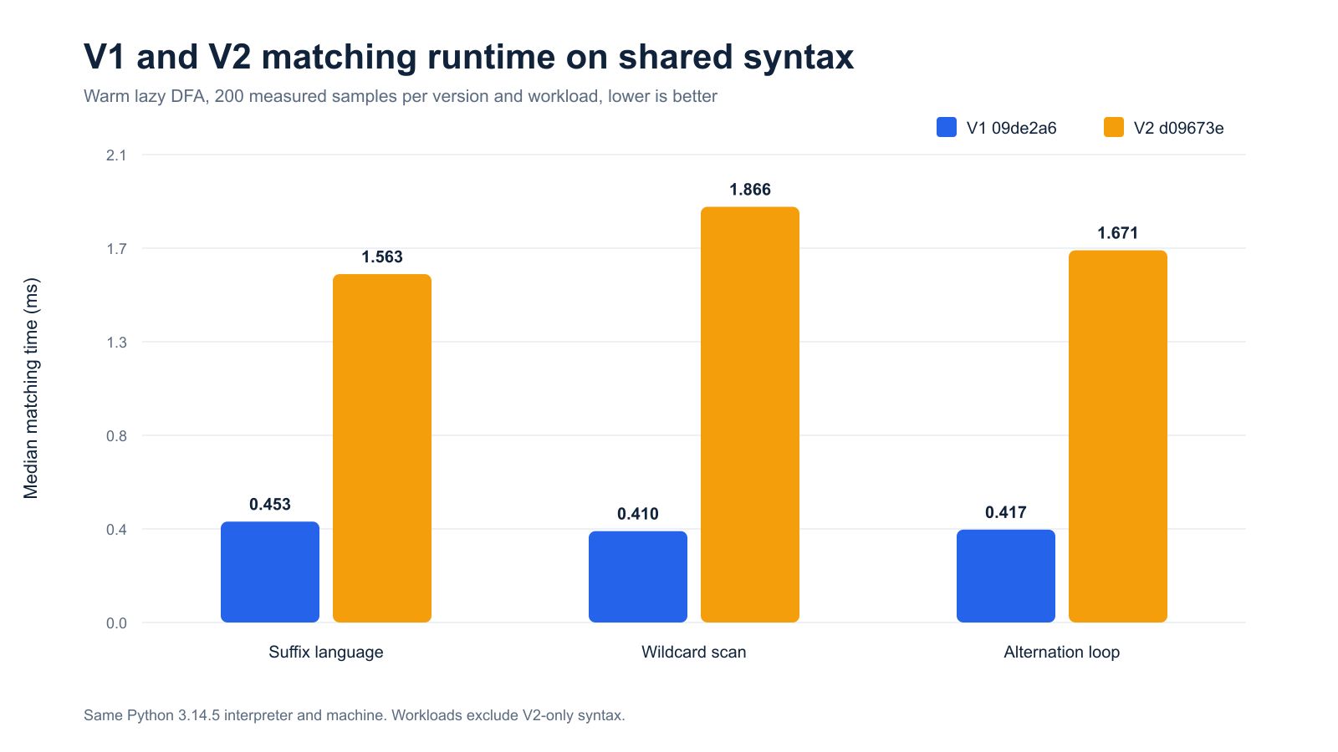
Figure 1. Median core matching time on shared syntax. Lower is better.
V2 was slower on all three shared-syntax workloads. The median ratio ranged from 3.45× to 4.55×. The state counts did not grow, so the measured cost comes from per-character work: V2 computes a generalized transition signature that supports literals, wildcards, positive classes, and negated classes. V1 uses a cheaper literal-or-wildcard cache key.

4.3 Memory and automaton size
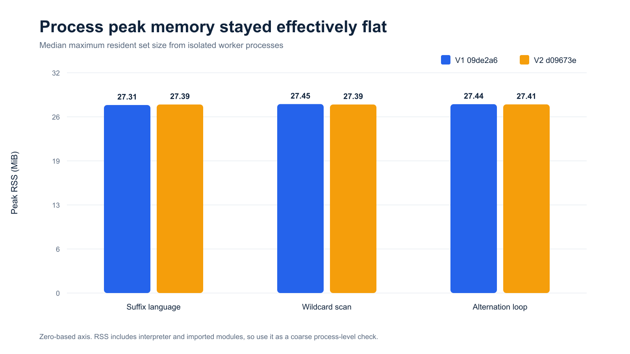
Figure 2. Median process peak RSS. The axis starts at zero to avoid exaggerating small differences.
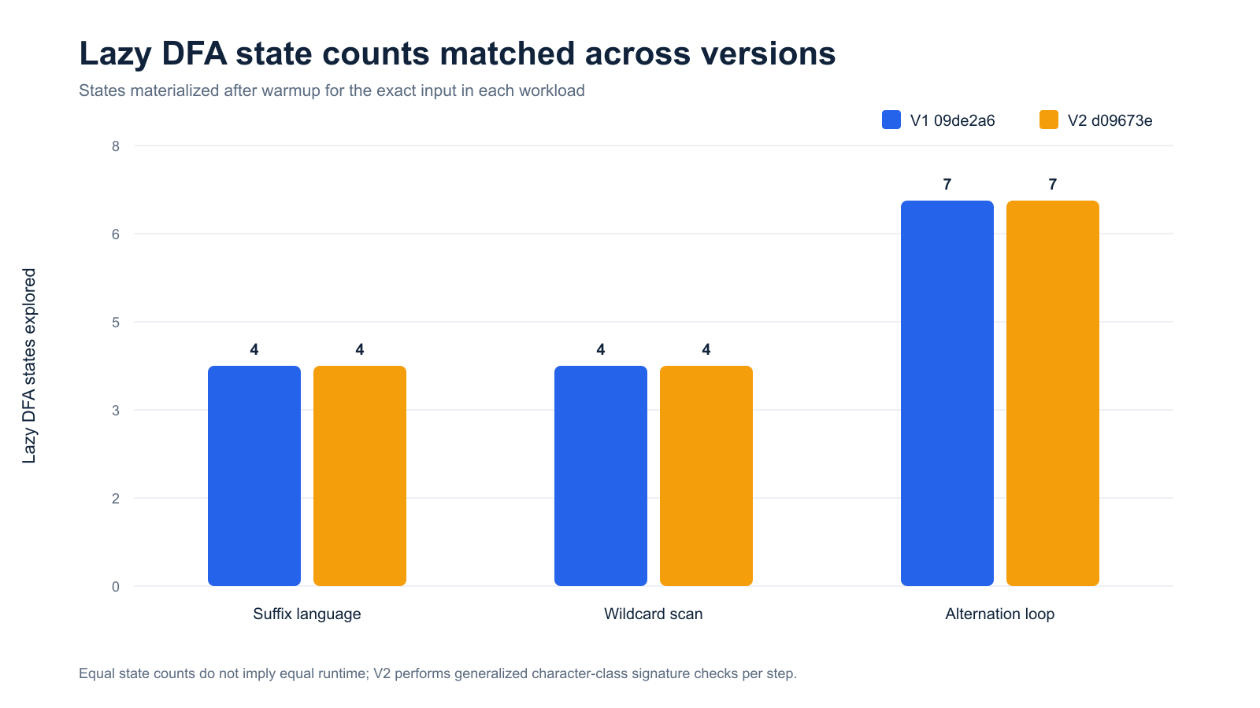
Figure 3. V1 and V2 explored identical lazy-DFA state counts on the shared workloads.
Workload | V1 RSS MiB | V2 RSS MiB | NFA states V1/V2 | Lazy DFA states V1/V2
Suffix language | 27.31 | 27.39 | 14 / 14 | 4 / 4
Wildcard scan | 27.45 | 27.39 | 8 / 8 | 4 / 4
Alternation loop | 27.44 | 27.41 | 20 / 20 | 7 / 7

Median maximum RSS differed by less than 0.3% in every workload. Median tracemalloc compile peaks were identical between versions for each workload. The incremental match probe rose from 224 bytes in V1 to 1,000 bytes in V2, but both values remain below 1 KiB and should be interpreted as Python-allocation probes rather than total memory use.

4.4 V2 feature workloads
Workload | Pattern | Input | Median ms | NFA | Lazy DFA | Complete → min
Class and range | [A-Za-z0-9_]{4,32} | 18 | 0.0083 | 120 | 19 | 34 → 34
Negated class | [^,]{1,1000} | 1000 | 0.5136 | 3998 | 1001 | 1002 → 1002

These measurements demonstrate V2-only behavior and are excluded from V1/V2 ratios. The negated-class case expands a {1,1000} quantifier to 3,998 NFA states and requires about 909 ms for complete-DFA minimization. Normal matching remains lazy and completed with a 0.514 ms median in the separate 25-repeat feature run.

5 Live DFA minimization demonstration
The review pattern (ab|ac|db|dc) makes equivalent states easy to explain. After reading a or d, the machine accepts the same suffix set: b or c. Its complete DFA has 8 reachable states including the dead state. Partition refinement produces 4 states, a 50.0% reduction.
cd /Users/shrey/Documents/compiler/project
./.venv/bin/python scripts/dfa_minimization_demo.py
Input | Expected | Reason
ab, ac, db, dc | MATCH | First symbol is a or d; second is b or c
aa | NO MATCH | Second symbol is outside b or c
cb | NO MATCH | First symbol is outside a or d
abc | NO MATCH | Full-string semantics reject the extra character
empty | NO MATCH | Exactly two characters are required

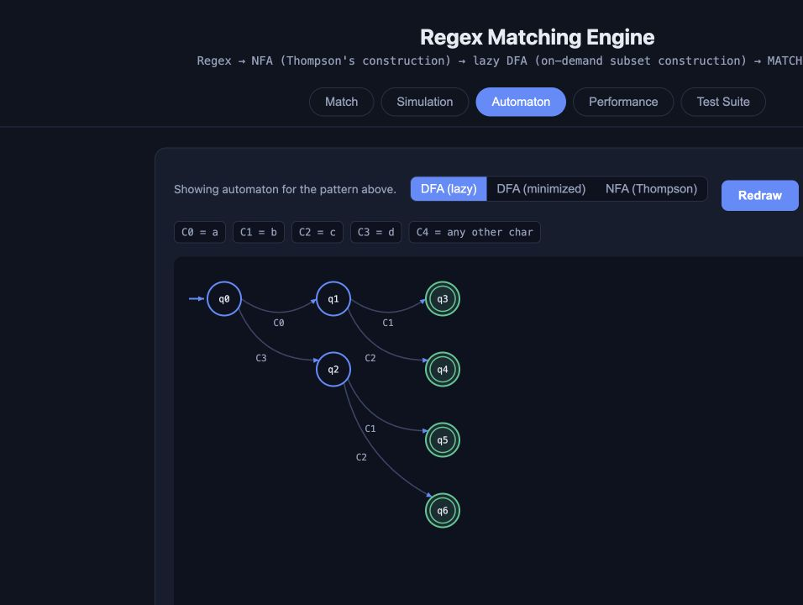
Figure 4. Dashboard lazy-DFA view before minimization.
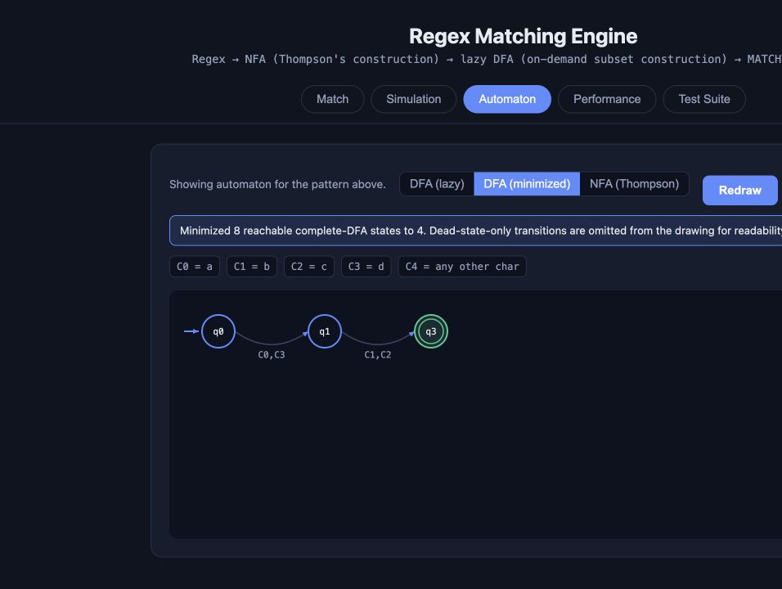
Figure 5. Dashboard minimized view. The graph omits the dead state, so it draws 3 of the 4 minimized states.
The complete command sequence, API fallback, expected output, and presenter explanation are in review/DFA_MINIMIZATION_LIVE_DEMO.md.

6 Safety limits
V2 keeps resource use bounded at parsing, NFA construction, lazy matching, minimization, simulation, and visualization boundaries. A limit produces a typed error instead of an unbounded computation or raw traceback.
Budget | Limit | Purpose
Pattern length | 20,000 code points | Bound parsing work
Group nesting | 200 levels | Bound recursive grouping
Class members | 4,096 per class | Bound range expansion
Numeric repeat | 1,000 per bound | Reject extreme repetitions early
Expanded NFA | 50,000 states | Bound Thompson expansion
Lazy DFA | 20,000 states | Bound cached subsets during matching
Minimization input | 5,000 states | Bound complete-DFA construction
Symbolic alphabet | 2,048 classes | Bound minimization fan-out
Input length | 2,000,000 code points | Bound matching work
Simulation display | 500 steps | Bound API and dashboard payloads
Analysis repetitions | 100 | Bound interactive benchmark time

7 Verification

7.1 Automated checks
• V1 checkpoint 09de2a6: 82 tests passed in the isolated temporary copy.
• V2 commit d09673e: 117 tests passed in 0.61 seconds.
• The dashboard API returned 8 reachable complete-DFA states, 4 minimized states, 3 drawn states, and dead_state_omitted=true for the live demo pattern.
• The command-line demo returned the expected four matching and four rejecting inputs.
• Benchmark JSON contains raw samples, checksums, environment metadata, protocol parameters, state counts, and memory probes.

7.2 Reproduction commands
cd /Users/shrey/Documents/compiler/project
PYTHONDONTWRITEBYTECODE=1 ./.venv/bin/python -m pytest -q -p no:cacheprovider
./.venv/bin/python scripts/benchmark.py --repeats 25 --output benchmarks/review_2026_10_27/v2_feature_workloads.json
./.venv/bin/python scripts/dfa_minimization_demo.py
The fair comparison script also needs an isolated V1 directory. Create it with git archive 09de2a6, then pass that path with --v1-root and the current project with --v2-root to scripts/review_benchmark.py.

8 Limitations
• V2 core matching is measurably slower on the shared workloads.
• Process RSS is a coarse peak measure. A longer-running profiler or allocation sampling tool would provide more detailed retention data.
• The engine performs full-string matching only. It does not implement anchors, capture groups, backreferences, lookaround, shorthand classes, flags, or substring search.
• Complete-DFA construction remains bounded and optional. Large patterns can hit the 5,000-state minimization limit even when lazy matching succeeds.
• The local FastAPI dashboard has no authentication or rate limiting and should not be exposed directly to the internet.
• The repository has no configured continuous-integration workflow. Test evidence currently comes from explicit local runs.

