**Services**

**Web and Software**

Web Development

We design and develop custom web solutions that guarantee a seamless user experience.

User – centric High Performance (SSD) Reliable 24X 7 Support

Free Customization

<https://www.w3schools.com/howto/howto_js_full_page_tabs.asp>

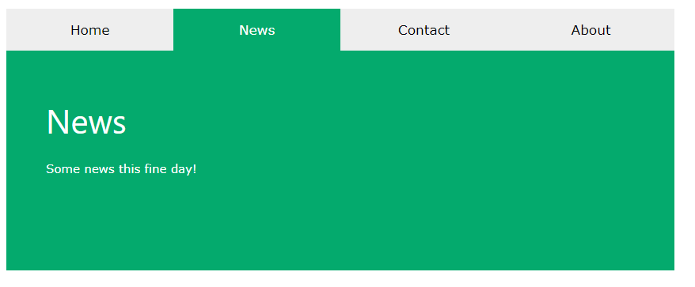

*Front-End Development and Backend development -*

Cyrus Information Technologies development team works on solutions of different complexity and deliver full cycle development services to make our clients dreams come true.

*UI/UX design*

Cyrus Information Technologies offers UI and UX design services that help brands create a human-centered design to attract new users, inspire them to buy your product, and build trust.  
  
We do UI/UX for web applications, SaaS Applications, Mobile Apps, Business Applications, AI.

*QA and testing*

Conduct a variety of tests, carry out load testing, and fix bugs. Our comprehensive quality management process embraces a range of tests to ensure we deliver top-performing software. Our QA and Testing is highly quality proven, Reduce future risks, we work transparently and high client satisfaction rate. Our senior QA specialists make sure the app complies with industry best software quality assurance guidelines.

*Maintenance and Support*

After the product release, we continue to take care of your solution with regular feature updates by providing service support and constantly monitoring and fixing issues to ensure correct operations

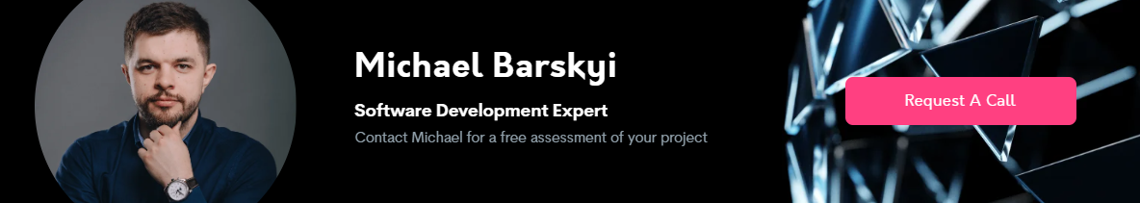

BUDDHIKA DESHAPRIYA

Software Development Expert

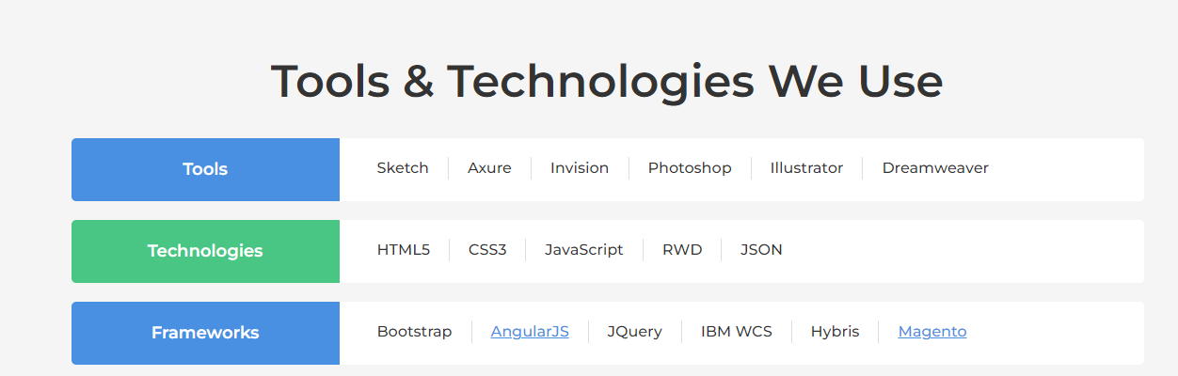

Build user-centric websites and web software using our unique web development services' processes and our skilled team of developers and designers.

|  |  |
| --- | --- |
| E-Commerce Services  Looking to build a unique E-commerce or online shopping app? Then you are at the right place. We design and develop ecommerce websites for B2C and B2B any business.  Contact our software development expert | Custom Software Development Services  We have a team of 100+ Custom Software developers. You can interview and shortlist candidates from our in-house tech pool and decide who joins your team.  Contact our software development expert |
|  |  |

Mobile App Development - We deliver incredible mobile experiences with native iOS and Android apps.

Do you have a new project in

Mind?

Contacts

Sri Lanka - +94 773 844 001

United Arab Emirates - +97 158 138 4647

[info@cyrusit.lk](mailto:info@cyrusit.lk)

Explain your project we will come back to you. Send us an Email.

[sales@cyrusit.lk](mailto:sales@cyrusit.lk)

[info@cyrusit.lk](mailto:info@cyrusit.lk)