KLE TECHNOLOGICAL UNIVERSITY, HUBBALLI.
DEPARTMENT OF BACHELOR OF COMPUTER APPLICATIONS
KLE Society’s

A Project SRS document

TOURIST PLACE SEARCH AND RANKING SYSTEM

Submitted in partial fulfilment of the requirement for degree

BACHELOR OF COMPUTER APPLICATIONS

Submitted by:
Shrilakshmi G.S – 01FE24BCA314
Vivek B M – 01FE24BCA266
Gouri k – 01FE24BCA312

Under the Guidance of
Prof. Pavankumar Vadavi
Prof. Sayeeda Anjum

Introduction
Tourism is an important activity for people who want to explore new destinations, experience different cultures, and visit historical, natural, and recreational attractions. However, tourists often find it difficult to select suitable places because information is spread across different sources and destinations may not be organized according to the traveller’s interests.
The proposed Tourist Place Search and Ranking System is designed to help users search for tourist destinations and view them in an ordered list based on selected criteria. Users can search by place name, city, category, or other available details, and compare destinations using information such as ratings, popularity, estimated cost, and visitor preferences. The system maintains tourist-place details in a normalized Relational Database Management System (RDBMS) and applies a transparent scoring method to rank matching places.
The project focuses on search, filtering, and rule-based ranking. It is intended as an academic decision-support system and does not aim to replace commercial travel-booking platforms. It cleanly separates database integrity (Engine 1), algorithmic ranking in C++ (Engine 2), and responsive web presentation (Engine 3) to ensure high reliability and consistency.
1.1 Purpose
The purpose of this project is to develop a reliable search and ranking system for managing and discovering tourist destinations efficiently. The system stores destination records in an RDBMS, validates input data through strict database constraints, and determines destination rankings using a transparent mathematical scoring formula. It aims to reduce information clutter, prevent invalid data entry, and provide reliable comparative information for travelers.
1.2 Scope
The project focuses on the basic operations required for tourist place discovery and catalog management. Its main features include:
• Maintaining Records: Maintaining tourist destination, city location, and category details systematically.
• Search & Filter: Searching destinations by keyword and filtering by city, region, and attraction category.
• Formula-Based Ranking: Evaluating destinations using a defined scoring method: Score = (w1 × Rating) + (w2 × Popularity) + (w3 × Preference Match).
• Data Validation & RDBMS Integrity: Enforcing strict database constraints to reject invalid, negative, or duplicate data at the database level.
• Destination Details & Comparison: Displaying comprehensive details, score breakdowns, and visitor reviews.
• Administrative Operations: Providing basic administrative features to add, update, view, and manage place records.
1.3 Objectives
The main objectives of the project are:
• Structured Information Storage: To maintain structured information about tourist places, including name, location, category, description, and available ratings in a normalized RDBMS.
• Keyword & Filter Search: To allow users to search for tourist places using keywords and location-based or category-based filters.
• Transparent Ranking: To rank search results using a defined scoring method based on selected criteria with configurable weights.
• Comparative Results Display: To display useful information and score breakdowns that help users compare different tourist destinations.
• Data Integrity Protection: To prevent invalid data operations (such as negative costs or out-of-bound ratings) through database constraints.
• Four-Engine Integration: To demonstrate individual engine ownership under the KLE Tech BCA framework across DBMS (Engine 1), C++ DSA (Engine 2), Web Technologies (Engine 3), and Software Engineering (Engine 4).
1.4 Intended Audience
This document is intended for project guides, faculty members, evaluators, developers, and students who want to understand the requirements and functionality of the proposed system. It describes the purpose, scope, features, constraints, and technical requirements of the Tourist Place Search and Ranking System. It can also be used as a reference during system design, development, testing, and maintenance.
1.5 Document Overview
This Software Requirements Specification (SRS) describes the requirements of the Tourist Place Search and Ranking System. It includes the project introduction, purpose, scope, objectives, functional and non-functional requirements, business rules, system constraints, hardware and software requirements, system architecture, ER and UML diagrams, data flow diagrams, references, and possible future enhancements. This document provides a clear understanding of the system's expected behaviour and serves as a guide throughout the software development process.
1.6 Foundational Concepts Used
The project applies the following foundational concepts:
• Database Management Systems (DBMS / RDBMS): Used to store and manage location, category, destination, and review records systematically with primary keys, foreign keys, 3NF normalization, and domain constraints.
• Data Structures and Programming: Used to organize records in memory, parse search tokens, and implement the C++ ranking and sorting algorithms.
• Object-Oriented Programming (OOP): Used to organize the application into modular classes and objects (TouristPlace, Location, Category, RankingEngine, DatabaseManager).
• Web Technologies: Used to develop responsive user interfaces enabling travelers and administrators to interact with the system through web pages.
• Software Engineering and SDLC: Used to follow a systematic development process involving requirement analysis, design, implementation, testing, and maintenance.
• Data Validation and Integrity: Used to ensure that bad data cannot get in even if the form is skipped, enforcing database-level constraints on fees, ratings, and weights.
Specific Requirements
Specific requirements describe the functional and operational requirements of the Tourist Place Search and Ranking System. It specifies the main features and operations that the system must support for destination management, search, filtering, and scoring.
2.1 Functional Requirements
Functional requirements describe the operations that the system must perform.
Requirement ID | Functional Requirement | Description
FR-01 | Manage Location Records | The system shall allow the administrator to add, view, search and update location details, including location ID, city name and state/region. Duplicate city-state entries shall be rejected.
FR-02 | Manage Category Details | The system shall allow the administrator to add, view, search and update attraction categories, including category ID, category name and description.
FR-03 | Manage Tourist Places | The system shall allow the administrator to add, view, search, update and deactivate tourist destination records, including name, location, category, entry fee and description.
FR-04 | Enforce Data Integrity | The database and system shall reject invalid records such as negative entry fees, empty place names, invalid ratings (< 1.0 or > 5.0), and non-existent location/category references.
FR-05 | Search Tourist Places | The system shall allow users to search for destinations using keywords that match place names, cities, or descriptions.
FR-06 | Filter Search Results | The system shall allow users to narrow results by selecting specific cities, attraction categories, and maximum entry fee budget.
FR-07 | Calculate Ranking Score | The system shall calculate a composite score for each matching destination based on normalized ratings, popularity measure, and user category preference.
FR-08 | Configure Ranking Weights | The system shall allow configuring the weights (w1, w2, w3) used in the ranking formula, ensuring that weights are non-negative and sum to exactly 1.0.
FR-09 | Display Ranked Results | The system shall present search results ordered in descending order of calculated score, displaying detailed score breakdowns and destination summaries.
FR-10 | View Place Details | The system shall allow users to view detailed information about a selected destination, including full description, entry fee, categories, and visitor feedback.
FR-11 | Record Visitor Ratings | The system shall allow visitors to submit ratings and reviews for destinations. The database shall automatically update average rating and review counts.
2.2 Non-Functional Requirement
Non-Functional Requirement | Description
Performance | The system shall execute search and ranking calculations within 500 ms for standard catalog sizes under typical hardware.
Reliability | The system shall maintain accurate destination records and handle missing attribute values consistently without system failures.
Usability | The system shall provide a simple, clean, and user-friendly interface that allows users to search, filter, and compare destinations easily.
Data Integrity | The system shall maintain consistent records by enforcing RDBMS entity, referential, and domain constraints, preventing corrupt or duplicate records.
Security | The system shall restrict administrative functions and validate all user inputs to prevent unauthorized modifications and SQL injection attacks.
Maintainability | The system shall be modularly structured across DBMS, C++ ranking core, and Web UI so components can be tested and modified independently.
Portability | The system shall be capable of running on Windows and Linux platforms with standard C++ compilers, MySQL, and modern browsers.
Accuracy | The system shall compute ranking scores deterministically according to the documented formula to ensure reliable and verifiable results.
2.3 Business Rules and System Constraints
• Rule 1: Each location, category, tourist destination, and review shall have a unique primary key identifier.
• Rule 2: Entry fees and estimated visit costs shall be non-negative (entry_fee >= 0.00).
• Rule 3: Visitor ratings and average ratings shall strictly fall within the range of 1.0 to 5.0.
• Rule 4: Ranking weights (w1, w2, w3) must be non-negative and their sum shall equal exactly 1.00 (w1 + w2 + w3 = 1.00).
• Rule 5: A location or category cannot be deleted if active tourist places reference it (ON DELETE RESTRICT).
• Rule 6: If a destination record is removed, all associated visitor reviews shall be automatically removed (ON DELETE CASCADE).
• Rule 7: A destination can be associated with multiple categories; resolved via an associative junction table with a composite primary key.
• Rule 8: The system shall use C++, MySQL RDBMS, HTML, CSS, JavaScript, and Visual Studio Code.
Hardware and Software Requirements
This section describes the basic hardware and software needed to develop and run the proposed system.
3.1 Hardware Requirements
• Computer: Desktop computer or laptop capable of running the C++ development environment, web browser, and MySQL.
• RAM: Minimum 4 GB RAM recommended; 8 GB is preferable for smoother development.
• Disk Space: Sufficient disk space (minimum 500 MB) for compiler, IDE, database software, and project files.
• Processor: A multi-core processor (Intel Core i3 / AMD Ryzen 3 or higher) capable of running development tools.
Software Requirements
• Operating System: Windows 10/11 or Linux.
• Programming Language: C++ (GCC/G++ or Visual C++ Compiler).
• Database: MySQL 8.0+ Relational Database Management System.
• Database Tool: MySQL Workbench or equivalent database client.
• Frontend / Web Technologies: HTML5, CSS3, and JavaScript.
• Development Tool: Visual Studio Code (VS Code) or compatible IDE.
• Web Browser: Google Chrome or Microsoft Edge.
Purpose of the Technologies
• C++: Used to implement the core algorithmic search, score calculation formula, and sorting logic independently.
• MySQL (RDBMS): Used to store tourist places, categories, locations, reviews, and ranking configuration tables with strict integrity constraints.
• MySQL Workbench: Used to design, execute, and inspect the relational schema, constraints, and triggers.
• HTML, CSS, JavaScript: Used to develop the user interface for searching, filtering, displaying ranked cards, and managing records.
• VS Code: Used for writing, editing, and debugging C++, SQL, and web code.
System Architecture
The System Architecture Diagram represents the layered structure of the Tourist Place Search and Ranking System. The system is divided into three decoupled layers: the Presentation Layer (Web Browser), the Application Layer (C++ Ranking and Processing Logic), and the Data Access Layer (MySQL RDBMS).
The Presentation Layer provides screens for visitors to enter search keywords, select city/category filters, and view ranked destination cards with score breakdowns. It also provides administrative forms for managing destination records.
The Application Layer processes user queries, evaluates candidate places using the linear ranking formula, applies attribute normalizations, and executes descending sorting routines.
The Data Access Layer maintains normalized relational tables (locations, categories, tourist_places, place_categories, place_reviews, and ranking_config) and enforces integrity rules, preventing invalid or orphan records from entering the database.
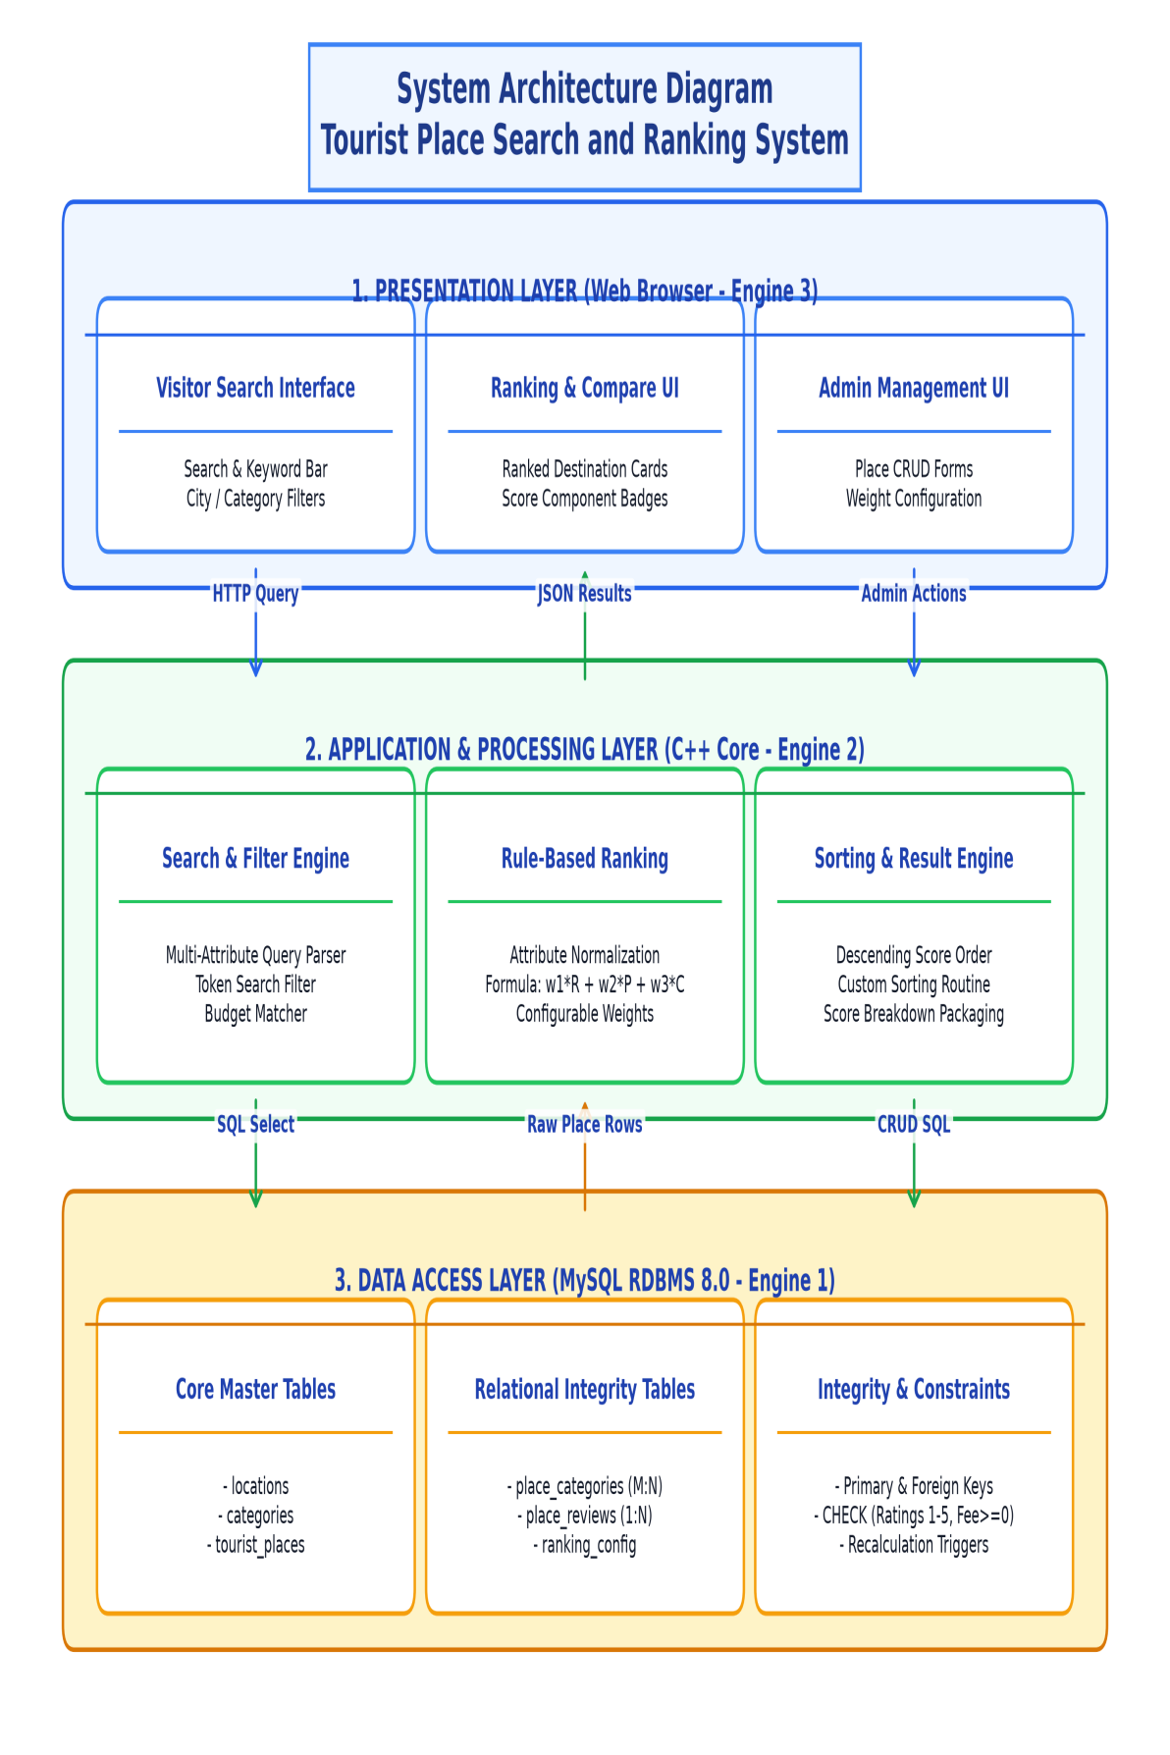
ER Diagram
The Entity Relationship Diagram represents the database structure of the system. The LOCATIONS entity stores geographic city and state information. The CATEGORIES entity maintains distinct attraction classifications. The TOURIST_PLACES entity stores destination profiles, entry fees, ratings, and popularity metrics.
The PLACE_CATEGORIES junction entity resolves the Many-to-Many (M:N) relationship between destinations and categories using a composite primary key (place_id, category_id). The PLACE_REVIEWS entity stores individual visitor ratings and reviews associated with destinations through foreign keys. The RANKING_CONFIG entity maintains system scoring parameters.
Primary keys uniquely identify records, while foreign keys maintain referential relationships. Database constraints (CHECK, UNIQUE, NOT NULL) guarantee domain and entity integrity, ensuring bad data cannot get in even if UI forms are bypassed.
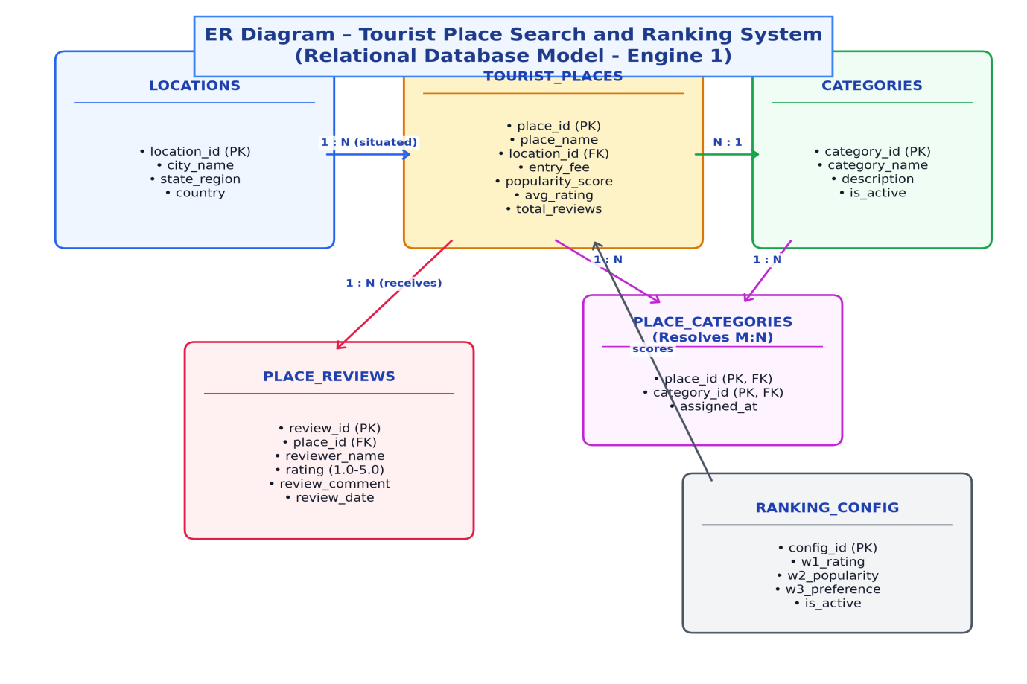
UML Diagrams
Unified Modeling Language (UML) diagrams are used to represent the structure and behaviour of the proposed system.
The Use-case Diagram shows the operations performed by visitors and administrators.
The Activity Diagram represents the step-by-step flow of search, filtering, database retrieval, score calculation, and result ranking.
The Sequence Diagram shows how the user interface, application logic, C++ ranking core, and MySQL database interact during search and ranking execution.
The Class Diagram represents the main classes, their attributes, methods, and relationships.
The State Diagram represents the lifecycle of a destination record and its transitions from Draft to Active, Evaluated, Ranked, and Rating Updated.
Activity Diagram
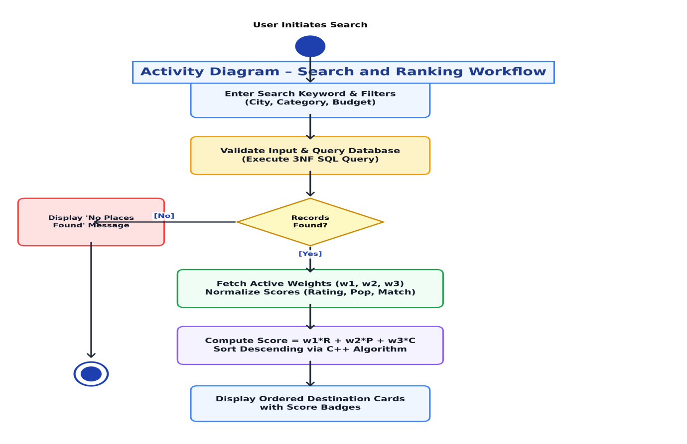
Use-case Diagram
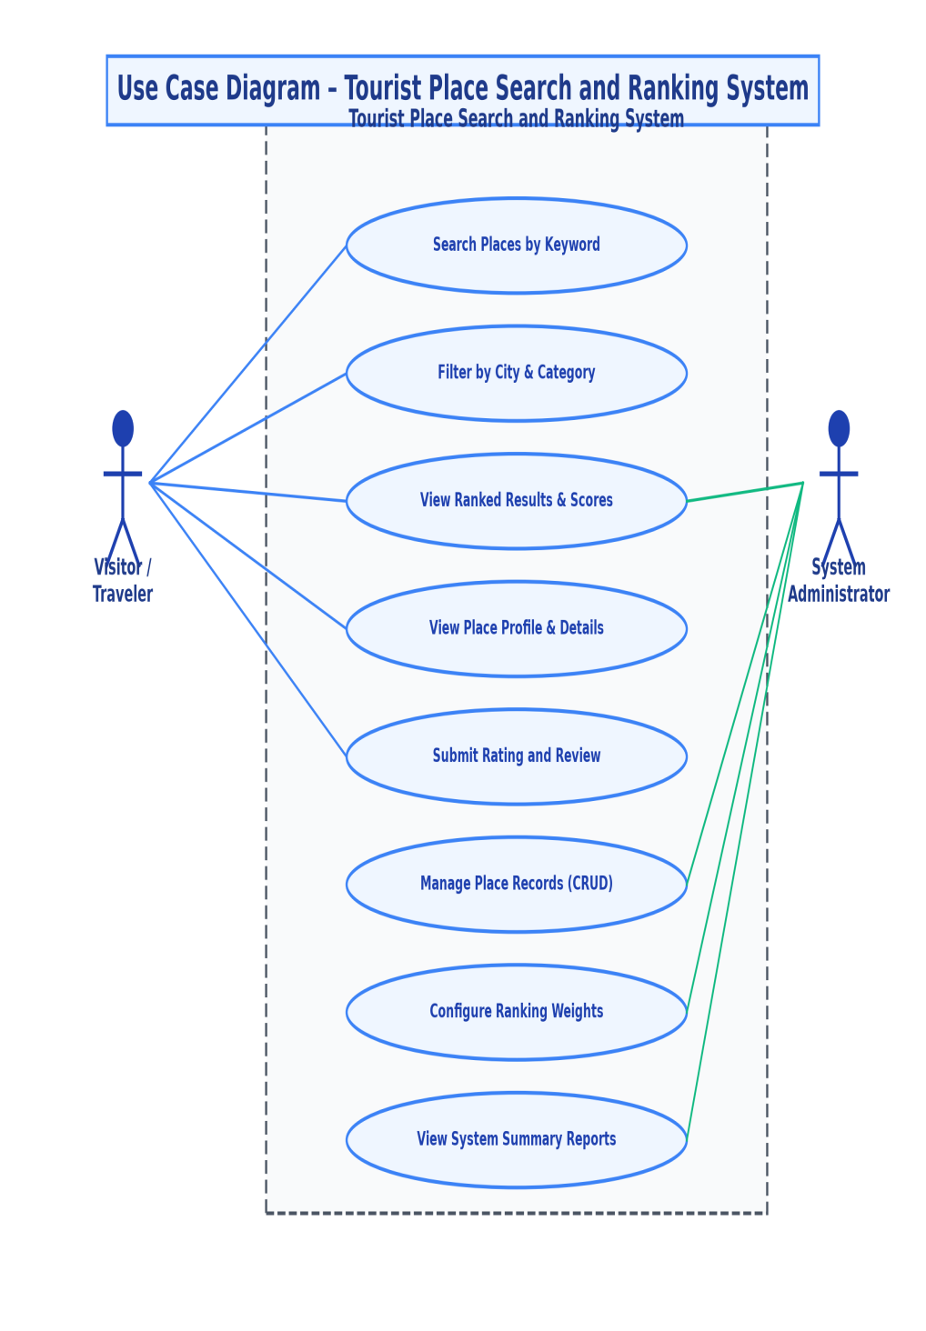
Sequence Diagram
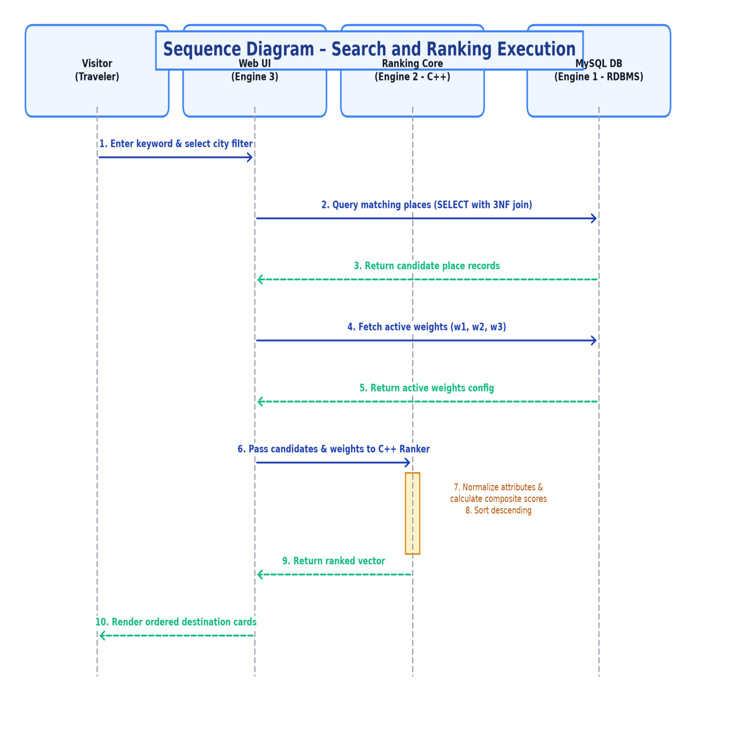
Class Diagram
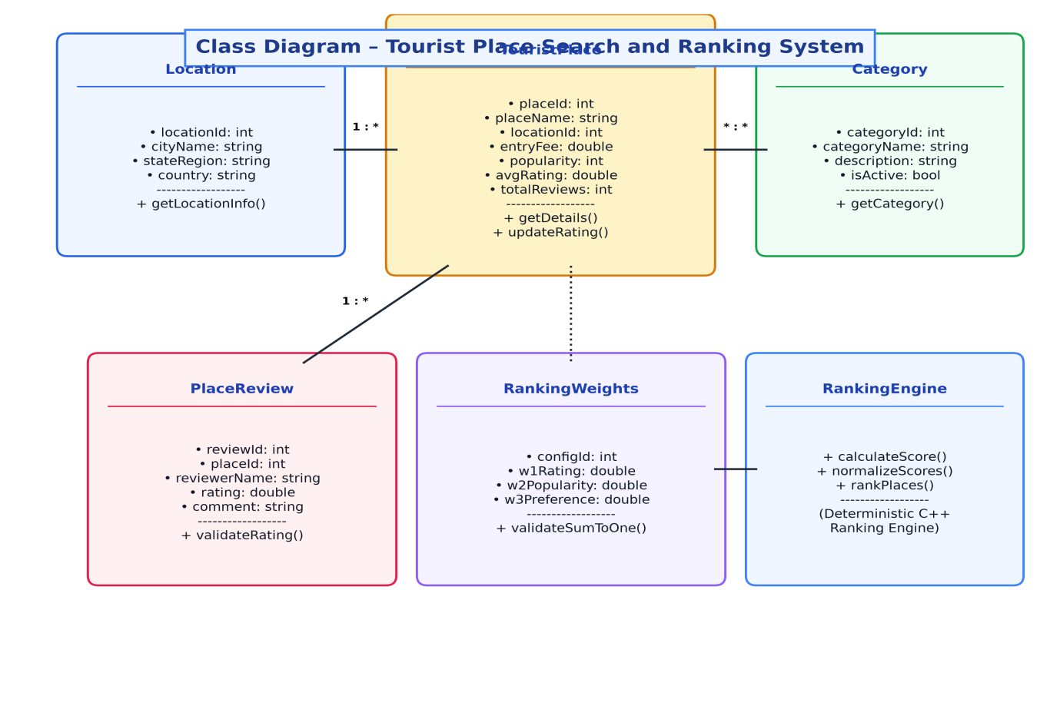
State Diagram
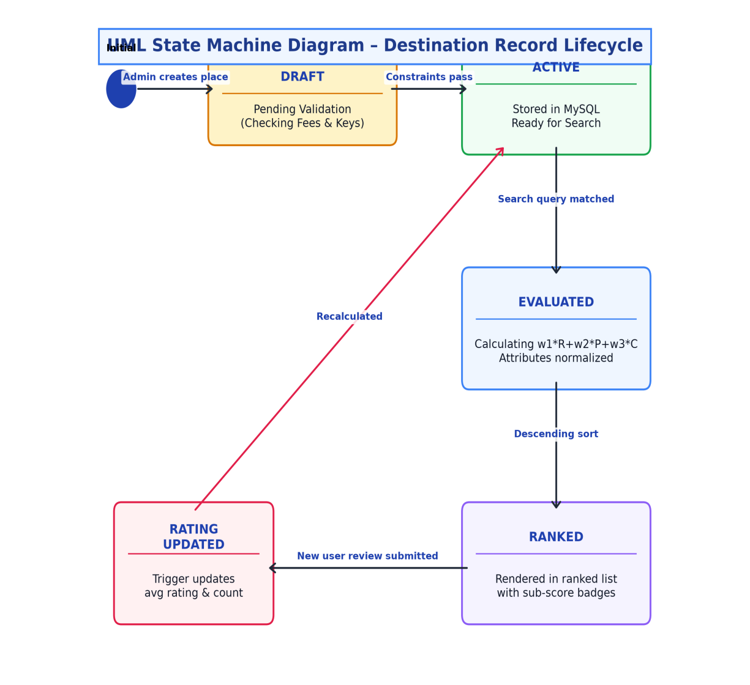
Data Flow Diagrams
Data Flow Diagrams represent how information moves through the system.
The Level 0 DFD provides an overall context view of the system and its interactions with the visitor, administrator, and the MySQL database.
The Level 1 DFD divides the system into major functional processes: master catalog management, place management, search and filtering, score computation, review processing, and summary reporting.
The Level 2 DFD provides a detailed view of the score calculation and ranking process (Process 4.0), illustrating attribute extraction, normalization, formula execution, descending sorting, and output generation.
Level 0 diagram
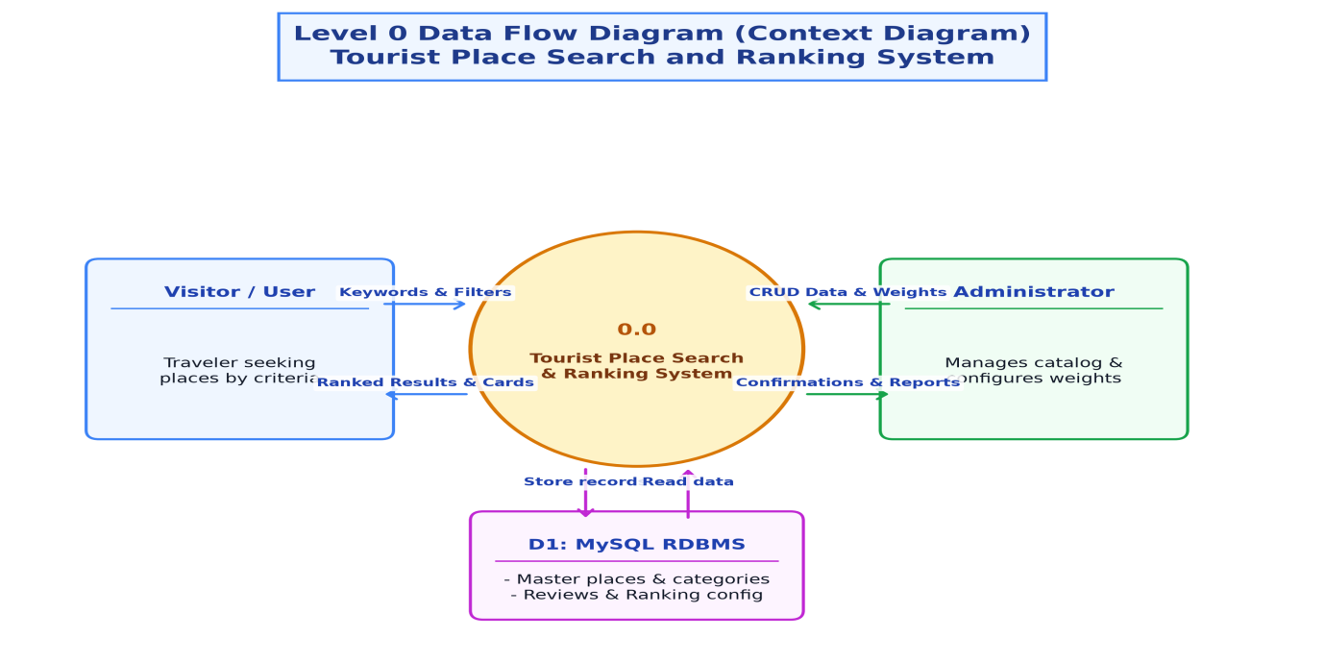
Level 1 Diagram
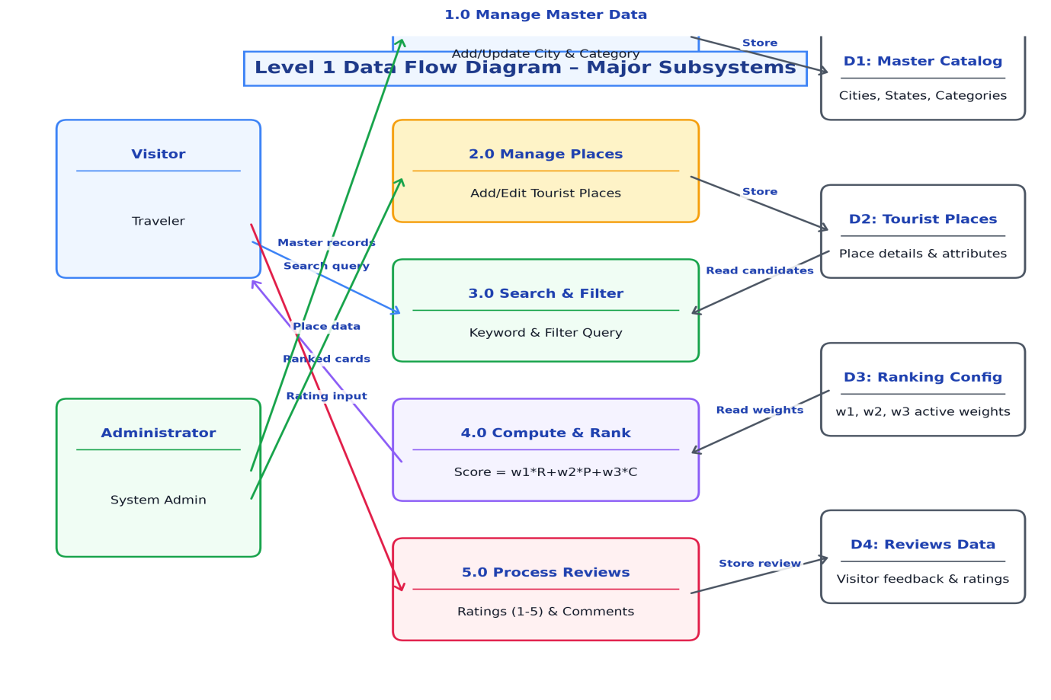
Level 2 DFD
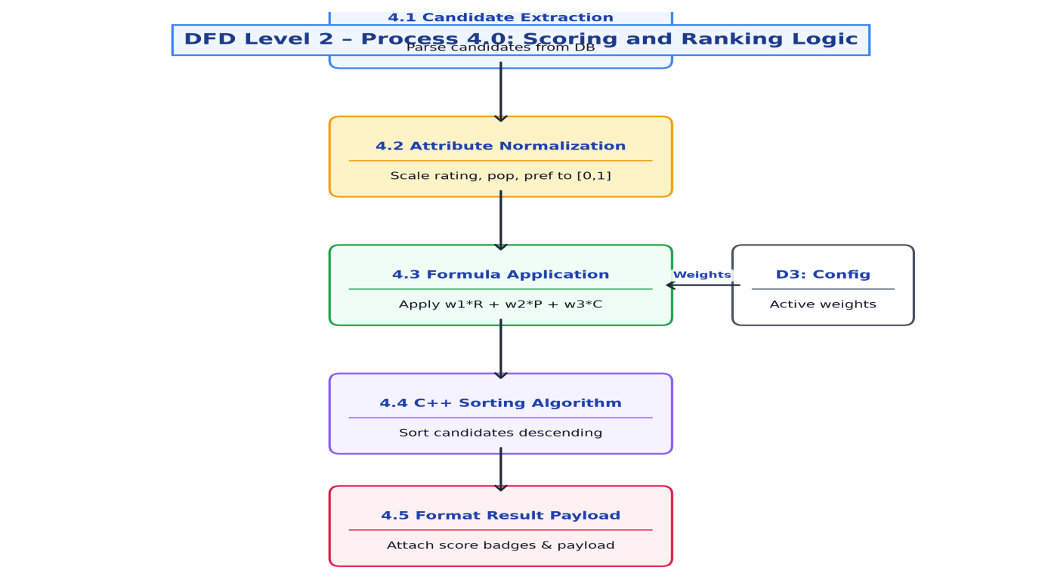
5. Future Enhancement
The current project focuses on maintaining structured tourist-place records, multi-attribute filtering, and transparent rule-based ranking. The system can be improved in the future by adding the following features:
• User Accounts & Profiles: Personalized accounts allowing travelers to save favorite places and view past visit history.
• Interactive Map Display: Integrating Leaflet or OpenStreetMap to display ranked places visually on interactive maps.
• Distance-Based Filtering: Calculating proximity and travel distance using geolocation coordinates.
• Review Sentiment Analysis: Extracting tourist feedback sentiment regarding safety, cleanliness, and accessibility.
• PDF Itinerary Export: Allowing users to export ranked search results and destination comparisons into downloadable PDF reports.
These features are not included in the initial scope and may be introduced in future releases.
6. Conclusion
The Tourist Place Search and Ranking System aims to make destination discovery organized, transparent, and academically rigorous. The system demonstrates how destinations can be evaluated and ranked using clear mathematical criteria rather than opaque commercial algorithms.
By grounding the system on Engine 1 (Data & Integrity / DBMS), the database guarantees that bad data cannot get in, even if front-end forms are skipped. Engine 2 (Logic & Rule / C++) ensures high-performance calculation and sorting, while Engine 3 (Interface & Access) delivers an intuitive user experience.
The project applies foundational concepts of DBMS, Data Structures and Programming, Object-Oriented Programming, Web Technologies, and Software Engineering and SDLC to build a reliable and maintainable academic platform.
4. References
• 1. Silberschatz, A., Korth, H. F., & Sudarshan, S. Database System Concepts, 7th Edition, McGraw-Hill.
• 2. Elmasri, R., & Navathe, S. B. Fundamentals of Database Systems, 7th Edition, Pearson.
• 3. Stroustrup, B. The C++ Programming Language, 4th Edition, Addison-Wesley.
• 4. Oracle Corporation. MySQL 8.0 Reference Manual, https://dev.mysql.com/doc/refman/8.0/en/
• 5. Pressman, R. S. Software Engineering: A Practitioner's Approach, 8th Edition, McGraw-Hill.
• 6. Microsoft. Visual Studio Code Documentation, https://code.visualstudio.com/docs
• 7. Course materials for DBMS, DSA, Web Technologies, OOP, and Software Engineering, Department of BCA, KLE Technological University.
• 8. BCA Mini Project Framework and Gate Assessment Guidelines provided by KLE Technological University, Hubballi.

