**Student Name: Anushri Srinath Aithal**

**Student ID: 012506897**

**Assignment#4 Async Task**

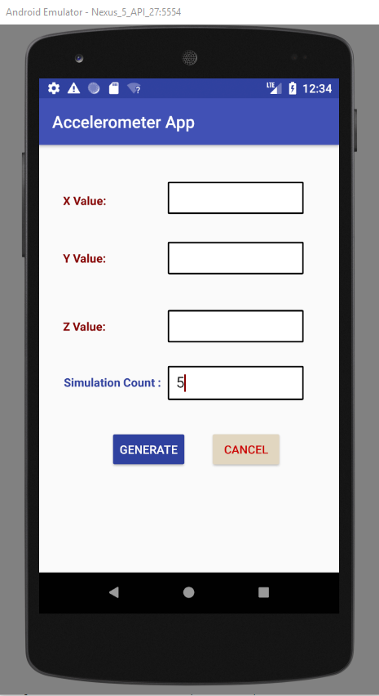

Fig.1 Above screenshot is the home page of Accelerometer App. The app takes simulation count as input and generates 3 random numbers for X, Y and Z Co-ordinates with a 2 second gap.

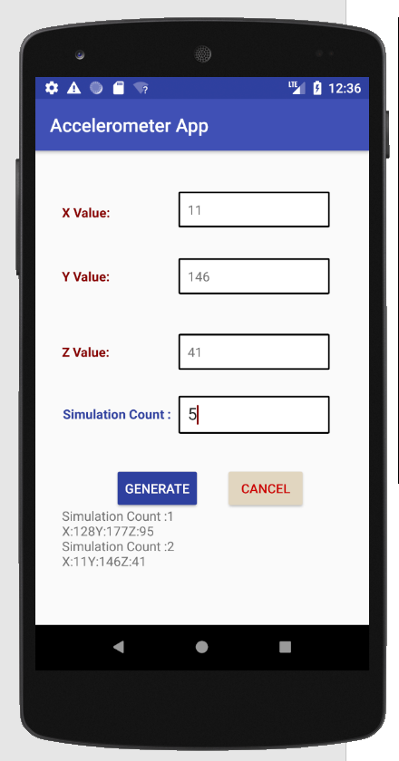

Fig.2 Generated Random Values are updated in the Text View. The Text Boxes have the new values generated while the scrollable text data below has the previously generated value.