**Student Name: Anushri Srinath Aithal**

**Student ID: 012506897**

**Assignment#5 Data Storage**

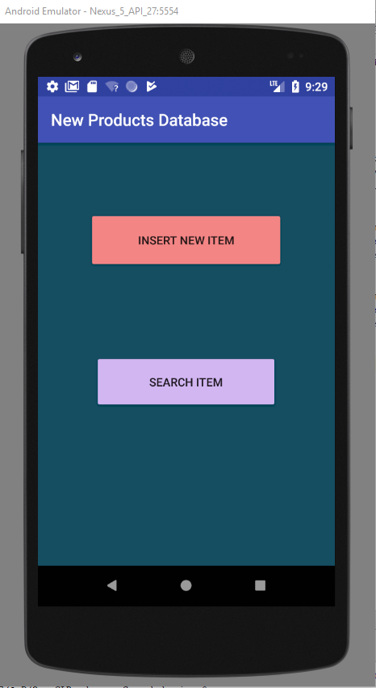

Fig.1 Home Screen of the app where user can click on insert new item button to add an item or click on search item to search an existing item.

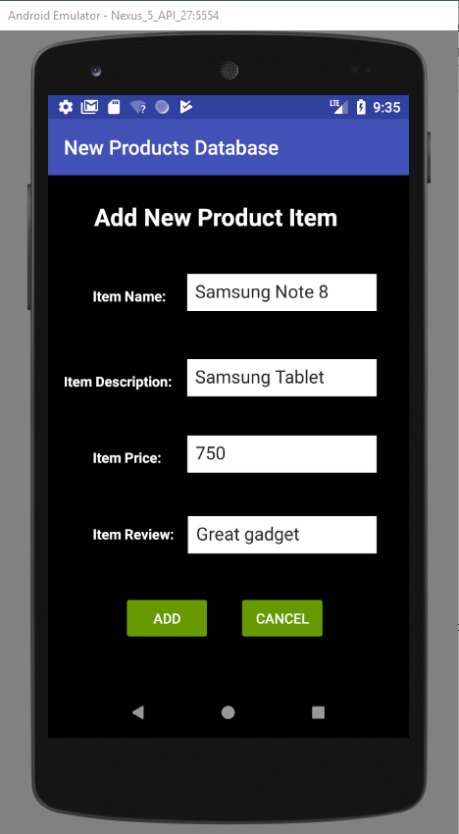

Fig.2 Add new product screen where we can insert a new item. User can click on add or cancel. Cancel takes user back to home screen.

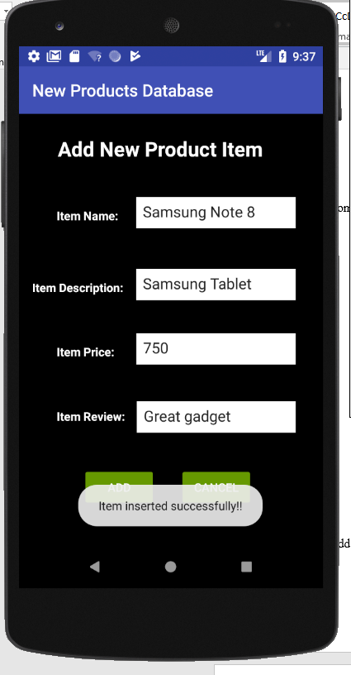

Fig.3 When a new item is added successfully a toast message is displayed to indicate it was successfully added

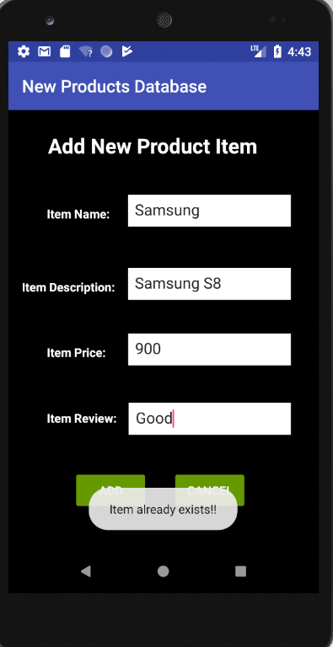

Fig.4 If Item already exists, error is displayed.

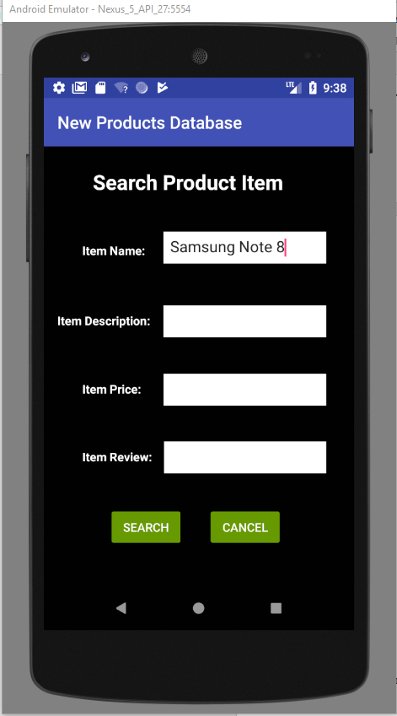

Fig.5 Search Item by item name. User inputs the item name in the given text box and click on search. It displays the search results. Cancel takes user back to home screen.

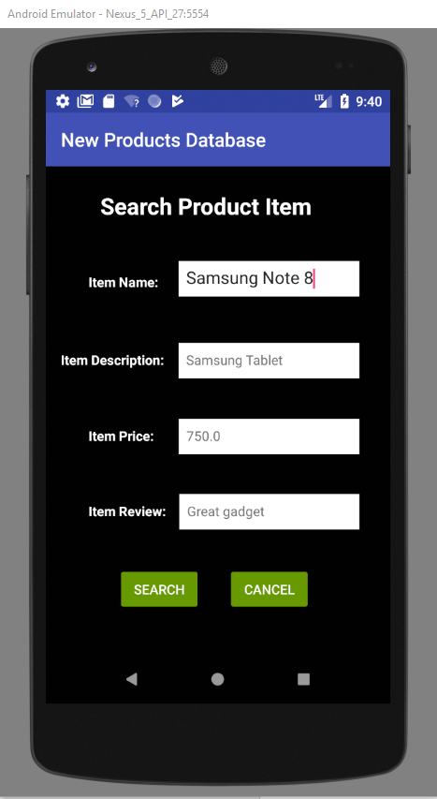

Fig.6 Search results displayed.

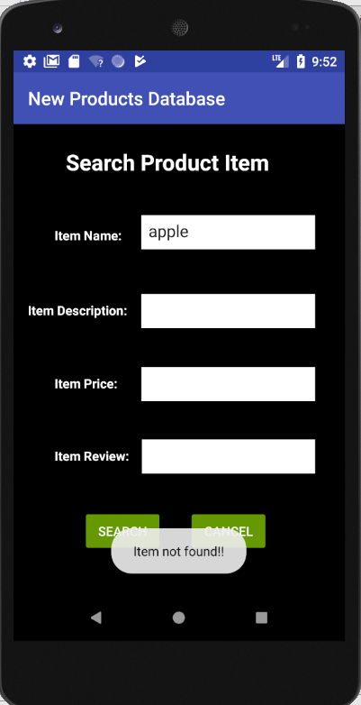

Fig. 7 If searched item is not found user can see the toast message Item not found