**Student Name: Anushri Srinath Aithal**

**Student ID: 012506897**

**Android: Assignment 1**

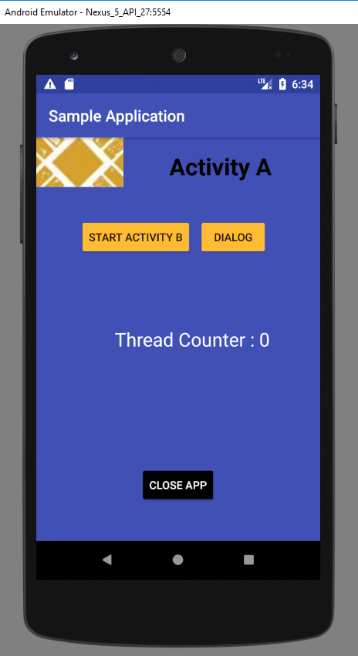

Fig.1 Activity A Home Screen

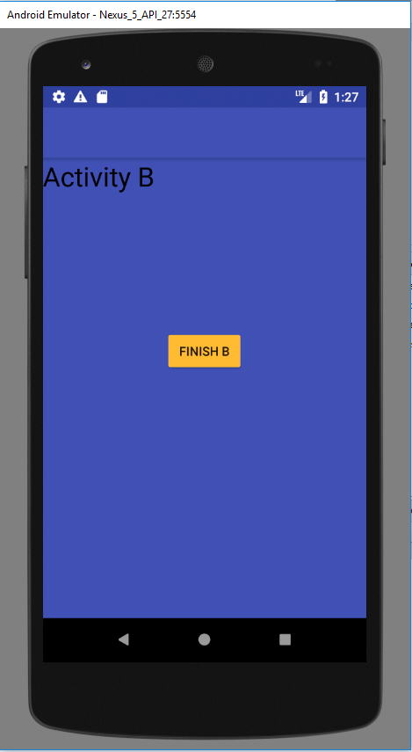

Fig.2 Activity B called from Activity A

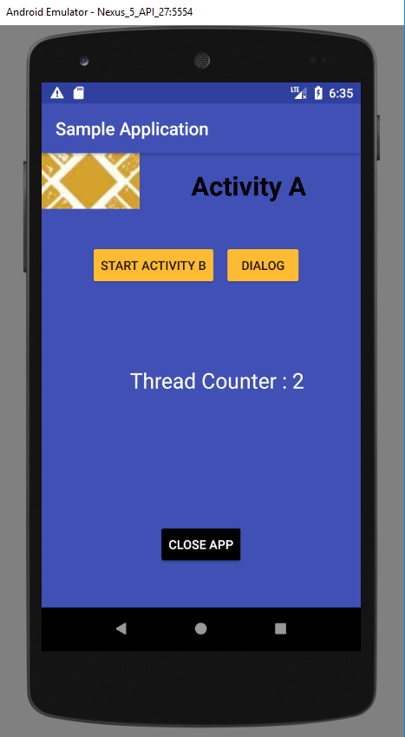

Fig.3 Thread Counter incremented on Finish. It increments by 2 as when Activity B is called from Activity A onPause() is called also on finish() of Activity B invokes onPause() of Activity B.

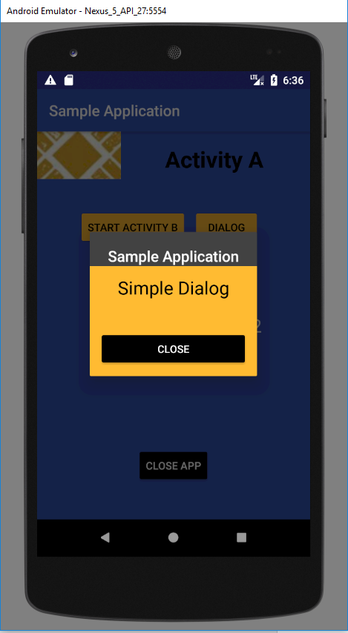

Fig.4 Simple Dialog invoked from Activity A.

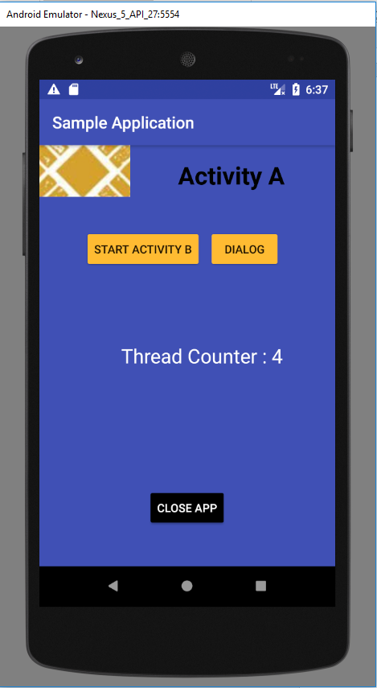

Fig. 5 Thread Counter incremented on close of Dialog. It increments by 2 as when Dialog Activity is called from Activity A onPause() is called also on finish() of Dialog Activity invokes onPause() of Dialog Activity .