**Student Name: Anushri Srinath Aithal**

**Student ID: 012506897**

**Assignment#2 Implicit Intent**

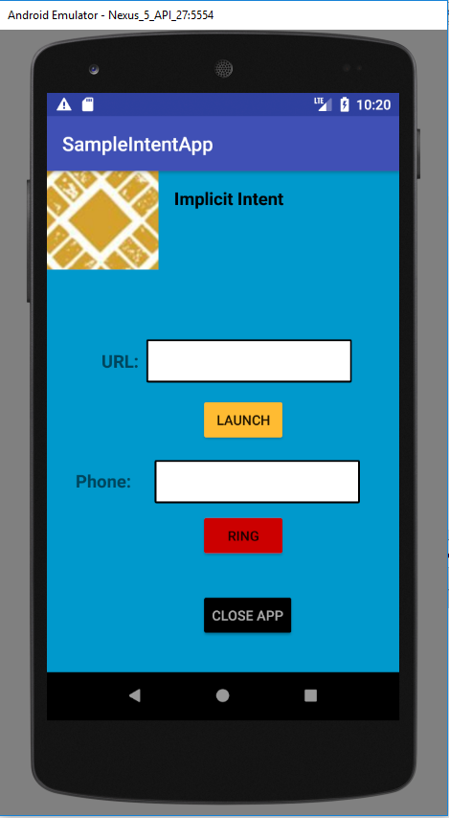

Fig.1 Activity 1 with input text box for URL and Phone Number

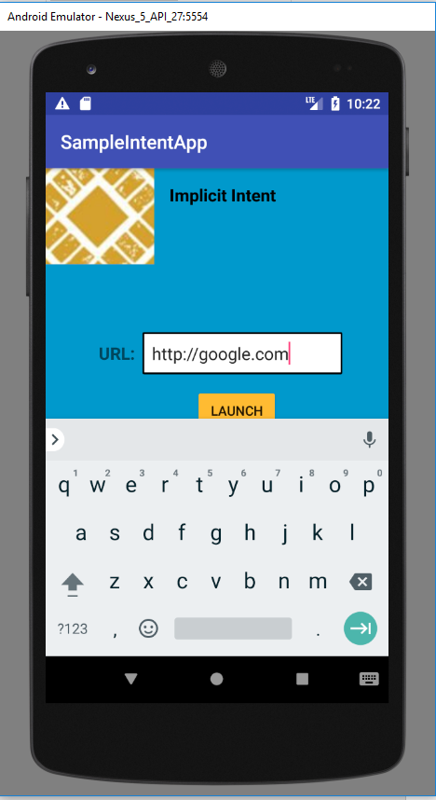

Fig.2 Enter the URL to load on click of Launch Button

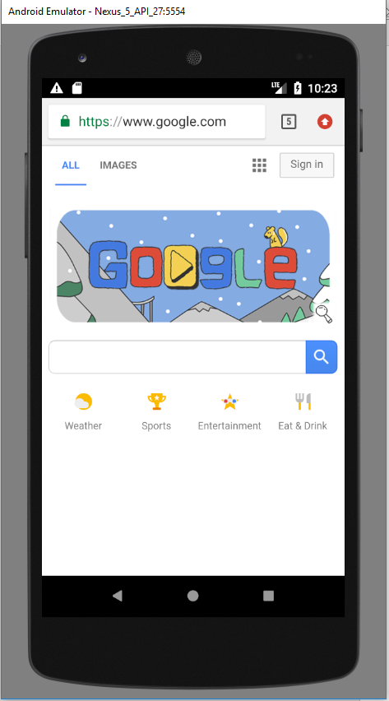

Fig.3 URL launched using Implicit Intent [ Intent intent = **new** Intent(Intent.***ACTION_VIEW***, webPageUrl);]

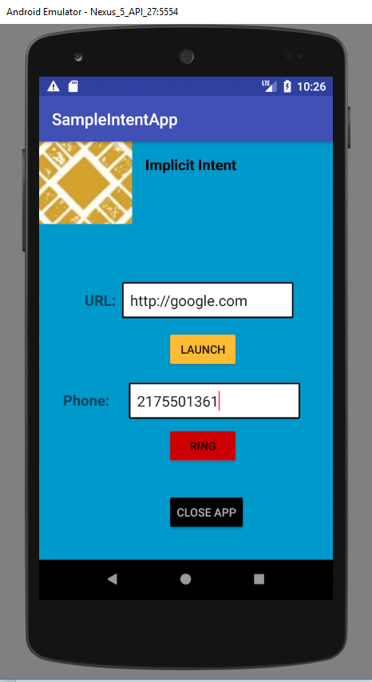

Fig.4 Number to be dialing using Implicit Intent

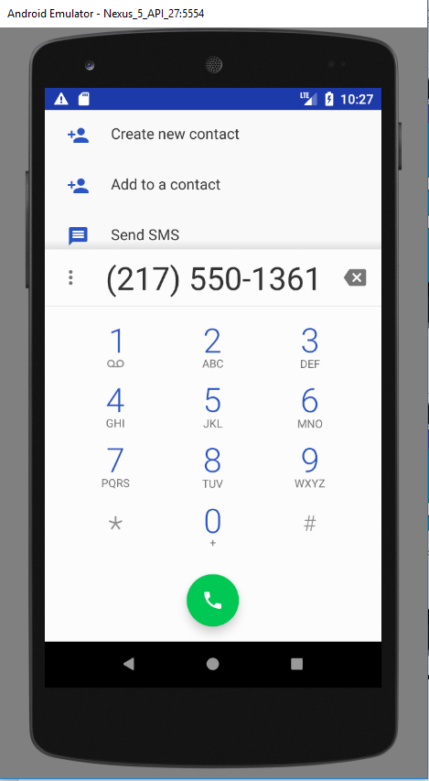

Fig.5 Passing phone number using Implicit Intent [ Intent intent = **new** Intent(Intent.***ACTION_DIAL***, phoneNumber); ]