**Lab 1**

**Basic Schema Definition – Data Definition Language (DDL)**

**Basic Datatypes:**

|  |  |  |  |
| --- | --- | --- | --- |
| Integer or int | 4 bytes | typical choice for integer | -2147483648 to +2147483647 |
| Numeric (precision,scale) | variable | user-specified precision, exact | up to 131072 digits before the decimal point; up to 16383 digits after the decimal point   The *scale* of a numeric is the count of decimal digits in the fractional part, to the right of the decimal point. The *precision* of a numeric is the total count of significant digits in the whole number, that is, the number of digits to both sides of the decimal point. So the number 23.5141 has a precision of 6 and a scale of 4. Integers can be considered to have a scale of zero. |
| varchar(*n*) | | | variable-length with limit |
| char(*n*) | | | fixed-length, blank padded |

1. **Create the tables using the DDL statements given below:**

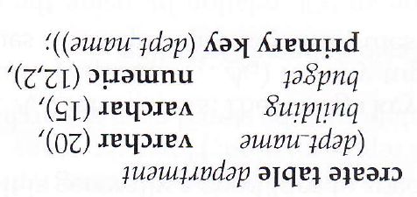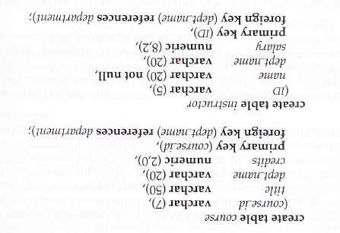  
**2. Remove table** – removes the table as well as data present in it.

Drop table *table_name*;

e.g. Drop table department;

**Data Manipulation Language (DML)**

1. **Insertion of data.**

Insert data into the tables as follows:

insert into instructor values (‘22222’,’Einstein’,’Physics’,95000)

or

insert into instructor(id, name, dept_name) values (‘22222’,’ Einstein’,’Physics’)

This is to insert only specific data. Here salary field is not entered.

Or

This is to insert multiple records in one insert statement.

insert into instructor(id,name,dept_name,salary) values

(‘22222’,’ Einstein’,’Physics’,95000), (‘12121’,’ Wu’,’Finance’,90000);

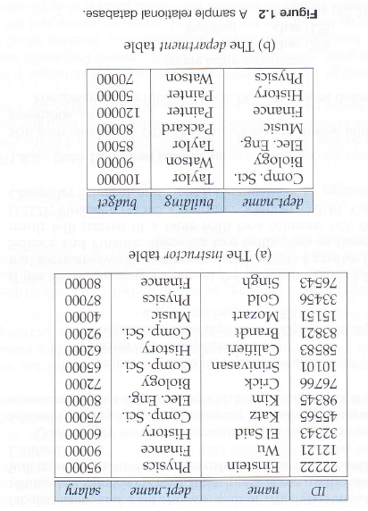

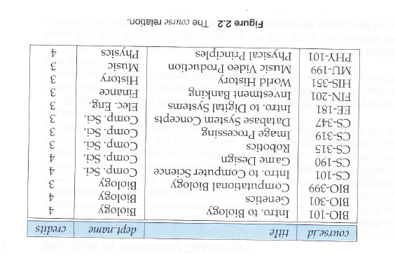

1. **Modification of the data**

**Deletion:**

delete from instructor;

delete from instructor where dept_name = ‘Finance’;

delete from instructor where salary between 1300 and 2000;

**Updates:**

update instructor set salary = salary + 1000 where salary<7000;

update instructor set salary=1000 where name =’Raj’;

**Queries on Single Relations**

1. Retrieve the contents of the instructors table.

Select * from instructors;

1. Find the name of all the instructors

select name from instructors;

1. Find the department name of all the instructors

select dept_name from instructors;

1. Select clause with arithmetic expression

select name, salary*1.1 from instructors;

1. Where clause with predicates

select name from instructor where dept_name=’Comp.Sci.’ and salary>7000;

**Self-try**

1. Retrieve the contents of the department table.
2. List the various courses offered by the Computer Science department.
3. List the various courses offered by the Computer Science department with 3 credits.
4. Change the credits for a particular course.
5. Delete from courses those courses with less than 3 credits.
6. Create a table student with attributes Rollnumber of type varchar(10), Name of type varchar(25), State of type varchar(10)
7. Insert suitable data to student table.
8. Add a column CGPA to student table and insert suitable data.

**Example Alter statements in PostgreSQL**

To add a column to a table:

1. ALTER TABLE student ADD COLUMN tuition_fee numeric(9,2);
2. ALTER TABLE student ADD COLUMN bus_fee numeric(9,2);

To drop a column from a table:

1. ALTER TABLE student DROP COLUMN bus_fee;

To change the types of two existing columns in one operation:

1. ALTER TABLE student

ALTER COLUMN state TYPE varchar(80),

ALTER COLUMN name TYPE varchar(30);

**To rename a column**

1. alter table student rename column state to state_1;

**To rename a table**

1. alter table student rename to student_123;