What is an antivirus? :-
- Software that is created specifically to help detect, prevent and remove malware (malicious software).
- Antivirus is a kind of software used to prevent, scan, detect and delete viruses from a computer. Once installed, most antivirus software runs automatically in the background to provide real-time protection against virus attacks.
- Comprehensive virus protection programs help protect your files and hardware from malware such as worms, Trojan horses and spyware, and may also offer additional protection such as customizable firewalls and website blocking.

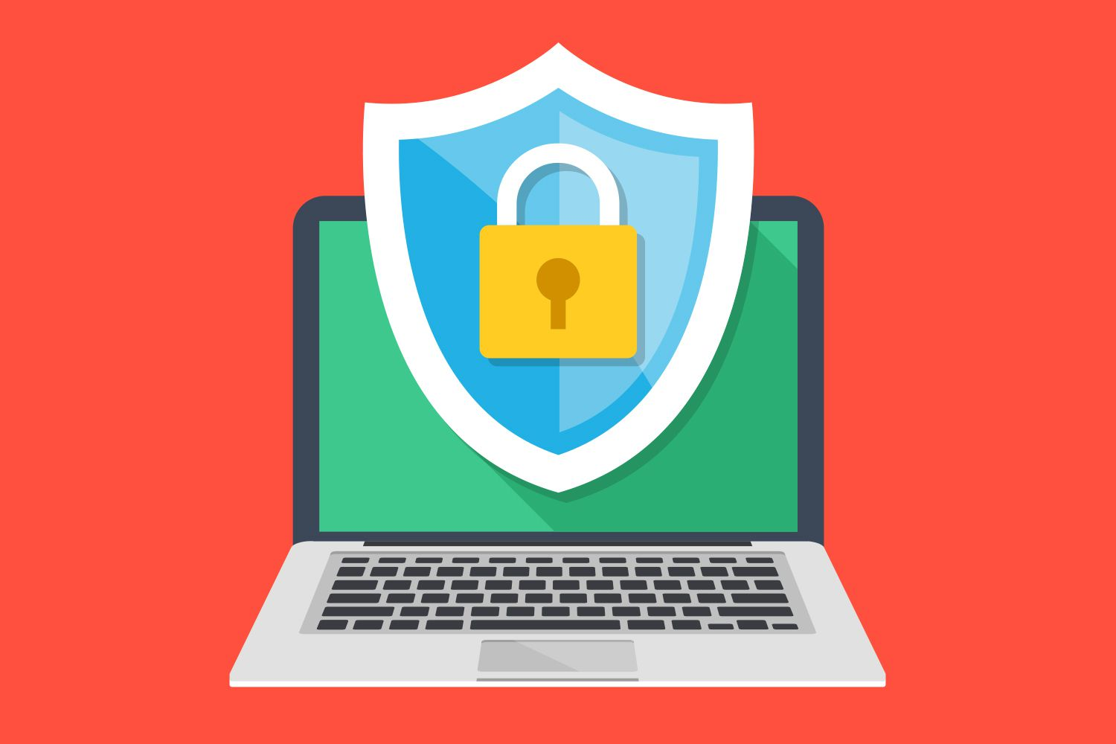
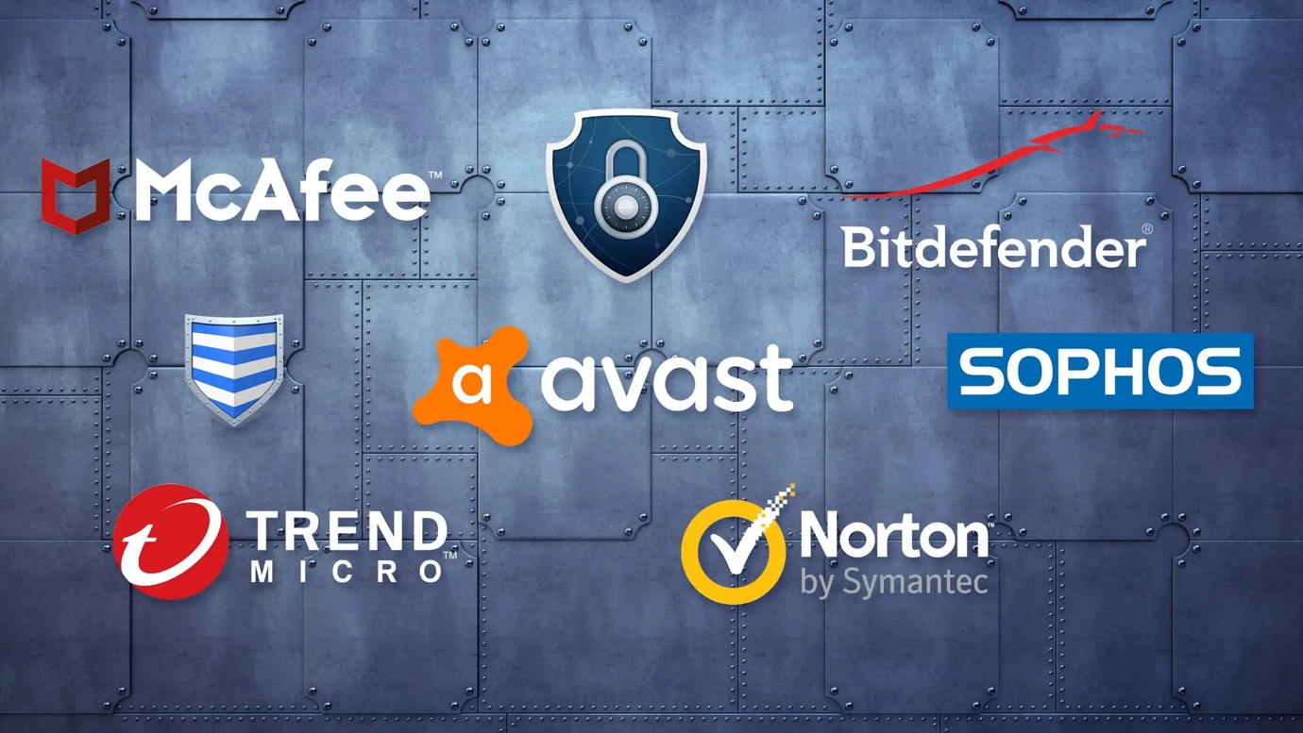

Benefits of Antivirus:-

It provides protection from viruses and their transmission

It blocks spam and ads
- It provides defense against hackers and data thieves

It ensures protection from removable devices

It protects your data and files

It supercharges your PC
- It provides firewall protection from spyware and phishing attacks

It limits the access of websites to enhance web protection

It helps you keeping an eye on kids

It protects your password

It is cost-effective

How to install antivirus software on Windows:-

- It's no different to any other program or app. First, check if you have any antivirus software installed (besides Windows Defender). Open the Settings app and click on Apps. Look through the list an uninstall any packages, since they can cause problems.
- Windows Defender will be disabled automatically when you install other security software, but here's how to turn on or off Windows Defender off manually.
- Next decide which antivirus you want to use - feel free to pick one from our list of the best free antivirus - then download it from the maker's website.
- Once the file is saved either double-click on its name that appears in the bar at the bottom of the screen (while still in your browser) or go to your downloads folder and double click on the file there. If you can’t see it straight away, click on the Date column (you’ll need to be in Details mode, which you’ll find in the View menu at the top of the window) so that the files are sorted by latest to oldest (if you see it’s the reverse then click the column a second time to switch it).
- Next, you’ll be presented with a window telling you that the software wants to make changes to your system, this is a normal part of the process, so click Accept and then an Install option should appear.

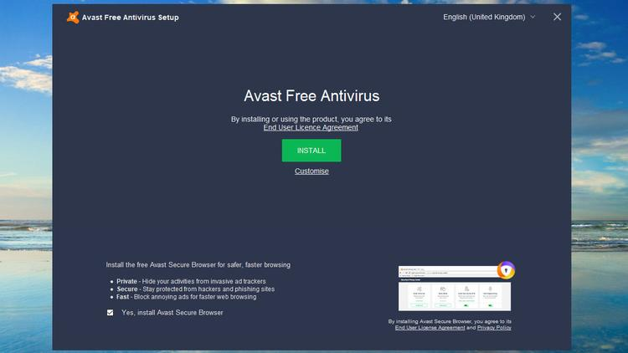

- Before you get things underway, check for any tickboxes on the screen, as free versions can often ask to additionally install secure web browsers, software from partners or for permission to share your details with advertisers. These aren’t necessarily bad things, but be sure you know what you’re agreeing to before you click Install.
- When the program has finished its installation process you’ll usually be asked a few questions regarding upgrading to other related products, but you can always do this later on or not at all.
- The last step is to run a full scan of your PC so that the new software can check that you don’t already have any harmful programs lurking on your system.

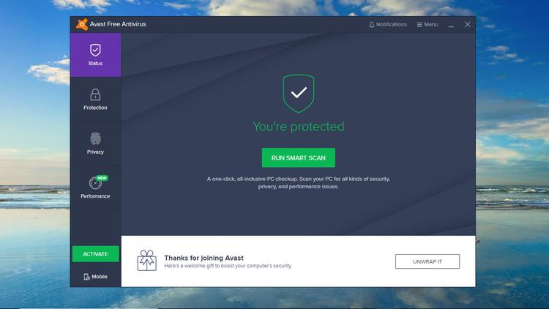

- That’s it. You’ve now updated your security. Take time to explore the various features offered by the software, and whether you need to set up regular scans or if the suite does this automatically.

