**Tech-Stack –**

* FrontEnd – React JS
* BackEnd – Asp.Net Core
* Db- SQL

**Backend**

* The Connection string(DevConnection) is added in the appsettings.json file of the backend solution.
* Modify the port of the API in the Configure method of Startup.cs as per the port generated.
* Run Update-Database command in Package Manager Console to create the Database.
* The Database will be created as shown in the below screenshot

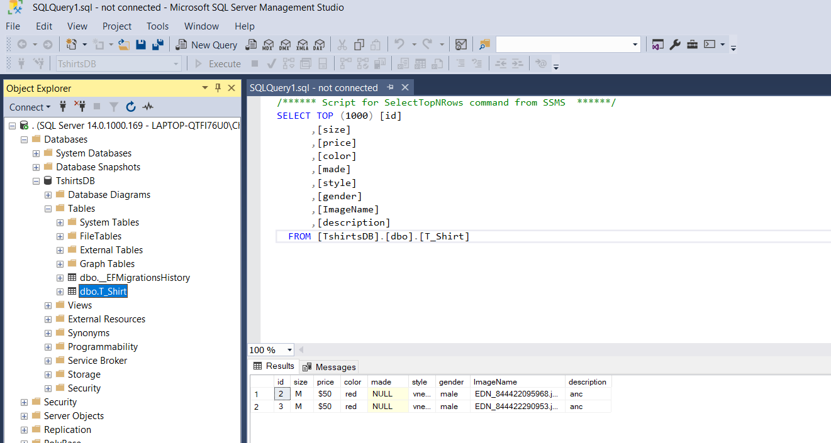

**Frontend –**

* Modify the port number in the Api in package.json accordingly.

 "proxy": "http://localhost:YOUR_PORTNUMBER"

Run the Backend and Frontend Application.

**Note – I was not able to figure out Uploading Images to the Api part of the assignment. I have written the code in the backend and frontend but since it is not working I have hardcoded a default image url in the frontend. The code can be found commented in Backend and Frontend.**