LAB ASSIGNMENT – 5 REPORT
Shridhar Ramachandran (ramachandran.65@osu.edu), Lakshmikanth Krishnan Kaushik (krishnankaushik.1@osu.edu)

INTRODUCTION:
In this assignment, we aimed to evaluate the efficacy and efficiency of minwise hashing for document similarity, when compared to (the baseline) Jaccard similarity for different values of K. We calculated jaccard and min-hash similarity based on 4 different types of feature vectors:
- Term frequencies
- Bigrams (ranked on frequency as well as PMI score)
- Character shingling (for multiple values of shingle-lengths)
We modified our preprocessing to suit the similarity calculations better. We observed a comparable difference in Jaccard vs Minhash similarity, especially in feature vectors with high dimensionality; and also observed an increase in efficacy (i.e. a decrease in error) when K increases.

PACKAGES USED:
The following packages were used for the specified tasks.
- NLTK - Data preprocessing
- Matplotlib – for representing our results

PREPROCESSING CHANGES (Including data transformations):
Note that we decided to implement our code in such a way that the code used to calculate similarity is very loosely coupled with our Preprocessor code. We did this by adopting a pipelined style – we outputted the feature vectors on to different json files in the exact same format as our implementation in Assignment 1. We then read these files during the similarity calculation phase, transformed them in to a format more convenient to calculate similarity and proceeded to calculate similarity. This ensured that minimal changes were required to our actual Preproccesor code and the Preprocessor Python class would still maintain its relevance of being an actual preprocessor (and not say, a preprocessor-cum-similarity calculator).

Now, coming to our actual feature vector changes - in assignment 1, we had written code to calculate term frequency and bigram values for documents as feature vectors. We represented this data in a transactional data format. As mentioned in the above paragraph, we made minor transformations to the outputs of these 2 feature vectors in order to ease calculations of similarity. In addition, because we wanted to explore with character shingling we also made changes to enumerate the different character shingles in each document. All the transformations were done using standard python data structures (dict, set, etc). Details of the changes made are described below:

Term Frequency:
Our preprocessor outputs a dictionary of <term>:<term-frequency> for each document. Only terms that have frequency > 1 are included. The average dimensionality of this feature vector turned out to be 45 and hence, we decided this would be a good candidate for similarity calculations. We transformed the dictionary to a set of unique <terms> for each document.
Bigrams:
In assignment 1, our bigram feature vector outputted the top 10 bigrams based on descending order of Pointwise Mutual Information (PMI) score. We increased it to output the top 50 bigrams. In addition, we also altered our code to also output an additional feature vector with the top 50 bigrams based on bigram frequency. We transformed the dictionary of <bigram>:<bigram-frequency/PMI score> to a set of <bigrams> for each doc. The average dimensionality of these 2 sets of bigrams for each document turned out to be 35.
Character Shingles:We also decided to explore character shingles for different shingle sizes (to satisfy of our own curiosity, and not just for the bonus :)). We implemented this by taking the finding out the shingles from the raw body of each doc (before stemming and removing stop words). We did however remove all white spaces and punctuation marks to ensure we retrieved only alphanumeric shingles. Our feature vector outputted in this scenario consisted of a dictionary of <shingle>:<count>. We tried for values of shingle size k=3 and k=5. The average dimensionality of the shingle feature vector was 357 for k=3 and 487 for k=5.

THE SIMILARITY ALGORITHMS:
The similarity algorithms were fairly straightforward to implement. We implemented them on our own using standard python data structures and operations. They are described below in brief.

Jaccard Similarity:
We used the 'intersection' operation in the native Python library to find the intersection between each pair of sets of data, and divided the number of items in this set by the difference between sum(number of items in the pair of documents whose similarity is being calculated) and the number of items in the intersection of those 2 documents.
Minhash Similarity Estimate:While transforming the data obtained during the Preprocessor step (from dict to set), we calculate a list of all the unique terms/bigrams/shingles. For each value of K, we calculated the hash matrix by shuffling through K different permutations and calculating the minhash for each doc. We then compared the minhash values for each pair of documents and divided the number of common minhashes by the value of K.
Error:
We opted to use the root mean square error between the estimate and jaccaard similarity across all documents to calculate error for different values of K.

EXPERIMENTAL DATA:
We tried running our code for all 21000 documents, but this unfortunately caused huge memory, CPU and disk I/O consumption. We tried running it over night, but woke up to find our laptops crashed after 1 hour of the program (during which it had outputted results for K=16 for term frequencies). As discussed in class, we decided to proceed with an alternative approach of running on incremental sizes and presenting results of different sizes. We ran our code on 3000, 5000 and 10000 documents. In the following sections, these sizes will be referred to as “input data sizes”

EXPERIMENTAL RESULTS:
Our results are 2 fold for each type of feature vector used – we have plotted the effect of both efficacy and efficiency as K varies. Each of these sets of 2 graphs have been replicated for different input data sizes.

Below are the results as well as evaluation of the performance data:

- Term Frequency:
- Input Data Size: 3000
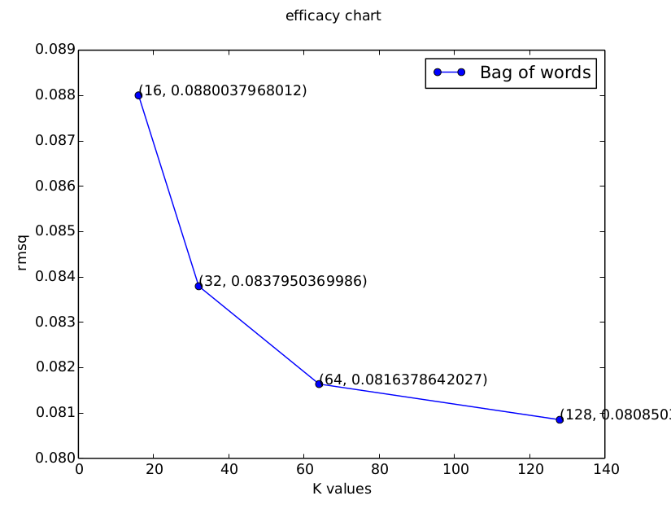
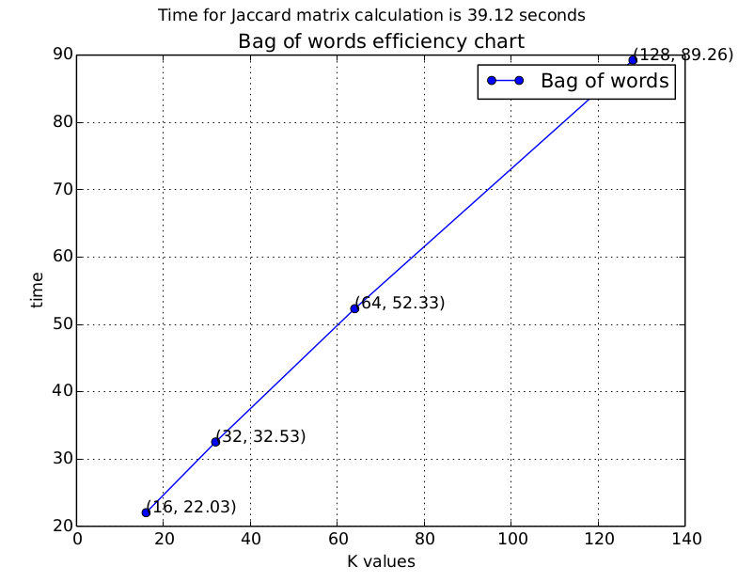

- Input Data Size: 5000
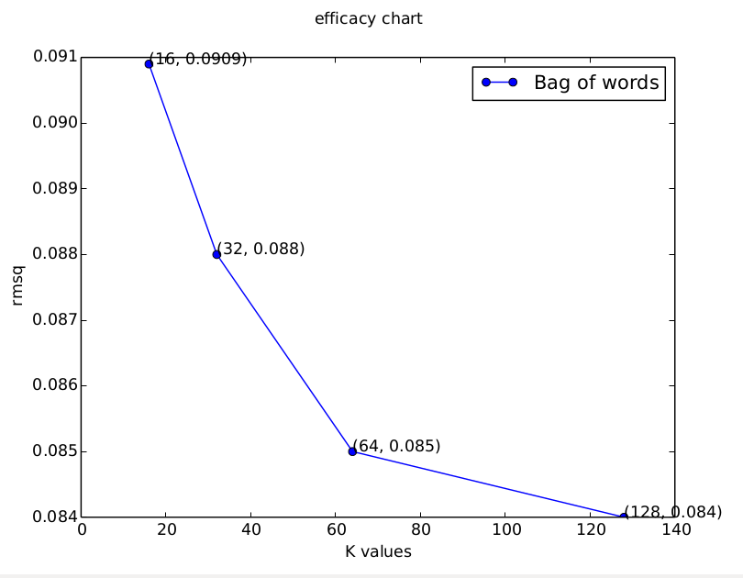
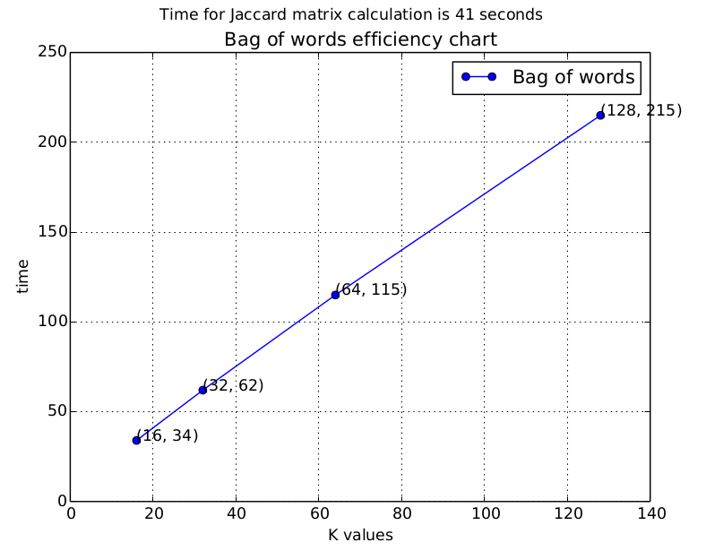

- Input Data Size: 10000
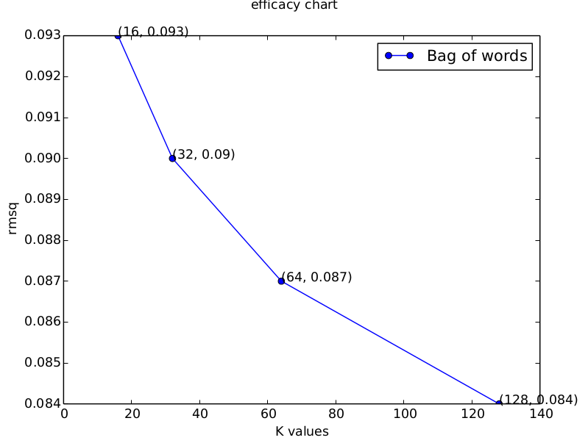
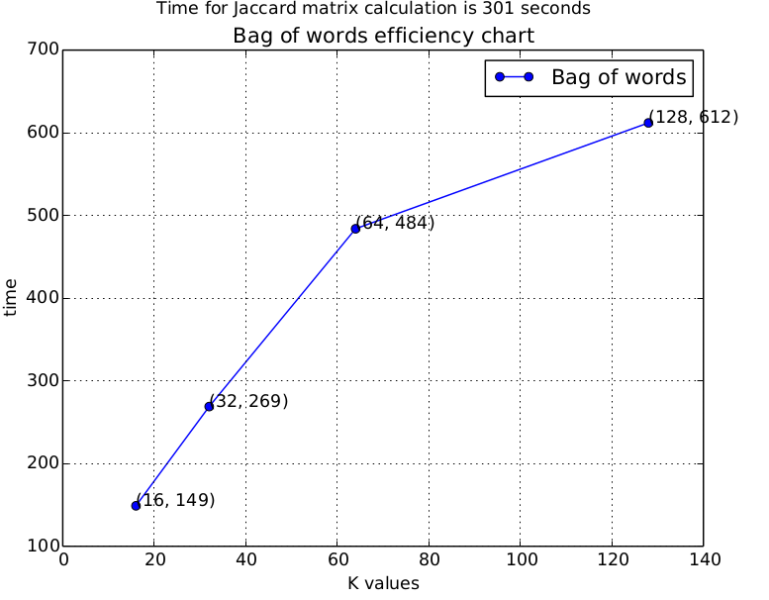

2. Bigrams – PMI and Frequency:
- Input Data Size: 3000
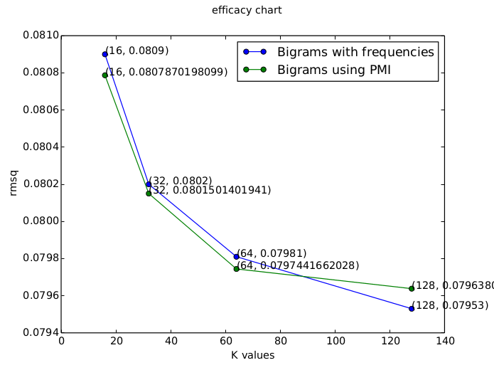
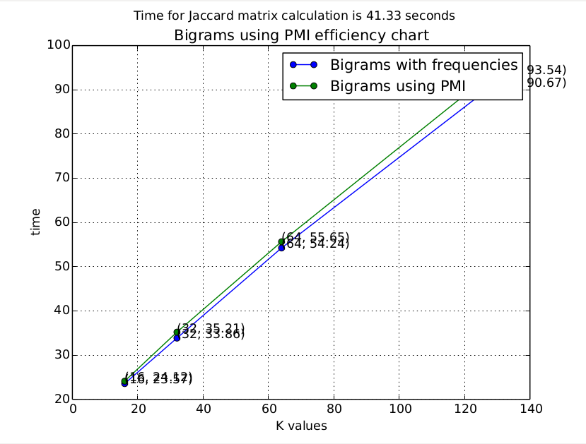

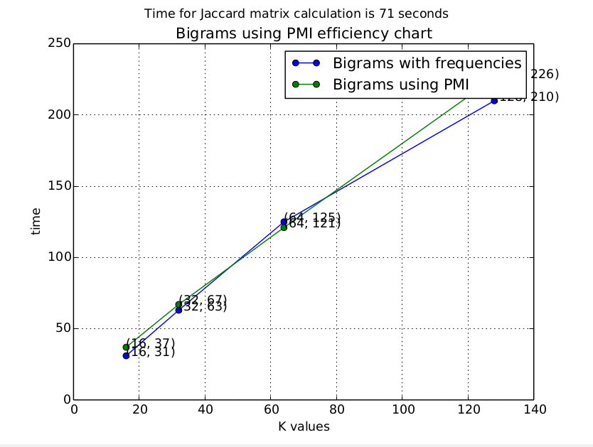
- Input Data Size: 5000
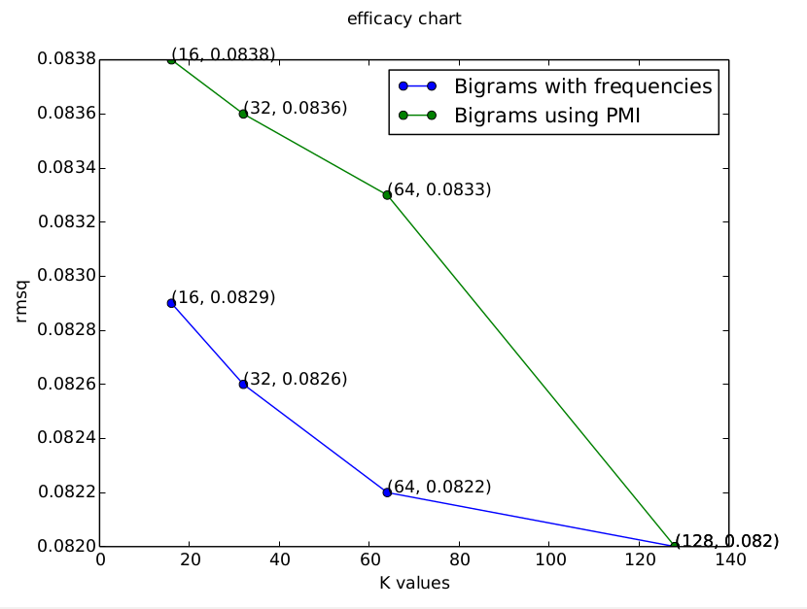

- Input Data Size: 10000
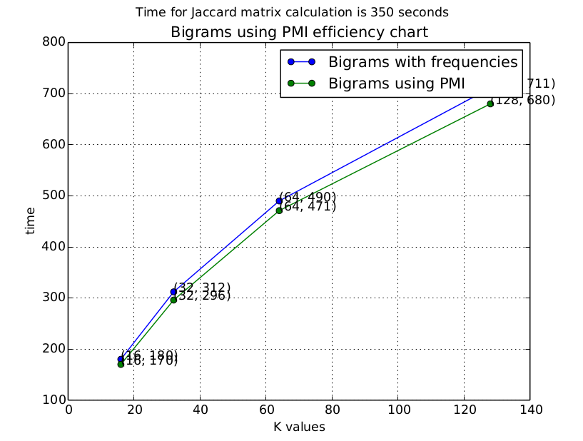
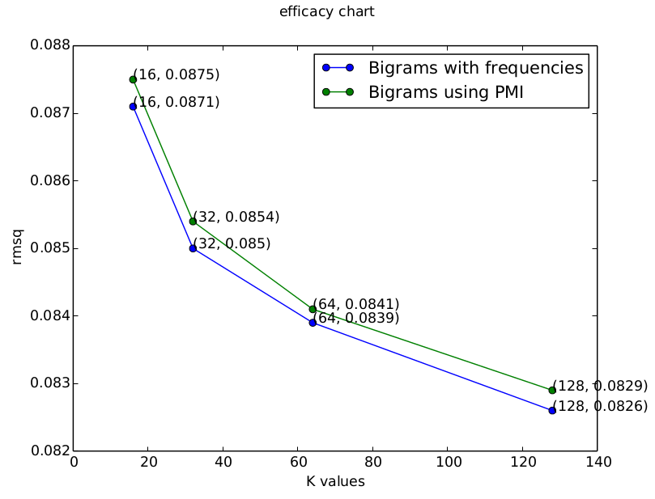
3. Shingles – size=3, 5
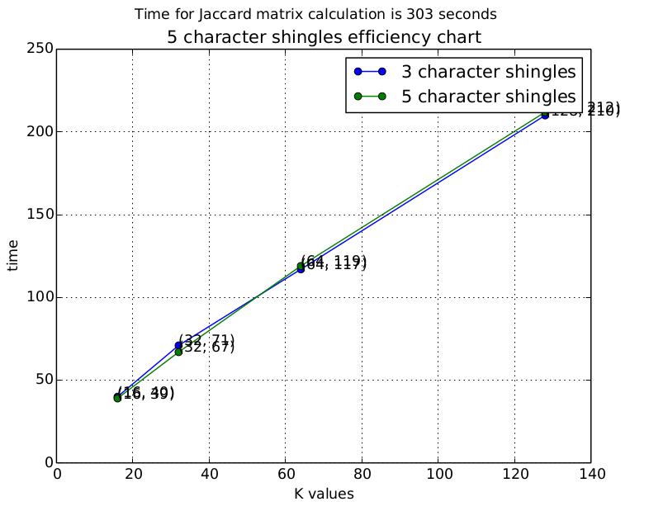
- Input Data Size: 5000
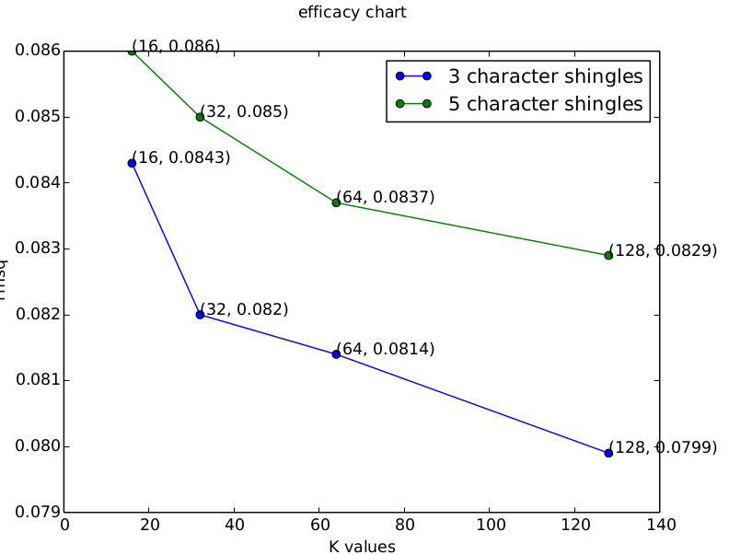

- Input Data Size: 10000
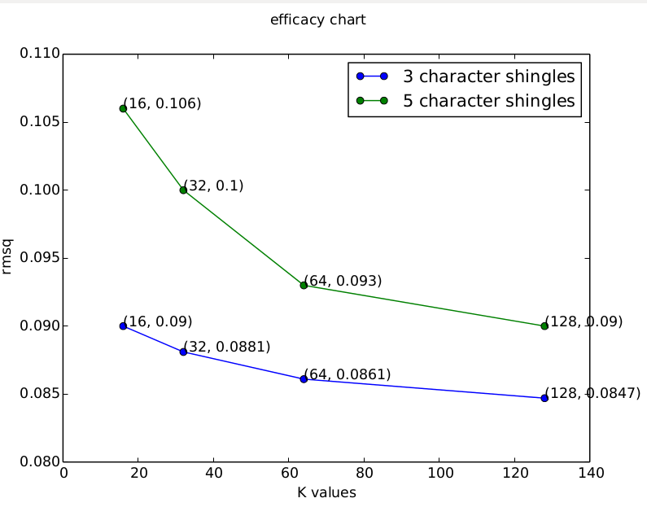
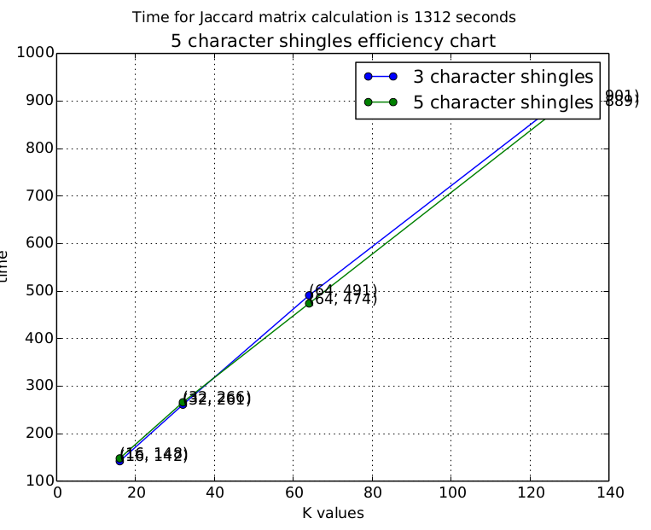

EVALUATION:
The following are the salient observations we made after retrieving results for different feature vectors and various values of K -
- Error reduces as we increase K:
This is expected. Reason - as the number of permutations increases, the probability of 2 documents with high Jaccard similarity having common minhash values increases. The maximum percentage of reduction in the value of Error when comparing K=16 and J=128 is 20%. In other words, efficacy improves by up to 20% as we increase K from 16 to 128.

- Efficiency reduces as we increase K:
This is also expected. We shall reason this using asymptotic complexity analysis. The total comparisons required to calculate minhash similarity for a single pair of documents is K. The total number of comparisons is nC2. Hence, the asymptotic complexity of calculating minhash similarity is O(nC2 * K). As K increases, complexity increases, time increases and hence efficiency reduces.

- Time taken to compute Jaccard similarity depends on dimensionality of feature vector:
This can also be reasoned using asymptotic complexity analysis. At the outset, it may seem that an efficient algorithm to calculate intersection of 2 sets has complexity O(max(size of set A, size of setB)). However, it is interesting to note that the python implementation of the 'intersect' method actually has time complexity O(min((size of set A, size of setB)) [Check Citations at the end of document]. The total time complexity is thus O(nC2 * min((size of set A, size of setB))In case of calculating Jaccard similarity, the size of Set A and Set B as mentioned above is essentially the dimensionality of 2 documents being prepared. The total time taken for calculating Jaccard similarity of 2 documents thus depends on the minimum of the dimensionality of the documents being compared. There are 2 insights we can draw from this:
- As mentioned in the Preprocessing Changes section, the dimensionality of the bigrams feature vector is 35 and that of the term frequencies feature vector is 45. In addition, the difference in sizes of dimensionality is not very high. This explains why the time taken to compute Jaccard similarity lies between the K=32 and K=64 values of time taken for minhash similarity for the bigrams and term frequencies feature vectors.
- In case of shingling, the dimensionality is > 350 and there is large amount of volatility in the dimensionality of different documents. For instance, some documents have in excess of 1000 distinct shingles whereas other have fewer than 50. This explains why the results of the shingling code were slightly anomalous in that the time taken, although > K = 128, is not directly proportional to the dimensionality.

Some minor insights:
- Shingle size does not seem to affect efficiency or efficacy by much.
- Both frequency and PMI bigrams feature vectors yield similar data.

CONCLUSION:
We believe that this assignment was an excellent exercise in understanding the efficiency and efficacy of of Minhash similarities. We learnt especially more as we implemented the entire code on our own without using any external libraries for the core logic.

WORK SPLIT UP:
Lakshmikanth Krishnan Kaushik (krishnankaushik.1@osu.edu)
Bigrams, Preprocessor changes for Character-shingling & minhash permutations, plotting results

Shridhar Ramachandran (ramachandran.65@osu.edu)
Preprocessor transformations for term frequency, jaccard similarity, minhash similarity

CITATIONS:
1. Time complexity of Set intersection in python: https://wiki.python.org/moin/TimeComplexity#set

