**ZOMATO DATABASE CREATION AND OPERATIONS.**

**Step 1: Database Schema Design**

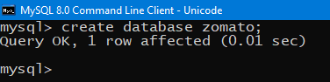

**STEP 2: USE THE DATABASE WE HAVE CREATED OF ZOMATO.**



**STEP 3: CREATE TABLE USERS.**

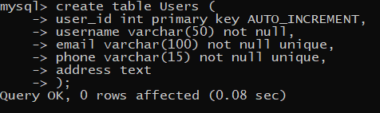

**STEP 4: CREATE TABLE RESTAURANTS.** 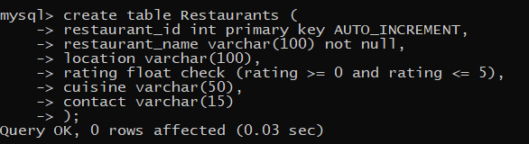

**STEP 5: CREATE TABLE MENU_ITEMS.**

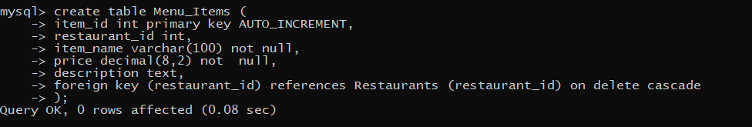

**STEP 6: CREATE TABLE ORDERS.**

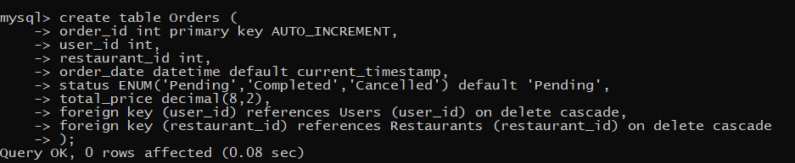

**STEP 7: CREATE TABLE ORDER_ITEMS.** 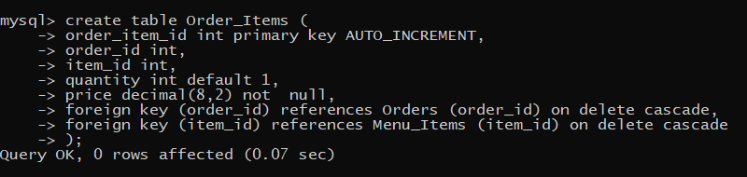

**STEP 8: CREATE TABLE REVIEWS.**

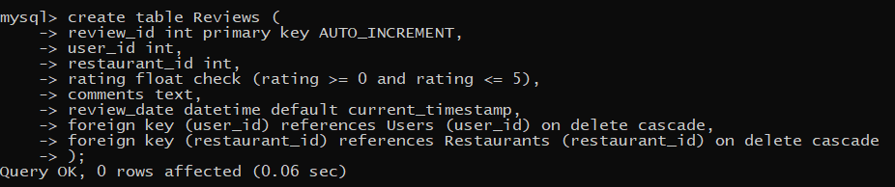

**STEP 9: INSERT INTO TABLE USERS**

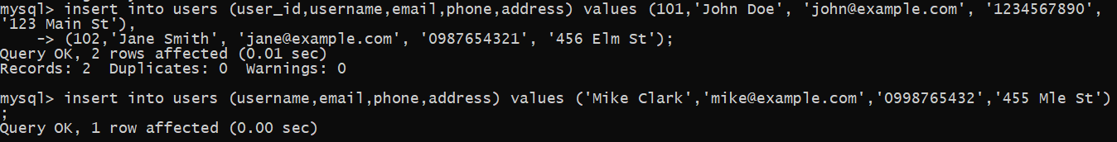

**STEP 10: INSERT INTO TABLE RESTAURANTS**



**STEP 11: INSERT INTO TABLE MENU_ITEMS**

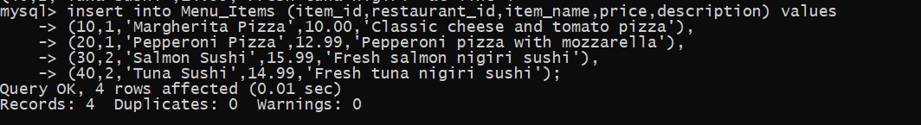

**STEP 12: INSERT INTO TABLE ORDERS**



**STEP 13: INSERT INTO TABLE ORDERS_ITEMS**

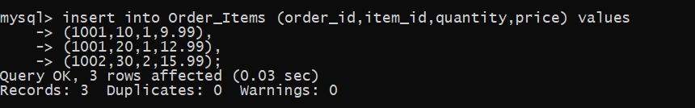

**STEP 14: INSERT INTO TABLE REVIEWS**

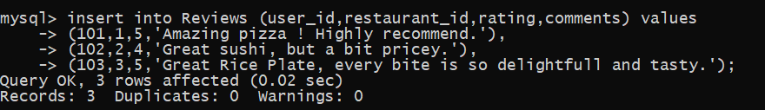

**STEP 15: PERFORMING SOME QUERIES**

**1: GETTING ALL THE RESTAURANTS AND THEIR AVERAGE RATING**

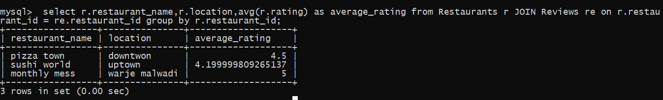

**2: FIND ALL MENU ITEMS OF ALL RESTAURANTS**

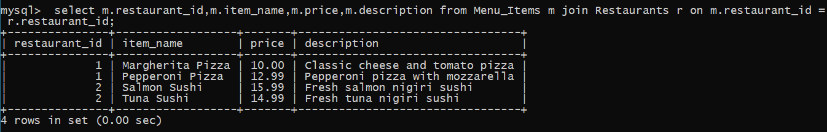

**3: RETRIEVE ALL ORDERS BY A USER**

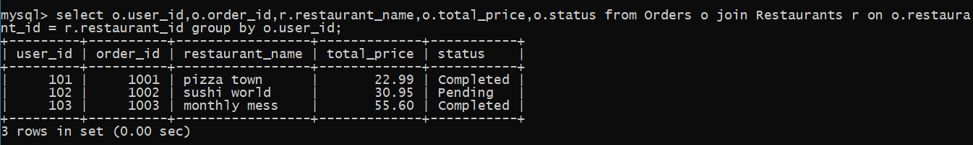

**4: DISPLAY ALL REVIEWS FOR A RESTAURANT**

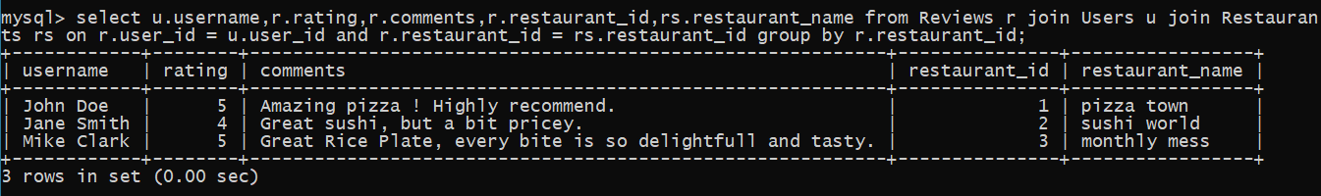

**5: CALCULATE TOTAL EARNINGS FOR EACH RESTAURANT**

