1. INTRODUCTION

1.1 Overview
The job market today moves incredibly fast. We noticed that qualified candidates often miss opportunities simply because they cannot tailor their resumes or submit applications quickly enough. We developed CareerAutomate to solve this precise problem. It is a cloud-based platform that acts as a personal career assistant, automating the repetitive parts of the job search process while giving users professional, AI-generated content to represent themselves better.
We designed the system to integrate seamlessly with the tools developers already use, like GitHub, and the platforms where they look for work. By automating repository tracking and resume updates, we allow users to focus on preparing for interviews rather than filling out forms.

1.2 Problem Statement
During our research, we identified four main bottlenecks in the traditional job search:
- Manual Repetition: A typical job seeker creates dozens of resume variations. We found that manually updating projects and skills for every single application is inefficient and prone to errors.
- Professional Visibility: Many developers have excellent code on GitHub but poor documentation. Their “README” files often lack the professional polish that recruiters look for.
- Disorganized Credentials: Users often struggle to keep track of their various certifications, leading to a scramble when an employer requests proof of qualification.
- Slow Response Time: High-demand jobs often close within days. Candidates relying on manual tracking and application often apply too late to be considered.

1.3 Scope of the Project
CareerAutomate is a web-based application focused on the following key areas:
- User Onboarding & Profile: A secure system for users to manage their professional identity, education, and career preferences.
- GitHub Integration: A direct link to GitHub that fetches repositories, analyzes code, and uses AI to write professional descriptions.
- Resume Management: Tools to generate and manage PDF resumes that are automatically updated with the user’s latest work.
- Document Verification: A workflow for uploading and verifying professional certifications to add credibility to the profile.
- Job Search Aggregation: A centralized dashboard to view job openings from multiple sources.

1.4 Objectives
- To build a microservices-based architecture that scales efficiently.
- To implement AI that can intelligently summarize technical projects.
- To create a secure, authenticated environment for personal data.
- To provide a unified dashboard for tracking career assets (resumes, projects, certs).

2. SYSTEM REQUIREMENTS

2.1 Hardware Requirements
Client Side: * Device: Any modern laptop or desktop computer. * RAM: Minimum 4GB (8GB recommended for smooth navigation). * Network: Stable internet connection (5 Mbps+).
Server Side: * Compute: AWS Lambda (Serverless) environment. * Database: Supabase (Cloud PostgreSQL) - requires no dedicated local server maintenance. * Storage: Scalable cloud object storage for documents.

2.2 Software Requirements
Development Tools: * Langauges: TypeScript (Frontend), Python 3.11 (Backend). * Frameworks: Next.js 14, FastAPI. * IDE: Visual Studio Code. * Version Control: Git & GitHub. * API Testing: Postman.
External Services: * Cloud Provider: AWS (Amazon Web Services). * Database Provider: Supabase. * AI Model: Google Gemini 1.5 Flash.

3. SYSTEM ANALYSIS AND DESIGN

3.1 Functional Requirements

3.1.1 Authentication & Security
- User Registration & Login: Users can create accounts using email/password or OAuth providers. Sessions are managed securely via JWT tokens.
- Route Protection: Sensitive pages (Dashboard, Profile) are protected; unauthenticated users are seamlessly redirected to the login page.
- Data Privacy: User data is isolated using Row Level Security (RLS) policies, ensuring users can only access their own information.

3.1.2 Profile & Onboarding
- Interactive Onboarding: New users are guided through a multi-step form to capture education, skills, and career goals.
- Profile Management: Users can update their personal details and professional summary at any time.
- Resume Upload: The system accepts existing resumes to pre-fill profile data.

3.1.3 GitHub Synchronization
- OAuth Connection: A secure “Connect GitHub” flow authorizes the application to read public repositories.
- Repository Fetching: The system automatically pulls repository names, languages, and README files.
- AI Description Generation: An integrated AI agent analyzes technical READMEs and rewrites them into professional, non-technical summaries suitable for recruiters.

3.1.4 Dashboard & Analytics
- Status Overview: A main dashboard displays real-time counts of synced projects, verified certificates, and active job applications.
- Activity Logging: Important user actions (logins, updates, syncs) are logged for security and auditing.

3.2 Microservices Architecture
We structured the backend into distinct, independently deployable services to ensure scalability and maintainability.
- Authentication Service (Auth Stack): Handles user identity, token generation (JWT), and session validation. Deployed on AWS Lambda behind API Gateway.
- Onboarding Service: Manages the initial user data collection, profile creation, and preferences setup. It ensures that a user’s profile is complete before they access core features.
- GitHub Sync Service: Responsible for all interactions with the GitHub API. It handles OAuth token exchange, repository fetching, and triggers the AI processing pipeline.
- Notification Service: Manages system alerts and updates. It logs events (like “Sync Complete” or “Certificate Verified”) to the database for the user to see in their activity feed.

3.3 Database Design
The system uses a relational PostgreSQL database hosted on Supabase. Below are the core tables used in the production environment.
- profiles: The central table storing user identity, bio, contact info, and linked URLs (LinkedIn/GitHub). It links directly to the authentication system.
- github_integrations: Stores the OAuth access tokens and metadata for the user’s connected GitHub account. Critical for persistent access to repositories.
- repositories: Contains details of all synced projects, including the raw README content and the AI-generated “professional description.”
- notification_logs: An event stream table that records system activities (e.g., “Repo synced”, “Welcome”) to build the user’s activity timeline.
- oauth_states: A temporary table used during the strict OAuth 2.0 flow to prevent CSRF attacks by verifying state parameters.

3.4 UML Diagrams

3.4.1 Architectural Design
The following diagram illustrates how our Next.js frontend interacts with the AWS Lambda microservices and Supabase backend components.
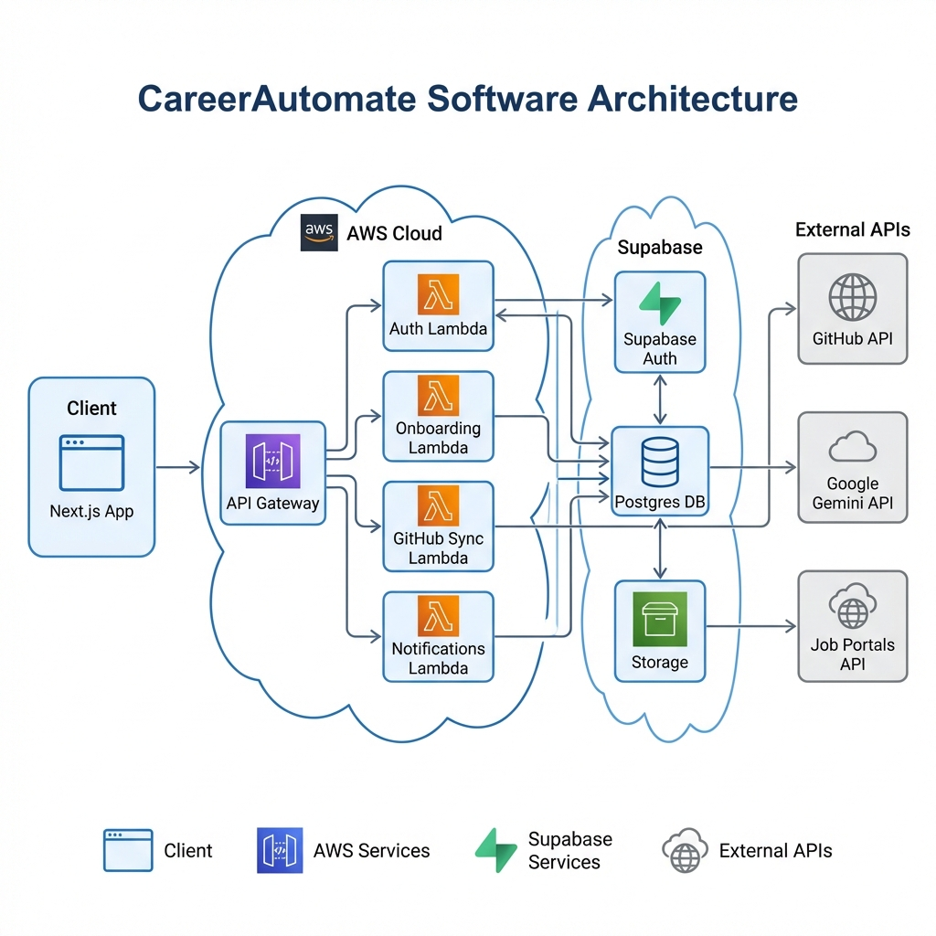
Software Architecture Diagram

3.4.2 Use Case Diagram
This visualizes the primary interactions available to the Job Seeker and Admin actors within the system.
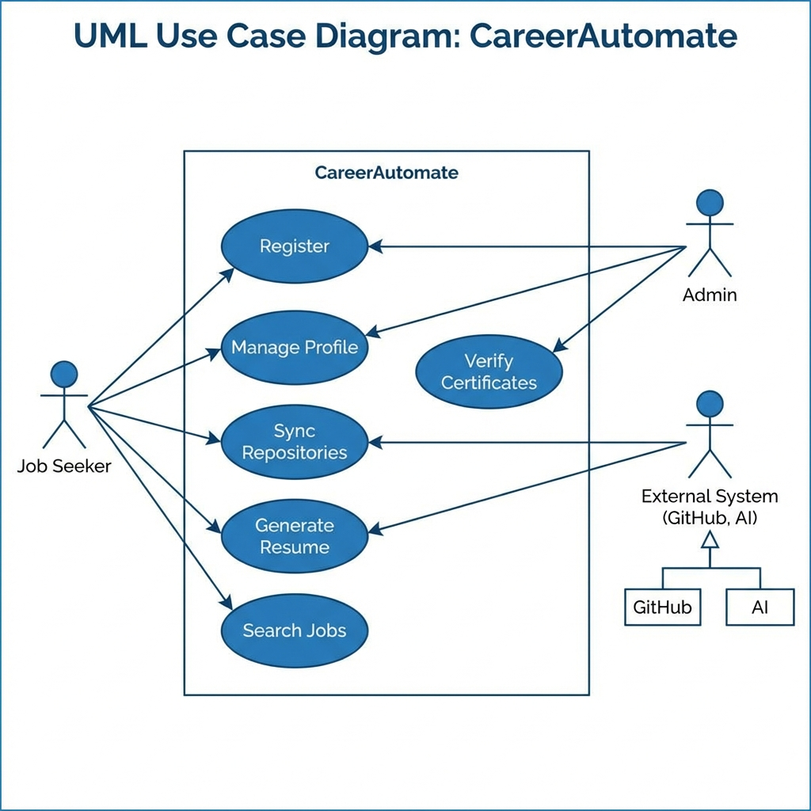
Use Case Diagram

3.4.3 Entity Relationship Diagram (ERD)
A structural view of the database schema showing the relationships between Profiles, repositories, and other entities.
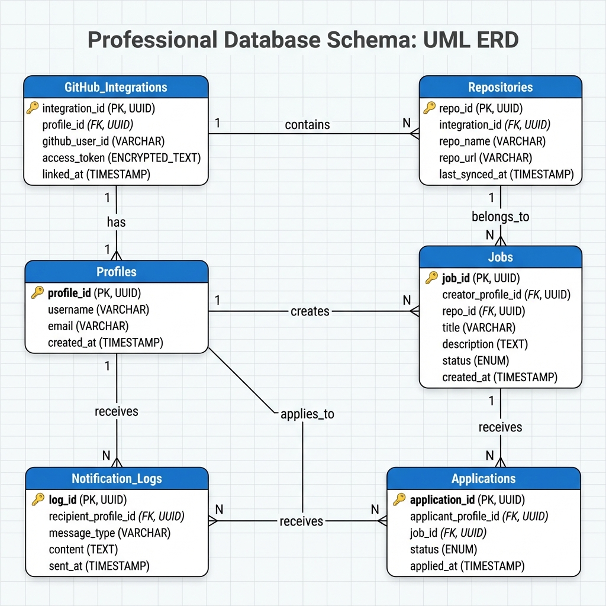
Entity Relationship Diagram

3.4.4 Sequence Diagram (GitHub Sync)
This sequence flow details the technical steps executed when a user clicks “Sync Repositories”.
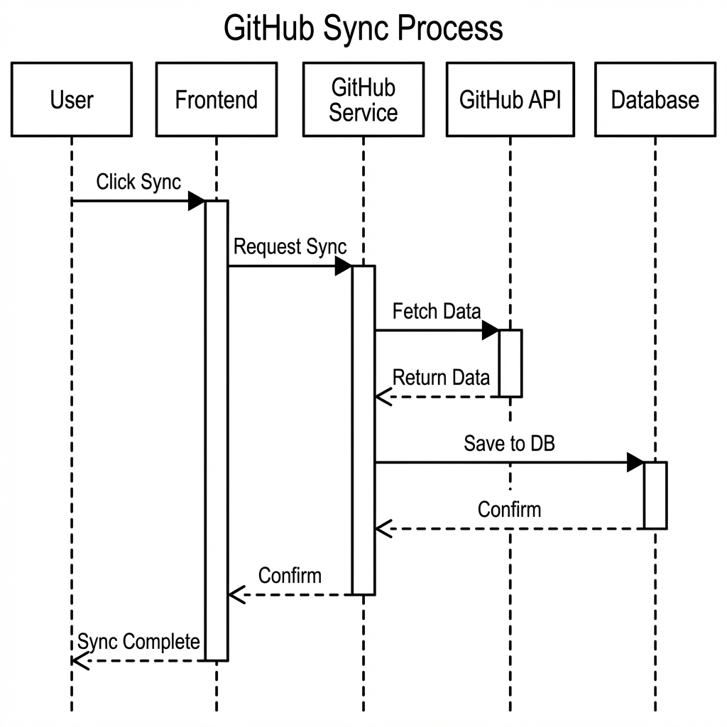
Sequence Diagram

4. IMPLEMENTATION DETAILS

4.1 Frontend Implementation
We built the user interface with Next.js 14, taking advantage of its server-side rendering for performance. The design system uses shadcn/ui, which provides accessible, pre-built components like Cards, Dialogs, and Forms. This allowed us to maintain a consistent “clean professional” aesthetic throughout the app.
We implemented custom React hooks (e.g., useSessionTimeout) to handle security features like auto-logout on the client side, ensuring that user sessions remain secure even if the tab is left open.

4.2 Backend Implementation
The backend logic is written in Python using the FastAPI framework. We chose FastAPI for its speed and automatic documentation capabilities.
The code is deployed using AWS SAM (Serverless Application Model). This defines our infrastructure (Lambda functions, API Gateways) as code, allowing us to deploy the entire backend stack with a single command. Each microservice (Auth, Onboarding, Sync) receives its own API endpoint URL, isolating them from one another.

4.3 AI Integration
The core innovation in CareerAutomate is the integration of Google Gemini 1.5 Flash. We implemented a prompt engineering layer that takes raw, messy technical documentation (README files) and instructs the AI to: 1. Identify the core problem the project solves. 2. List the technologies used. 3. Rewrite the description in the first person (“I built…”, “I implemented…”). 4. Keep the summary concise (under 5 lines).
This ensures consistency across all project descriptions in the user’s resume.

5. TESTING

5.1 Testing Strategy
Our testing strategy focused primarily on ensuring the functionality and reliability of our APIs and the overall user experience. Since our architecture relies heavily on microservices and third-party integrations (GitHub, Gemini AI), we prioritized API Endpoint Testing using Postman and Manual System Testing to verify real-world workflows.

5.2 API Endpoint Verification (Postman)
We used Postman to rigorously test each microservice endpoint. This allowed us to verify that our backend correctly handles requests, validates data, and interacts with the database and external APIs as expected.
Key API Test Scenarios:
Module | Endpoint | Method | Purpose | Status
Auth | /auth/token | POST | Verify JWT generation on login | PASS
Auth | /auth/register | POST | Account creation with validation | PASS
Github | /projects/sync | POST | Trigger repo sync from GitHub | PASS
Github | /projects/{id} | GET | Retrieve project details | PASS
AI | /projects/describe | POST | specific repo description generation | PASS
Resume | /resumes/build | POST | Generate PDF resume | PASS
Jobs | /jobs/fetch | GET | Fetch jobs from external portals | PASS
We verified that all endpoints return appropriate HTTP status codes (200 OK, 400 Bad Request, 401 Unauthorized) and correct JSON structures.

5.3 Integration Scenarios
We tested the integration between the frontend and our backend services manually to ensure data flows correctly across the system.
Tested Workflows:
- User Onboarding:
  - Verified that a new user can sign up, complete their profile, and that data persists in Supabase.
  - Confirmed that the authentication state is correctly maintained across page reloads.
- GitHub Connection:
  - Tested the OAuth flow: Clicking “Connect GitHub” -> Redirect to GitHub -> Authorization -> Redirect back to App.
  - Verified that the access token is securely stored and used for subsequent requests.
- AI Generation:
  - Triggered the “Generate AI Description” feature for a repository.
  - Confirmed that the backend retrieves the README, sends it to Gemini AI, and saves the returned summary to the database.
- Resume Building:
  - Verified that the resume builder pulls the correct project data and user info.
  - Tested the PDF download functionality to ensure the file is generated and formatted correctly.

5.4 Manual System Testing
We conducted manual testing of the complete platform to validate the end-to-end user experience.
Scenario 1: New User Journey * Step: Register -> Onboard -> Connect GitHub -> Sync Repos. * Result: The user was able to complete the flow without errors. Repositories appeared in the dashboard within seconds.
Scenario 2: Job Application Flow * Step: Search Jobs -> Select Job -> Apply with Resume. * Result: The application status tracked correctly in the “Applications” tab.
Scenario 3: Certificate Verification (Admin) * Step: User uploads cert -> Admin logs in -> Admin approves cert. * Result: User sees “Verified” badge on their profile immediately after admin approval.

5.5 Functionality & Security Checks
We performed manual checks to verify security and core functionality:
- Route Protection: Verified that trying to access /dashboard without being logged in redirects to the login page.
- Data Isolation: Confirmed that a user cannot see another user’s repositories or resumes by manipulating IDs in the URL.
- Input Validation: Tested forms with invalid emails and empty fields to ensure proper error messages are displayed.

6. FUTURE ENHANCEMENTS
While the current version of CareerAutomate acts as a robust prototype, we have identified several key areas for future development to make it a commercially viable product.
- Expanded Job Portal Integration: Currently, we aggregate a limited set of jobs. Future versions will use the official APIs of major platforms like Glassdoor and LinkedIn (Enterprise) to fetch real-time listings with one-click apply functionality.
- Advanced AI Interview Prep: We plan to leverage the “multimodal” capabilities of newer Gemini models to offer mock interviews where the AI listens to the user’s voice answers and provides feedback on tone and content.
- Mobile Application: A dedicated React Native mobile app would allow users to receive push notifications for job alerts and “Quick Apply” while on the move.
- Community Features: Adding a “Peer Review” system where users can anonymize their resumes and get feedback from the CareerAutomate community or verified mentors.
- Enterprise Recruiter Portal: Building a separate interface for recruiters to search for candidates based on specific verified skills in our database, pivoting the business model to B2B.

7. CONCLUSION
The CareerAutomate project successfully demonstrates how modern cloud technologies can simplify complex, stress-inducing human processes. By combining a serverless microservices architecture with Generative AI, we have built a platform that not only saves time but fundamentally upgrades how a job seeker presents themselves to the world.
From a technical perspective, the project proves the viability of the “Serverless” model for keeping costs low while maintaining high scalability. The integration of Google Gemini showed us that AI can be a reliable partner in creative tasks like writing and summarization, provided it is guided by strong prompt engineering.
Key Outcome: The final system meets all primary objectives: it provides a secure, automated, and intelligent workspace for career management. We have moved from a manual, disjointed job search process to a streamlined, data-driven workflow that empowers the user. The project stands at a high level of technical readiness and is well-positioned for future expansion into a full commercial product.

