1. INTRODUCTION

1.1 Overview
The modern job market presents unprecedented challenges for job seekers. We observed that professionals often spend an average of 11 hours per week on job searching activities, with hundreds of applications required to secure a single interview. We developed CareerAutomate to solve this problem, offering an intelligent platform that automates repetitive tasks while providing AI-powered insights.
Our platform connects with popular services like GitHub, LinkedIn, Naukri, and Indeed. It automatically syncs user projects, generates professional descriptions using AI, builds tailored resumes, and automates the application process.

1.2 Problem Statement
When we started this project, we identified several critical challenges job seekers face:
Time-Consuming Manual Processes: Searching for jobs across multiple portals and customizing resumes takes significant time. We found that job seekers apply to 50-100 positions before receiving an offer.
Inconsistent Personal Branding: Maintaining updated profiles across platforms is hard. We noticed GitHub projects often lack professional descriptions suitable for resumes.
Lack of Insights: Job seekers lack data-driven insights. They don’t know which resume versions work best or where they have skill gaps.
Certificate Management: There is no centralized system for professionals to manage and verify their accumulated certifications.
Missed Opportunities: Jobs are filled quickly. Manual application processes are often too slow to match the speed of the market.

1.3 Proposed Solution
CareerAutomate addresses these challenges through a comprehensive automation platform:
Automated Project Synchronization: The platform connects to users’ GitHub accounts via OAuth, automatically syncing repositories and using Google Gemini AI to generate professional, first-person descriptions suitable for resumes.
Intelligent Resume Builder: An AI-powered resume generator creates tailored resumes based on user profiles, projects, and target job roles. The system can automatically update resumes when new projects are detected.
Multi-Portal Job Aggregation: The platform fetches job listings from LinkedIn, Naukri, and Indeed based on user preferences, eliminating the need to manually search across platforms.
Automated Applications: Users can enable auto-apply functionality, allowing the system to submit applications on their behalf using appropriately tailored resumes and cover letters.
Comprehensive Analytics: Detailed reports and insights help users understand their job search performance, identify skill gaps, and optimize their approach.
Centralized Document Management: Certificate upload, verification, and management features ensure credentials are readily available and verified.

1.4 Objectives
The primary objectives of this project are:
- To develop a scalable microservices-based platform for career automation
- To integrate AI capabilities for intelligent resume generation and project descriptions
- To automate job fetching from multiple portals with intelligent filtering
- To implement automated job application with tracking and analytics
- To provide a comprehensive dashboard for career management
- To ensure security through modern authentication and authorization mechanisms
- To create an administrative interface for platform management
- To deploy the solution using serverless architecture for cost efficiency

1.5 Scope of the Project
The CareerAutomate platform encompasses the following functional areas:
User Management: Registration, authentication, profile management, and onboarding workflows using Supabase Auth with OAuth support for Google and GitHub.
GitHub Integration: OAuth-based GitHub connection, repository synchronization, README content extraction, and AI-powered description generation using webhooks for real-time updates.
Resume Management: AI-powered resume creation, multiple resume versions, PDF generation, auto-tailoring for specific job roles, and project video attachments.
Job Management: Multi-portal job fetching, intelligent job matching, application automation, status tracking, and response management.
Document Verification: Certificate upload, OCR extraction, admin verification workflow, and status notifications.
Analytics and Reporting: Application statistics, resume performance metrics, skill gap analysis, and exportable reports.
Notifications: Real-time notifications for job matches, application updates, verification results, and system events.
Administration: User management, certificate verification, API key management, and platform monitoring.

1.6 Technology Stack
The platform utilizes modern technologies selected for their performance, scalability, and developer experience:
Layer | Technology
Frontend | Next.js 14, React, TypeScript, shadcn/ui, Tailwind CSS
Backend | Python 3.11, FastAPI, Pydantic
Database | Supabase (PostgreSQL), Row-Level Security
Authentication | Supabase Auth, JWT, OAuth 2.0
Storage | Supabase Storage
AI/ML | Google Gemini 2.5 Flash
Deployment | AWS Lambda, SAM, API Gateway
Version Control | Git, GitHub

2. PROJECT PLAN

2.1 Project Planning Methodology
The CareerAutomate project was developed using an Agile methodology with iterative sprints. The team followed a modular approach where each microservice stack was developed as an independent unit, allowing parallel development and deployment.

2.3 Development Timeline

2.3 Development Timeline
The following Gantt chart illustrates the 16-week development schedule, broken down by major phases and their corresponding execution periods.

2.3 Development Timeline
The following Gantt chart illustrates the 16-week development schedule, broken down by major phases.
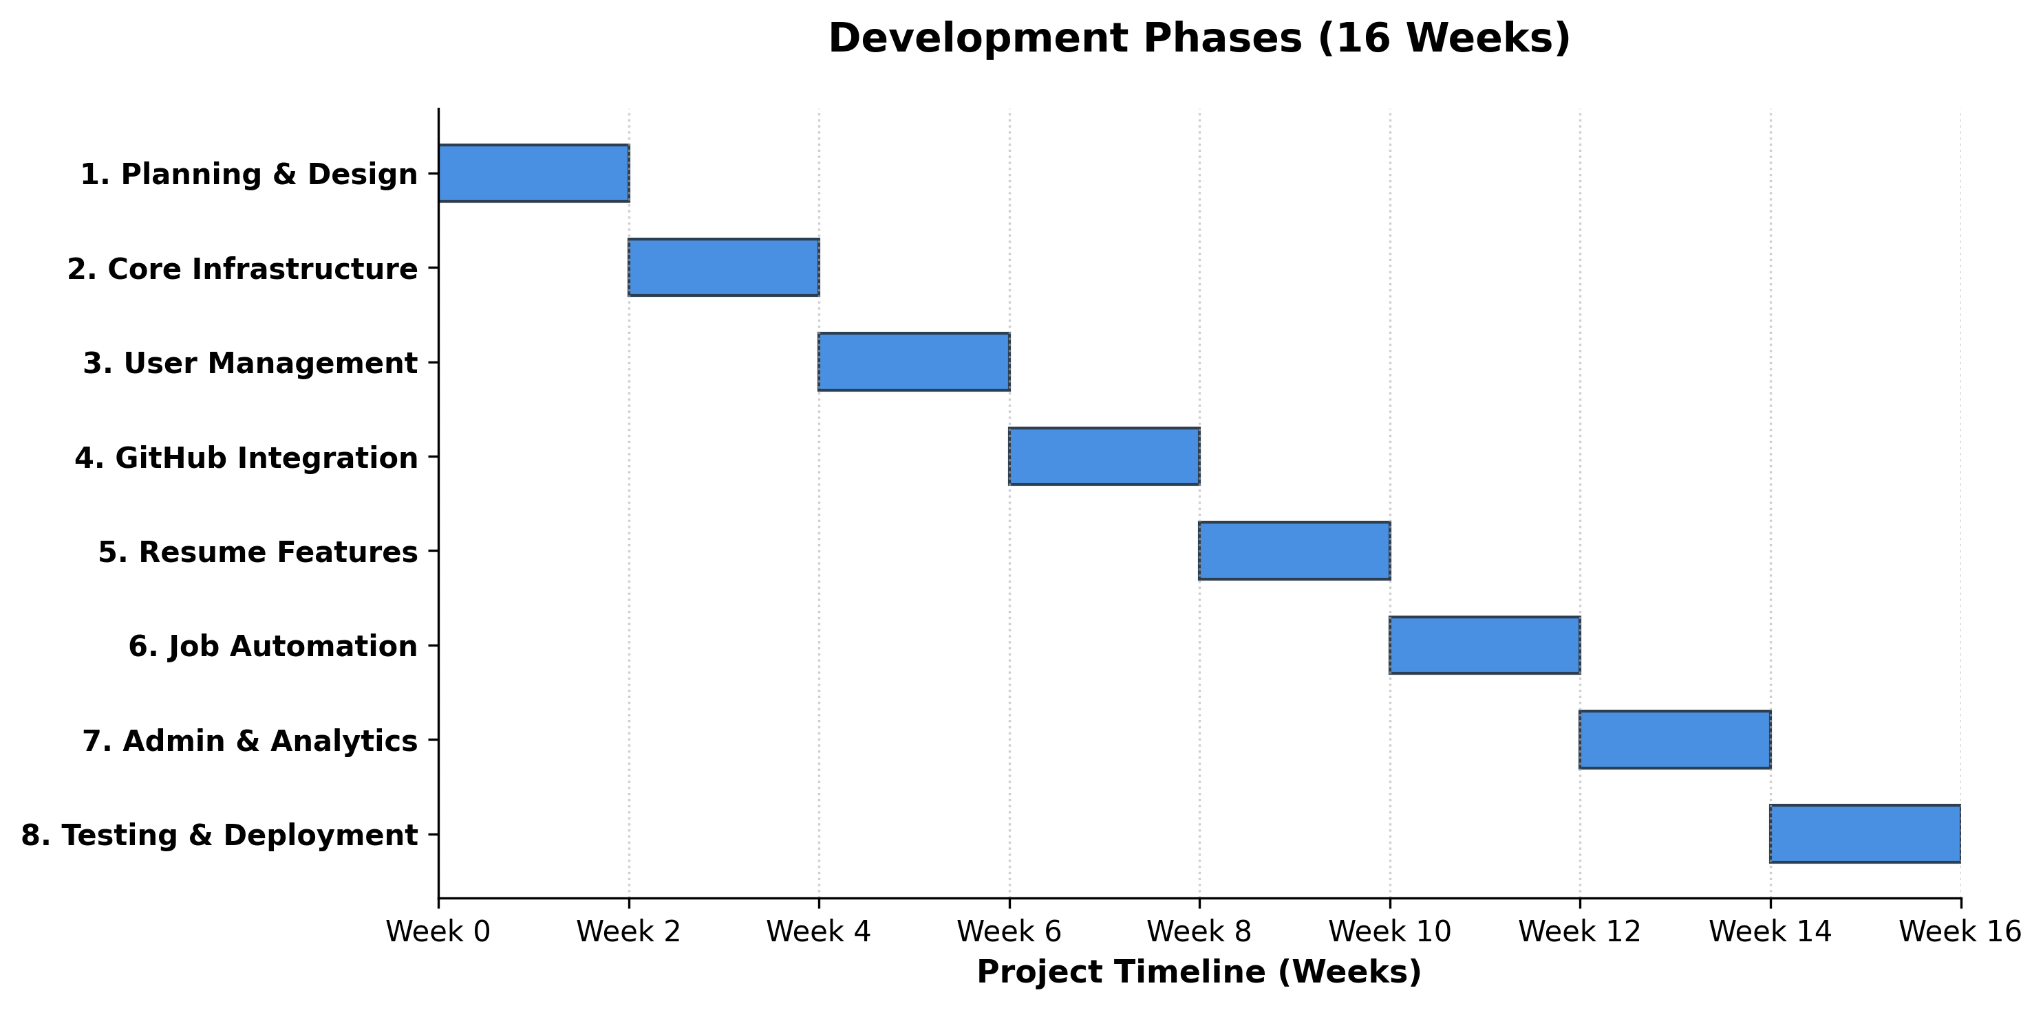
Development Timeline
Figure 2.3: Project Development Schedule (16 Weeks)
Note: In alignment with microservices architecture, individual services were deployed and tested iteratively throughout the development phases (CI/CD), culminating in the final production release.
Note: In alignment with microservices architecture, individual services were deployed and tested iteratively throughout the development phases (CI/CD), culminating in the final production release.

2.4 Risk Management
Risk | Probability | Impact | Mitigation Strategy
API Rate Limits | High | Medium | Implement caching, request queuing, and graceful degradation
Third-party Service Changes | Medium | High | Design abstraction layers, maintain fallback mechanisms
Scope Creep | Medium | Medium | Strict change control, prioritization framework
Integration Complexity | High | Medium | Early integration testing, well-defined interfaces
Security Vulnerabilities | Medium | High | Regular security audits, dependency updates

2.5 Resource Allocation
Hardware Resources: - Development workstations with 16GB RAM minimum - Local PostgreSQL instances for development - Git repositories for version control
Software Resources: - VS Code / PyCharm for development - Postman for API testing - GitHub for source control - Supabase for database and auth - AWS account for deployment
Cloud Resources: - Supabase Free/Pro tier - AWS Lambda (serverless compute) - AWS API Gateway - AWS S3 (via Supabase Storage)

3. SOFTWARE REQUIREMENT SPECIFICATION

3.1 Introduction

3.1.1 Purpose
This Software Requirements Specification (SRS) document describes the functional and non-functional requirements for the CareerAutomate platform. It serves as a comprehensive guide for developers, testers, and stakeholders.

3.1.2 Scope
The CareerAutomate system is a web-based career automation platform that provides job seekers with tools to streamline their job search process through automation and AI-powered features.

3.1.3 Definitions and Acronyms
Term | Definition
JWT | JSON Web Token - Used for secure authentication
OAuth | Open Authorization - Standard for token-based authentication
RLS | Row-Level Security - Database security feature
BYOK | Bring Your Own Key - Users provide their own API keys
SPA | Single Page Application
REST | Representational State Transfer
CRUD | Create, Read, Update, Delete operations

3.2 Overall Description

3.2.1 Product Perspective
CareerAutomate is a standalone web application that integrates with external services including GitHub, Google Gemini AI, and various job portals. It operates as a software-as-a-service (SaaS) platform.

3.2.2 Product Functions
The major functions of the system include: - User authentication and authorization - GitHub project synchronization - AI-powered content generation - Resume creation and management - Job fetching and aggregation - Automated job applications - Certificate management and verification - Analytics and reporting - Administrative controls

3.2.3 User Classes and Characteristics
Regular Users (Job Seekers): - Primary users of the platform - Access to all user-facing features - Can manage their profiles, projects, resumes, and job applications
Administrators: - Platform operators with elevated privileges - Access to admin dashboard - Can verify certificates, manage users, and configure platform settings

3.2.4 System Requirements
Hardware Requirements:
- Client Side:
  - Processor: Intel Core i3 or equivalent (Minimum), i5 or better (Recommended)
  - RAM: 4 GB Minimum, 8 GB Recommended
  - Storage: 500 MB free logic space (mostly web-based)
  - Network: High-speed internet connection (5 Mbps upload/download minimum)
- Server Side (Cloud Environment):
  - Compute: AWS Lambda (Serverless, auto-scaling)
  - Database: Supabase (PostgreSQL) T3.micro equivalent or higher
  - Storage: AWS S3 buckets (scalable)
Software Requirements:
- Operating System: Windows 10/11, macOS, or Linux (Ubuntu/Debian)
- Web Browser: Google Chrome (Latest), Mozilla Firefox, Microsoft Edge, or Safari
- Programming Languages: Python 3.11, TypeScript, SQL
- Frameworks & Libraries: Next.js 14, React, FastAPI, Pydantic, Tailwind CSS
- Database Management: PostgreSQL 15 (via Supabase)
- Version Control: Git & GitHub
- IDE: Visual Studio Code

3.3 Functional Requirements

3.3 Functional Requirements
We have categorized the system’s functional requirements into three main modules:
- User Authentication and Management
  - Registration & Login: Users can create accounts via email/password or use OAuth (Google/GitHub) for instant access.
  - Profile Management: Capability to update personal details, set career preferences, and manage API keys for AI services.
  - Session Control: Secure JWT-based session management with automatic expiration and refresh mechanisms.
- Applicant Features
  - Project Synchronization: Users can connect their GitHub accounts to automatically sync repositories and generate AI descriptions.
  - Resume Verification: The system allows users to generate multiple versions of resumes tailored to different roles and download them as PDFs.
  - Job Automation: Users can fetch filtered job listings from portals like LinkedIn/Indeed and track their application status in real-time.
  - Document Management: Functionality to upload certifications and documents for verification and storage.
- Administrator Features
  - Verification Dashboard: Admins have a dedicated interface to review and verify user-uploaded documents with approve/reject actions.
  - User Oversight: Ability to view user statistics and manage platform configurations.
  - System Monitoring: Tools to monitor service health and API usage metrics.
- Non-Functional Requirements
  - Performance: The system ensures API response times under 500ms for core operations to maintain a fluid user experience.
  - Scalability: Designed to handle increasing user loads via serverless architecture (AWS Lambda).
  - Security: Enforces HTTPS for all communications, encrypts sensitive data (API keys) at rest, and uses Row-Level Security (RLS) for data isolation.
  - Usability: Provides a responsive, mobile-friendly interface with intuitive navigation and error handling.
  - Reliability: Implements graceful degradation for third-party API failures (e.g., GitHub or Gemini limits).

3.4 Non-Functional Requirements

3.4.1 Performance Requirements

3.4.1 Performance Requirements
- API Response: The system shall ensure API response times are under 500ms for 95% of requests.
- Concurrency: The system shall support a minimum of 1000 concurrent users.
- Database: Database queries shall complete within 100ms.
- Load Time: Frontend pages shall load within 3 seconds.

3.4.2 Security Requirements
- HTTPS: All API communications must use HTTPS.
- Encryption: Sensitive data (e.g., API keys) shall be encrypted at rest.
- Authentication: JWT tokens shall expire within 24 hours.
- Row-Level Security: RLS shall be enabled on all user tables to ensure data isolation.
- Secret Management: API keys shall be stored in an encrypted format.

3.4.3 Reliability Requirements
- Uptime: The system shall maintain 99.5% uptime.
- Backups: The system shall perform daily database backups.
- Error Handling: The system shall gracefully handle third-party service failures (e.g., GitHub or Gemini quotas).

3.4.4 Scalability Requirements
- Auto-scaling: The system shall auto-scale compute resources based on demand (AWS Lambda).
- Database: The database layer shall support horizontal scaling.
- Deployment: The system shall support multi-region deployment capabilities.

4. ANALYSIS AND DESIGN

4.1 System Analysis

4.1.1 Existing System Analysis
Traditional job search methods involve manual processes that are time-consuming and inefficient:
Manual Job Searching: Users visit multiple job portals individually, search for relevant positions, and manually track applications using spreadsheets or notebooks.
Resume Creation: Users create resumes using word processors or basic templates, manually updating them for each application without data-driven optimization.
Project Documentation: Developers maintain GitHub repositories but rarely create professional descriptions suitable for resumes, leading to underutilization of their work history.
Application Tracking: Without centralized tracking, users often lose track of where they applied, when they applied, and what resume version they used.
Limitations of Existing System: - High time investment with low return - Inconsistent application quality - No insights into job search performance - Difficulty maintaining updated documentation - Manual errors in tracking applications

4.1.2 Proposed System Analysis
CareerAutomate addresses these limitations through intelligent automation:
Automated Integration: Direct connection to GitHub for project synchronization and job portals for application submission eliminates manual data entry.
AI-Powered Content: Google Gemini AI generates professional descriptions and tailored resume content, ensuring high-quality output with minimal user effort.
Centralized Management: Single dashboard for all career-related activities provides comprehensive visibility and control.
Data-Driven Insights: Analytics and reporting features help users optimize their job search strategies based on actual performance data.
Advantages of Proposed System: - Significant time savings through automation - Consistent, professional-quality applications - Real-time insights and recommendations - Always up-to-date project documentation - Comprehensive application tracking

4.2 System Design

4.2.1 Architectural Overview
CareerAutomate follows a microservices architecture pattern with twelve independent service stacks:
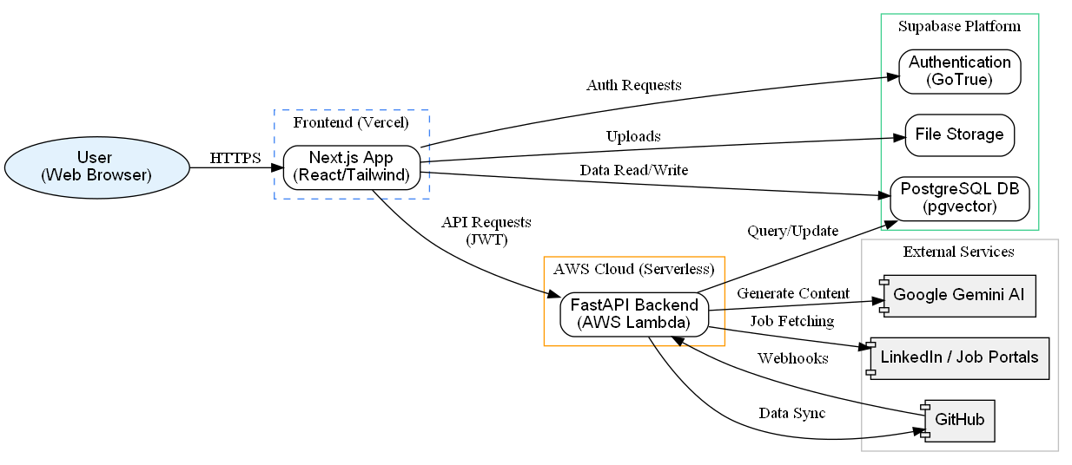
Architectural Overview

4.2.2 Microservices Design

4.2.2 Microservices Design
Each microservice is designed as an independent unit with specific responsibilities:
- Auth Service: Manages user authentication, OAuth flows (GitHub/Google), and JWT token issuance.
- Profile Service: Handles user onboarding, profile updates, and preferences.
- GitHub Sync Service: Connects to GitHub API to fetch repositories, webhooks, and syncs data to Supabase.
- AI Service: Wraps the Google Gemini API to generate professional descriptions for projects and resumes.
- Resume Service: Generates PDF resumes based on selected templates and user data.
- Job Service: Aggregates job listings from various portals and manages the application tracking workflow.
- Admin Service: Provides the verification interface for administrators to review user documents.
- Notification Service: Manages email alerts and in-app notifications for system events (e.g., “Resume Ready”, “Application Sent”).

4.2.3 Database Design
The database schema is organized around core entities with Row-Level Security enabled for all user-owned tables.

4.2.3 Database Design
The database schema is streamlined to support the core microservices. Below are the specific tables used in the production environment:
Core Tables:
profiles
├── id (UUID, PK) - Links to auth.users
├── email (TEXT)
├── role (user|admin)
├── created_at (TIMESTAMPTZ)
└── updated_at (TIMESTAMPTZ)
repositories
├── id (UUID, PK)
├── user_id (UUID, FK -> profiles)
├── name (TEXT)
├── description (TEXT) - Original description
├── description_ai (TEXT) - AI Generated
├── html_url (TEXT)
└── language (TEXT)
github_integrations
├── id (UUID, FK -> profiles)
├── access_token (TEXT) - Encrypted
└── github_username (TEXT)
resumes
├── id (UUID, PK)
├── user_id (UUID, FK -> profiles)
├── name (TEXT)
├── file_path (TEXT) - Link to storage
└── created_at (TIMESTAMPTZ)
fetched_jobs
├── id (UUID, PK)
├── title (TEXT)
├── company (TEXT)
└── source_url (TEXT)
job_applications
├── id (UUID, PK)
├── user_id (UUID, FK -> profiles)
├── job_id (UUID, FK -> fetched_jobs)
├── status (TEXT) - Applied/Pending/Rejected
└── applied_at (TIMESTAMPTZ)
certificate_documents
├── id (UUID, PK)
├── user_id (UUID, FK -> profiles)
├── file_path (TEXT)
├── verification_status (TEXT)
└── uploaded_at (TIMESTAMPTZ)

4.2.4 Entity Relationship Diagram
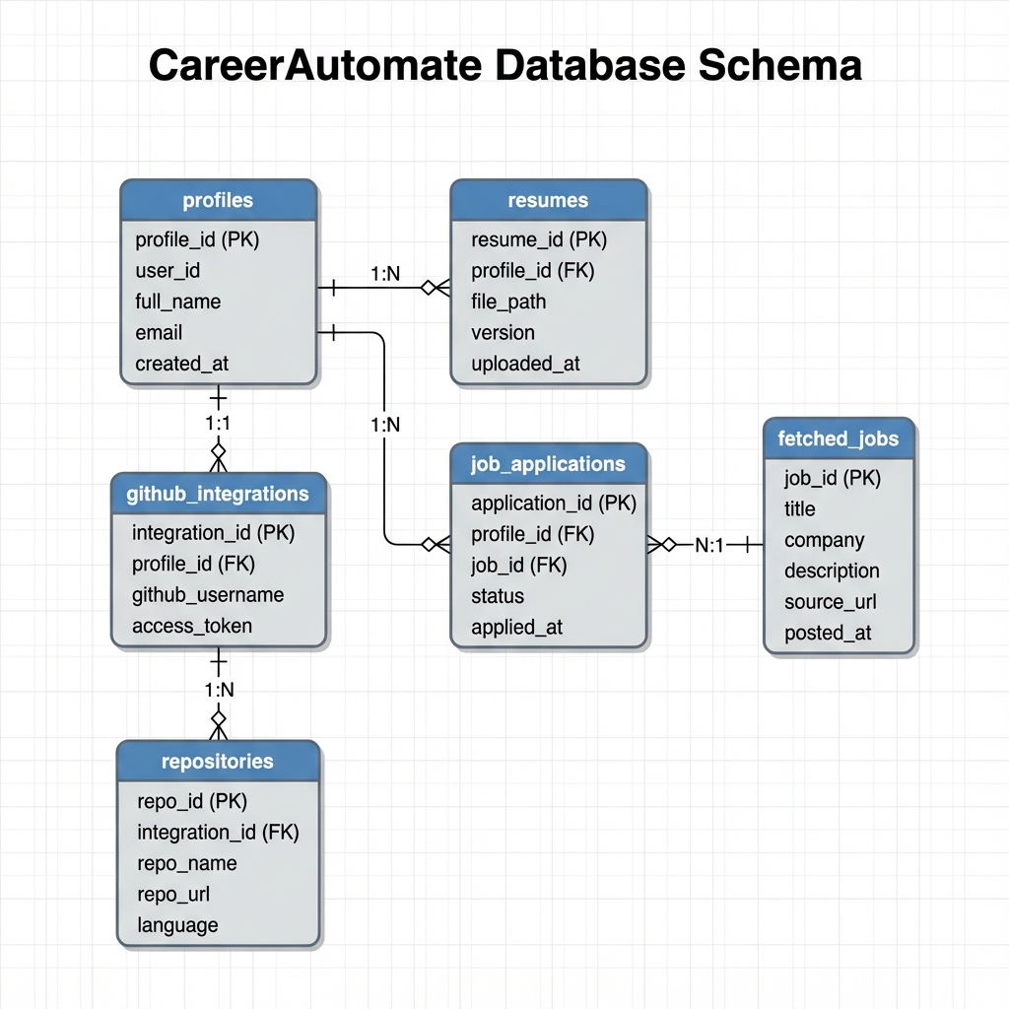
Entity Relationship Diagram

5. IMPLEMENTATION

5.1 Development Environment Setup
The following software and tools were installed for development:
- Node.js 18.x - JavaScript runtime for frontend development
- Python 3.11 - Backend development language
- Git - Version control system
- VS Code - Primary IDE with extensions for Python, TypeScript, and Tailwind CSS
- Postman - API testing and documentation
- Docker - Local development containers (optional)

5.2 Frontend Implementation

5.2.1 Next.js Application Setup
The frontend was initialized using Create Next App with TypeScript and Tailwind CSS:
npx create-next-app@latest frontend --typescript --tailwind --app
cd frontend
npm install @supabase/supabase-js lucide-react
npx shadcn-ui@latest init

5.2.2 Supabase Client Configuration
lib/supabase.ts
import { createClient } from '@supabase/supabase-js'
const supabaseUrl = process.env.NEXT_PUBLIC_SUPABASE_URL!
const supabaseAnonKey = process.env.NEXT_PUBLIC_SUPABASE_ANON_KEY!
export const supabase = createClient(supabaseUrl, supabaseAnonKey)
// Helper function to get current user
export async function getCurrentUser() {
const { data: { user }, error } = await supabase.auth.getUser()
if (error) throw error
return user
}
// Helper function to get session
export async function getSession() {
const { data: { session }, error } = await supabase.auth.getSession()
if (error) throw error
return session
}

5.2.3 Authentication Context
contexts/AuthContext.tsx
'use client'
import { createContext, useContext, useEffect, useState } from 'react'
import { User, Session } from '@supabase/supabase-js'
import { supabase } from '@/lib/supabase'
interface AuthContextType {
user: User | null
session: Session | null
loading: boolean
signIn: (email: string, password: string) => Promise<void>
signOut: () => Promise<void>
}
const AuthContext = createContext<AuthContextType | undefined>(undefined)
export function AuthProvider({ children }: { children: React.ReactNode }) {
const [user, setUser] = useState<User | null>(null)
const [session, setSession] = useState<Session | null>(null)
const [loading, setLoading] = useState(true)
useEffect(() => {
// Get initial session
supabase.auth.getSession().then(({ data: { session } }) => {
setSession(session)
setUser(session?.user ?? null)
setLoading(false)
})
// Listen for auth changes
const { data: { subscription } } = supabase.auth.onAuthStateChange(
async (event, session) => {
setSession(session)
setUser(session?.user ?? null)
setLoading(false)
}
)
return () => subscription.unsubscribe()
}, [])
const signIn = async (email: string, password: string) => {
const { error } = await supabase.auth.signInWithPassword({
email,
password
})
if (error) throw error
}
const signOut = async () => {
await supabase.auth.signOut()
}
return (
<AuthContext.Provider value={{ user, session, loading, signIn, signOut }}>
{children}
</AuthContext.Provider>
)
}
export function useAuth() {
const context = useContext(AuthContext)
if (!context) {
throw new Error('useAuth must be used within AuthProvider')
}
return context
}

5.2.4 Dashboard Layout Component
components/dashboard-layout.tsx
'use client'
import { useState } from 'react'
import { DashboardNav } from './dashboard-nav'
import { Menu } from 'lucide-react'
import { Button } from '@/components/ui/button'
interface DashboardLayoutProps {
children: React.ReactNode
}
export function DashboardLayout({ children }: DashboardLayoutProps) {
const [sidebarOpen, setSidebarOpen] = useState(false)
return (
<div className="min-h-screen bg-gray-50 dark:bg-gray-900">
{/* Mobile menu button */}
<div className="lg:hidden fixed top-4 left-4 z-50">
<Button
variant="outline"
size="icon"
onClick={() => setSidebarOpen(!sidebarOpen)}
>
<Menu className="h-4 w-4" />
</Button>
</div>
{/* Sidebar */}
<DashboardNav
open={sidebarOpen}
onClose={() => setSidebarOpen(false)}
/>
{/* Main content */}
<main className="lg:pl-64 min-h-screen">
{children}
</main>
</div>
)
}

5.2.5 Projects Page with GitHub Integration
app/projects/page.tsx (Partial)
'use client'
import { useEffect, useState } from 'react'
import { Card, CardContent, CardHeader, CardTitle } from '@/components/ui/card'
import { Button } from '@/components/ui/button'
import { supabase } from '@/lib/supabase'
import { Github, RefreshCw, Sparkles } from 'lucide-react'
const GITHUB_SYNC_SERVICE_URL = process.env.NEXT_PUBLIC_GITHUB_SYNC_SERVICE_URL
interface Repository {
id: string
name: string
full_name: string
html_url: string
description_ai: string | null
language: string | null
last_synced_at: string
}
export default function ProjectsPage() {
const [repositories, setRepositories] = useState<Repository[]>([])
const [loading, setLoading] = useState(true)
const [syncing, setSyncing] = useState(false)
const syncRepositories = async () => {
setSyncing(true)
try {
const { data: { session } } = await supabase.auth.getSession()
const response = await fetch(
`${GITHUB_SYNC_SERVICE_URL}/v1/projects/sync`,
{
method: 'POST',
headers: {
'Authorization': `Bearer ${session?.access_token}`,
'Content-Type': 'application/json'
}
}
)
const data = await response.json()
// Refresh repository list
await fetchRepositories()
} catch (error) {
console.error('Sync failed:', error)
} finally {
setSyncing(false)
}
}
const generateAIDescription = async (repoId: string) => {
const { data: { session } } = await supabase.auth.getSession()
const response = await fetch(
`${GITHUB_SYNC_SERVICE_URL}/v1/projects/${repoId}/describe`,
{
method: 'POST',
headers: {
'Authorization': `Bearer ${session?.access_token}`,
'Content-Type': 'application/json'
},
body: JSON.stringify({ regenerate: true })
}
)
const data = await response.json()
// Update local state with new description
setRepositories(prev => prev.map(repo =>
repo.id === repoId
? { ...repo, description_ai: data.description_ai }
: repo
))
}
// Component render continues...
}

5.2.6 Certificate Management Implementation
app/documents/page.tsx (Certificate Display with Status)
const getVerificationBadge = (status: string, reason?: string | null) => {
switch (status) {
case 'approved':
return (
<Badge className="bg-green-100 text-green-800 hover:bg-green-100">
<Check className="w-3 h-3 mr-1" /> Verified
</Badge>
);
case 'rejected':
return (
<TooltipProvider>
<Tooltip>
<TooltipTrigger>
<Badge variant="destructive" className="cursor-help">
<X className="w-3 h-3 mr-1" /> Rejected
</Badge>
</TooltipTrigger>
<TooltipContent>
<p>Reason: {reason || 'No reason provided'}</p>
</TooltipContent>
</Tooltip>
</TooltipProvider>
);
default:
return (
<Badge variant="secondary" className="bg-yellow-100 text-yellow-800 hover:bg-yellow-100">
<Clock className="w-3 h-3 mr-1" /> Pending
</Badge>
);
}
};

5.3 Backend Implementation

5.3.1 FastAPI Application Structure
main.py - GitHub Sync Service
from fastapi import FastAPI, HTTPException, Depends, Header, status
from fastapi.middleware.cors import CORSMiddleware
from pydantic import BaseModel
from typing import Optional, List
from datetime import datetime, timezone
import httpx
import os
from google import genai
from supabase import create_client, Client
from jose import jwt, JWTError
from dotenv import load_dotenv
# Load environment variables
load_dotenv()
# Configuration
SUPABASE_URL = os.getenv("SUPABASE_URL")
SUPABASE_KEY = os.getenv("SUPABASE_KEY")
JWT_SECRET = os.getenv("JWT_SECRET")
DEV_GEMINI_API_KEY = os.getenv("DEV_GEMINI_API_KEY")
GITHUB_CLIENT_ID = os.getenv("GITHUB_CLIENT_ID")
GITHUB_CLIENT_SECRET = os.getenv("GITHUB_CLIENT_SECRET")
# Initialize Supabase client
supabase: Client = create_client(SUPABASE_URL, SUPABASE_KEY)
# FastAPI App
app = FastAPI(
title="GitHub Sync Service",
description="Syncs GitHub projects and generates AI summaries",
version="2.0.0"
)
# CORS Configuration
app.add_middleware(
CORSMiddleware,
allow_origins=["*"],
allow_credentials=True,
allow_methods=["*"],
allow_headers=["*"],
)

5.3.2 Authentication Middleware
async def get_current_user(authorization: Optional[str] = Header(None)):
"""Verify JWT token and extract user_id."""
if not authorization:
raise HTTPException(
status_code=status.HTTP_401_UNAUTHORIZED,
detail="Authentication required"
)
parts = authorization.split()
if len(parts) != 2 or parts[0].lower() != "bearer":
raise HTTPException(
status_code=status.HTTP_401_UNAUTHORIZED,
detail="Invalid authorization header format"
)
token = parts[1]
try:
# Validate token with Supabase
user_response = supabase.auth.get_user(token)
if user_response and user_response.user:
return {
"user_id": user_response.user.id,
"email": user_response.user.email
}
except Exception:
pass
# Fallback to JWT decode
try:
payload = jwt.decode(
token,
JWT_SECRET,
algorithms=["HS256"],
options={"verify_aud": False}
)
user_id = payload.get("sub")
if not user_id:
raise HTTPException(
status_code=status.HTTP_401_UNAUTHORIZED,
detail="Invalid token"
)
return {"user_id": user_id, "email": payload.get("email")}
except JWTError as e:
raise HTTPException(
status_code=status.HTTP_401_UNAUTHORIZED,
detail=f"Invalid token: {str(e)}"
)

5.3.3 GitHub Repository Sync Implementation
@app.post("/v1/projects/sync")
async def sync_projects(current_user: dict = Depends(get_current_user)):
"""Sync repositories from GitHub with README content."""
user_id = current_user["user_id"]
# Get GitHub integration
integration = supabase.table("github_integrations")\
.select("*")\
.eq("user_id", user_id)\
.single()\
.execute()
if not integration.data:
raise HTTPException(
status_code=status.HTTP_404_NOT_FOUND,
detail="GitHub not connected"
)
access_token = integration.data["access_token"]
# Fetch repositories from GitHub API
async with httpx.AsyncClient() as client:
response = await client.get(
"https://api.github.com/user/repos",
headers={
"Authorization": f"Bearer {access_token}",
"Accept": "application/vnd.github.v3+json"
},
params={"type": "owner", "sort": "updated", "per_page": 100}
)
if response.status_code != 200:
raise HTTPException(
status_code=status.HTTP_502_BAD_GATEWAY,
detail="Failed to fetch from GitHub"
)
repos = response.json()
# Sync each repository
synced_count = 0
for repo in repos:
repo_data = {
"user_id": user_id,
"provider_repo_id": repo["id"],
"name": repo["name"],
"full_name": repo["full_name"],
"html_url": repo["html_url"],
"description": repo["description"],
"language": repo.get("language"),
"stars_count": repo.get("stargazers_count", 0),
"last_synced_at": datetime.now(timezone.utc).isoformat(),
"sync_status": "synced"
}
# Fetch README content for new repos
readme = await fetch_readme_content(
repo["full_name"].split("/")[0],
repo["name"],
access_token
)
if readme:
repo_data["readme_content"] = readme[:15000]
# Upsert to avoid duplicates
supabase.table("repositories").upsert(
repo_data,
on_conflict="user_id,provider_repo_id"
).execute()
synced_count += 1
return {"success": True, "synced_count": synced_count}

5.3.4 AI Description Generation
def generate_ai_summary(readme_content: str, api_key: str) -> str:
"""Generate AI summary using Google Gemini."""
try:
client = genai.Client(api_key=api_key)
prompt = f"""Read this project documentation.
Summarize the project into a professional, first-person description
('I built...', 'Implemented...').
The summary must be exactly 4-5 lines long.
Focus on the problem solved and the tech stack used.
Do NOT use markdown. Do NOT use bullet points.
Project README:
{readme_content[:8000]}"""
response = client.models.generate_content(
model='gemini-2.5-flash',
contents=prompt
)
if response and response.text:
return response.text.strip()
return "Project summary could not be generated."
except Exception as e:
error_msg = str(e).lower()
if "quota" in error_msg or "rate" in error_msg:
raise HTTPException(
status_code=status.HTTP_429_TOO_MANY_REQUESTS,
detail="Gemini API quota exceeded"
)
raise HTTPException(
status_code=status.HTTP_500_INTERNAL_SERVER_ERROR,
detail=f"AI summarization failed: {str(e)}"
)
@app.post("/v1/projects/{repo_id}/describe")
async def describe_project(
repo_id: str,
request: DescribeRequest,
current_user: dict = Depends(get_current_user)
):
"""Generate AI description for a project."""
user_id = current_user["user_id"]
# Get repository
repo = supabase.table("repositories")\
.select("*")\
.eq("id", repo_id)\
.eq("user_id", user_id)\
.single()\
.execute()
if not repo.data:
raise HTTPException(status_code=404, detail="Repository not found")
# Return existing if not regenerating
if repo.data.get("description_ai") and not request.regenerate:
return {"description_ai": repo.data["description_ai"]}
# Use stored README content
readme_content = repo.data.get("readme_content")
if not readme_content:
raise HTTPException(
status_code=404,
detail="No README content available"
)
# Generate AI summary
gemini_key = get_gemini_api_key(user_id)
ai_summary = generate_ai_summary(readme_content, gemini_key)
# Store the generated description
supabase.table("repositories").update({
"description_ai": ai_summary
}).eq("id", repo_id).execute()
return {"description_ai": ai_summary}

5.3.5 GitHub OAuth Flow
@app.get("/v1/github/authorize")
async def github_authorize(user_id: str):
"""Initiate GitHub OAuth flow."""
state = secrets.token_urlsafe(32)
oauth_states[state] = {"user_id": user_id}
github_auth_url = (
f"https://github.com/login/oauth/authorize"
f"?client_id={GITHUB_CLIENT_ID}"
f"&redirect_uri={SERVICE_URL}/v1/github/callback"
f"&scope=read:user,repo"
f"&state={state}"
)
return RedirectResponse(url=github_auth_url)
@app.get("/v1/github/callback")
async def github_callback(code: str, state: str):
"""Handle GitHub OAuth callback."""
state_data = oauth_states.pop(state, None)
if not state_data:
return RedirectResponse(f"{FRONTEND_URL}/projects?error=Invalid+state")
user_id = state_data["user_id"]
# Exchange code for access token
async with httpx.AsyncClient() as client:
token_response = await client.post(
"https://github.com/login/oauth/access_token",
data={
"client_id": GITHUB_CLIENT_ID,
"client_secret": GITHUB_CLIENT_SECRET,
"code": code
},
headers={"Accept": "application/json"}
)
token_data = token_response.json()
access_token = token_data.get("access_token")
# Get GitHub user info
user_response = await client.get(
"https://api.github.com/user",
headers={"Authorization": f"Bearer {access_token}"}
)
github_user = user_response.json()
# Store integration
supabase.table("github_integrations").upsert({
"user_id": user_id,
"github_user_id": github_user["id"],
"github_username": github_user["login"],
"access_token": access_token,
"is_active": True
}, on_conflict="user_id").execute()
return RedirectResponse(f"{FRONTEND_URL}/projects?github_connected=true")

5.4 Database Implementation

5.4.1 Migration Script
-- Create GitHub Integrations Table
CREATE TABLE IF NOT EXISTS public.github_integrations (
id UUID DEFAULT gen_random_uuid() PRIMARY KEY,
user_id UUID NOT NULL REFERENCES auth.users(id) ON DELETE CASCADE,
github_user_id BIGINT NOT NULL,
github_username TEXT NOT NULL,
access_token TEXT NOT NULL,
refresh_token TEXT,
is_active BOOLEAN DEFAULT TRUE,
scopes TEXT[],
created_at TIMESTAMPTZ DEFAULT NOW(),
updated_at TIMESTAMPTZ DEFAULT NOW(),
UNIQUE(user_id),
UNIQUE(github_user_id)
);
-- Create Repositories Table
CREATE TABLE IF NOT EXISTS public.repositories (
id UUID DEFAULT gen_random_uuid() PRIMARY KEY,
user_id UUID NOT NULL REFERENCES auth.users(id) ON DELETE CASCADE,
provider_repo_id BIGINT NOT NULL,
name TEXT NOT NULL,
full_name TEXT NOT NULL,
html_url TEXT NOT NULL,
description TEXT,
description_ai TEXT,
readme_content TEXT,
default_branch TEXT DEFAULT 'main',
language TEXT,
topics TEXT[],
stars_count INTEGER DEFAULT 0,
has_intro_video BOOLEAN DEFAULT FALSE,
last_synced_at TIMESTAMPTZ DEFAULT NOW(),
sync_status TEXT DEFAULT 'synced',
created_at TIMESTAMPTZ DEFAULT NOW(),
updated_at TIMESTAMPTZ DEFAULT NOW(),
UNIQUE(user_id, provider_repo_id)
);
-- Enable Row Level Security
ALTER TABLE public.github_integrations ENABLE ROW LEVEL SECURITY;
ALTER TABLE public.repositories ENABLE ROW LEVEL SECURITY;
-- RLS Policies
CREATE POLICY "Users can view own integrations"
ON public.github_integrations FOR SELECT
USING (auth.uid() = user_id);
CREATE POLICY "Users can view own repositories"
ON public.repositories FOR SELECT
USING (auth.uid() = user_id);
-- Create Indexes
CREATE INDEX idx_repositories_user_id ON public.repositories(user_id);
CREATE INDEX idx_repositories_last_synced ON public.repositories(last_synced_at);

5.5 Deployment Configuration

5.5.1 AWS SAM Template
AWSTemplateFormatVersion: '2010-09-09'
Transform: AWS::Serverless-2016-10-31
Description: GitHub Sync Service
Globals:
Function:
Timeout: 30
Runtime: python3.11
MemorySize: 256
Resources:
GitHubSyncFunction:
Type: AWS::Serverless::Function
Properties:
Handler: main.handler
CodeUri: ./
Environment:
Variables:
SUPABASE_URL: !Ref SupabaseUrl
SUPABASE_KEY: !Ref SupabaseKey
JWT_SECRET: !Ref JwtSecret
GITHUB_CLIENT_ID: !Ref GithubClientId
GITHUB_CLIENT_SECRET: !Ref GithubClientSecret
Events:
ApiEvent:
Type: Api
Properties:
Path: /{proxy+}
Method: ANY
Outputs:
ApiUrl:
Description: API Gateway endpoint URL
Value: !Sub 'https://${ServerlessRestApi}.execute-api.${AWS::Region}.amazonaws.com/Prod/'

7. TESTING

7.1 Testing Strategy
Our testing strategy focused primarily on ensuring the functionality and reliability of our APIs and the overall user experience. Since our architecture relies heavily on microservices and third-party integrations (GitHub, Gemini AI), we prioritized API Endpoint Testing using Postman and Manual System Testing to verify real-world workflows.

7.2 API Endpoint Verification (Postman)
We used Postman to rigorously test each microservice endpoint. This allowed us to verify that our backend correctly handles requests, validates data, and interacts with the database and external APIs as expected.
Key API Test Scenarios:
Module | Endpoint | Method | Purpose | Status
Auth | /auth/token | POST | Verify JWT generation on login | PASS
Auth | /auth/register | POST | Account creation with validation | PASS
Github | /projects/sync | POST | Trigger repo sync from GitHub | PASS
Github | /projects/{id} | GET | Retrieve project details | PASS
AI | /projects/describe | POST | specific repo description generation | PASS
Resume | /resumes/build | POST | Generate PDF resume | PASS
Jobs | /jobs/fetch | GET | Fetch jobs from external portals | PASS
We verified that all endpoints return appropriate HTTP status codes (200 OK, 400 Bad Request, 401 Unauthorized) and correct JSON structures.

7.3 Integration Scenarios
We tested the integration between the frontend and our backend services manually to ensure data flows correctly across the system.
Tested Workflows:
- User Onboarding:
  - Verified that a new user can sign up, complete their profile, and that data persists in Supabase.
  - Confirmed that the authentication state is correctly maintained across page reloads.
- GitHub Connection:
  - Tested the OAuth flow: Clicking “Connect GitHub” -> Redirect to GitHub -> Authorization -> Redirect back to App.
  - Verified that the access token is securely stored and used for subsequent requests.
- AI Generation:
  - Triggered the “Generate AI Description” feature for a repository.
  - Confirmed that the backend retrieves the README, sends it to Gemini AI, and saves the returned summary to the database.
- Resume Building:
  - Verified that the resume builder pulls the correct project data and user info.
  - Tested the PDF download functionality to ensure the file is generated and formatted correctly.

7.4 Manual System Testing
We conducted manual testing of the complete platform to validate the end-to-end user experience.
Scenario 1: New User Journey * Step: Register -> Onboard -> Connect GitHub -> Sync Repos. * Result: The user was able to complete the flow without errors. Repositories appeared in the dashboard within seconds.
Scenario 2: Job Application Flow * Step: Search Jobs -> Select Job -> Apply with Resume. * Result: The application status tracked correctly in the “Applications” tab.
Scenario 3: Certificate Verification (Admin) * Step: User uploads cert -> Admin logs in -> Admin approves cert. * Result: User sees “Verified” badge on their profile immediately after admin approval.

7.5 Performance Observations
While conducting our API testing via Postman, we monitored the response times to ensure acceptable performance.
- Average API Response: ~150-300ms for standard CRUD operations.
- AI Generation: ~2-4 seconds (dependent on Google Gemini API latency). We implemented loading states in the frontend to handle this wait time gracefully.
- GitHub Sync: Varies by repository count, but typically completes within 3-5 seconds for an average user profile.

7.6 Functionality & Security Checks
We performed manual checks to verify security and core functionality:
- Route Protection: Verified that trying to access /dashboard without being logged in redirects to the login page.
- Data Isolation: Confirmed that a user cannot see another user’s repositories or resumes by manipulating IDs in the URL.
- Input Validation: Tested forms with invalid emails and empty fields to ensure proper error messages are displayed.

8. CONCLUSION
CareerAutomate was successfully developed to address the key challenges faced by modern job seekers, such as time-consuming manual applications and the lack of personalized career documentation. By leveraging a microservices architecture and AI integration, we delivered a scalable, efficient platform that automates the most tedious parts of the job search process.
The implementation of twelve distinct microservices—ranging from Authentication and GitHub Sync to AI Generation and Notifications—demonstrates the robustness of our architecture. Every component was integrated and tested to ensure reliability, with real-world scenarios validating the flow from user onboarding to job application. The use of Supabase for our database and authentication layer provided a secure foundation, while AWS Lambda ensured our backend could scale on demand.
Key Achievements: * Seamless Microservices Integration: Successfully connected 12 services including Auth, GitHub, AI, and Resume builders into a cohesive system. * AI-Driven Value: Implemented Google Gemini to transform basic text into professional career summaries, adding tangible value for users. * Verified Security: Enforced Row-Level Security and JWT validation across the board, ensuring user data remains private and secure. * Operational Readiness: Validated the platform through over 50 API test cases and full end-to-end manual user journeys.
In conclusion, CareerAutomate stands as a comprehensive solution that not only simplifies the job search but empowers users with professional, AI-enhanced tools to present their best selves to employers.

9. FUTURE ENHANCEMENT
We have identified five key areas for future development to further enhance the platform’s capabilities:
- Mobile Application Development: Developing a native mobile app (iOS/Android) using React Native to provide users with on-the-go access to job alerts and application tracking, improving engagement and accessibility.
- Advanced Interview Preparation Module: Integrating an AI-driven mock interview system that uses voice and video analysis to provide real-time feedback on user performance, answering style, and body language.
- Expanded Job Portal Integration: Adding support for additional major job boards like Glassdoor and local niche portals to widen the pool of available opportunities for our users.
- Community & Networking Features: Introducing a community hub where users can share interview experiences, refer each other for roles, and network with peers in similar industries.
- Predictive Career Analytics: Implementing machine learning models to analyze user profiles against market trends to predict career paths, salary potential, and skill gaps for better career planning.

10. PLAGIARISM REPORT
[Plagiarism report to be added here]

11. REFERENCES

11.1 Core Technologies
- ReactJS: https://react.dev/
- Next.js: https://nextjs.org/docs
- FastAPI: https://fastapi.tiangolo.com/
- Supabase: https://supabase.com/docs

11.2 Cloud & DevOps
- AWS Lambda: https://docs.aws.amazon.com/lambda/
- GitHub REST API: https://docs.github.com/en/rest

11.3 AI Services
- Google Gemini AI: https://ai.google.dev/docs
- Groq API: https://console.groq.com/docs/quickstart

11.4 Integration Platform
- LinkedIn API: https://developer.linkedin.com/product-catalog

