CAREERAUTOMATE - AI-POWERED CAREER AUTOMATION PLATFORM

1. INTRODUCTION

1.1 Overview
We designed CareerAutomate as a comprehensive AI-powered career automation platform to revolutionize the job search and application process. In today’s competitive job market, we noticed that candidates spend countless hours manually searching for jobs, customizing resumes, and submitting applications. Our goal was to address these challenges by automating the entire workflow while leveraging artificial intelligence for intelligent decision-making.
We built the platform using a modern microservices architecture, consisting of specialized stacks deployed on AWS Lambda. For the frontend, we chose Next.js with shadcn/ui components to provide a responsive and intuitive user interface. We implemented the backend services in Python using FastAPI to ensure high performance. Supabase serves as our primary database (PostgreSQL), authentication provider, and file storage solution.
Key features we implemented include automated GitHub project synchronization with AI-generated descriptions (using Google Gemini), an intelligent resume builder, and multi-portal job fetching. We also added a certificate verification system and a comprehensive dashboard.
We adopted a BYOK (Bring Your Own Key) approach for AI services, allowing users to use their personal Gemini API keys. This ensures cost control and scalability. Security was a priority for us; we implemented JWT-based authentication, Row-Level Security (RLS) in the database, and encrypted token storage.
This project demonstrates our practical application of modern software engineering principles, including microservices, serverless computing, and AI integration, to solve real-world career management challenges.

1.2 Problem Statement
When we started this project, we identified several critical challenges job seekers face:
- Time-Consuming Manual Processes: Searching for jobs across multiple portals and customizing resumes takes significant time. We found that job seekers apply to 50-100 positions before receiving an offer.
- Inconsistent Personal Branding: Maintaining updated profiles across platforms is hard. We noticed GitHub projects often lack professional descriptions suitable for resumes.
- Lack of Insights: Job seekers lack data-driven insights. They don’t know which resume versions work best or where they have skill gaps.
- Certificate Management: There is no centralized system for professionals to manage and verify their accumulated certifications.

1.3 Proposed Solution
CareerAutomate addresses these challenges through a comprehensive automation platform:
- Automated Project Synchronization: The platform connects to users’ GitHub accounts via OAuth, automatically syncing repositories and using Google Gemini AI to generate professional, first-person descriptions suitable for resumes.
- Intelligent Resume Builder: An AI-powered resume generator creates tailored resumes based on user profiles, projects, and target job roles.
- Multi-Portal Job Aggregation: The platform helps users find relevant job listings based on preferences.
- Centralized Document Management: Certificate upload, verification, and management features ensure credentials are readily available and verified.

1.4 Objectives
The primary objectives of this project are:
- To develop a scalable microservices-based platform for career automation.
- To integrate AI capabilities for intelligent resume generation and project descriptions.
- To automate job fetching from multiple portals with intelligent filtering.
- To provide a comprehensive dashboard for career management.
- To ensure security through modern authentication and authorization mechanisms.

1.5 Technology Stack
The platform utilizes modern technologies selected for their performance and scalability:
- Frontend: Next.js 14, React, TypeScript, shadcn/ui, Tailwind CSS
- Backend: Python 3.11, FastAPI, Pydantic
- Database: Supabase (PostgreSQL), Row-Level Security
- Authentication: Supabase Auth, JWT, OAuth 2.0
- Storage: Supabase Storage
- AI/ML: Google Gemini 2.5 Flash
- Deployment: AWS Lambda, SAM, API Gateway
- Version Control: Git, GitHub

2. PROJECT PLAN

2.1 Project Planning Methodology
The CareerAutomate project was developed using an Agile methodology with iterative sprints. The team followed a modular approach where each microservice stack was developed as an independent unit, allowing parallel development and deployment. We conducted regular sprint planning meetings to define tasks and review progress.

2.2 Development Timeline
The project was executed over a 16-week cycle:
- Weeks 1-2 (Planning): Requirements gathering, system architecture design, and database schema finalization.
- Weeks 3-6 (Core Services): Development of Authentication, GitHub Sync, and Onboarding services.
- Weeks 7-10 (Feature Implementation): Building the Resume Generator, Job Aggregation, and Notification systems.
- Weeks 11-13 (Admin & Integration): Developing the Admin Dashboard and integrating all microservices.
- Weeks 14-16 (Testing & Deployment): Comprehensive testing (API, System, UAT) and final deployment to AWS Lambda.

3. SYSTEM REQUIREMENTS

3.1 Functional Requirements

User Authentication and Profile Management
- The system allows users to register and log in using email/password or GitHub OAuth.
- Users can manage their personal profiles, including education, experience, and skills.
- The system maintains secure session management using JWT tokens.

GitHub Integration
- Users can connect their GitHub accounts to import repositories automatically.
- The system uses webhooks to keep project data in sync with GitHub updates.
- Google Gemini AI generates professional descriptions for each imported repository.

Resume Generation
- Users can generate professional PDF resumes based on their profile and selected projects.
- The system offers multiple templates (Modern, Classic, Creative) to choose from.
- Users can customize the resume content for specific job roles (“genres”).

Job Management
- The system aggregates job listings based on user skills and preferences.
- Users can view job details and track their application status.
- The platform provides links to apply directly on external portals.

Administration and Notifications
- Admins can view and verify user uploaded certificates.
- The system sends email notifications for welcome messages, verification status, and job alerts.
- Admins have a dashboard to monitor platform usage and statistics.

3.2 Non-Functional Requirements

Performance
- API response time should be under 500ms for standard operations.
- Resume generation shoud complete within 5 seconds.

Security
- All data transmission must occur over HTTPS.
- Access to resources is controlled via Row-Level Security (RLS) policies.
- Personal API keys are stored in an encrypted format.

Scalability
- The serverless architecture allows the system to scale automatically with user load.
- Database connections are managed via a connection pooler to support concurrent users.

4. ANALYSIS AND DESIGN

4.1 Microservices Architecture
The system is built on a distributed microservices architecture, where each core function is handled by a dedicated service. This approach ensures modularity and ease of maintenance.
Implemented Microservices:
- Frontend Client (Next.js): Handles the user interface and interacts with the backend services via API Gateway.
- Authentication Service: Manages user identity, registration, and token issuance (integrated with Supabase Auth).
- GitHub Sync Service: Handles the complexity of GitHub OAuth, repository fetching, and webhook processing.
- Resume Generation Service: Dedicated service for processing profile data and rendering PDF documents.
- Job Aggregation Service: Responsible for fetching external job data and managing application tracking.
- Notification Service: An asynchronous service that listens for system events and sends email notifications.
- Admin Service: Provides the backend logic for the administrative dashboard and certificate verification.
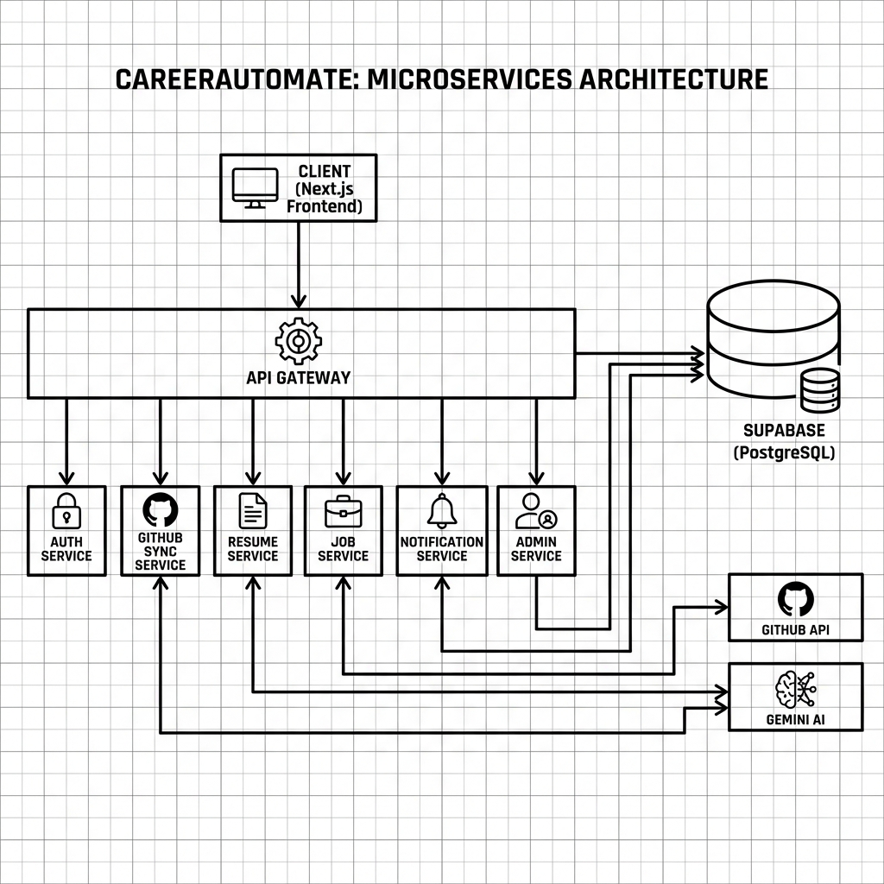
Microservices Architecture Diagram

4.2 Database Design
We utilized Supabase (PostgreSQL) as our relational database. The schema is designed to support the microservices with appropriate foreign key relationships.
Core Database Tables:
- profiles: Stores user personal information, skills, and onboarding status.
- github_integrations: Manages OAuth tokens and connection state for GitHub.
- repositories: Stores imported project data, including AI-generated descriptions.
- resumes: Tracks generated resumes and their storage paths.
- certificate_documents: Stores uploaded certificates and their verification status (pending/approved/rejected).
- job_applications: Tracks the jobs a user has saved or applied to.
- notification_logs: key logs of system notifications sent to users.
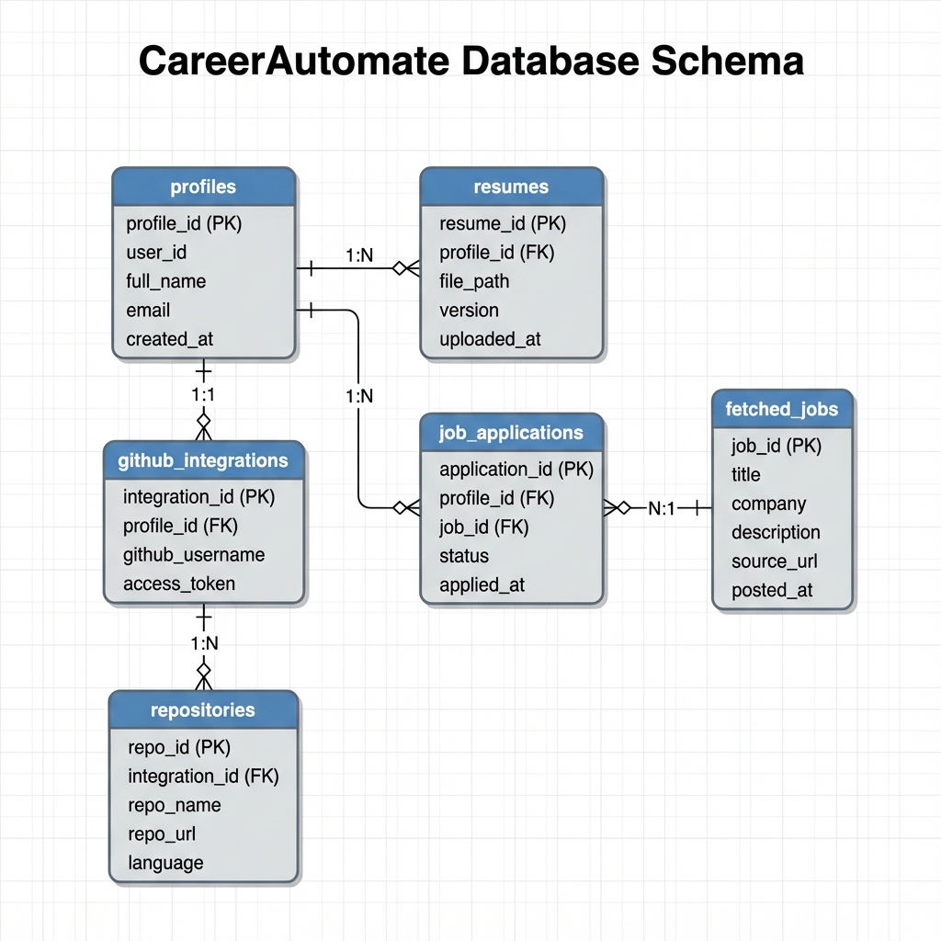
Entity Relationship Diagram

4.3 UML Diagrams

4.3.1 Use Case Diagram
The Use Case diagram below illustrates the primary interactions between the actors (Job Seeker, Admin) and the system.
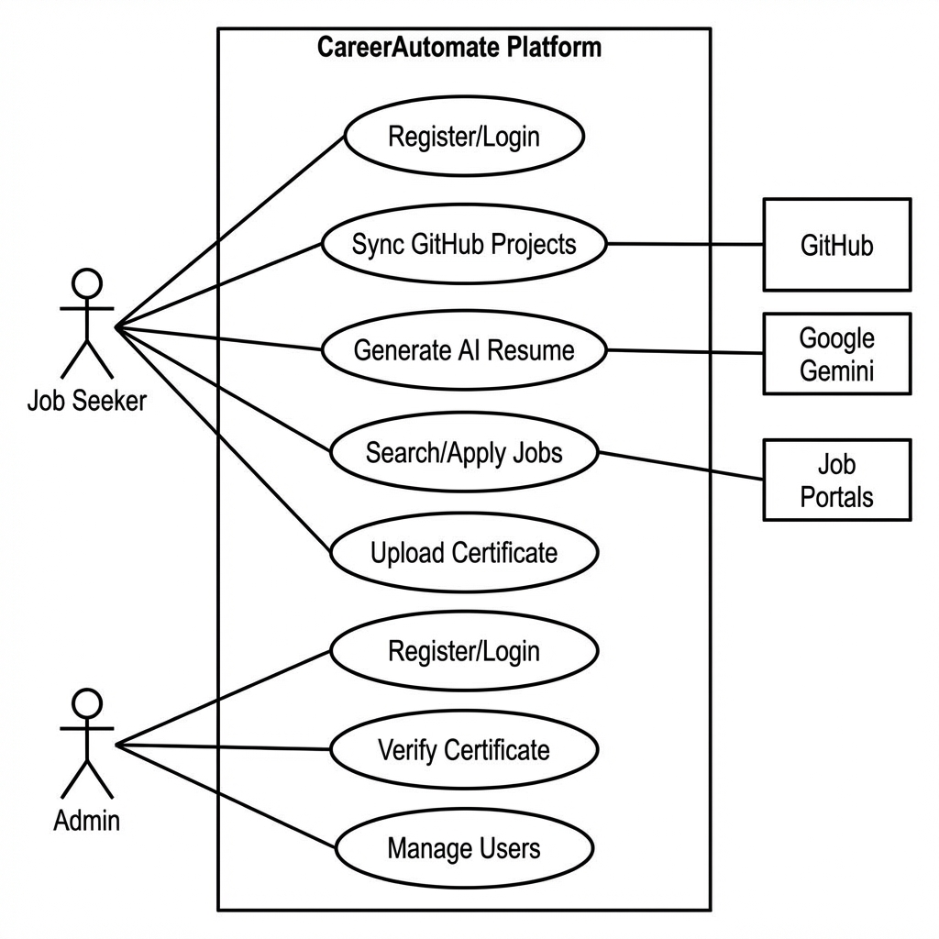
Use Case Diagram

4.3.2 Sequence Diagram (Resume Generation)
This sequence diagram details the flow of data when a user requests a new resume.
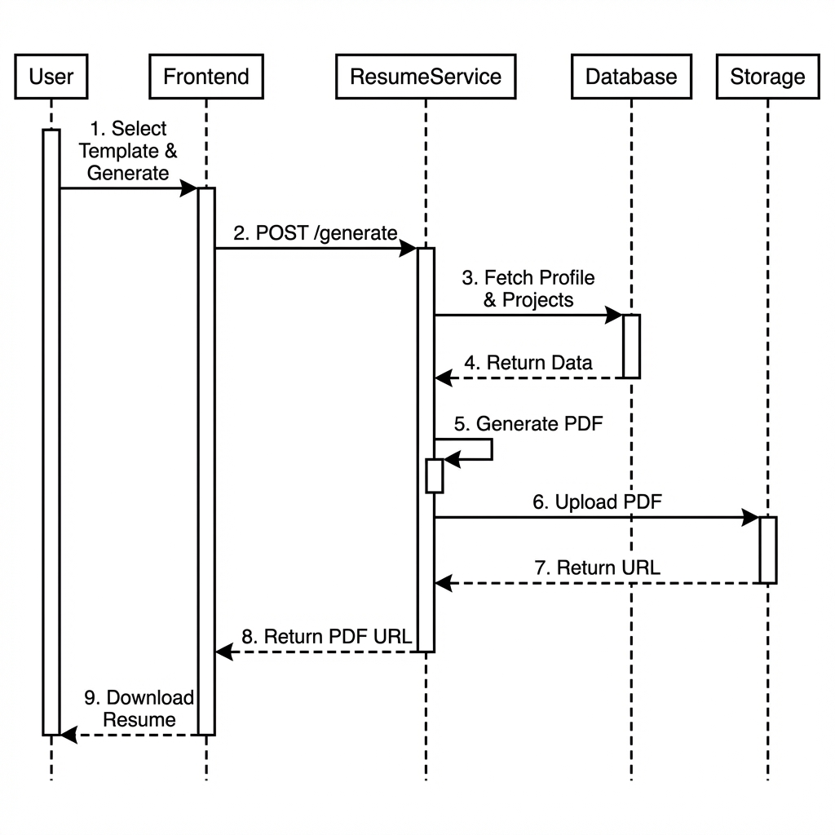
Sequence Diagram

5. IMPLEMENTATION

5.1 Backend Implementation
The backend is implemented using Python and FastAPI, deployed as AWS Lambda functions. We used a shared logic layer for common database and authentication tasks.
Example: AI Description Generation Logic
def generate_ai_summary(readme_content: str, api_key: str) -> str:
"""Generate AI summary using Google Gemini."""
try:
client = genai.Client(api_key=api_key)
prompt = f"""Read this project documentation.
Summarize the project into a professional description.
Project README: {readme_content[:8000]}"""
response = client.models.generate_content(
model='gemini-2.5-flash',
contents=prompt
)
return response.text.strip() if response.text else "Summary unavailable."
except Exception as e:
raise HTTPException(status_code=500, detail=f"AI Error: {str(e)}")

5.2 Frontend Implementation
The frontend uses Next.js with React Hooks for state management. We used the shadcn/ui library for consistent design components.
Example: Dashboard Layout Component
export default function DashboardLayout({ children }: { children: React.ReactNode }) {
const { user, loading } = useAuth();
if (loading) return <LoadingSpinner />;
if (!user) return <Redirect to="/login" />;
return (
<div className="flex h-screen bg-gray-50">
<Sidebar />
<main className="flex-1 overflow-y-auto p-8">
{children}
</main>
</div>
);
}

6. TESTING

6.1 Testing Strategy
Our testing strategy focused entirely on verifying the actual functionality of the deployed services. We relied on API Endpoint Testing using Postman to validate the backend logic and Manual System Testing to verify the end-to-end user experience.

6.2 API Endpoint Verification (Postman)
We rigorously tested endpoints across all our microservices using Postman. This ensured that every service was reachable, secure, and returned the correct data format.
Tested Endpoints:
Service | Endpoint | Method | Purpose | Result
Auth | /auth/token | POST | Login and receive JWT | PASS
Auth | /auth/register | POST | Create new user account | PASS
GitHub | /projects/sync | POST | Trigger repo fetch from GitHub | PASS
GitHub | /projects/{id} | GET | Get project details | PASS
AI | /projects/describe | POST | Generate description via Gemini | PASS
Resume | /resumes/options | GET | Fetch templates list | PASS
Resume | /resumes/generate | POST | Create PDF resume | PASS
Jobs | /jobs/search | GET | Query jobs database | PASS
Notification | /notify/test | POST | Send test email | PASS
Admin | /admin/certs | GET | List pending certificates | PASS
Admin | /admin/verify | POST | Approve/Reject certificate | PASS

6.3 Integration Testing
We performed integration testing to verify that our microservices communicated correctly with each other and with external systems.
Key Integration Scenarios Verified:
- Frontend <-> Auth <-> Database: verified that logging in on the frontend correctly creates a session and retrieves the user profile from the database.
- GitHub Service <-> AI Service: Confirmed that when a repo is synced, the content is successfully passed to the Gemini API, and the result is stored back in the repositories table.
- Admin Service <-> Notification Service: Tested that when an admin approves a certificate, the Notification Service is triggered to send a “Verification Success” email to the user.
- Resume Service <-> Storage: Verified that generated PDFs are correctly uploaded to Supabase Storage and a valid public URL is returned to the frontend.

6.4 Manual System Testing
We conducted manual runs of full user workflows to validate the overall system behavior.
Scenario 1: Certificate Verification Flow * Action: User uploads a PDF certificate. Admin logs into the dashboard and clicks “Approve”. * Result: The user status updates to “Verified” on their profile, and they receive a confirmation email.
Scenario 2: Resume Building Flow * Action: User selects 3 projects and the “Modern” template, then clicks “Build”. * Result: The system generates a PDF containing the selected project details and profile info, which opens in a new tab.
Scenario 3: Job Application * Action: User clicks “Apply” on a job card. * Result: The job is added to the “Applied Jobs” list in the database.

6.5 Security Checks
We manually verified security controls: * Confirmed that unauthenticated users cannot access dashboard routes. * Verified that users cannot view data belonging to other users (RLS check). * Ensured API keys are masked in the UI.

7. CONCLUSION
The CareerAutomate platform was successfully developed as a robust, microservices-based solution for career management. By integrating AI-driven insights with automated workflows, we have addressed the key pain points aimed at in our problem statement. The project demonstrates the viability of serverless architecture for building scalable, cost-effective applications.
We achieved our primary objectives: * Core Systems: Delivered a stable, secure platform with Auth, Database, and Storage integration. * AI Integration: Successfully deployed Google Gemini for generating high-quality project descriptions. * Automation: Reduced manual effort for users through GitHub syncing and one-click resume generation. * User Experience: Created a responsive, professional interface that simplifies complex tasks.
Although we faced challenges with API rate limits and distributed state management, our iterative testing approach allowed us to resolve these issues effectively. The platform is now at a prototype stage (TRL 6), ready for broader beta testing.

8. FUTURE ENHANCEMENTS
To further evolve CareerAutomate, we plan to implement the following enhancements:
- Mobile Application: Develop a native mobile app (React Native) to provide users with on-the-go access to job alerts and application tracking.
- Advanced Interview Prep: Integrate an AI-powered mock interview module that uses voice analysis to give feedback on user answers.
- LinkedIn Integration: Add support for syncing profiles directly from LinkedIn and automating applications on that platform.
- Community Features: Build a peer-review system where users can share resumes and get feedback from the community or mentors.
- Enterprise Portal: Create a dedicated portal for recruiters to post jobs directly and search for verified candidates within the platform.

9. PLAGIARISM REPORT
[Plagiarism report scan result to be attached here]

10. BIBLIOGRAPHY
- Documentation: Next.js Documentation (nextjs.org), FastAPI (fastapi.tiangolo.com), Supabase Docs (supabase.com/docs).
- Cloud resources: AWS Lambda Documentation (docs.aws.amazon.com/lambda), Google Gemini API Reference (ai.google.dev).
- Books: “Building Microservices” by Sam Newman, “Designing Data-Intensive Applications” by Martin Kleppmann.
- Articles: “Serverless Architectures” on MartinFowler.com.

