* Implement multi-threaded client/server Process communication using RMI.
  + Extend is used for inheritance
  + Remote method Invocation
    - Remote Method Invocation (RMI) is an API that allows an object to invoke a method on an object that exists in another address space, which could be on the same machine or on a remote machine. Through RMI, an object running in a JVM present on a computer (Client-side) can invoke methods on an object present in another JVM (Server-side). RMI creates a public remote server object that enables client and server-side communications through simple method calls on the server object.
    - Stub Object: The stub object on the client machine builds an information block and sends this information to the server.
      * An identifier of the remote object to be used
      * Method name which is to be invoked
      * Parameters to the remote JVM
    - 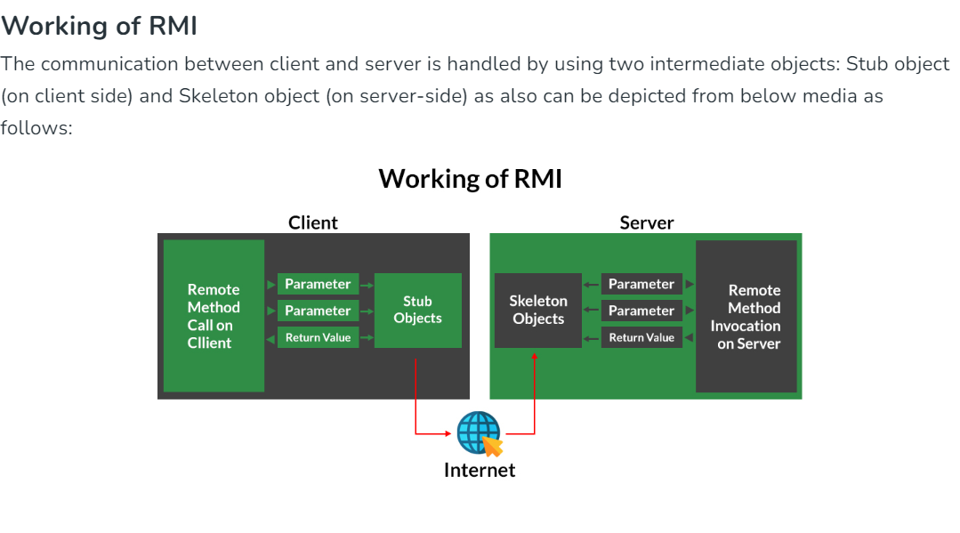
  + i/p from client -> pass it to server -> query it -> returns o/p to client
  + 4 files
    - **Server**
      * **Server.java**
      * public static void main (string[] args ){}
      * Creation of Stub object here – ServerImpl object
      * **Registering the object in RMI registry** 
        + Naming.rebind(“stubname”,stubobject)
    - **Client**
      * **Client.java**
      * Take input
        + Import java.rmi.*;
        + Import java.util.Scanner;
      * public static void main (string[] args ){}
      * stored object reference in serverIntf not object is created . basically we are creating a remote object reference
    - **Server Interface** – declare methods
      * Name – **ServerIntf.java**
      * Library – import java.rmi.*;
      * extend Remote –
        + declares remote interfaces
        + remote is interface in RMI class
        + methods declared here can be called remotely
      * methods signature
      * throws RemoteException – if object not found , communication-related exceptions
    - **Server Implementation** – body of methods
      * **ServerImpl.java**
      * Extends UnicastRemoteObject
        + Extending the UnicastRemoteObject class is a way to create remote objects. Implementation detail used for simplifying remote object creation.
        + Enables remote invocation: Your class inherits the functionalities required for remote method calls. This allows clients on different machines to interact with your object as if it were local.
        + Provides a stub: The RMI framework automatically generates a stub class for your remote object. This stub acts as a local representative on the client-side, handling communication with the actual remote object on the server.
      * implements ServerIntf – defining the class
  + commands
    - java -version
    - javac -version
    - rmic name
      * This is the command-line tool used for generating RMI stubs and skeletons.