Implement Bully and Ring algorithm for leader election.

* Election algorithm
  + Distributed system -> process -> coordinator
  + Problems with process is solved by coordinator
  + Algorithm is used to select coordinator
  + Points
    - Every process can become coordinator
    - Any process can initiate election algorithm
    - Every process has unique id
* Ring Algorithm
  + A white board with black writing

    Description automatically generated
  + A diagram of a ring algorithm

    Description automatically generated
  + A diagram of a number

    Description automatically generated with medium confidence
  + link between the process are unidirectional and every process can message to the process on its right only.
  + 2 messaages
    - Election
    - Coordinate
  + Adv
    - Less space utilisation
* Bully algorithm
  + A process can only tell to the processes that election algorithm is initiated which are bigger than itself
  + Only that process can become coordinator which is biggest
  + If there are no replies from process then the process which initiates a bully algorithm gets to become coordinator
  + Reply – process bigger than the process which initiates coordinator selection is present
  + The Bully Algorithm operates on the principle of higher priority.
  + 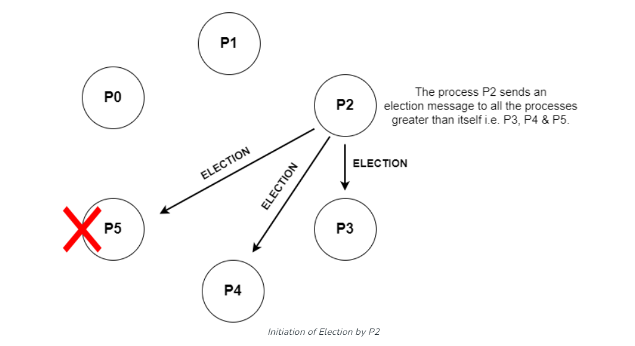
  + Messages
    - Election message
    - Ok – alive message
    - Coordinator – victory message
  + Uses
    - Resource Allocation: Coordinating resource allocation or access among multiple Processes.
    - Leader Election: Electing leaders or coordinators in distributed databases, server clusters, and fault-tolerant systems.
  + Assumption

1. Each process has a unique priority number.

2. All processes in the system are fully connected.

3. The process with the highest priority number will be elected as coordinator.

4. Each process knows the process number of all other processes.

5. What the process doesn’t know is which process is up or down.

6. During recovery, the failed process can take appropriate steps to resume the set of active processes.