Create Exp Task

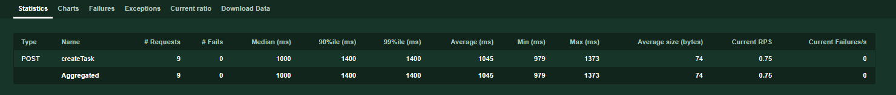

Create SOP Task

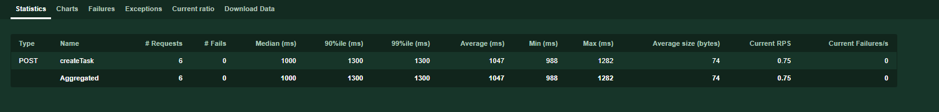

Create DOC Task

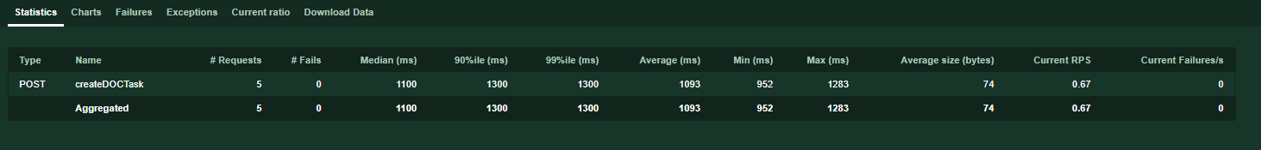

Add Schedule

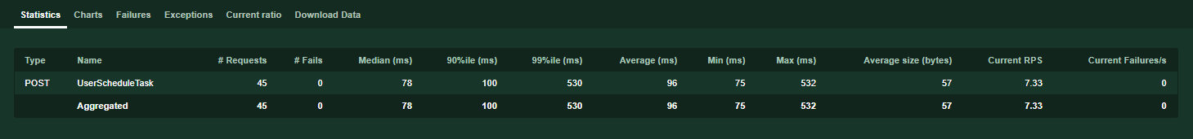

Update Schedule

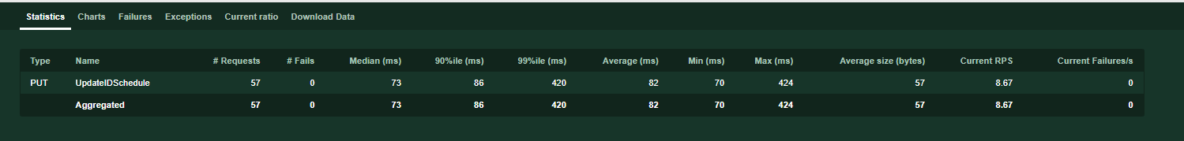

GetAssignedSchedule

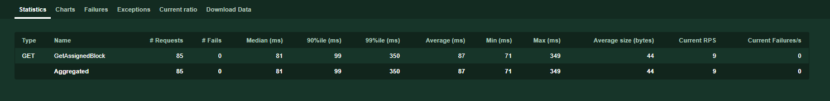

Get Doc By ID

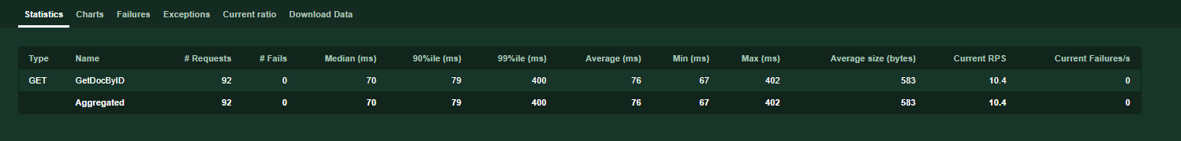

Trigger-Notification

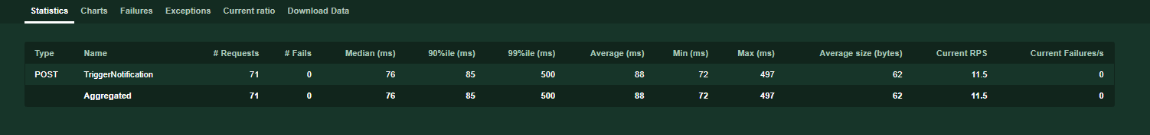

Get Notification List

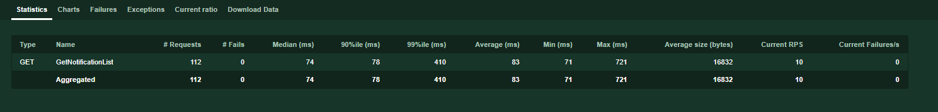

Reserve inventory ID-00c332c9-7f54-4ca6-88a7-2db7357ddad2

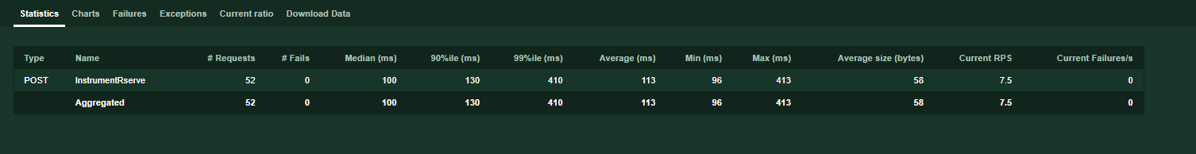

Reserve Sample - 01de9888-9a59-4138-9515-0def5181d106

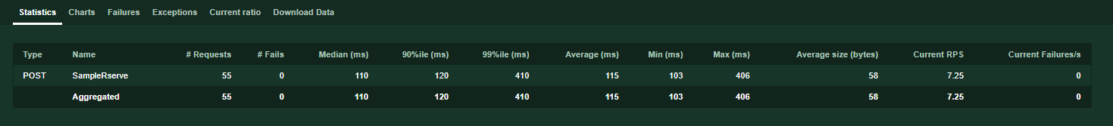

AccessCheck

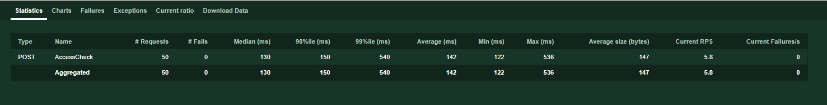

AccessToken

