# C:\Users\ahsaa\Downloads\Architecture (1).jpeg**Program Architecture**

# **Bootstrapping**

As Server asks the user to enter number of clients that will connect. Server then waits for all clients to connect before starting the program. After all clients are connected, Server then starts the program and file transfer mechanism is initiated.

In GO BACK N we retransmit all frames till corrupted files if find corrupted

if it receives a corrupt packet, then also, the entire window is re-transmitted

while on the other side in Selective Repeat only those frames are sent that are suspected only.

If a data is dropped and is assumed to be a corrupted packet then we transmit that data back to client in order to ensure the complete transfer of files

This program ensures that there is a complete file transfer as far as the file is present in local directory. Program opens the file entered by user and starts looking for the data to be transmitted. It ensures that the data is completely transmitted. This program has a ACK mechanism implementation along with Selective and GoBackN.

As network bandwidth increases, it can task the switches to a point at which they begin to drop packets. I recommend that you do not use greater part of the rated bandwidth because the rated bandwidths are based on normal network traffic

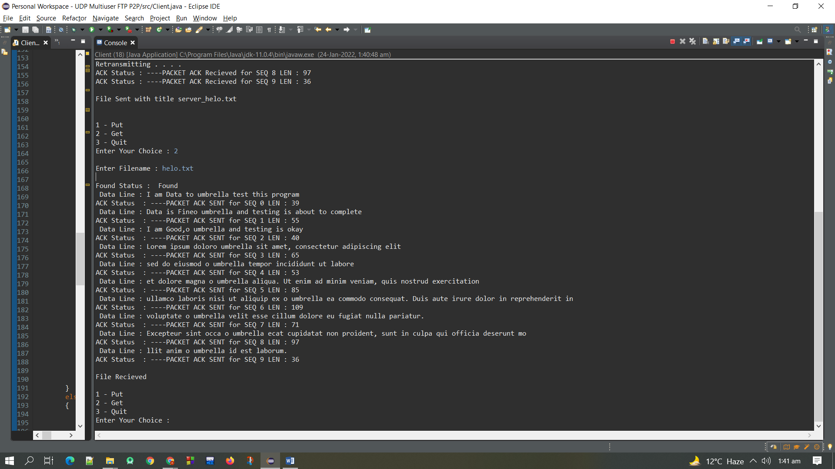**Below is the Output Of Program**

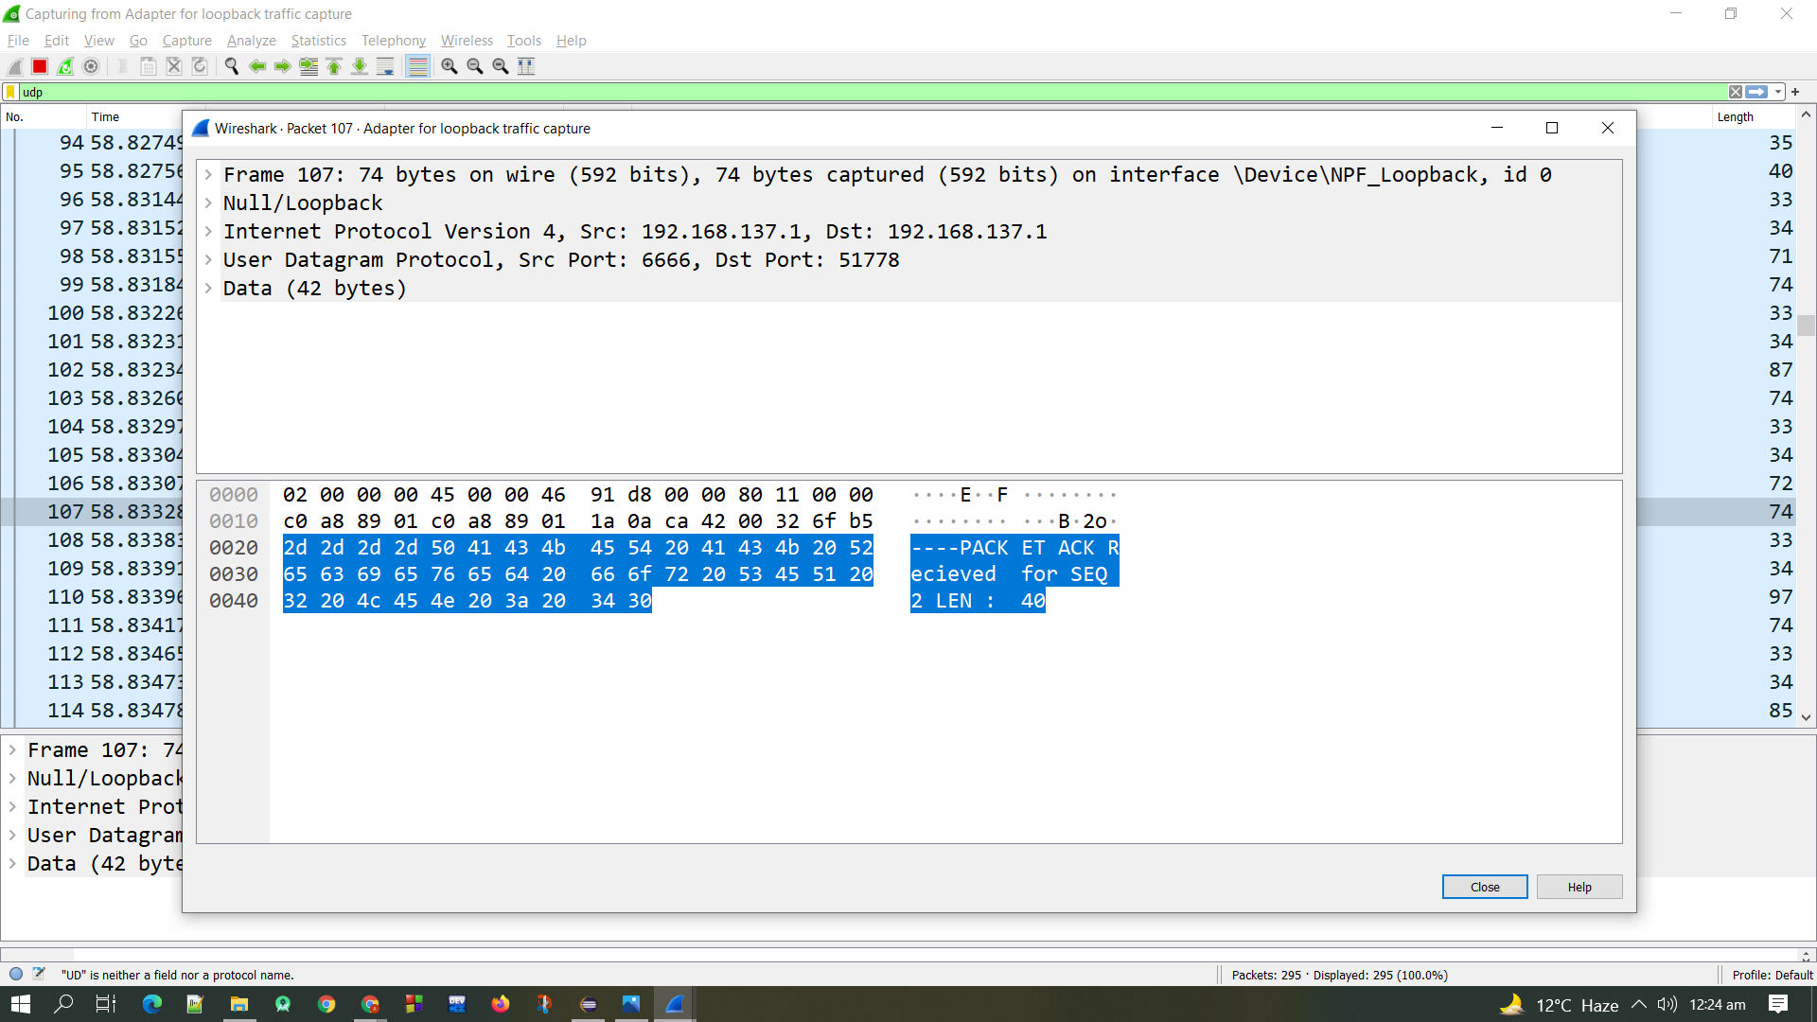**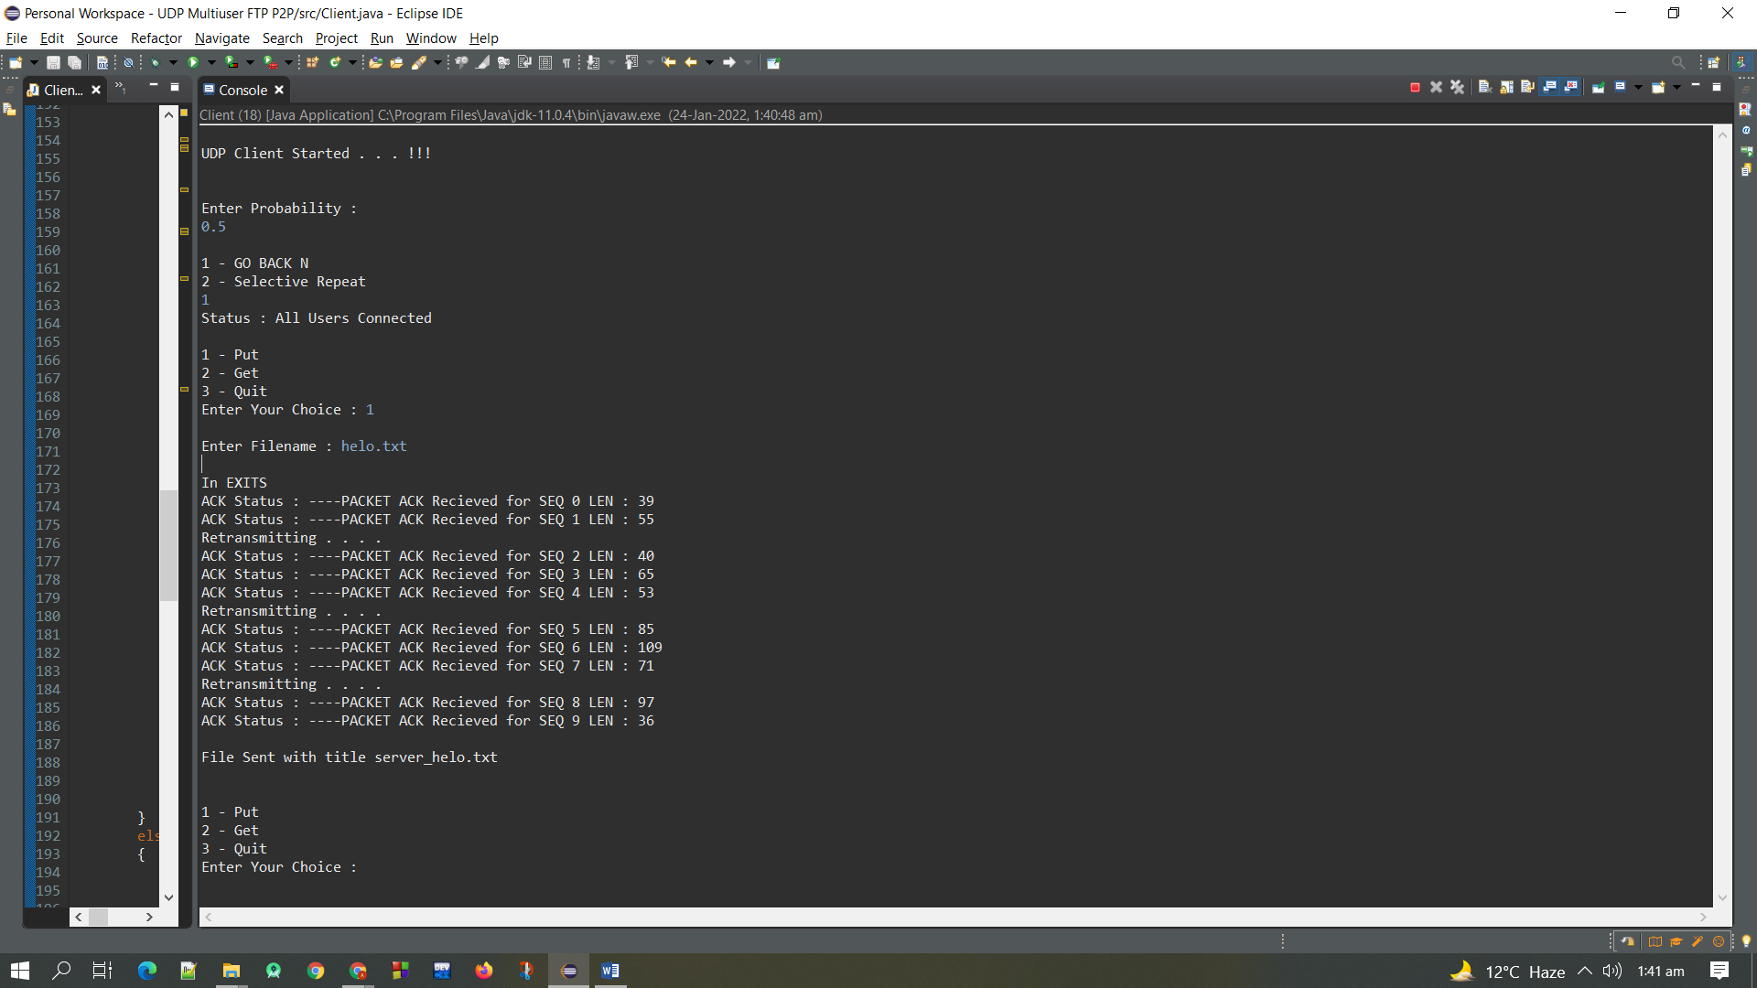Following is the Screenshot of the Wireshark**

