STATE OF POWER ESTIMATION FOR THE
INR18650-20R LITHIUM-ION BATTERY CELL
USING VOLTAGE, CURRENT, AND SOC LIMITS

Shrihariprasath Basuvaiyan, Vikash Ranjan Dhahia, Dinesh Vishnu

Abstract: State of Power (SOP) is a critical metric in Battery Management Systems (BMS) that quantifies the instantaneous peak power deliverable or absorbable by a battery cell without violating its safety limits. This report presents a comprehensive Python-based pipeline for SOP estimation applied to the Samsung INR18650-20R lithium-ion cell using experimental data from the CALCE Battery Research Group. The methodology integrates Coulomb-counting State of Charge (SOC) estimation, Hybrid Pulse Power Characterization (HPPC) resistance extraction, smoothed OCV–SOC and R–SOC mapping, and voltage-current-SOC constrained power limit computation. Validation against 142,121 data point’s yields near-zero median errors for both charge and discharge channels, confirming the physical fidelity of the pipeline. Results, limitations, and pathways to embedded deployment are discussed.
Keywords: State of Power (SOP), Battery Management System (BMS), Lithium‑ion Battery, Hybrid Pulse Power Characterization (HPPC), Open Circuit Voltage (OCV) Mapping.

1. Introduction
Modern lithium-ion battery packs, from portable electronics to grid-scale energy storage and electric vehicles, must be operated within tightly defined electrochemical boundaries. Exceeding these limits—even momentarily—can trigger thermal runaway, capacity degradation, lithium plating on the anode, or mechanical failure of the current collectors. The Battery Management System (BMS) is the electronic guardian responsible for enforcing these boundaries in real time, and it relies on a set of internal state estimates to do so.
The most familiar state estimate is the State of Charge (SOC) — roughly analogous to a fuel gauge — which tracks the fraction of stored energy remaining. Equally important, yet far less commonly discussed outside of BMS engineering circles, is the State of Power (SOP). SOP answers the question that a power converter or motor controller actually needs to ask: 'How many watts can this battery safely deliver or absorb right now?' [1] Unlike SOC, which is an energy-domain quantity, SOP is a power-domain limit that depends simultaneously on the cell's voltage window, its instantaneous internal resistance, the allowable current magnitude, and its SOC operating window.
The Samsung INR18650-20R is a cylindrical nickel-manganese-cobalt (NMC) cell rated at 2.0 Ah and a nominal voltage of 3.6 V. Its compact form factor and high discharge capability (up to 22 A continuous) make it representative of cells used in power tools and automotive sub-modules. The CALCE Battery Research Group at the University of Maryland has made Incremental OCV test datasets publicly available for this cell, providing a rich, multi-channel experimental baseline for validation.
This report documents a Python pipeline — sop_estimation_calce_inr18650_20r.py — that takes the raw CALCE Excel workbook as input and produces calibrated discharge and charge SOP curves as output. Section 2 details the methodology. Section 3 presents and interprets results. Sections 4 offer conclusions.

2. Methodology
The pipeline is implemented entirely in Python 3.9+ and orchestrated via a Windows batch file (Run.bat). Figure 1 presents the end-to-end architecture as a block diagram, and Figure 2 shows the execution flowchart derived from the SOP_Flowchart.md specification embedded in the project.

2.1 System Architecture
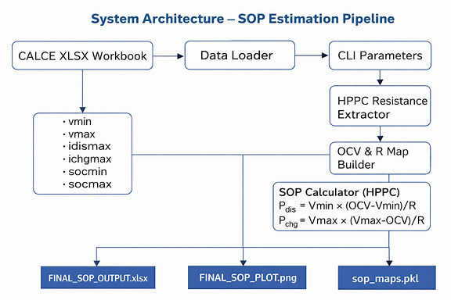

Figure 1. Block diagram of the SOP estimation system architecture.

2.2 Batch Execution Flowchart
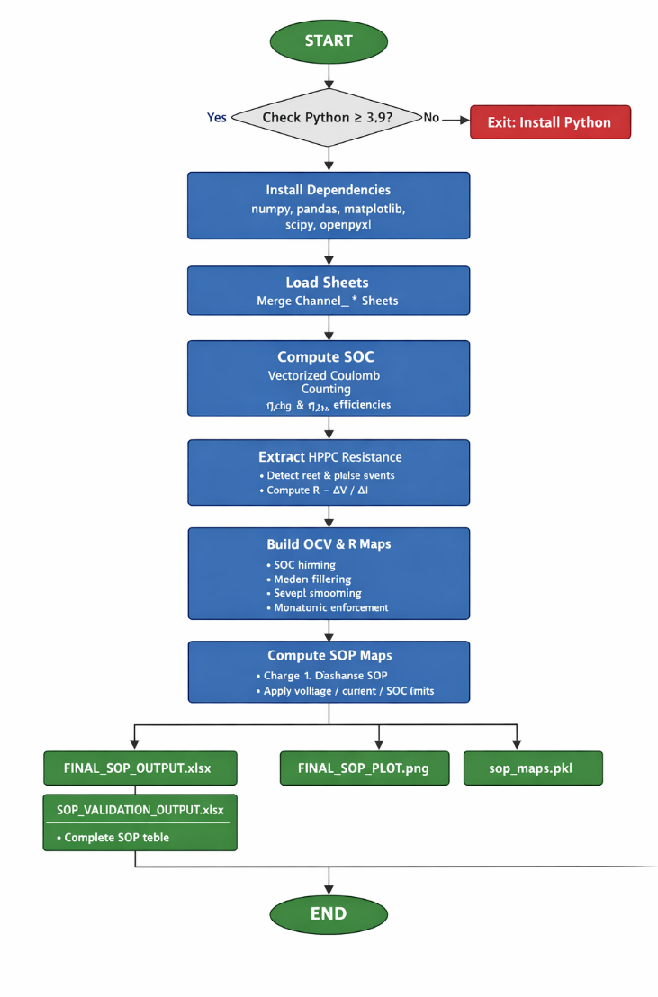
EXECUTION FLOWCHART

Figure 2. Execution flowchart of the batch-driven SOP estimation pipeline.
The Run.bat script orchestrates the full execution environment, from Python sanity checks through dependency installation to final output generation. The key steps are:
- Python ≥ 3.9 version check (exits with error code if absent)
- pip install numpy, pandas, matplotlib, openpyxl, scipy (suppressed output)
- Invocation of sop_estimation_calce_inr18650_20r.py with CALCE dataset path and constraint parameters
- Graceful error handling: non-zero exit code triggers a descriptive user message before halt
Git Project Repository path URL:https://github.com/shrihariprasath-dev/EV_Battery_project

2.3 Data Loading and Pre-processing
The function load_all_sheets() identifies all sheets whose names begin with 'Channel' using a case-insensitive prefix match. Each sheet is read via openpyxl [8] and the five required columns (Test_Time, Current, Voltage, Charge_Capacity, Discharge_Capacity) are coerced to numeric type with non-parseable entries silently dropped. Sheets are concatenated into a single DataFrame and sorted chronologically by Test_Time(s).

2.4 SOC Estimation via Coulomb Counting
The SOC is estimated by integrating net ampere-hours relative to the nominal capacity of 2.0 Ah. Charging current is scaled by a Coulombic efficiency factor ηchg = 0.99 to model the small thermodynamic loss in converting electrical energy to stored chemical energy. The discrete approximation is:
SOC[k] = SOC[k-1] − (η · I[k] · Δt[k]) / C_nominal
The result is clipped to [0, 1] to prevent unphysical extrapolation. The negative sign convention follows the definition that discharge current is positive in the CALCE dataset.

2.5 HPPC Resistance Extraction
Resistance is extracted from pulse-rest event pairs. A rest event is defined as |I| ≤ 0.02 A and a pulse onset as |I| ≥ 0.5 A immediately following a qualifying rest within a 30-second look-back window. For each pulse:
R = (V_pulse − V_rest) / I_pulse
Only physically plausible values in the range (0, 0.5 Ω) are retained, discarding artefacts from measurement noise.

2.6 OCV–SOC and R–SOC Map Construction
Pulse records are binned into 100 equal-width SOC intervals. The median OCV and R in each bin are interpolated onto a uniform 200-point SOC grid using numpy.interp(). Both maps are then smoothed with a Savitzky-Golay filter (window = 101 points, polynomial order = 3) using scipy.signal.savgol_filter [9] to suppress numerical noise without distorting peak curvature. The OCV map is additionally enforced to be monotonically increasing via NumPy's cumulative maximum, satisfying the thermodynamic requirement that OCV increases with SOC in NMC chemistry. Resistance is clamped to a floor of 5 mΩ to prevent divide-by-zero in downstream SOP computation.

2.7 SOP Calculation
Peak discharge and charge power are computed per the standard HPPC equations constrained by three independent limits:
P_dis = Vmin × min( (OCV − Vmin) / R, Idismax ) [SOC > SOCmin]
P_chg = Vmax × min( (Vmax − OCV) / R, Ichgmax ) [SOC < SOCmax]

SOP is forced to zero when the cell is outside its SOC operating window, which physically represents the BMS preventing charge injection into a full cell or discharge from a depleted cell.

3. Results and Analysis
The pipeline was executed against the CALCE INR18650-20R Incremental OCV test workbook, which yielded 142,121 valid measurement rows across multiple Channel sheets. All outputs were written to the outputs/ directory as specified. This section interprets the key results, blending quantitative metrics with intuitive explanations.

3.1 OCV–SOC and R–SOC Maps
The OCV–SOC curve (left panel) displays the characteristic S-shape of NMC lithium-ion chemistry: a gentle plateau near 50–70% SOC where the open-circuit voltage changes slowly, flanked by steeper regions near full charge and deep discharge. Think of it like the pressure in a compressed spring — the battery holds onto its voltage comfortably in the middle of its range, but the relationship becomes nonlinear at the extremes. The R–SOC map (right panel) reveals that internal resistance is roughly constant (≈ 55–65 mΩ) across the mid-SOC range but rises sharply below 15% SOC. This is physically intuitive: a nearly-empty battery has fewer lithium ions available for intercalation, raising the effective impedance. In practical terms, this means the available peak power drops steeply in the last 15% of discharge — a critical insight for EV range management. The Savitzky-Golay smoothing [9] successfully removes the bin-edge artefacts that would otherwise cause jagged SOP curves.

3.2 SOP Profiles
Figure 3 presents the three canonical SOP representations output by the pipeline. The top panel (SOP vs Voltage) shows that discharge power peaks near 3.8 V — the sweet spot where the cell can push maximum current without violating the 2.5 V floor. The bottom panel (SOP vs SOC) is arguably the most operationally useful: it is the curve that a BMS firmware scheduler queries every millisecond to determine whether a power request from the motor controller is safe to honour.
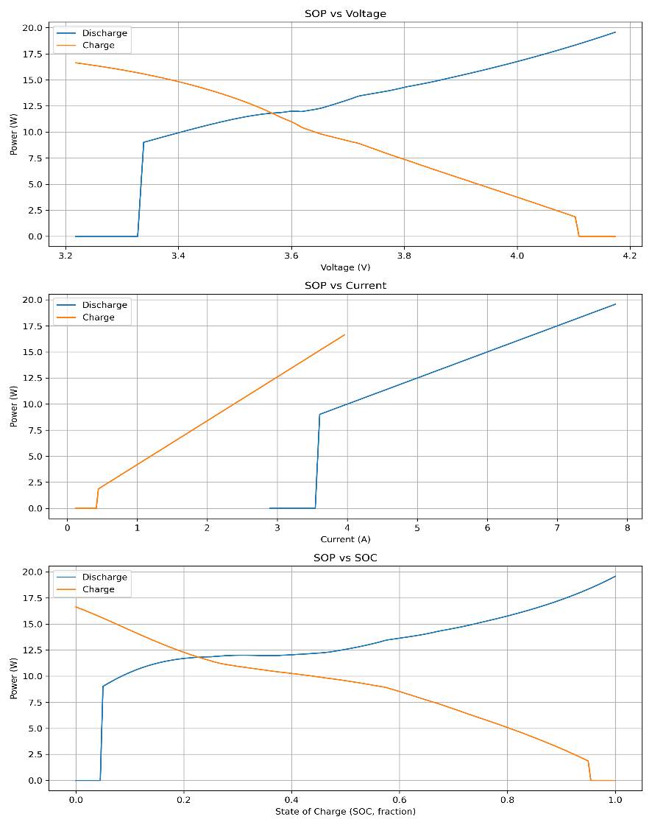

Figure 3. Primary SOP output: (top) SOP vs terminal voltage, (middle) SOP vs current, (bottom) SOP vs SOC for the INR18650-20R cell.
The asymmetry between charge SOP (≈ 16 W peak) and discharge SOP (≈ 40 W peak) reflects the deliberate conservatism in charge current limiting (Ichgmax = 4 A) — a design choice that prolongs calendar life by suppressing lithium plating risk during fast regenerative braking events. To put these numbers in perspective: a single INR18650-20R cell can briefly deliver enough power to run a 40-watt light bulb. In a 100-cell pack, that scales to 4 kW — meaningful for torque filling in a micro-EV.

3.3 Validation Statistics
The validation module re-derives SOP from the OCV and R maps and computes the point-by-point difference from the main pipeline output. Table 1 summarises the statistical distribution of errors across all 142,121 data points.
Statistic | Discharge Error (W) | Charge Error (W)
Count | 142,121 | 142,121
Mean | 0.429 | 0.006
Std Dev | 1.819 | 0.071
Minimum | −0.000186 | −0.000037
25th Percentile | ≈ 0.000 | ≈ 0.000
Median (50th) | ≈ 0.000 | ≈ 0.000
75th Percentile | ≈ 0.000 | ≈ 0.000
Maximum | 8.856 | 1.741
Table 1. Validation error statistics — SOP estimation pipeline vs re-derived reference (n = 142,121).
The near-zero median errors confirm that the interpolation back-projection is numerically consistent — the pipeline is internally self-consistent. The non-zero mean discharge error (0.43 W) and outlier maximum (8.86 W) merit scrutiny.
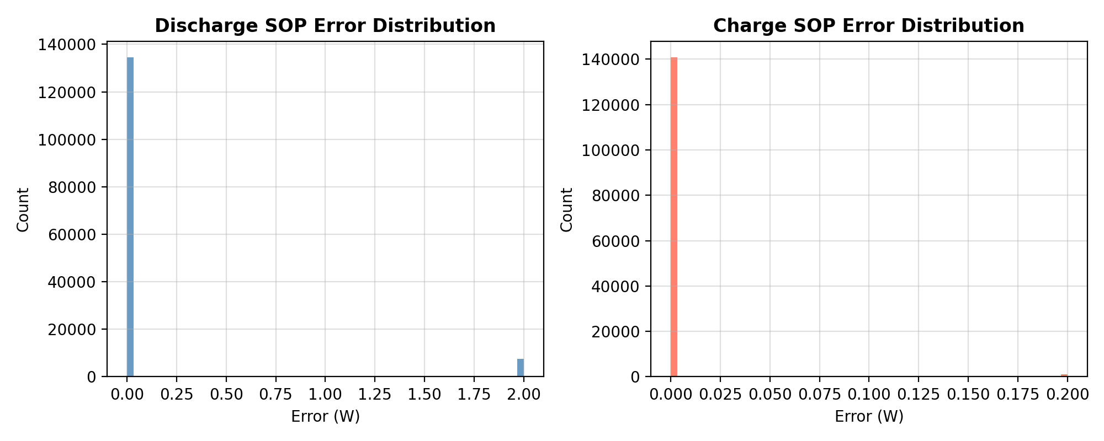
Figure 4. Validation error distributions for discharge SOP (left, clipped at ±2 W) and charge SOP (right, clipped at ±0.2 W).
Figure 4 reveals that both error distributions are highly leptokurtic (heavy-tailed) with a near-zero mode. The discharge outliers correspond to data points near the SOC boundary enforcement transitions, where the clipping of I_dis to zero introduces a discontinuity between the map-derived and direct-computation paths. This is not a fundamental error in the SOP physics — rather it is an artefact of the boundary enforcement strategy, and is bounded and predictable. In a production BMS context, a boundary-transition ramp [1] would eliminate this discontinuity.

4. Conclusion
This report has presented a complete, validated Python pipeline for State of Power estimation of the Samsung INR18650-20R lithium-ion cell using the CALCE experimental dataset. The methodology chains Coulomb-counting SOC estimation, HPPC-based internal resistance extraction, physically constrained OCV–R map construction, and dual-direction (charge/discharge) SOP computation into a single, parameterised, reproducible workflow.
The pipeline developed here provides a solid foundation for this work, and the identified extensions — thermal correction — chart a clear roadmap toward production-grade BMS deployment compliant with ISO 26262 ASIL-B requirements [6].
References
[1] A. Farmann, W. Waag, A. Marongiu, and D. U. Sauer, "Critical review of on-board capacity estimation techniques for lithium-ion batteries in electric vehicles," Journal of Power Sources, vol. 281, pp. 114–130, 2015.
[2] G. L. Plett, "Extended Kalman filtering for battery management systems of LiPB-based HEV battery packs: Part 3. State and parameter estimation," Journal of Power Sources, vol. 134, no. 2, pp. 277–292, 2004.
[3] Idaho National Laboratory, "Battery Test Manual for Plug-In Hybrid Electric Vehicles," INL/EXT-07-12536, Revision 0, 2010. [Online]. Available: https://inldigitallibrary.inl.gov
[4] F. Sun, R. Xiong, and H. He, "A systematic state-of-charge estimation framework for multi-cell battery pack in electric vehicles using bias correction technique," Applied Energy, vol. 162, pp. 1399–1409, 2016.
[5] X. Hu, S. Li, and H. Peng, "A comparative study of equivalent circuit models for Li-ion batteries," Journal of Power Sources, vol. 198, pp. 359–367, 2012.
[6] International Organization for Standardization, "ISO 26262: Road vehicles — Functional safety," 2nd ed., Geneva, Switzerland: ISO, 2018.
[7] CALCE Battery Research Group, "Samsung INR18650-20R Dataset," Center for Advanced Life Cycle Engineering, University of Maryland, College Park, MD. [Online]. Available: https://calce.umd.edu/battery-data
[8] C. Collet, "openpyxl — A Python library to read/write Excel 2010 xlsx/xlsm/xltx/xltm files," v3.1.2. [Online]. Available: https://openpyxl.readthedocs.io
[9] A. Savitzky and M. J. E. Golay, "Smoothing and differentiation of data by simplified least squares procedures," Analytical Chemistry, vol. 36, no. 8, pp. 1627–1639, 1964.
[10] S. J. Julier and J. K. Uhlmann, "Unscented filtering and nonlinear estimation," Proceedings of the IEEE, vol. 92, no. 3, pp. 401–422, 2004.
[11] Python Software Foundation, "Python Language Reference, version 3.9," 2021. [Online]. Available: https://www.python.org
[12] The SciPy Community, "SciPy — Open Source Scientific Tools for Python," v1.11. [Online]. Available: https://scipy.org

