PRACTICAL END SEMESTER EXAMINATION
SUBJECT:Computer Algorithm
Name:Padmanabhan Shrikrishna Deokar
PRN:2020BTEIT00024

Problem Statement:Write code that create fractal file or 8 bit gray level image of size 128*128 by finding a similar image block with transformation.

Code:

import matplotlib.pyplot as plt
import matplotlib.image as mpimg
from scipy import ndimage
from scipy import optimize
import numpy as np
import math

# Manipulate channels

def get_greyscale_image(img):
return np.mean(img[:,:,:2], 2)

# Transformations

def reduce(img, factor):
result = np.zeros((img.shape[0] // factor, img.shape[1] // factor))
for i in range(result.shape[0]):
for j in range(result.shape[1]):
result[i,j] = np.mean(img[i*factor:(i+1)*factor,j*factor:(j+1)*factor])
return result

def rotate(img, angle):
return ndimage.rotate(img, angle, reshape=False)

def flip(img, direction):
return img[::direction,:]

def apply_transformation(img, direction, angle, contrast=1.0, brightness=0.0):
return contrast*rotate(flip(img, direction), angle) + brightness

# Contrast and brightness

def find_contrast_and_brightness1(D, S):
# Fix the contrast and only fit the brightness
contrast = 0.75
brightness = (np.sum(D - contrast*S)) / D.size
return contrast, brightness

def find_contrast_and_brightness2(D, S):
# Fit the contrast and the brightness
A = np.concatenate((np.ones((S.size, 1)), np.reshape(S, (S.size, 1))), axis=1)
b = np.reshape(D, (D.size,))
x, _, _, _ = np.linalg.lstsq(A, b)
#x = optimize.lsq_linear(A, b, [(-np.inf, -2.0), (np.inf, 2.0)]).x
return x[1], x[0]

# Compression for greyscale images

def generate_all_transformed_blocks(img, source_size, destination_size, step):
factor = source_size // destination_size
transformed_blocks = []
for k in range((img.shape[0] - source_size) // step + 1):
for l in range((img.shape[1] - source_size) // step + 1):
# Extract the source block and reduce it to the shape of a destination block
S = reduce(img[k*step:k*step+source_size,l*step:l*step+source_size], factor)
# Generate all possible transformed blocks
for direction, angle in candidates:
transformed_blocks.append((k, l, direction, angle, apply_transformation(S, direction, angle)))
return transformed_blocks

def compress(img, source_size, destination_size, step):
transformations = []
transformed_blocks = generate_all_transformed_blocks(img, source_size, destination_size, step)
i_count = img.shape[0] // destination_size
j_count = img.shape[1] // destination_size
for i in range(i_count):
transformations.append([])
for j in range(j_count):
print("{}/{} ; {}/{}".format(i, i_count, j, j_count))
transformations[i].append(None)
min_d = float('inf')
# Extract the destination block
D = img[i*destination_size:(i+1)*destination_size,j*destination_size:(j+1)*destination_size]
# Test all possible transformations and take the best one
for k, l, direction, angle, S in transformed_blocks:
contrast, brightness = find_contrast_and_brightness2(D, S)
S = contrast*S + brightness
d = np.sum(np.square(D - S))
if d < min_d:
min_d = d
transformations[i][j] = (k, l, direction, angle, contrast, brightness)
return transformations

def decompress(transformations, source_size, destination_size, step, nb_iter=8):
factor = source_size // destination_size
height = len(transformations) * destination_size
width = len(transformations[0]) * destination_size
iterations = [np.random.randint(0, 256, (height, width))]
cur_img = np.zeros((height, width))
for i_iter in range(nb_iter):
print(i_iter)
for i in range(len(transformations)):
for j in range(len(transformations[i])):
# Apply transform
k, l, flip, angle, contrast, brightness = transformations[i][j]
S = reduce(iterations[-1][k*step:k*step+source_size,l*step:l*step+source_size], factor)
D = apply_transformation(S, flip, angle, contrast, brightness)
cur_img[i*destination_size:(i+1)*destination_size,j*destination_size:(j+1)*destination_size] = D
iterations.append(cur_img)
cur_img = np.zeros((height, width))
return iterations

# Plot
def PSNR(original, compressed):
mse = np.mean((original - compressed) ** 2)
if(mse == 0): # MSE is zero means no noise is present in the signal .
# Therefore PSNR have no importance.
return 100
max_pixel = 255.0
psnr = 20 * np.log10(max_pixel / np.sqrt(mse))
return psnr

def plot_iterations(iterations, target=None):
# Configure plot
plt.figure()
nb_row = math.ceil(np.sqrt(len(iterations)))
nb_cols = nb_row
# Plot
count = 0
for i, img in enumerate(iterations):
plt.subplot(nb_row, nb_cols, i+1)
plt.imshow(img, cmap='gray', vmin=0, vmax=255, interpolation='none')
if target is None:
plt.title(str(i))
else:
# Display the RMSE
if (i==8):
img1 = mpimg.imread('lena.gif')
img1 = get_greyscale_image(img1)
img1 = reduce(img1, 4)
value = PSNR(img1,img)
print("PSNR value of compressed image with original image will be: ",value)
plt.title(str(i) + ' (' + '{0:.2f}'.format(np.sqrt(np.mean(np.square(target - img)))) + ')')
frame = plt.gca()
frame.axes.get_xaxis().set_visible(False)
frame.axes.get_yaxis().set_visible(False)

plt.tight_layout()

# Parameters

directions = [1, -1]
angles = [0, 90, 180, 270]
candidates = [[direction, angle] for direction in directions for angle in angles]

# Tests

def test_greyscale():
img = mpimg.imread('lena.gif')
img = get_greyscale_image(img)
img = reduce(img, 4)
plt.figure()
plt.imshow(img, cmap='gray', interpolation='none')
transformations = compress(img, 8, 4, 8)
iterations = decompress(transformations, 8, 4, 8)
plot_iterations(iterations, img)
plt.show()

if __name__ == '__main__':
test_greyscale()

output:
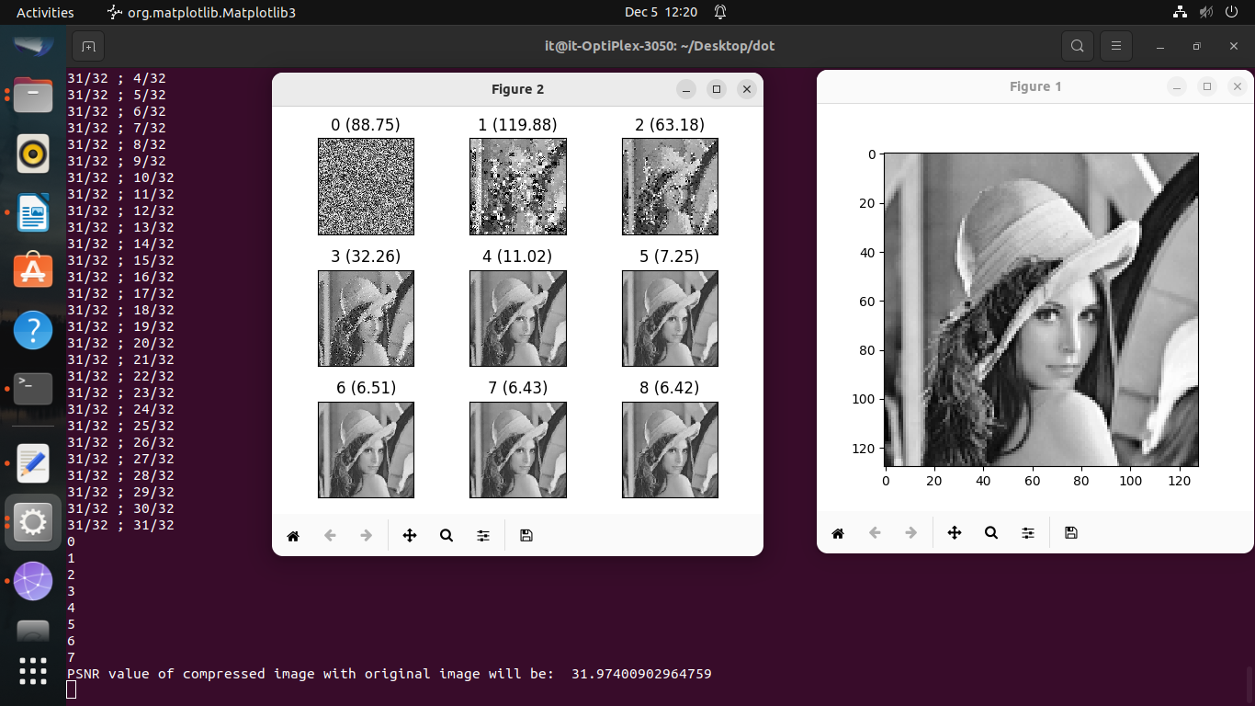

programming language:python

