Synopsis

Spam Email Detection System

Project Id: AIML-22

Bhaskar Bahukhandi (GL)
University Roll No.: 2028689
Section: K

Shrijit Mittra
University Roll No.: 2028854
Section: K

Bipul Bhatt
University Roll No.:
Section: K

- Problem Description:
Problem Statement:
Spam Email Detection System.
This system classifies emails as spam or not using text data. Text preprocessing includes removing stopwords, punctuation, and converting text to numeric features. Feature selection removes less important words and keeps high-impact spam keywords. Logistic Regression, SVM (Linear, Polynomial, and RBF kernels for different text patterns), Random Forest, KNN and Ridge Regression are trained. Models are evaluated using confusion matrix and accuracy.
The core issue: Every day, billions of emails are sent globally, and nearly 50% of then are unsolicited junk, spams or malicious phishing attempts. Spammers constantly evolve their emails to bypass basic security rules. A static, rule-based system is ineffective and will accidently block legitimate emails.
Our solution: An automated, intelligent system that can read and understand the underlying mathematical patterns of text and utilize Machine Learning algorithms to accurately separate legitimate emails from unwanted or malicious emails while strictly minimizing False Positive cases.
Role in real life:
- Not having a spam filter in an inbox would result in the user having to manually analyze and delete spam emails every single day, and filter out legitimate emails.
- Spam emails can be dangerous. Phishing attacks, ransomware links and financial scams rely on emails. By catching high-impact spam keywords and unusual text patterns, the model prevents spam emails from reaching inbox.
- For massive corporations, server storage and network bandwidth costs can be saved by filtering out spam emails before they reach inboxes instead of storing them on servers and later analyzing them.

- Steps of Implementation:
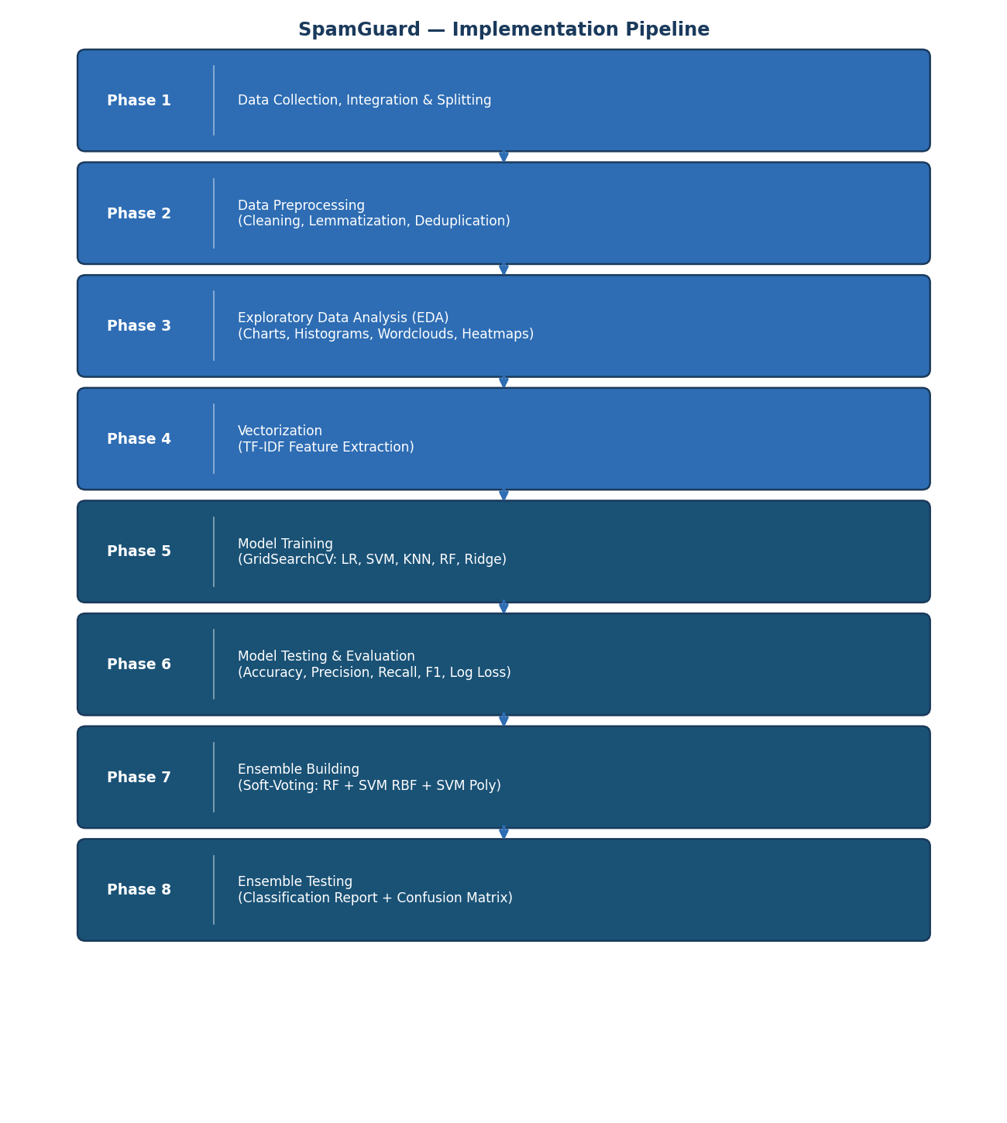
Phase 1
- Data collection, integration and splitting
Gathering and merging raw email datasets containing spam and legitimate (Ham) emails.
Loading CSV files, handling structural issues (removing unwanted columns, renaming columns, etc.), merging all datasets into a combined dataset and preparing raw text for data cleaning and preprocessing.
Splitting combined dataset into training and testing datasets in the ratio 80:20 for training and testing respectively, and loading into CSV files.

- Data preprocessing
Transforming raw, unstructured data into clean, standardized data before EDA.
- Loading raw training and testing datasets from respective CSV files.
- Partially cleaning text.
- Replacing labels (ham: 0, spam: 1)
- Removing duplicates.
- Dropping rows with null values
- Calculating character, word and sentence counts on raw text column.
- Fully cleaning text:
- Convert all text to lowercase
- Replacing URLs, emails, numbers and currency symbols with expressions using regular expressions
- Removing stopwords
- Lemmatizing words and replacing similar context/meaning words with singular words.
- Making columns uniform.
- Writing datasets into CSV files.

- Exploratory Data Analysis (EDA)
Analyzing cleaned, formatted data to discover underlying patterns, statistical anomalies between Spam and Ham emails
Plotting pie charts, histograms, wordclouds and correlation heatmaps to visualize how Spam emails structurally differ from Ham emails and identifying the most frequent high-impact keywords unique to spam emails.

- Expected Modules/ Libraries to be used:
- pandas: Loading datasets from .csv files, merging dataframes, handling missing values and manipulating dataset structures.
- numpy: Used to perform complex mathematical operations and handling arrays
- nltk (Natural Language Toolkit): The Natural Language Processing library used for cleaning text.
- nltk.tokenize: Used to count number of characters, words and sentences in raw text.
- nltk.corpus.stopwords: Used to filter out words like “the”, “and”, “this”, etc. during preprocessing.
- nltk.stem: Used for using WordNetLemmatizer to lemmatize words into base dictionary words or into words with similar context/meaning.
- re (Regular Expression): Used to clean text by replacing URLs, emails, numbers and currency symbols into particular expressions.
- matplotlib: The primary plotting library used in the EDA phase to generate histograms showing email length distributions, bar charts for label counts, and the Confusion Matrix heatmap for model evaluation visualisation.
- seaborn: A higher-level statistical visualisation library built on top of matplotlib, used in EDA to produce colour-coded correlation heatmaps that reveal statistical relationships between numerical features such as character count, word count, and sentence count across spam and ham classes.
- wordcloud: Used in EDA to generate word cloud visualisations separately for spam and ham emails, providing an intuitive visual representation of the most frequent and high-impact keywords in each class and aiding the identification of patterns unique to spam.

- Expected Evaluation metrics and Plots to be used:
Evaluation metrices:
- Hyperparameter Tuning:
Hyperparameters are settings used to change how a model trains. Tuning these settings is necessary to get the highest accuracy out of a model.
- Evaluation Matrix:
A detailed table that breaks down performance beyond just Accuracy. It shows Precision, Recall and the F1-Score (the balance between the two).
- Confusion Matrix:
A 2x2 grid that shows exactly where the model got confused. It plots: True Positives, True Negatives, False Positives, and False Negatives.
- Accuracy: The simplest matrix (Total correct predictions/total predictions)
- Loss (Log Loss): A number representing by how much the model’s predictions are wrong.
Visualization Plots:
- Pie Chart: A circular chart divided into two slices for Ham and Spam emails based on percentages
- Histogram: A bar chart showing the frequency distribution of no. of emails versus no. of emails (log 10).
- Correlation Heatmap: A colour coded gid showing how strongly numerical features related to each other.
- Wordcloud: A visual collage of words where the physical size of the word corresponds to the frequency of word in text.

- Required topics from the subject:
- String Manipulation & Regular Expressions (Regex):
Python’s built-in string methods and the re module are the backbone of text-based Machine Learning. In this project, they are used to convert raw emails to lowercase, strip out punctuation, and replace messy URLs, emails, numbers and currency symbols with standard expressions to clean the data.
- Data Structures (Lists, Sets, and Dictionaries):
These foundational Python structures are used extensively to organize and manage data efficiently in memory. Lists hold tokenized words, sets provide lightning-fast lookups for filtering out stopwords, and dictionaries easily map string labels ("ham"/"spam") to binary numbers (0/1).
- Functions and Lambda Expressions:
Functions allow us to encapsulate reusable blocks of code to keep the architecture organized and modular. Custom functions are paired with Pandas' .apply() method and lambda expressions to rapidly execute cleaning steps across thousands of rows.
- File I/O and Serialization (Pickling):
Python’s file handling capabilities are required to read raw datasets and export finished products. This project uses Pandas to read raw .csv files into memory, and libraries like joblib to serialize (pickle) our trained ML models and vectorizers into .pkl files for future deployment.
- External Modules and Package Management:
This project relies heavily on importing specific modules like pandas for dataframes, nltk for language processing, and scikit-learn for the classification algorithms.

- Platform Required:
Visual Studio Code / Jupyter Notebook / Python IDLE.
- Books and Link Sources:
Books:
[B1] A. Géron, Hands-On Machine Learning with Scikit-Learn, Keras, and TensorFlow, 3rd ed. Sebastopol, CA: O’Reilly Media, 2022.
[B2] S. Bird, E. Klein, and E. Loper, Natural Language Processing with Python: Analyzing Text with the Natural Language Toolkit. Sebastopol, CA: O’Reilly Media, 2009. [Online]. Available: https://www.nltk.org/book/
[B3] C. M. Bishop, Pattern Recognition and Machine Learning. New York, NY: Springer, 2006.
[B4] W. McKinney, Python for Data Analysis: Data Wrangling with pandas, NumPy, and Jupyter, 3rd ed. Sebastopol, CA: O’Reilly Media, 2022.
Research Papers:
[P1] T. Joachims, “Text categorization with Support Vector Machines: Learning with many relevant features,” in Proc. 10th European Conf. Machine Learning (ECML), Chemnitz, Germany, 1998, pp. 137–142.
[P2] M. Sahami, S. Dumais, D. Heckerman, and E. Horvitz, “A Bayesian approach to filtering junk e-mail,” in Proc. AAAI-98 Workshop on Learning for Text Categorization, Madison, WI, 1998, pp. 98–105.
[P3] F. Pedregosa et al., “Scikit-learn: Machine Learning in Python,” Journal of Machine Learning Research, vol. 12, pp. 2825–2830, 2011.
[P4] G. V. Cormack, “Email spam filtering: A systematic review,” Foundations and Trends in Information Retrieval, vol. 1, no. 4, pp. 335–455, 2008.

