Spam Email Detection System

Project Id: AIML-22

Name : Bhaskar Bahukhandi (Team Leader)
Class Roll Number: 42
University Roll Number : 2028689
Section and Group: K, G2

Name : Shrijit Mittra
Class Roll Number: 70
University Roll Number : 2028854
Section and Group: K, G2

Name : Member3
Class Roll Number: 44
University Roll Number : 2028692
Section and Group: K, G2

Table of Contents

- Problem Description ………………………………………………………… 3
- Architecture …………………………………………………………………. 4
- Models model ………………………………………………………………... 5
- Evaluation metrics used …………………………………………………….. 6
- Preliminary Results and Visualizations ……………………………………. 7
- References …………………………………………………………………….. 8

- Problem Description
The Spam Email Detection System is a Python-based machine learning project developed to automatically identify whether an email message is spam or ham. In the present digital world, email is one of the most commonly used communication methods for academic, professional, and personal purposes. However, the increasing use of email has also led to a rapid rise in unwanted messages such as advertisements, promotional emails, phishing attempts, fraud messages, and harmful links. These spam emails not only disturb users but may also create serious security risks by stealing personal information, spreading malware, or misleading users into clicking unsafe links.
The main purpose of this project is to design a system that can analyze the text content of an email and classify it into the correct category. Instead of manually checking every email, the system uses machine learning techniques to learn patterns from previously labeled email data. It studies the words, structure, and frequency of terms commonly found in spam and non-spam messages. Based on this learning, the model can predict whether a new email is likely to be spam or genuine. This makes the project useful for improving email filtering, reducing unwanted messages, and supporting safer digital communication.
In this project, the email text first goes through preprocessing steps such as converting text to lowercase, removing punctuation, eliminating stopwords, and cleaning unnecessary symbols or characters. These steps help in reducing noise from the data and improving the quality of input given to the machine learning model. After preprocessing, the text data is converted into numerical form using TF-IDF Vectorization, which assigns importance to words based on how frequently they appear in a message and how meaningful they are across the dataset. This allows the machine learning models to understand the email content in a mathematical form.
Different classification algorithms such as Logistic Regression, Support Vector Machine, Random Forest, K-Nearest Neighbors, and Ridge Classifier are applied or planned for comparison. The performance of these models is evaluated using standard evaluation metrics such as accuracy, precision, recall, F1-score, and confusion matrix. These metrics help in understanding not only how many emails are classified correctly, but also how effectively the system detects spam emails without wrongly marking genuine emails as spam.
The final goal of the project is to build an accurate, efficient, and easy-to-use spam detection system that can take an email message as input and predict whether it belongs to the spam or ham category. This project demonstrates the practical use of Natural Language Processing and Machine Learning in solving a real-world communication and cybersecurity problem. It also helps in understanding how raw text data can be processed, transformed, trained, and evaluated to create a useful prediction-based application.

- Architecture

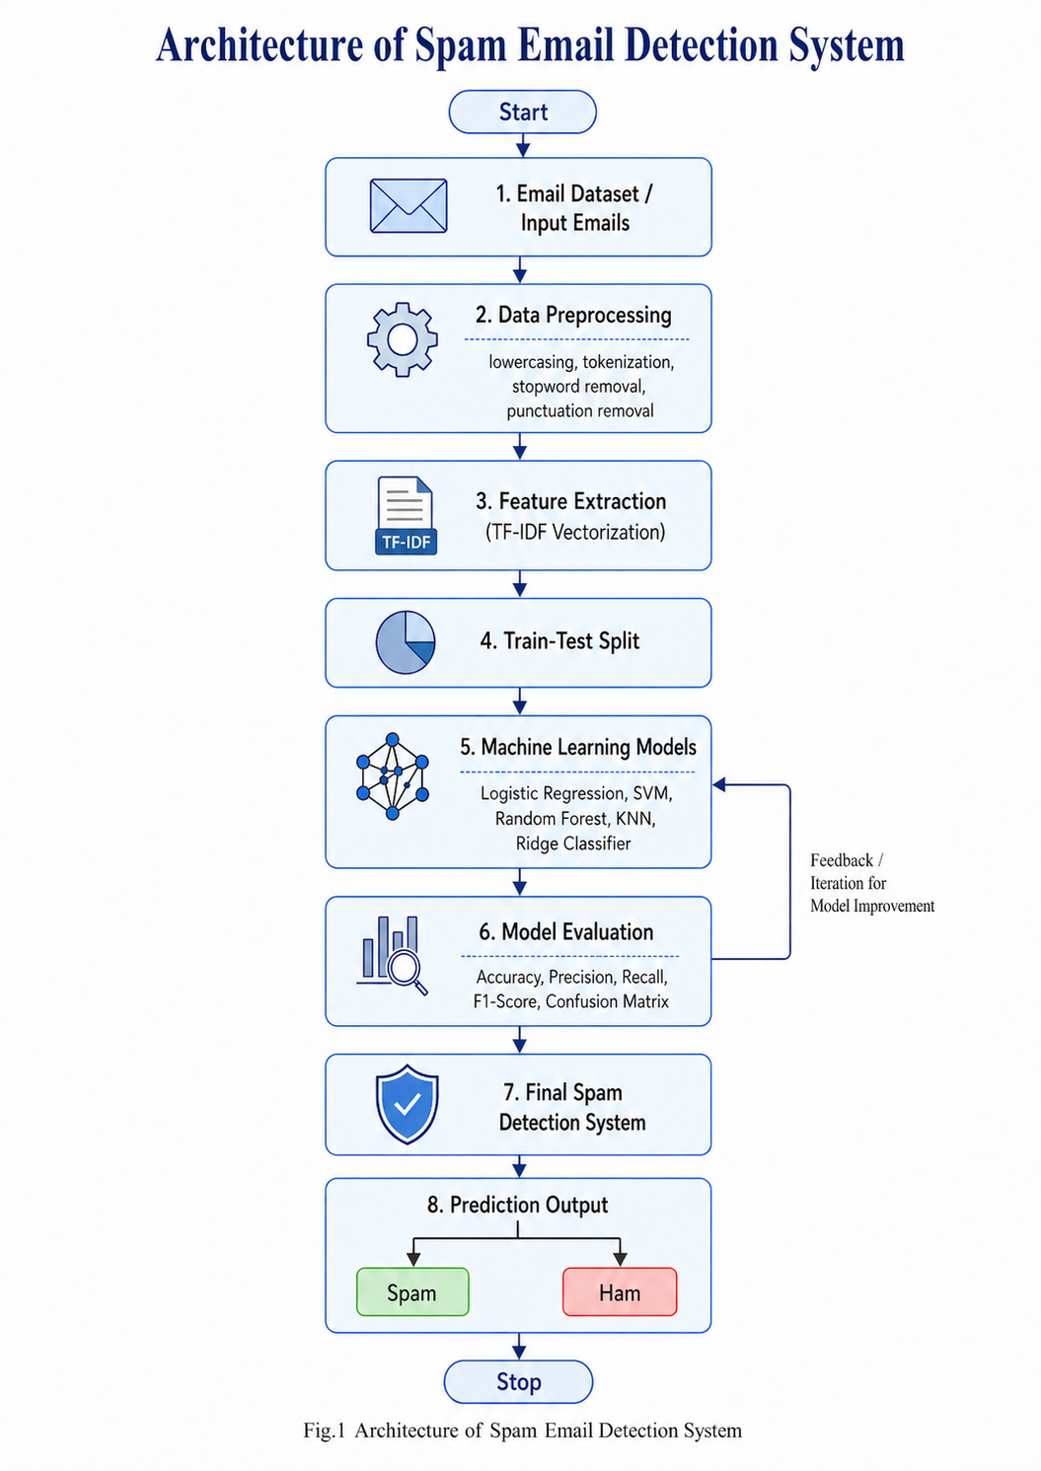

Fig.1 Architecture of Spam Email Detection System
- Models Used(Applied/ Planned)

In this project, different supervised machine learning classification models are used to detect whether an email is Spam or Ham. Since the input data is text-based, the raw email messages are first cleaned and converted into numerical form using TF-IDF Vectorization. After feature extraction, multiple classification algorithms are trained and compared so that the best-performing model can be selected for the final spam detection system. The models are evaluated using accuracy, precision, recall, F1-score, confusion matrix, and log loss.
The reason for using multiple models is that each algorithm learns patterns in a different way. Some models work better with high-dimensional text data, while others are useful for comparison and performance analysis. By testing different models, the system becomes more reliable and helps identify which approach is most suitable for spam email classification.

3.1 Logistic Regression
Logistic Regression is one of the most commonly used classification algorithms for binary classification problems. In this project, it is used to classify emails into two categories: spam and ham. Although it is a simple model, it performs well on text classification tasks because TF-IDF creates numerical features that can be separated using a linear decision boundary.
Logistic Regression calculates the probability of an email belonging to a particular class. If the probability is higher for spam, the email is classified as spam; otherwise, it is classified as ham. It is also useful as a baseline model because its performance can be compared with more complex models.

3.2 Support Vector Machine
Support Vector Machine, or SVM, is a powerful supervised learning algorithm used for classification tasks. It tries to find the best separating boundary between different classes. In spam detection, SVM helps separate spam emails from genuine emails based on the TF-IDF features generated from the email text.
SVM is especially useful for text classification because text data usually contains a large number of features. Different kernel types such as Linear, Polynomial, and RBF can be used to improve classification performance. In this project, SVM models are useful for identifying complex patterns in email content and improving the accuracy of spam detection.

3.3 Random Forest Classifier
Random Forest is an ensemble learning algorithm that combines multiple decision trees to make a final prediction. Instead of depending on a single decision tree, it builds many trees and combines their outputs. This helps in improving accuracy and reducing overfitting.
In this project, Random Forest is used to classify emails by learning patterns from the TF-IDF features. It can handle complex relationships in the data and is useful for comparing performance with linear models such as Logistic Regression and Ridge Classifier. Random Forest is also helpful because it is generally stable and performs well on many classification problems.

3.4 K-Nearest Neighbors
K-Nearest Neighbors, or KNN, is a simple classification algorithm that classifies a new email based on the most similar emails present in the training dataset. It checks the nearest data points and assigns the class that appears most frequently among them.
In spam detection, KNN compares the TF-IDF representation of a new email with already labeled emails. If most of the nearby emails are spam, the new email is classified as spam. Although KNN is easy to understand, it can become slower for large datasets because it needs to compare the new input with many existing data points.

3.5 Ridge Classifier
Ridge Classifier is a linear classification model that uses regularization to improve stability and reduce overfitting. It is useful when the dataset contains many features, which is common in text classification after applying TF-IDF vectorization. In this project, Ridge Classifier helps classify emails by learning a linear relationship between the extracted text features and the output class. It is included because it is fast, stable, and suitable for high-dimensional data. It also provides a good comparison with Logistic Regression and SVM-based models.

3.6 Ensemble Model
An Ensemble Model combines the predictions of multiple machine learning models to produce a stronger final prediction. Instead of relying on only one model, the ensemble approach uses the combined learning of selected models. This can improve the overall reliability and accuracy of the system.
In this project, models such as Random Forest, SVM RBF, and SVM Polynomial can be combined using a voting-based ensemble method. The ensemble model takes the predictions from these models and produces a final output. This approach is useful because different models may detect different patterns in spam emails, and combining them can lead to better classification performance.

Final Model Selection
After training and testing all models, their results are compared using evaluation metrics such as accuracy, precision, recall, F1-score, confusion matrix, and log loss. The model with the best overall performance is selected for the final spam detection system. Special attention is given to precision and recall because wrongly marking a genuine email as spam or failing to detect a spam email can both affect the usefulness of the system. Therefore, the project does not depend on a single algorithm from the beginning. Instead, it follows a comparative approach where multiple models are applied evaluated, and improved to select the most suitable model for spam email detection.
- Evaluation metrics used

Evaluation metrics are used to measure how well the spam email detection system is performing. Since this project is a classification problem, the model does not only need to predict correctly, but it also needs to avoid important mistakes such as marking a genuine email as spam or allowing a spam email to pass as normal. Therefore, different evaluation metrics are used to study the model performance from different angles.
In this project, the email messages are classified into two categories: Spam and Ham. After training the machine learning models, their predictions are compared with the actual labels present in the testing dataset. Based on this comparison, the performance of each model is calculated using metrics such as Accuracy, Precision, Recall, F1-Score, Confusion Matrix, and Log Loss.

4.1 Confusion Matrix
A Confusion Matrix is a table used to show the comparison between actual values and predicted values. It gives a clear understanding of how many emails were classified correctly and how many were classified incorrectly.
For spam email detection, the confusion matrix contains four main terms:

Term |  |  | | Meaning
True Positive (TP) |  |  | | Spam emails correctly predicted as spam
True Negative (TN) |  |  | | Ham emails correctly predicted as ham
False Positive (FP) |  |  | | Ham emails incorrectly predicted as spam
False Negative (FN) |  |  | | Spam emails incorrectly predicted as ham
In this project, the confusion matrix is important because it shows the exact type of mistakes made by the model. For example, a false positive means that a genuine email is marked as spam, while a false negative means that a spam email is not detected by the system.

4.2 Accuracy
Accuracy measures the overall correctness of the model. It tells what percentage of total emails were correctly classified as spam or ham.

[Accuracy = (TP + TN) / (TP + TN + FP + FN)]

Accuracy is useful when the dataset is balanced, meaning the number of spam and ham emails is nearly equal. However, in real-world email datasets, ham emails may be much more common than spam emails. In such cases, accuracy alone may not be enough to judge the model properly. Therefore, other metrics such as precision, recall, and F1-score are also used.

4.3 Precision
Precision measures how many emails predicted as spam were actually spam. It focuses on the correctness of spam predictions.

[Precision = (TP) / (TP + FP)]

Precision is important in spam detection because a low precision value means that the model is marking genuine emails as spam. This can be a serious problem because important emails may get wrongly filtered into the spam folder. A high precision value means that when the system predicts an email as spam, it is usually correct.

4.4 Recall
Recall measures how many actual spam emails were correctly detected by the model. It shows the ability of the system to catch spam messages.

[Recall = (TP) / (TP + FN)]

Recall is important because a low recall value means that many spam emails are being missed and treated as normal emails. In spam detection, high recall is useful because the main goal is to identify as many spam emails as possible. However, recall should be balanced with precision so that genuine emails are not wrongly classified as spam.

4.5 F1-Score
F1-Score is the harmonic mean of precision and recall. It provides a balanced measurement of the model’s performance, especially when there is an imbalance between spam and ham emails.
[ F1-Score = 2 * (Precision * Recall) / (Precision + Recall) ]
F1-score is useful because it considers both false positives and false negatives. A high F1-score means that the model has a good balance between correctly detecting spam emails and avoiding incorrect spam predictions for genuine emails.

4.6 Log Loss
Log Loss is used to measure how confident and correct the model’s predicted probabilities are. It does not only check whether the final class prediction is correct, but also checks how strongly the model predicted that class.
If a model predicts the correct class with high confidence, the log loss value becomes lower. If a model predicts the wrong class with high confidence, the log loss value becomes higher. Therefore, a lower log loss value indicates better model performance.
In this project, log loss is useful for comparing models that provide probability-based outputs. It helps in understanding which model is not only accurate but also more confident and reliable in its predictions.

4.7 Importance of Using Multiple Metrics
Using only one metric may not give a complete idea of model performance. For example, a model may have high accuracy but still fail to detect many spam emails. Similarly, a model may detect most spam emails but may also wrongly classify many genuine emails as spam.
Therefore, this project uses multiple evaluation metrics to compare all models properly. Accuracy gives the overall correctness, precision checks the quality of spam predictions, recall checks how many spam emails are detected, F1-score balances precision and recall, confusion matrix shows detailed prediction results, and log loss checks prediction confidence.
Based on these metrics, the best-performing model can be selected for the final spam email detection system.

5. Preliminary Results and Visualizations

Output:

Combined dataset shape:
(560199, 2)
Columns:
['text', 'label']

Inference:
The combined dataset contains 560,199 email records and 2 main columns, namely text and label. The text column contains the email message, while the label column represents whether the email is spam or ham. This shows that the dataset was successfully prepared for further preprocessing and model training.

Output:

Spam emails : 172225
Ham emails : 153997

Inference:
The class distribution shows that the dataset contains a large number of both spam and ham emails. The number of spam emails is slightly higher than the number of ham emails. Since both classes have sufficient records, the dataset is suitable for training a spam classification model.

Output:

Evaluation Matrix:

Model Accuracy Precision Recall F1 Loss (Log Loss)
Random Forest 0.9922 0.9889 0.9963 0.9926 0.0448
SVM RBF 0.9848 0.9804 0.9908 0.9856 0.0488
KNN 0.9835 0.9755 0.9936 0.9845 0.3066
SVM Poly 0.9822 0.9736 0.9930 0.9832 0.0507
Logistic Regression 0.9693 0.9684 0.9734 0.9709 0.0805
SVM Linear 0.9683 0.9633 0.9768 0.9700 0.0893
Ridge Classifier 0.9642 0.9631 0.9690 0.9660 0.0963

Inference:
The individual model testing results show that Random Forest performed the best among all tested models. It achieved the highest accuracy of 0.9922 and the highest F1-score of 0.9926. SVM RBF, KNN, and SVM Polynomial also performed well, but Random Forest gave the strongest overall result. Logistic Regression, SVM Linear, and Ridge Classifier also produced good results but were slightly lower compared to the top models.

Output:

--- Accuracy & Log Loss ---

Accuracy: 98.99%
Log Loss: 0.038

Classification Report Output:

precision recall f1-score support

Ham 0.99 0.99 0.99 48476
Spam 0.99 0.99 0.99 53635

accuracy 0.99 102111
macro avg 0.99 0.99 0.99 102111
weighted avg 0.99 0.99 0.99 102111

Inference:
The ensemble model achieved an accuracy of 98.99%, which shows that it performed very well on the testing data. The precision, recall, and F1-score for both ham and spam classes are 0.99, which means the model is highly effective in detecting both genuine and spam emails. The log loss value of 0.038 is also low, showing that the model gives confident and reliable predictions.
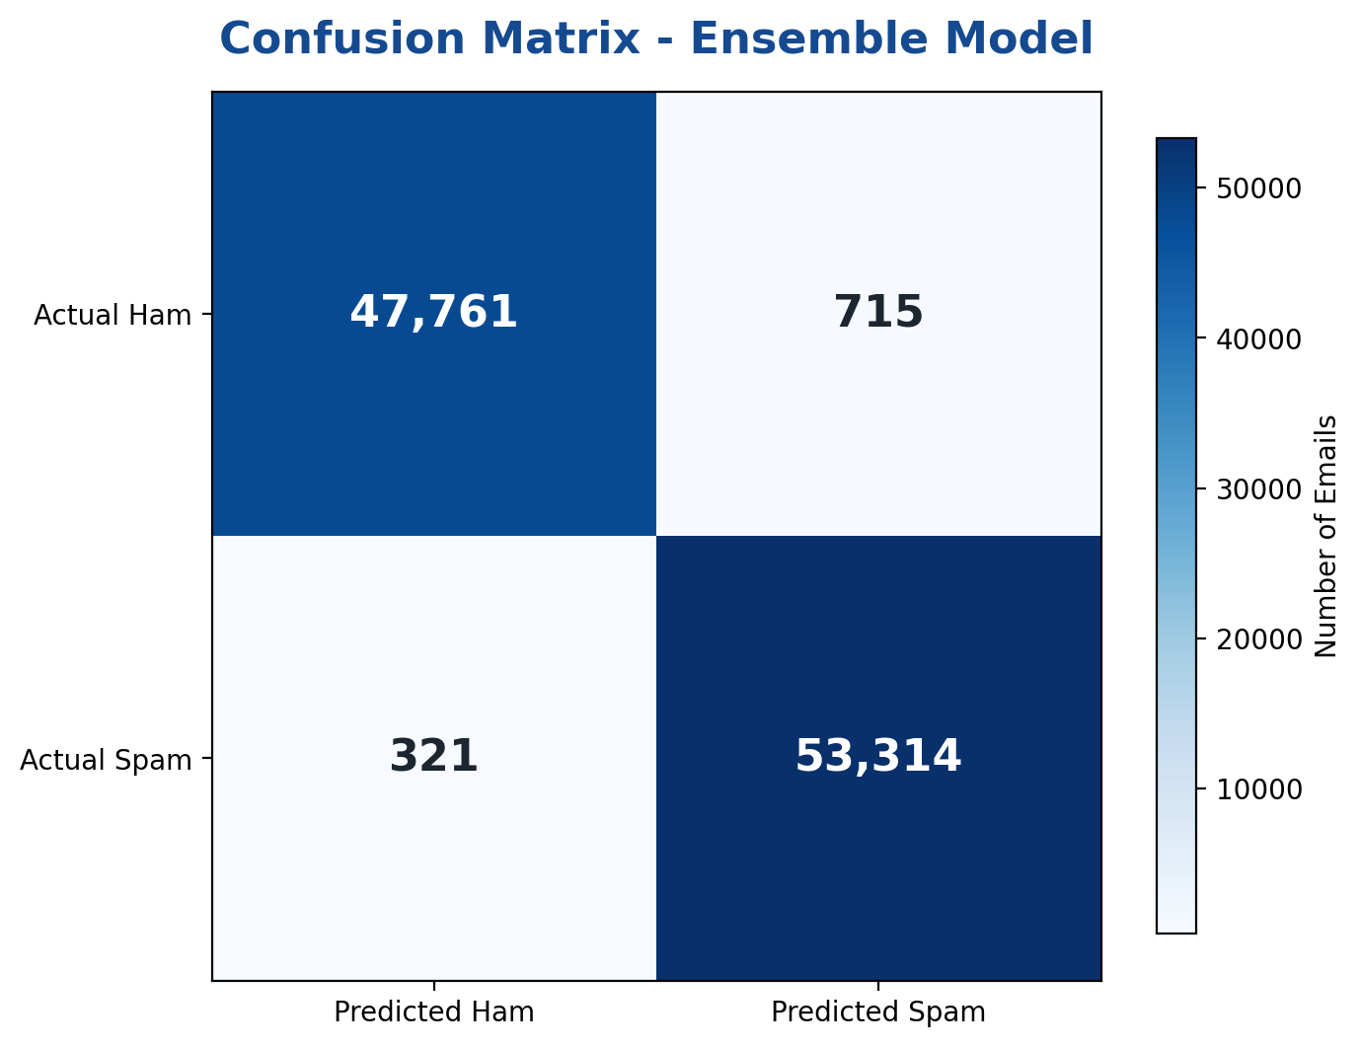

Fig.2 Confusion Matrix – Ensemble Model
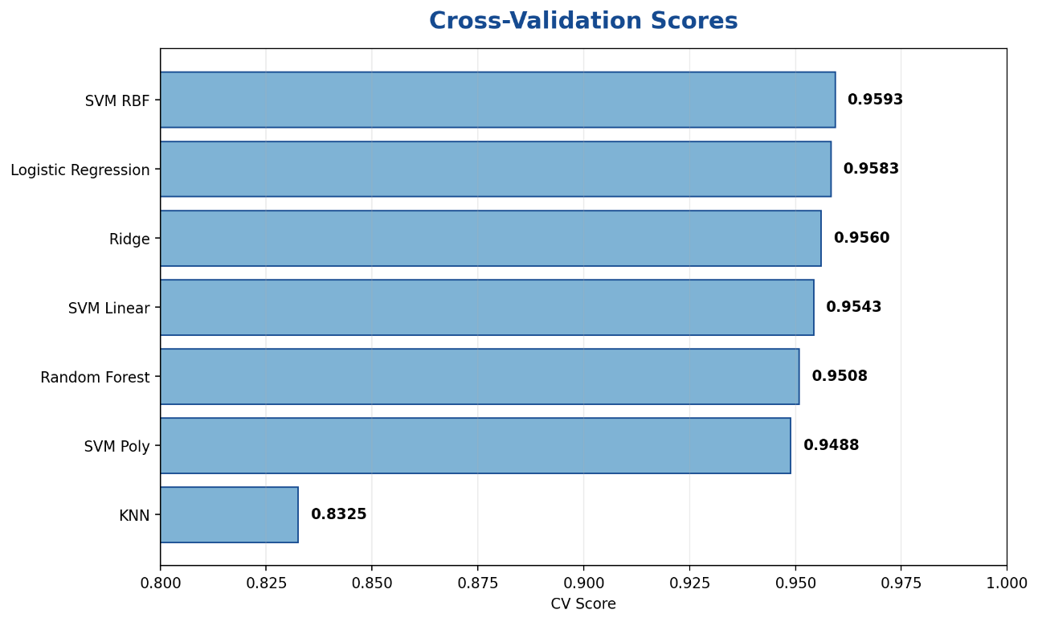

Fig.3 Cross-Validation Scores

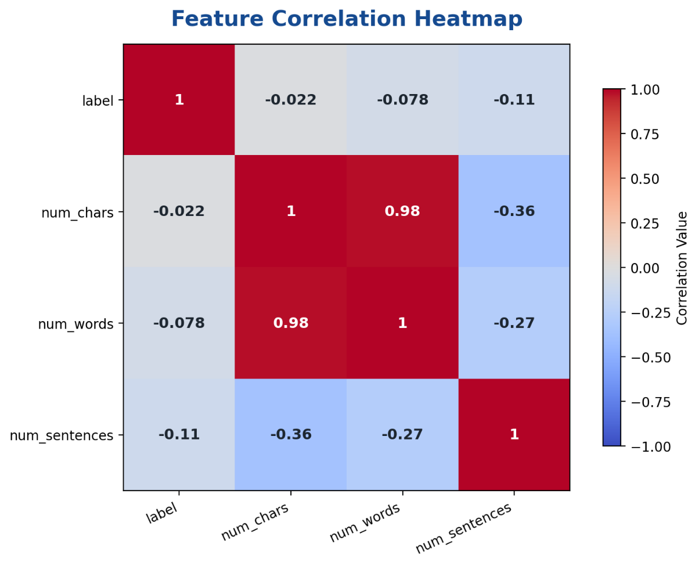
Fig.4 Feature Correlation Heatmap
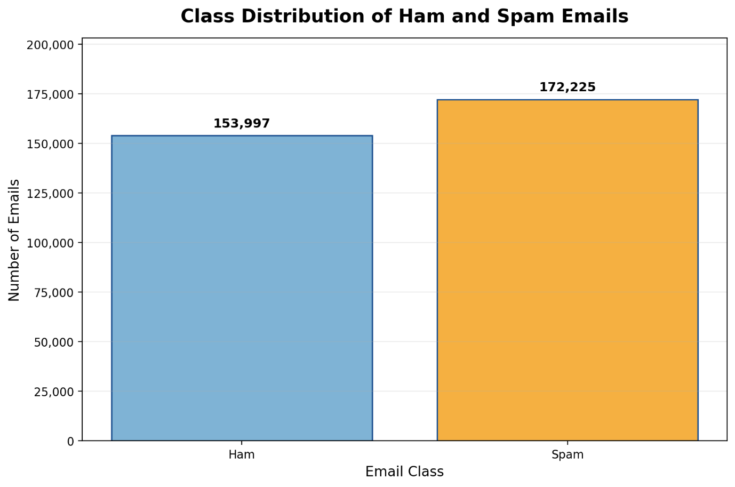

Fig.5 Class Distribution of Ham and Spam Emails

- References:

Books:
1. Let Us Python – Yashavant Kanetkar
2. Introduction to Machine Learning with Python – Andreas C. Müller and Sarah Guido

Online Resources:
1. Scikit-learn Documentation – https://scikit-learn.org/
2. Pandas Documentation – https://pandas.pydata.org/
3. Matplotlib Documentation – https://matplotlib.org/
4. GeeksforGeeks – https://www.geeksforgeeks.org/
5. Stack Overflow – https://stackoverflow.com/

