Spam Email Detection System

Project Id: AIML-22

Name : Bhaskar Bahukhandi (Team Leader)
Class Roll Number: 42
University Roll Number : 2028689
Section and Group: K, G2

Name : Shrijit Mittra
Class Roll Number: 70
University Roll Number : 2028854
Section and Group: K, G2

Name : Member3
Class Roll Number: 44
University Roll Number : 2028692
Section and Group: K, G2

TABLE OF CONTENTS
- Problem Description 3
  - Dataset Description 3
  - Flow diagram 4
- Modules for Project Implementation………………….…………………………5
  - Modules Used 5
  - Platform Used 6
- Machine Learning model/ Searching Technique used 7
- Evaluation metrics used 8
- Results and Visualizations 9
- Conclusion and Future Scope 11
- References 12

- Problem Description

1.1 Dataset Description
The Spam Email Detection System is a Python-based machine learning project developed to automatically identify whether an email message is spam or ham. In the present digital world, email is one of the most commonly used communication methods for academic, professional, and personal purposes. However, the increasing use of email has also led to a rapid rise in unwanted messages such as advertisements, promotional emails, phishing attempts, fraud messages, and harmful links. These spam emails not only disturb users but may also create serious security risks by stealing personal information, spreading malware, or misleading users into clicking unsafe links.
The main purpose of this project is to design a system that can analyze the text content of an email and classify it into the correct category. Instead of manually checking every email, the system uses machine learning techniques to learn patterns from previously labeled email data. It studies the words, structure, and frequency of terms commonly found in spam and non-spam messages. Based on this learning, the model can predict whether a new email is likely to be spam or genuine. This makes the project useful for improving email filtering, reducing unwanted messages, and supporting safer digital communication.
In this project, the email text first goes through preprocessing steps such as converting text to lowercase, removing punctuation, eliminating stopwords, and cleaning unnecessary symbols or characters. These steps help in reducing noise from the data and improving the quality of input given to the machine learning model. After preprocessing, the text data is converted into numerical form using TF-IDF Vectorization, which assigns importance to words based on how frequently they appear in a message and how meaningful they are across the dataset. This allows the machine learning models to understand the email content in a mathematical form.
Different classification algorithms such as Logistic Regression, Support Vector Machine, Random Forest, K-Nearest Neighbors, and Ridge Classifier are applied or planned for comparison. The performance of these models is evaluated using standard evaluation metrics such as accuracy, precision, recall, F1-score, and confusion matrix. These metrics help in understanding not only how many emails are classified correctly, but also how effectively the system detects spam emails without wrongly marking genuine emails as spam.
The final goal of the project is to build an accurate, efficient, and easy-to-use spam detection system that can take an email message as input and predict whether it belongs to the spam or ham category. This project demonstrates the practical use of Natural Language Processing and Machine Learning in solving a real-world communication and cybersecurity problem. It also helps in understanding how raw text data can be processed, transformed, trained, and evaluated to create a useful prediction-based application.

  - Flow Diagram

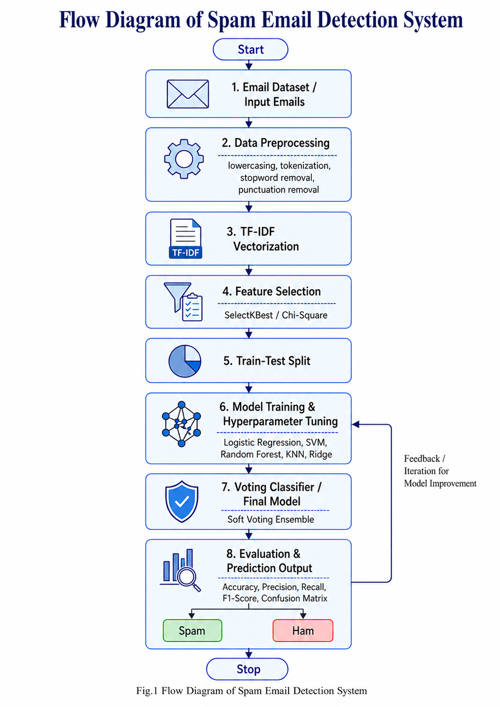

Fig.1 Flow Diagram of Spam Email Detection System
2. Modules for Project Implementation

In this project, different Python modules and libraries were used for data handling, text preprocessing, feature extraction, model training, model testing, visualization, and final prediction. Since the Spam Email Detection System is based on Natural Language Processing and Machine Learning, the implementation required modules for working with text data, converting text into numerical vectors, training classification models, evaluating model performance, and saving trained models for future use.
The complete project was implemented in Python using both script files and Jupyter notebooks. The modules helped in dividing the project into proper stages such as dataset creation, preprocessing, exploratory data analysis, TF-IDF vectorization, feature selection, model training, model testing, voting classifier creation, and final email prediction.

2.1 Modules Used

1. Pandas
Pandas is used for data manipulation and analysis. In this project, it was mainly used to read datasets, combine different email datasets, clean rows, remove duplicate records, handle columns, and save processed data into CSV files.
Functions used:
- pd.read_csv() – to read dataset files in CSV format.
- pd.concat() – to combine multiple datasets.
- drop_duplicates() – to remove duplicate email records.
- dropna() – to remove missing or empty values.
- value_counts() – to count spam and ham records.
- to_csv() – to save processed datasets into CSV files.
- describe() – to generate statistical summary of numerical columns.

2. NumPy
NumPy is used for numerical operations and array handling. In this project, it supported numerical processing during model training, testing, and ensemble prediction.
Functions used:
- np.array() – to work with numerical arrays.
- NumPy operations were also used indirectly while handling vectorized data and model outputs.

3. Regular Expression Module — re
The re module is a built-in Python module used for text pattern matching and cleaning. In this project, it was used during email text preprocessing.
Functions used:
- re.sub() – to remove or replace unwanted text patterns such as URLs, email addresses, numbers, currency symbols, special characters, and punctuation marks.
Purpose in project:
The re module helped clean raw email text by replacing links, email addresses, numbers, and special symbols with suitable tokens or by removing them completely. This made the email text more suitable for machine learning.

4. NLTK
NLTK stands for Natural Language Toolkit. It is used for Natural Language Processing tasks. In this project, NLTK was mainly used for stopword removal and lemmatization.
Functions and classes used:
- nltk.download() – to download required NLP resources.
- stopwords.words('english') – to get common English stopwords.
- WordNetLemmatizer() – to convert words into their base form.
Purpose in project:
NLTK helped in removing unnecessary common words such as “the”, “is”, “are”, and “and”. It also helped in converting words to their root form so that similar words could be treated more uniformly.

5. Scikit-learn
Scikit-learn is the main machine learning library used in this project. It was used for dataset splitting, vectorization, feature selection, model training, hyperparameter tuning, classification, voting classifier creation, and evaluation.
Important functions and classes used:
- train_test_split() – to split the dataset into training and testing parts.
- TfidfVectorizer() – to convert email text into numerical TF-IDF vectors.
- SelectKBest() – to select the most important features.
- chi2 – to apply Chi-Square based feature selection.
- GridSearchCV() – to perform hyperparameter tuning.
- LogisticRegression() – to train the Logistic Regression model.
- SVC() – to train Support Vector Machine models.
- KNeighborsClassifier() – to train the KNN model.
- RandomForestClassifier() – to train the Random Forest model.
- RidgeClassifier() – to train the Ridge Classifier model.
- CalibratedClassifierCV() – to generate probability-based output for models that do not naturally provide probability values.
- VotingClassifier() – to combine multiple trained models into a final voting-based ensemble model.
Purpose in project:
Scikit-learn was used to implement the complete machine learning pipeline. It helped convert email text into vectors, select useful features, train multiple models, tune model parameters, compare model performance, and create the final voting classifier for spam detection.

6. Scikit-learn Metrics
The metrics module of Scikit-learn was used to evaluate the performance of trained models.
Functions used:
- accuracy_score() – to calculate overall model accuracy.
- precision_score() – to calculate how many predicted spam emails were actually spam.
- recall_score() – to calculate how many actual spam emails were correctly detected.
- f1_score() – to calculate the balance between precision and recall.
- confusion_matrix() – to show correct and incorrect predictions.
- classification_report() – to generate a detailed report of precision, recall, F1-score, and support.
- log_loss() – to measure the confidence and correctness of probability-based predictions.
Purpose in project:
These evaluation metrics helped compare all trained models and identify the best-performing model for spam email detection.

7. Joblib
Joblib is used for saving and loading trained machine learning models, vectorizers, and feature selection objects.
Functions used:
- joblib.dump() – to save trained models, TF-IDF vectorizer, selected features, and vector files.
- joblib.load() – to load saved models and use them again for testing or prediction.
Purpose in project:
Joblib allowed the project to save trained models and reuse them later without training again. This was especially useful for the final SpamGuard prediction system.

8. Matplotlib
Matplotlib is used for data visualization. In this project, it was used to create graphs and visual outputs for exploratory data analysis.
Functions used:
- plt.figure() – to create a new figure.
- plt.pie() – to create class distribution pie charts.
- plt.title() – to add titles to graphs.
- plt.xlabel() – to label the x-axis.
- plt.ylabel() – to label the y-axis.
- plt.show() – to display the graph.
- plt.imshow() – to display the word cloud image.
Purpose in project:
Matplotlib helped generate visual outputs such as class distribution charts, email length distribution graphs, heatmaps, and word cloud figures.

9. Seaborn
Seaborn is a Python visualization library built on top of Matplotlib. It was used to create more attractive and informative statistical graphs.
Functions used:
- sns.histplot() – to plot the distribution of email lengths.
- sns.heatmap() – to create the feature correlation heatmap.
Purpose in project:
Seaborn helped in visualizing the relationship between numerical features such as number of characters, words, sentences, and labels. It made the graphs easier to understand and more suitable for the report.

10. TQDM
TQDM is used to display progress bars during long-running operations.
Function used:
- tqdm() – to show progress during TF-IDF vectorization, model tuning, training, and testing.
Purpose in project:
Since the dataset contains a large number of email records, some operations take time. TQDM helped monitor the progress of these operations in a clear way.

11. Pathlib
Pathlib is a Python module used for handling file paths.
Class used:
- Path() – to manage file and folder paths.
Purpose in project:
Pathlib helped in managing paths for model files, report files, and saved outputs in a cleaner and more organized way.

12. Collections Module
The collections module is a built-in Python module used for counting and organizing data.
Class used:
- Counter() – to count repeated words or items.
Purpose in project:
It was useful during exploratory analysis to understand word frequency and text patterns in email messages.

13. Scikit-learn Intel Extension — sklearnex
The sklearnex module was used to patch Scikit-learn and improve performance during model training and testing.
Function used:
- patch_sklearn() – to optimize Scikit-learn operations.
Purpose in project:
This module helped speed up some machine learning operations, especially during training and testing on large datasets.

14. Custom Project Files / Modules
Apart from standard Python libraries, the project was divided into multiple custom Python files to keep the implementation organized.
Custom files used:
- dataset_creation.py
Used to combine and prepare the original email datasets.
- dataset_split.py
Used to divide the dataset into training and testing data.
- data_preprocessing.py
Used to clean raw email text, remove unwanted symbols, remove stopwords, apply lemmatization, and prepare clean text.
- exploratory_data_analysis.py
Used to generate graphs, statistics, heatmaps, and word clouds for dataset analysis.
- data_vectorizer.py
Used to apply TF-IDF Vectorization and convert text data into numerical vectors.
- model_training.py
Used to perform feature selection, hyperparameter tuning, and training of machine learning models.
- model_testing.py
Used to test individual trained models and calculate their performance.
- ensemble_build.py
Used to create the final Voting Classifier by combining selected models.
- ensemble_testing.py
Used to test the final Voting Classifier and generate the final evaluation report.
- main.py
Used as the final user-facing program where a user can enter an email and get the prediction as Spam or Ham.

2.2 Platform Used

1. Python
Python was used as the main programming language for this project. It is widely used in machine learning, data science, and Natural Language Processing because it provides powerful libraries such as Pandas, NumPy, Scikit-learn, NLTK, Matplotlib, and Seaborn.
Reason for using Python:
Python makes it easier to implement machine learning models, process text data, create visualizations, and evaluate results. It also provides simple syntax, which makes the project easier to understand, modify, and test.

2. Jupyter Notebook
Jupyter Notebook was used for step-by-step implementation, experimentation, and output visualization. It was helpful during dataset analysis, preprocessing, EDA, vectorization, model training, and model testing.
Reason for using Jupyter Notebook:
Jupyter Notebook allows code, output, graphs, and explanations to be shown together in one place. This made it easier to understand each stage of the project and verify the outputs after every step. It was especially useful for displaying graphs such as class distribution, heatmaps, word clouds, and model comparison results.

3. Visual Studio Code
Visual Studio Code was used for writing, editing, organizing, and debugging Python script files. The final project contains multiple Python files, and VS Code helped manage these files in a structured way.
Reason for using Visual Studio Code:
VS Code provides useful features such as syntax highlighting, file explorer, terminal, extensions, debugging tools, and code formatting. It helped in writing the final Python scripts and organizing the complete project folder properly.

4. Google Drive
Google Drive was used for storing large project files such as datasets, TF-IDF vectors, and trained machine learning models.
Reason for using Google Drive:
The dataset, vector files, and trained model files can become large in size. Google Drive helped in storing these files safely and made it easier to share them among team members.

5. Windows Operating System
The project was developed and tested on a Windows-based system. Windows provided the required environment for installing Python, running Jupyter Notebook, using VS Code, and managing project files.
Reason for using Windows:
Windows is easy to use and supports Python, machine learning libraries, Jupyter Notebook, and Visual Studio Code. It also provides a simple file management system for handling datasets, reports, models, and output files.

6. Command Line / Terminal
The command line or terminal was used to run Python scripts and test the final SpamGuard program.
Reason for using Command Line / Terminal:
The terminal helped run project files directly and check whether the final spam detection system was working correctly. It was also used to test the final program where the user enters an email and receives the prediction result as Spam or Ham.

- Machine Learning Models/Searching Techniques used

In this project, different supervised machine learning classification models are used to detect whether an email is Spam or Ham. Since the input data is text-based, the raw email messages are first cleaned and converted into numerical form using TF-IDF Vectorization. After feature extraction, multiple classification algorithms are trained and compared so that the best-performing model can be selected for the final spam detection system. The models are evaluated using accuracy, precision, recall, F1-score, confusion matrix, and log loss.
The reason for using multiple models is that each algorithm learns patterns in a different way. Some models work better with high-dimensional text data, while others are useful for comparison and performance analysis. By testing different models, the system becomes more reliable and helps identify which approach is most suitable for spam email classification.

3.1 Logistic Regression
Logistic Regression is one of the most commonly used classification algorithms for binary classification problems. In this project, it is used to classify emails into two categories: spam and ham. Although it is a simple model, it performs well on text classification tasks because TF-IDF creates numerical features that can be separated using a linear decision boundary.
Logistic Regression calculates the probability of an email belonging to a particular class. If the probability is higher for spam, the email is classified as spam; otherwise, it is classified as ham. It is also useful as a baseline model because its performance can be compared with more complex models.

3.2 Support Vector Machine
Support Vector Machine, or SVM, is a powerful supervised learning algorithm used for classification tasks. It tries to find the best separating boundary between different classes. In spam detection, SVM helps separate spam emails from genuine emails based on the TF-IDF features generated from the email text.
SVM is especially useful for text classification because text data usually contains a large number of features. Different kernel types such as Linear, Polynomial, and RBF can be used to improve classification performance. In this project, SVM models are useful for identifying complex patterns in email content and improving the accuracy of spam detection.

3.3 Random Forest Classifier
Random Forest is an ensemble learning algorithm that combines multiple decision trees to make a final prediction. Instead of depending on a single decision tree, it builds many trees and combines their outputs. This helps in improving accuracy and reducing overfitting.
In this project, Random Forest is used to classify emails by learning patterns from the TF-IDF features. It can handle complex relationships in the data and is useful for comparing performance with linear models such as Logistic Regression and Ridge Classifier. Random Forest is also helpful because it is generally stable and performs well on many classification problems.

3.4 K-Nearest Neighbors
K-Nearest Neighbors, or KNN, is a simple classification algorithm that classifies a new email based on the most similar emails present in the training dataset. It checks the nearest data points and assigns the class that appears most frequently among them.
In spam detection, KNN compares the TF-IDF representation of a new email with already labeled emails. If most of the nearby emails are spam, the new email is classified as spam. Although KNN is easy to understand, it can become slower for large datasets because it needs to compare the new input with many existing data points.

3.5 Ridge Classifier
Ridge Classifier is a linear classification model that uses regularization to improve stability and reduce overfitting. It is useful when the dataset contains many features, which is common in text classification after applying TF-IDF vectorization. In this project, Ridge Classifier helps classify emails by learning a linear relationship between the extracted text features and the output class. It is included because it is fast, stable, and suitable for high-dimensional data. It also provides a good comparison with Logistic Regression and SVM-based models.

3.6 Ensemble Model
An Ensemble Model combines the predictions of multiple machine learning models to produce a stronger final prediction. Instead of relying on only one model, the ensemble approach uses the combined learning of selected models. This can improve the overall reliability and accuracy of the system.
In this project, models such as Random Forest, SVM RBF, and SVM Polynomial can be combined using a voting-based ensemble method. The ensemble model takes the predictions from these models and produces a final output. This approach is useful because different models may detect different patterns in spam emails, and combining them can lead to better classification performance.

Final Model Selection
After training and testing all models, their results are compared using evaluation metrics such as accuracy, precision, recall, F1-score, confusion matrix, and log loss. The model with the best overall performance is selected for the final spam detection system. Special attention is given to precision and recall because wrongly marking a genuine email as spam or failing to detect a spam email can both affect the usefulness of the system. Therefore, the project does not depend on a single algorithm from the beginning. Instead, it follows a comparative approach where multiple models are applied evaluated, and improved to select the most suitable model for spam email detection.

Searching Technique Used for Model Selection

In this project, the main searching technique used was Grid Search with Cross-Validation, implemented using GridSearchCV from Scikit-learn. Since different machine learning models can give different results depending on their parameter values, hyperparameter tuning was performed to search for the best combination of parameters for each model.
Grid Search works by testing different predefined combinations of hyperparameters and selecting the combination that gives the best performance. Instead of manually trying different values one by one, GridSearchCV automatically trains the model using multiple parameter combinations and compares their performance using cross-validation.
In this project, GridSearchCV was used during model training to improve the performance of models such as Logistic Regression, Support Vector Machine, K-Nearest Neighbors, Random Forest, and Ridge Classifier. The scoring metric used for comparison was mainly F1-score, because spam email detection requires a balance between precision and recall. A model should not only detect spam emails correctly, but should also avoid wrongly marking genuine emails as spam.

Working of GridSearchCV in the Project
The working of GridSearchCV in this project can be explained as follows:
- A machine learning model was selected.
- A set of possible hyperparameter values was defined for that model.
- GridSearchCV trained the model using different parameter combinations.
- Cross-validation was performed to test the model on different parts of the training data.
- The best parameter combination was selected based on the highest performance score.
- The tuned model was then trained and tested on the final testing dataset.
This technique helped in selecting better model settings and improving the overall accuracy and reliability of the spam detection system.

Hyperparameter Searching Used for Different Models

Model | Hyperparameters Tuned / Searched
Logistic Regression | Regularization strength, solver, maximum iterations
SVM Linear | Regularization parameter C
SVM Polynomial | C, degree, kernel type
SVM RBF | C, gamma, kernel type
K-Nearest Neighbors | Number of neighbors, distance metric, weights
Random Forest | Number of trees, maximum depth, splitting criteria
Ridge Classifier | Regularization parameter alpha

Importance of Searching Technique
The searching technique was important because default model parameters may not always give the best result. By using GridSearchCV, the project was able to compare different parameter combinations and select the most suitable settings for each model. This made the model training process more systematic and improved the final performance of the spam email detection system.
In addition to hyperparameter searching, feature selection was also applied using SelectKBest with the Chi-Square method. This helped select the most important TF-IDF features from the vectorized email text. Therefore, the project used both feature selection and hyperparameter searching to improve model efficiency and classification accuracy.

- Evaluation metrics used

Evaluation metrics are used to measure how well the spam email detection system is performing. Since this project is a classification problem, the model does not only need to predict correctly, but it also needs to avoid important mistakes such as marking a genuine email as spam or allowing a spam email to pass as normal. Therefore, different evaluation metrics are used to study the model performance from different angles.
In this project, the email messages are classified into two categories: Spam and Ham. After training the machine learning models, their predictions are compared with the actual labels present in the testing dataset. Based on this comparison, the performance of each model is calculated using metrics such as Accuracy, Precision, Recall, F1-Score, Confusion Matrix, and Log Loss.

4.1 Confusion Matrix
A Confusion Matrix is a table used to show the comparison between actual values and predicted values. It gives a clear understanding of how many emails were classified correctly and how many were classified incorrectly.
For spam email detection, the confusion matrix contains four main terms:

Term |  |  | | Meaning
True Positive (TP) |  |  | | Spam emails correctly predicted as spam
True Negative (TN) |  |  | | Ham emails correctly predicted as ham
False Positive (FP) |  |  | | Ham emails incorrectly predicted as spam
False Negative (FN) |  |  | | Spam emails incorrectly predicted as ham
In this project, the confusion matrix is important because it shows the exact type of mistakes made by the model. For example, a false positive means that a genuine email is marked as spam, while a false negative means that a spam email is not detected by the system.

4.2 Accuracy
Accuracy measures the overall correctness of the model. It tells what percentage of total emails were correctly classified as spam or ham.

[Accuracy = (TP + TN) / (TP + TN + FP + FN)]

Accuracy is useful when the dataset is balanced, meaning the number of spam and ham emails is nearly equal. However, in real-world email datasets, ham emails may be much more common than spam emails. In such cases, accuracy alone may not be enough to judge the model properly. Therefore, other metrics such as precision, recall, and F1-score are also used.

4.3 Precision
Precision measures how many emails predicted as spam were actually spam. It focuses on the correctness of spam predictions.

[Precision = (TP) / (TP + FP)]

Precision is important in spam detection because a low precision value means that the model is marking genuine emails as spam. This can be a serious problem because important emails may get wrongly filtered into the spam folder. A high precision value means that when the system predicts an email as spam, it is usually correct.

4.4 Recall
Recall measures how many actual spam emails were correctly detected by the model. It shows the ability of the system to catch spam messages.

[Recall = (TP) / (TP + FN)]

Recall is important because a low recall value means that many spam emails are being missed and treated as normal emails. In spam detection, high recall is useful because the main goal is to identify as many spam emails as possible. However, recall should be balanced with precision so that genuine emails are not wrongly classified as spam.

4.5 F1-Score
F1-Score is the harmonic mean of precision and recall. It provides a balanced measurement of the model’s performance, especially when there is an imbalance between spam and ham emails.
[ F1-Score = 2 * (Precision * Recall) / (Precision + Recall) ]
F1-score is useful because it considers both false positives and false negatives. A high F1-score means that the model has a good balance between correctly detecting spam emails and avoiding incorrect spam predictions for genuine emails.

4.6 Log Loss
Log Loss is used to measure how confident and correct the model’s predicted probabilities are. It does not only check whether the final class prediction is correct, but also checks how strongly the model predicted that class.
If a model predicts the correct class with high confidence, the log loss value becomes lower. If a model predicts the wrong class with high confidence, the log loss value becomes higher. Therefore, a lower log loss value indicates better model performance.
In this project, log loss is useful for comparing models that provide probability-based outputs. It helps in understanding which model is not only accurate but also more confident and reliable in its predictions.

4.7 Importance of Using Multiple Metrics
Using only one metric may not give a complete idea of model performance. For example, a model may have high accuracy but still fail to detect many spam emails. Similarly, a model may detect most spam emails but may also wrongly classify many genuine emails as spam.
Therefore, this project uses multiple evaluation metrics to compare all models properly. Accuracy gives the overall correctness, precision checks the quality of spam predictions, recall checks how many spam emails are detected, F1-score balances precision and recall, confusion matrix shows detailed prediction results, and log loss checks prediction confidence.
Based on these metrics, the best-performing model can be selected for the final spam email detection system.

5. Results and Visualizations

Output:

Combined dataset shape:
(560199, 2)
Columns:
['text', 'label']

Inference:
The combined dataset contains 560,199 email records and 2 main columns, namely text and label. The text column contains the email message, while the label column represents whether the email is spam or ham. This shows that the dataset was successfully prepared for further preprocessing and model training.

Output:

Spam emails: 172225
Ham emails : 153997

Inference:
The class distribution shows that the dataset contains a large number of both spam and ham emails. The number of spam emails is slightly higher than the number of ham emails. Since both classes have sufficient records, the dataset is suitable for training a spam classification model.

Output:

Evaluation Matrix:

Model Accuracy Precision Recall F1 Loss (Log Loss)
Random Forest 0.9922 0.9889 0.9963 0.9926 0.0448
SVM RBF 0.9848 0.9804 0.9908 0.9856 0.0488
KNN 0.9835 0.9755 0.9936 0.9845 0.3066
SVM Poly 0.9822 0.9736 0.9930 0.9832 0.0507
Logistic Regression 0.9693 0.9684 0.9734 0.9709 0.0805
SVM Linear 0.9683 0.9633 0.9768 0.9700 0.0893
Ridge Classifier 0.9642 0.9631 0.9690 0.9660 0.0963

Inference:
The individual model testing results show that Random Forest performed the best among all tested models. It achieved the highest accuracy of 0.9922 and the highest F1-score of 0.9926. SVM RBF, KNN, and SVM Polynomial also performed well, but Random Forest gave the strongest overall result. Logistic Regression, SVM Linear, and Ridge Classifier also produced good results but were slightly lower compared to the top models.

Output:

--- Accuracy & Log Loss ---

Accuracy: 98.99%
Log Loss: 0.038

Classification Report Output:

precision recall f1-score support

Ham 0.99 0.99 0.99 48476
Spam 0.99 0.99 0.99 53635

accuracy 0.99 102111
macro avg 0.99 0.99 0.99 102111
weighted avg 0.99 0.99 0.99 102111

Inference:
The ensemble model achieved an accuracy of 98.99%, which shows that it performed very well on the testing data. The precision, recall, and F1-score for both ham and spam classes are 0.99, which means the model is highly effective in detecting both genuine and spam emails. The log loss value of 0.038 is also low, showing that the model gives confident and reliable predictions.
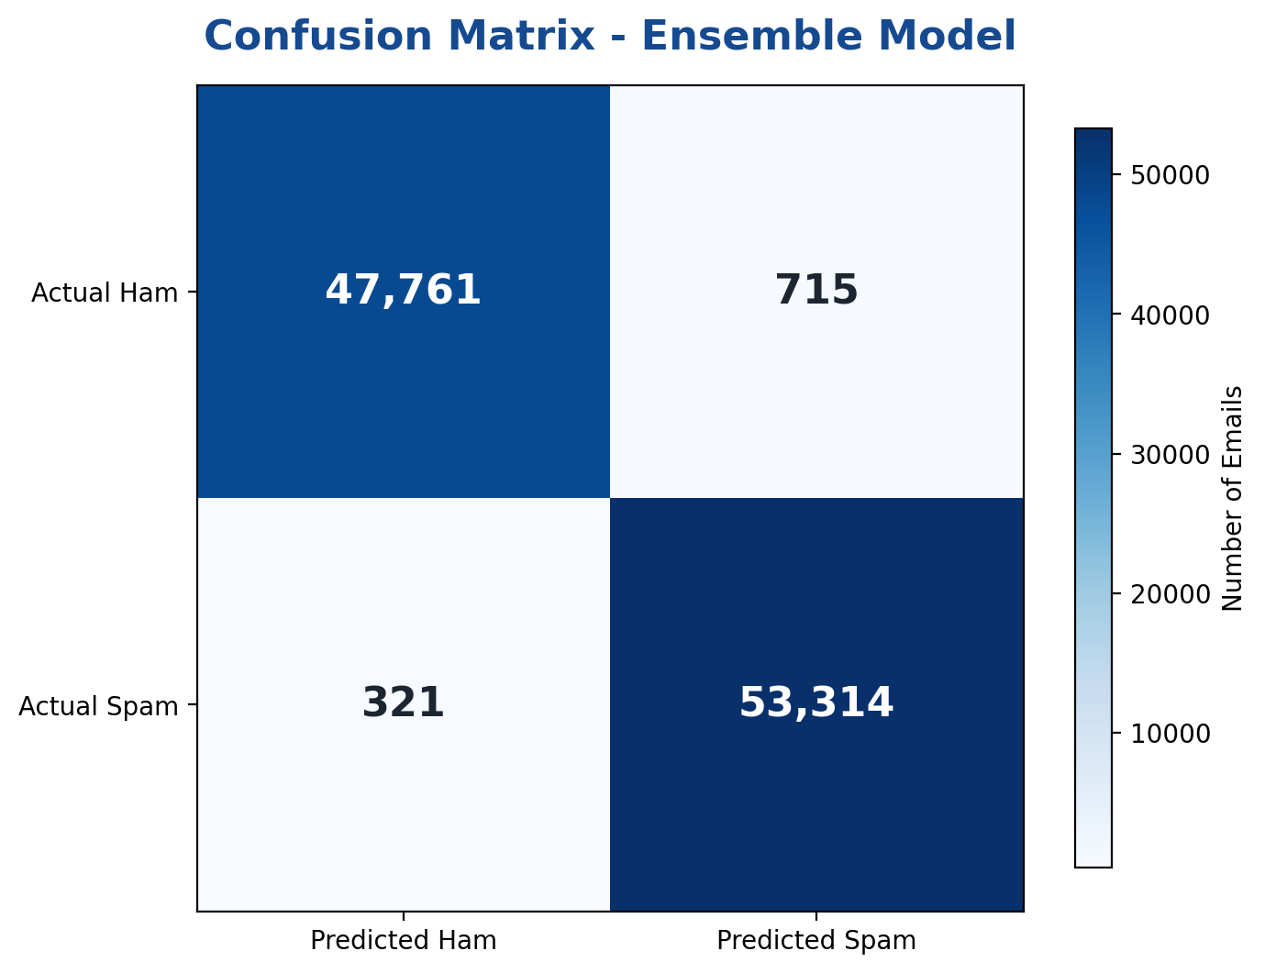

Fig.2 Confusion Matrix – Ensemble Model
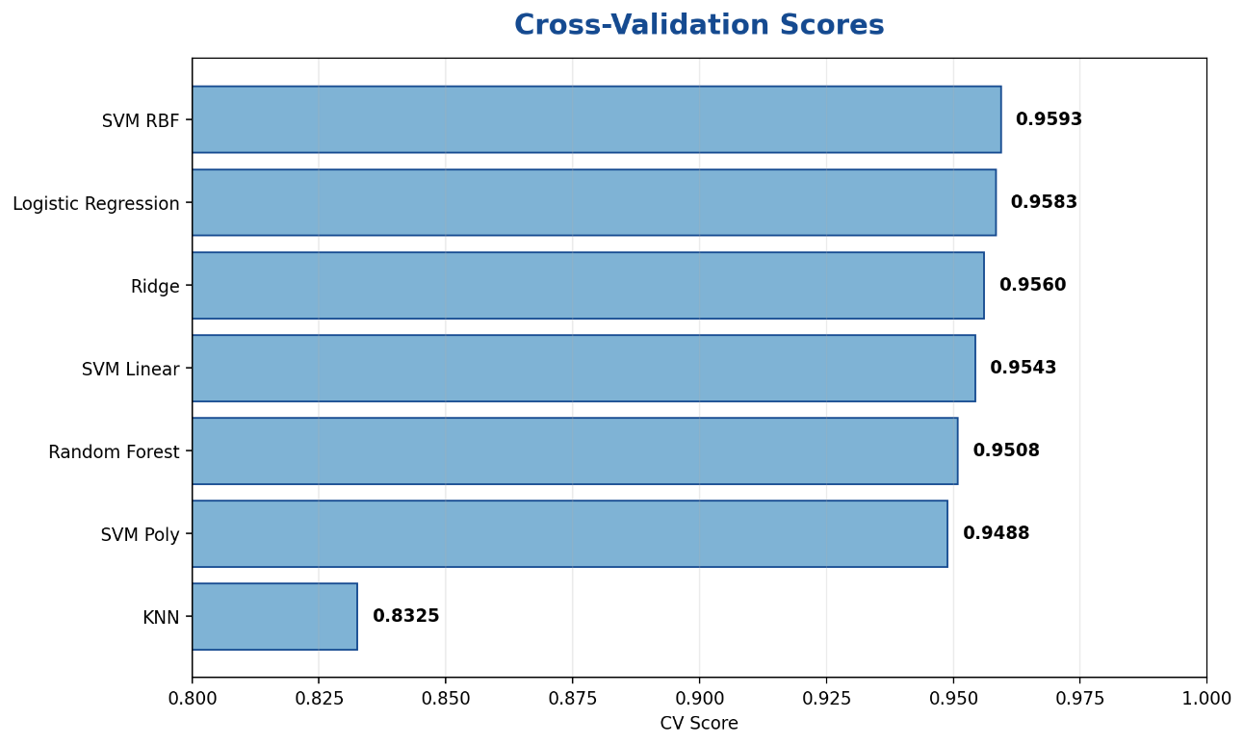

Fig.3 Cross-Validation Scores

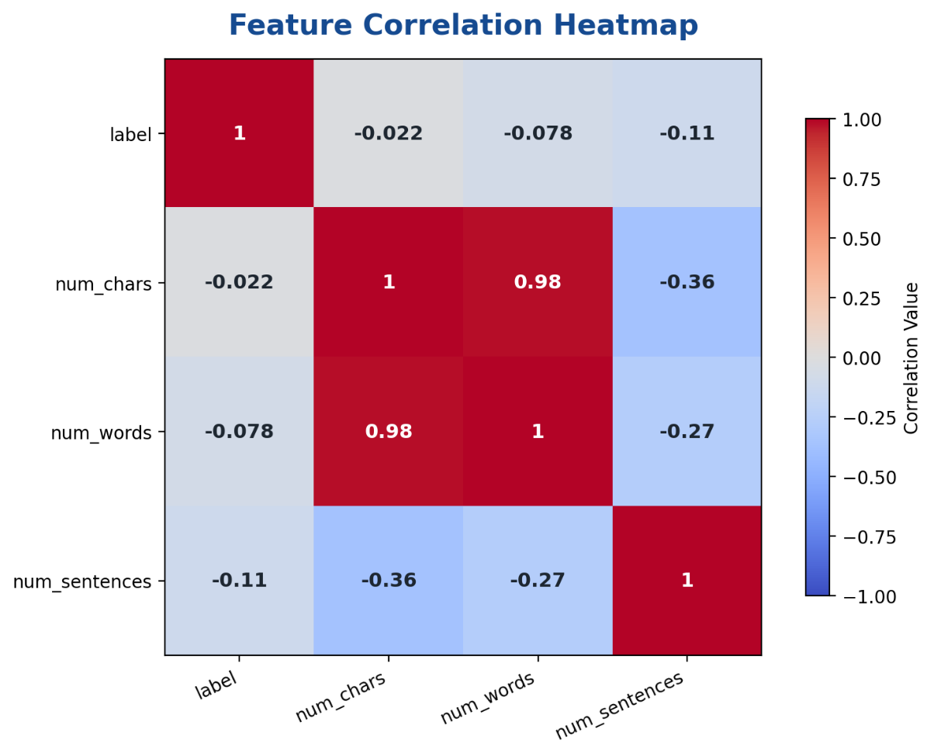
Fig.4 Feature Correlation Heatmap
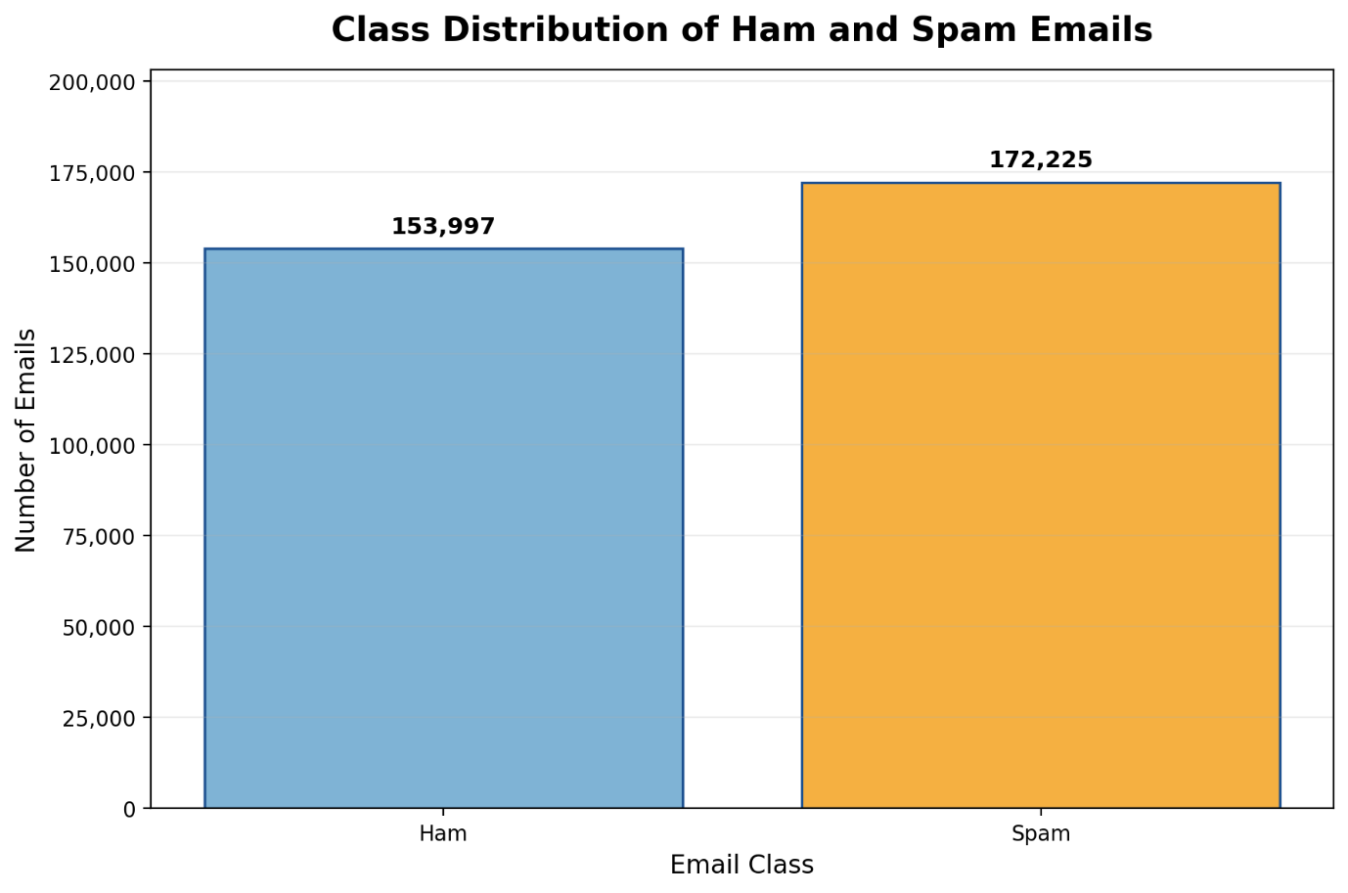

Fig.5 Class Distribution of Ham and Spam Emails

6. Conclusion and Future Scope

Conclusion

The Spam Email Detection System was successfully developed as a machine learning-based project to classify email messages into Spam and Ham categories. The project followed a complete machine learning workflow starting from dataset collection, dataset cleaning, preprocessing, exploratory data analysis, TF-IDF vectorization, feature selection, model training, hyperparameter tuning, model testing, and final prediction.

In this project, raw email text data was first cleaned by removing unnecessary elements such as punctuation marks, stopwords, special characters, and unwanted symbols. After preprocessing, the cleaned text was converted into numerical form using TF-IDF Vectorization, which helped represent email messages in a format suitable for machine learning models. Feature selection was also applied using SelectKBest with Chi-Square to reduce unnecessary features and keep the most useful words for classification.

Different supervised machine learning models such as Logistic Regression, Support Vector Machine, Random Forest, K-Nearest Neighbors, and Ridge Classifier were trained and tested. Hyperparameter tuning was performed using GridSearchCV to improve model performance and select better parameter combinations. After comparing individual models, a Voting Classifier was used to combine the strengths of selected models and produce the final prediction.

The results showed that the system performed very well in identifying spam and ham emails. The models achieved high accuracy, precision, recall, and F1-score. The confusion matrix also showed that most emails were correctly classified, with only a small number of incorrect predictions. This proves that machine learning and Natural Language Processing techniques can be effectively used to solve real-world email filtering problems.

Overall, the project successfully demonstrates how text data can be processed, transformed, trained, evaluated, and used for prediction. The Spam Email Detection System is simple, efficient, and useful for detecting unwanted emails. It can help reduce spam messages, improve email safety, and support better digital communication.

Future Scope

Although the current system gives strong results, it can be improved further in the future by adding more advanced features and technologies. Some possible future improvements are:
1. Real-Time Email Filtering
In the future, the system can be connected with real email services so that incoming emails can be checked automatically in real time. This would make the system more practical and useful for daily email communication.

2. Integration with Gmail or Outlook
The project can be extended by integrating it with platforms such as Gmail, Outlook, or other email clients. This would allow the model to directly classify emails from a user’s inbox and move spam emails to a separate spam folder.

3. Use of Deep Learning Models
Advanced deep learning models such as LSTM, GRU, BERT, or transformer-based models can be used to improve spam detection accuracy. These models can understand the context and meaning of email text better than traditional machine learning models.

4. Detection of Phishing Emails
The system can be expanded to detect phishing emails separately. Phishing emails are more dangerous than normal spam because they try to steal personal information such as passwords, bank details, or login credentials.

5. Multilingual Spam Detection
The current system mainly focuses on English email text. In the future, it can be improved to detect spam emails written in different languages such as Hindi, Hinglish, or other regional languages.

6. Attachment and Link Analysis
Future versions of the system can also analyze email attachments and embedded links. This would help detect harmful files, malicious URLs, and suspicious websites included in spam or phishing emails.

7. User Feedback-Based Learning
A feedback option can be added where users can mark wrong predictions as correct or incorrect. This feedback can be used to retrain the model and improve its performance over time.

8. Deployment as a Web Application
The system can be deployed as a web application using Flask, Django, or Streamlit. This would allow users to enter email text through a simple web interface and receive instant spam or ham prediction.

9. Improved Dataset and Regular Updating
Spam email patterns keep changing over time. Therefore, the dataset can be updated regularly with new types of spam emails. This would help the model stay effective against new spam techniques.

10. Explainable AI Features
The system can be improved by showing why an email was classified as spam or ham. For example, it can highlight suspicious words or phrases that affected the prediction. This would make the system more transparent and easier to trust.
7. References:

Books

1. Yashavant Kanetkar, Let Us Python, BPB Publications.
2. Andreas C. Müller and Sarah Guido, Introduction to Machine Learning with Python, O’Reilly Media.
3. Aurélien Géron, Hands-On Machine Learning with Scikit-Learn, Keras, and TensorFlow, O’Reilly Media.

Online Resources

1. Scikit-learn Documentation — [https://scikit-learn.org/]
2. Pandas Documentation — [https://pandas.pydata.org/]
3. NumPy Documentation — [https://numpy.org/]
4. Matplotlib Documentation — [https://matplotlib.org/]
5. Seaborn Documentation — [https://seaborn.pydata.org/]
6. NLTK Documentation — [https://www.nltk.org/]
7. WordCloud Documentation — [https://amueller.github.io/word_cloud/]
8. GeeksforGeeks —[https://www.geeksforgeeks.org/]
9. Stack Overflow — [https://stackoverflow.com/]

