-- Shark Tank Data set Season1

SELECT * from SharkTank.dbo.Offer

--- Total episodes

Select Count (Distinct (Epno)) as Episode_Count from SharkTank..Offer

Output -> **30**

--- Total Brands

Select Count(Distinct(Brand)) as Episode_Count from SharkTank..Offer

**Output -> 98**

-- Brands that got Fundings

Select count(*) as Got_Funding from SharkTank..Offer where Total_investors <> 0

**Output -> 57**

-- Total Male & Female Pitchers

select sum(Male) as Male_Pitchers , Sum(Female) as Female_Pitchers from SharkTank..Offer

**Male Pitchers -> 139, Female Pitchers -> 59**

-- Total Amount Invested in the Show

Select

concat (Sum (Amount_Invested_lakhs),' Lakh Rupees')

as Total_Amount_Invested from SharkTank..Offer

**Output -> 3422 Lakh Rupees**

-- Average Equity Asked

Select round (avg (Equity_Asked),2) as Average_Equity_Asked from SharkTank..Offer

**Output -> 5.20%**

--Average Equity Given

Select AVg(EquityTaken) as Average_Equity_Taken from

(Select * From SharkTank..Offer where EquityTaken <> 0)

Output -> 16.58

-- Highest Deal of the Show

Select Brand, Location, Sector, Deal, Amount_Invested_lakhs, Partners from SharkTank..Offer

where Amount_Invested_lakhs =

(Select Max(Amount_Invested_lakhs) as Highest_Deal from SharkTank..Offer)

**Aas-Vidyalaya Mumbai Technology ₹1.5 Crore for 15% Equity 150 Ash-Nam-Pey**

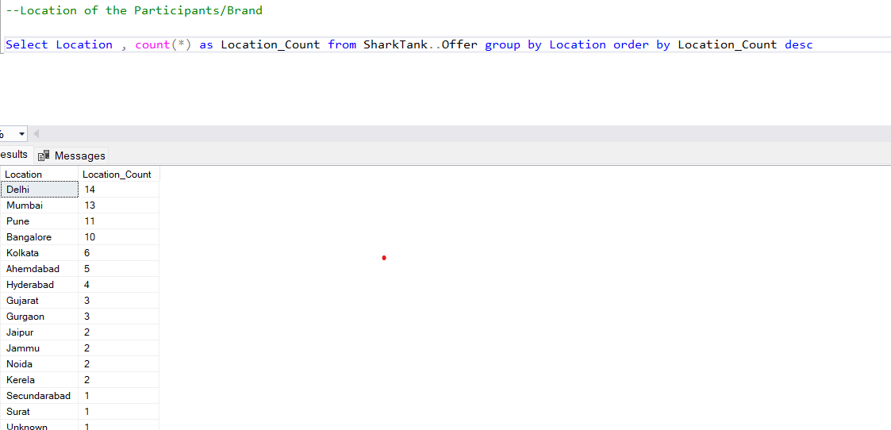

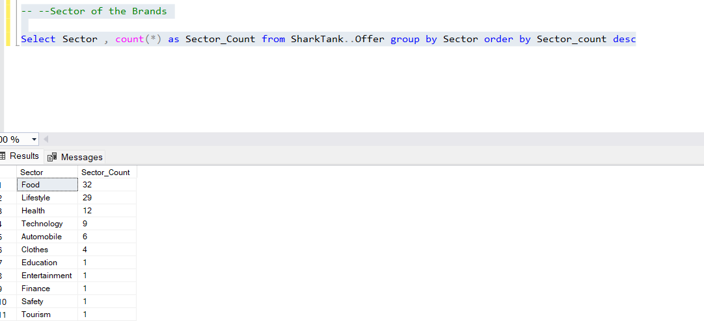

--Which Sector got the most Investments

Select Sector, Sum(Amount_Invested_lakhs) as Total_Amount_Sector from SharkTank..Offer group by Sector

order by Total_Amount_Sector_ desc

-- Which Shark got most deals

Select partners, count(partners) as Number_of_deals from SharkTank..Offer

where partners <> '-' group by Partners order by Number_of_deals desc