**1) /*Population Data set*/**

**select * from SQLProject1.dbo.Sheet1**

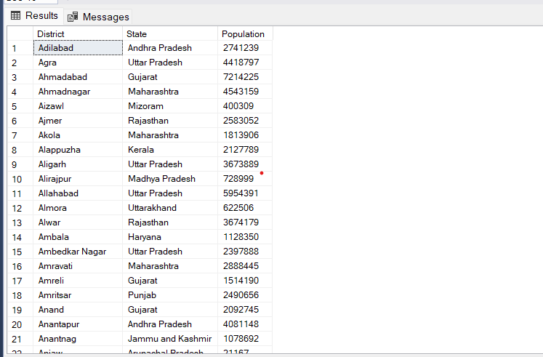

**2) /*General Details Data Set */**

**select * from SQLProject1.dbo.Data1**

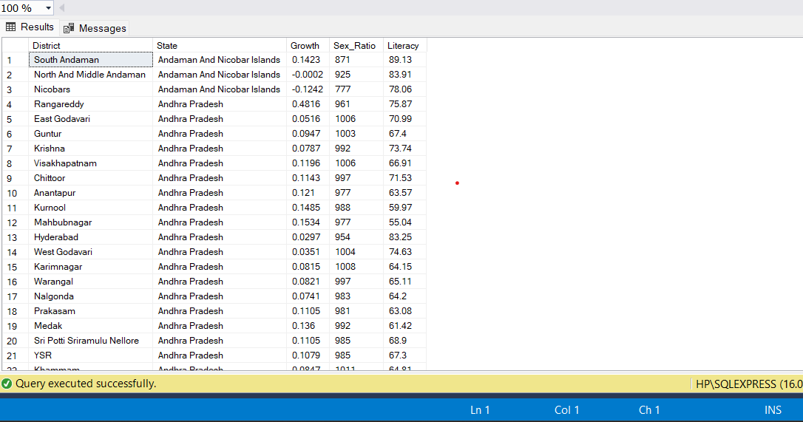

**3) -- Number of Rows in Population Data set**

**select count (*) as Total_Rows from SQLProject1.dbo.Sheet1**

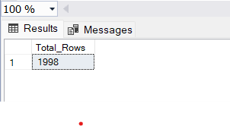

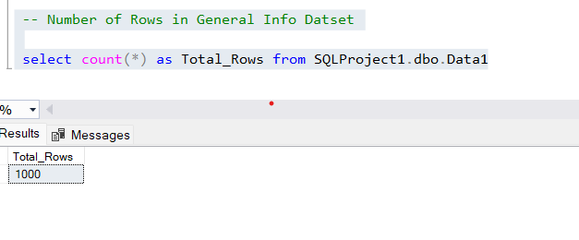

**Details about Bihar & Jharkhand States**

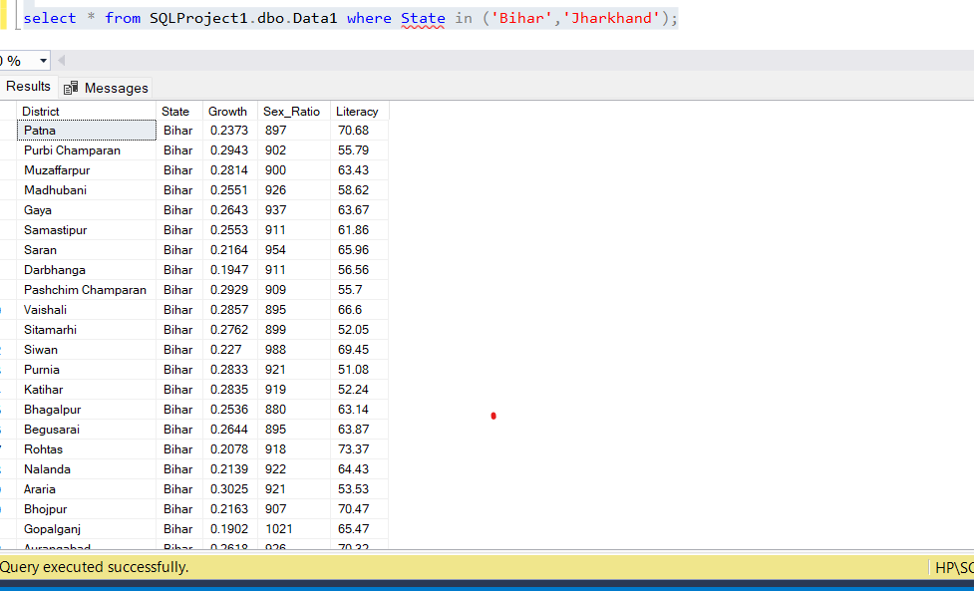

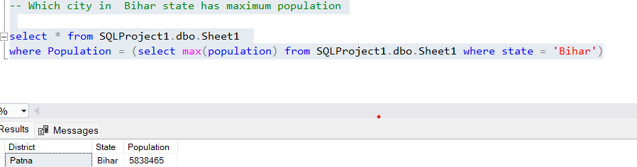

**# Total Population of India**

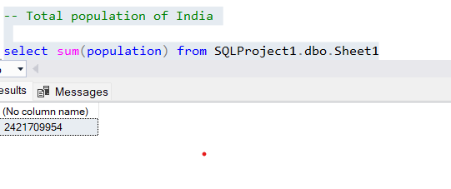

**-- Avearge Growth of India**

**select round (AVG (growth),2) from SQLProject1.dbo.Data1**

* **19.25**

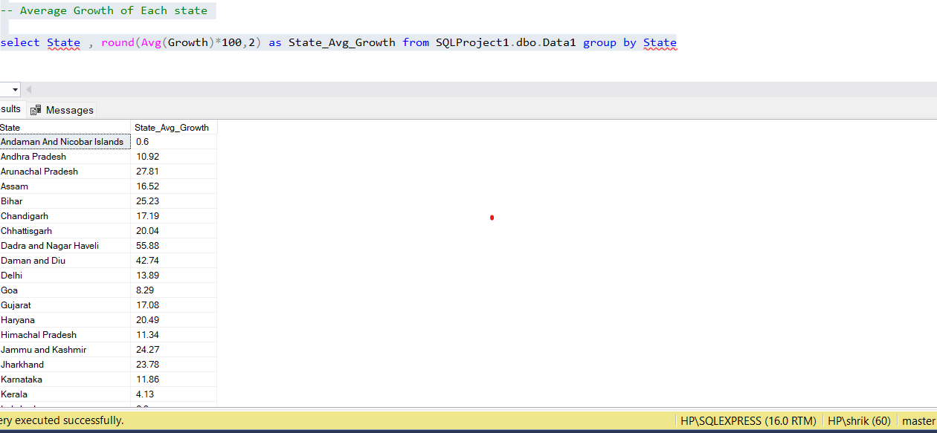

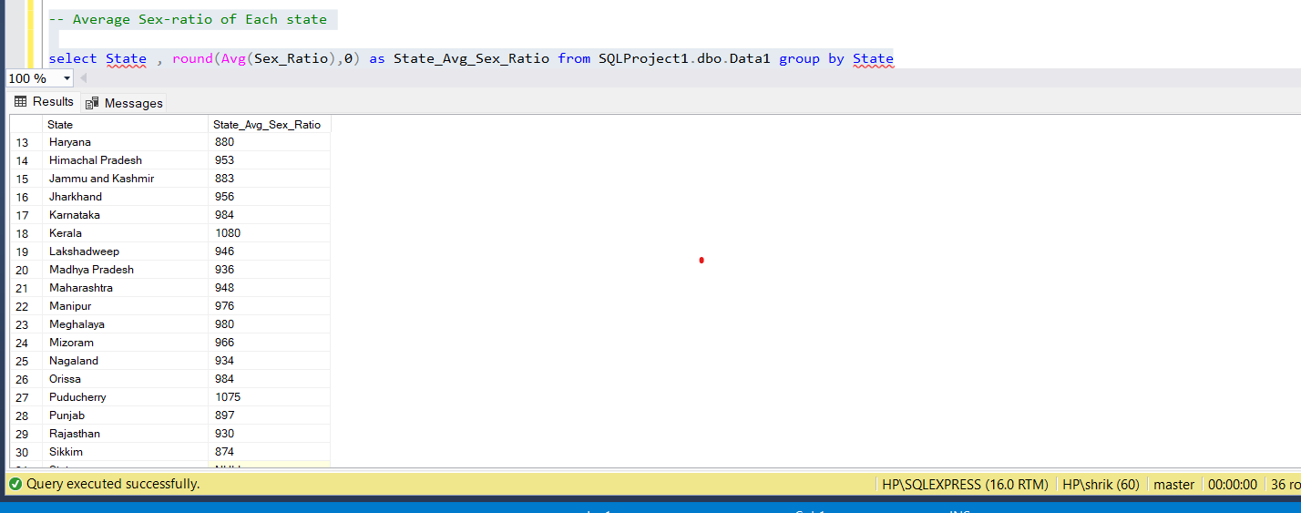

-- Average Literacy Rate of Each state

select State, concat (round (Avg (Literacy),2),'%') as State_Avg_Literacy_Rate from SQLProject1.dbo.Data1 group by State

-- States having Literacy rate greater than 90%

select State, round(Avg(Literacy),2) as State_Avg_Literacy_Rate from SQLProject1.dbo.Data1 group by State having round(Avg(Literacy),2) > 90

Kerela -> 93.70

Lakshadweep -> 91.85

**-- Top 3 States in Growth**

**select TOP 3 State, round(Avg(Growth)*100,2) as State_Avg_Growth**

**from SQLProject1.dbo.Data1 group by State order by State_Avg_Growth desc**

Nagaland -> 82.28

Dadra and Nagar Haveli -> 55.88

Daman and Diu -> 42.74

-- Bottom 3 Sex ratio States

select TOP 3 State, round(Avg(Sex_Ratio),0) as State_Avg_Sex_Ratio

from SQLProject1.dbo.Data1 group by State order by State_Avg_Sex_Ratio asc

Dadra and Nagar Haveli -> 774

Daman and Diu -> 783

Chandigarh -> 818

-- States Starting with letter A

select DISTINCT(State) from SQLProject1.dbo.Sheet1

where State like 'A%'

Andaman And Nicobar Islands

Andhra Pradesh

Arunachal Pradesh

Assam

-- Literate Population

SELECT a.district, a.Literacy , b.Population , round(((b.Population*a.Literacy)/100),0) as Literate_Population

from SQLProject1.dbo.Data1 a inner join SQLProject1.dbo.Sheet1 b

on a.District = b.District

-- Most Literate City in Every State

with city_cte as (select *, rank() over (partition by State order by Literacy) as Highest_Literate_City from SQLProject1.dbo.Data1)

select District, State, Literacy from city_cte where Highest_Literate_City = 1