**Loops**

In programming languages, loops are used to execute a set of instructions/functions repeatedly when some conditions become true.

There are three types of loops in java:

1. **For**
2. **While**
3. **Do_While**

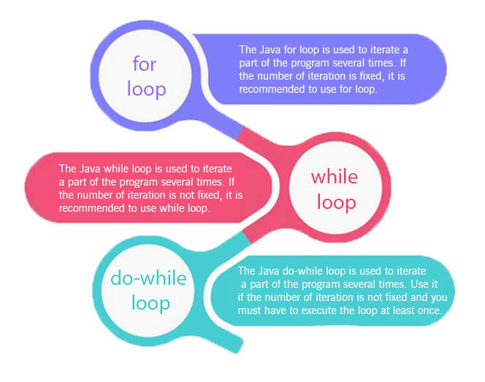

**For –**

**for(initialization;condition;incr/decr){**

**//statement or code to be executed**

**}**

* **Nested**
* **For_Each**

**While –**

**while(condition){**

**//code to be executed**

**}**

**Do_While**

**do{**

**//code to be executed**

**}while(condition);**

**Break -** When a break statement is encountered inside a loop, the loop is immediately terminated and the program control resumes at the next statement following the loop.

**Continue** - The continue statement is used in loop control structure when you need to jump to the next iteration of the loop immediately. It can be used with for loop or while loop.