# Project: Billing Management System

1. Use case diagram

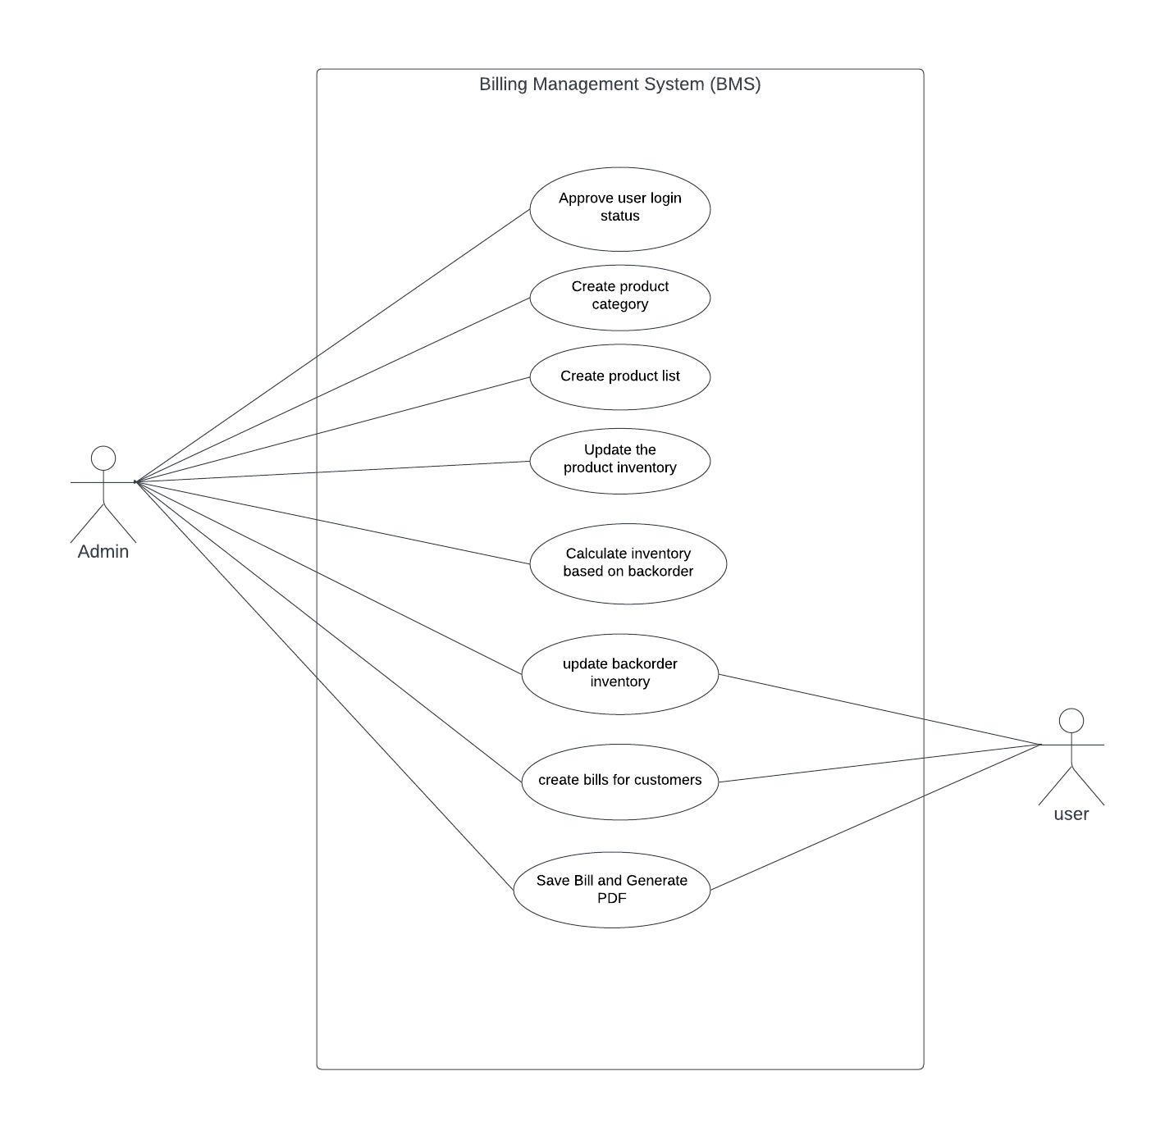

1. Sequence diagram
2. Admin :

1. User

