Lab1 Report - Build Testing Environment

**Name: Shrikant Kale - #700727822**

1. Ubuntu20.04 VM loaded in VMWare.

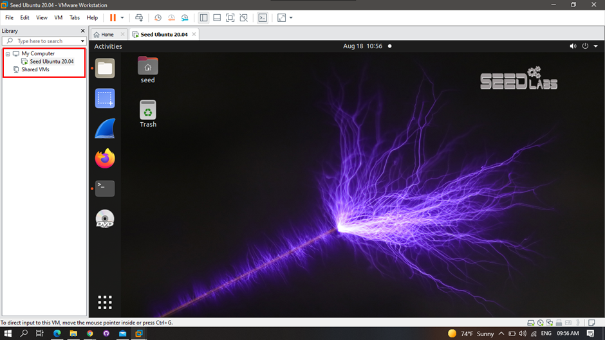

1. Changed terminal name to Shrikant (my first name)

