GAN (Generative Adversarial Network)

Generator: generator learns to make make fakes that look real

Discriminator: learns to distinguish real from fake. It learns the probability of class Y (real or fake) for given features. The probabilities are the feedback for the generator.

This is also called the vanishing gradient problem because the gradients approach 0 when the distributions are far apart.

Problem with BCE (Binary Cross Entropy) Loss:

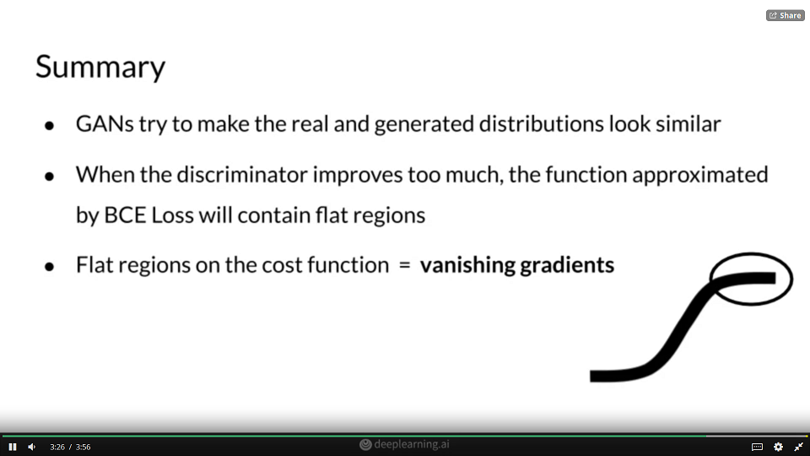

### Wasserstein Loss

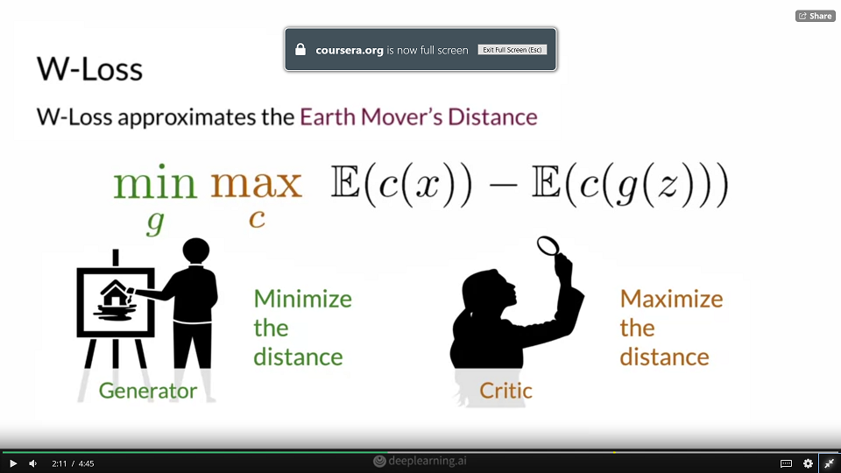

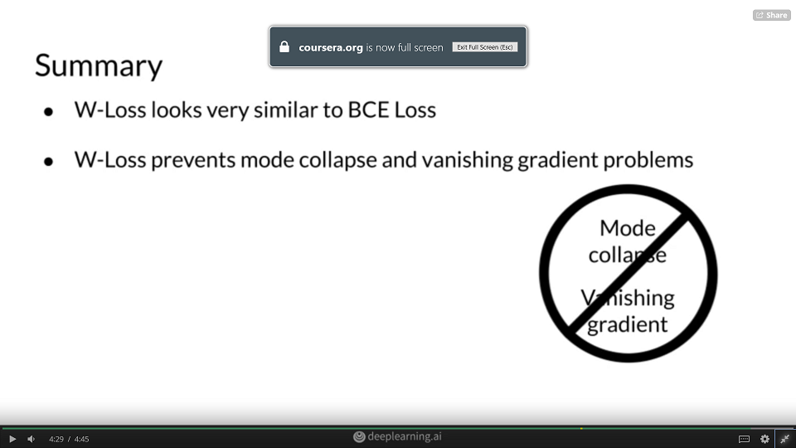

### Conditional Generation: Inputs

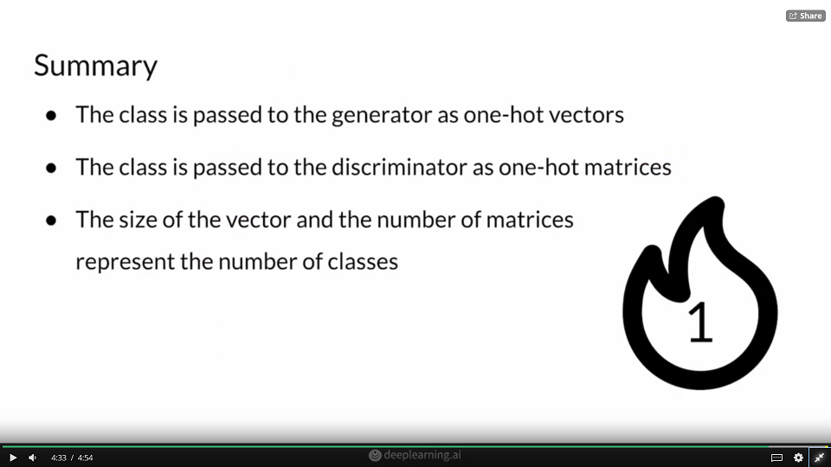

How does the generator learn what class to generate?

The discriminator also receives the class label and will classify the images based on if they look like real images from that specific class or not.

How is adding the class information different for the discriminator and generator, and why?

Both the discriminator and generator receive the class information appended to their traditional inputs for conditional generation.

### Controllable Generation

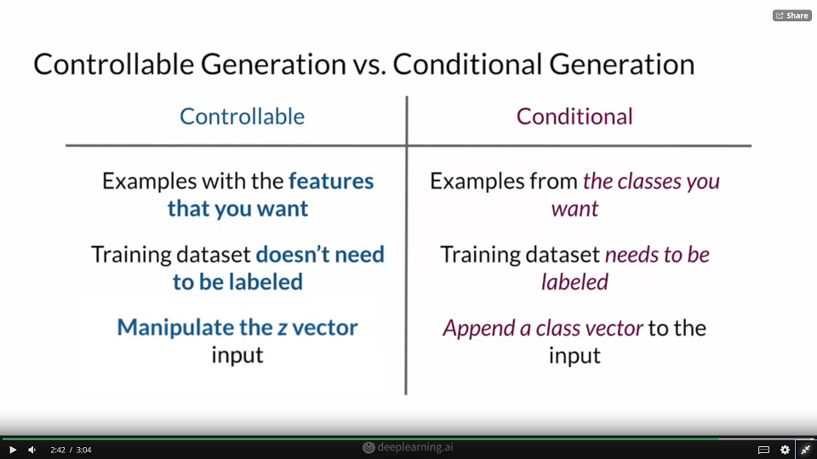

### Vector Algebra in the Z-Space

### Picture comparing:

### 

### Fréchet Inception Distance (FID)

### Inception Score

### 

### What is the purpose of progressive growing?

### To gradually train the generator by increasing the resolution of images being generated in iterations. StyleGAN uses progressive growing to handle large image resolutions by gradually increasing the image resolution being generated by the generator.

### Adaptive Instance Normalization (AdaIN)

### 

### What is the purpose of the AdaIN layers

### To get the style info from w into the feature maps.

### AdaIN blocks transfer learned style info from the intermediate noise vector (w) onto the generated image. They also renormalize the statistics so each block overrides the one that came before it.

### Style and Stochastic Variation

### Why is random noise added throughout StyleGAN?

### To introduce more randomness into the feature map and increase diversity.

### Extra noise is injected at several different levels of StyleGAN, and affects the generated image in a different way depending on whether the noise was injected earlier or later.

### Overview of GAN Applications

### Image to image translation

### Image to image (blur to sharpen image)

### Image to image (multimodal i.e., one image can generate multiclass image)

### Text to image

### Image and landmark -> video

### Image filter (as in snapchat)

### Image editing (mask image)

### Styled images

### Data Augmentation

### Medicine : simulating tissue.

### Data Augmentation: Pros & Cons

### 

### What is paired translation?

### When you have corresponding input-output images that you can gather training data for. Paired translation means that you have input-output pairs that map exactly onto each other (1-to-1).

### Pix2Pix Overview

### What is one way Pix2Pix is different than the traditional GAN?

### The Pix2Pix generator takes an image as input instead of the class vector and noise. Instead of a class vector, the Pix2Pix generator takes an entire image as input.

### Pix2Pix: U-Net

### 

### What is the purpose of the skip connections in the Pix2Pix generator?

### They allow information to flow to later layers by reducing the vanishing gradient problem, which occurs when there are too many layers.

### Skip connections help prevent the vanishing gradient problem when gradients get too small when there are many layers because they are weighed less and less as the layers get deeper.

### Pix2Pix: Pixel Distance Loss Term

### 

### Why is pixel distance used for L1 regularization in Pix2Pix?

### Because the real output image and the generated image should be encouraged to be similar. Since they are so correlated, you can use the absolute difference or pixel difference.

### Unpaired Image-to-Image Translation

### 

### 

### 

### 

### Why is unpaired image-to-image translation different than paired image-to-image translation?

### There is no longer a clear target output. WIth unpaired image-to-image translation, you can just have a pile of images in one style and another pile of another style.

### CycleGAN Overview

### 

### CycleGAN: Two GANs

### 

### 

### 

### CycleGAN: Cycle Consistency

### CycleGAN Applications & Variants